**Create an ARIMA model for time series forecasting.**

**EX:No.8**

**DATE:12/04/25**

**AIM:**

To build and evaluate an ARIMA model for time series forecasting on stock market data.

**ALGORITHM:**

• Import the necessary libraries and load the time series dataset (e.g., AAPL.csv).

• Convert the 'Date' column to datetime format and set it as the index.

• Visualize the data and check for stationarity using ADF (Augmented Dickey-Fuller) test.

• Apply differencing if the data is non-stationary.

• Determine the optimal (p, d, q) parameters using ACF, PACF, or auto_arima.

• Fit the ARIMA model on the training data using the selected parameters.

• Forecast future values and evaluate the model using metrics like MAE, MSE, and RMSE.

**CODE:**

import pandas as pd

import matplotlib.pyplot as plt

from sklearn.metrics import mean_squared_error

import pmdarima as pm

# Load dataset

data = pd.read_csv('AAPL.csv')

data['Date'] = pd.to_datetime(data['Date'])

data.set_index('Date', inplace=True)

# Use 'Close' column

ts = data['Close']

# Train-test split

train_size = int(len(ts) * 0.8)

train, test = ts[:train_size], ts[train_size:]

# Fit Auto ARIMA on training data

auto_model = pm.auto_arima(train, seasonal=False, stepwise=True, trace=True,

suppress_warnings=True, error_action="ignore")

# Summary of model

print(auto_model.summary())

# Forecast for test period

forecast = auto_model.predict(n_periods=len(test))

# Evaluate the model

mse = mean_squared_error(test, forecast)

print(f"\nMean Squared Error: {mse:.4f}")

# Plot results

plt.figure(figsize=(12, 6))

plt.plot(train.index, train, label='Training Data', color='blue')

plt.plot(test.index, test, label='Actual Data', color='green')

plt.plot(test.index, forecast, label='Forecasted Data', color='red', linestyle='--')

plt.title('ARIMA Forecast vs Actual')

plt.xlabel('Date')

plt.ylabel('Stock Price')

plt.legend()

plt.tight_layout()

plt.show()

**OUTPUT:**

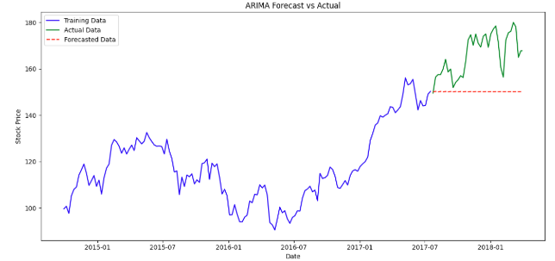

**RESULT:**

Thus the program has been completed and verified successfully.