**Develop neural network-based time series forecasting model.**

**EX:No.9**

**DATE:12/04/25**

**AIM:**

To develop a neural network-based time series forecasting model using LSTM on AAPL stock data.

**ALGORITHM:**

• Import AAPL stock data and necessary libraries (Pandas, Keras, etc.).

• Preprocess the data: sort by date, normalize, and create sequences.

• Split the dataset into training and testing sets.

• Reshape the data to fit LSTM input format: [samples, time_steps, features].

• Build the LSTM model with layers and compile it.

• Train the model using the training set with validation split.

• Predict on test data, inverse-transform predictions, and evaluate performance.

**CODE:**

import pandas as pd

import numpy as np

import matplotlib.pyplot as plt

from sklearn.preprocessing import MinMaxScaler

from sklearn.metrics import mean_absolute_error, mean_squared_error

from tensorflow.keras.models import Sequential

from tensorflow.keras.layers import LSTM, Dense, Dropout

from tensorflow.keras.callbacks import EarlyStopping

# 1. Load the dataset

data = pd.read_csv('/content/AAPL.csv')

data['Date'] = pd.to_datetime(data['Date'])

data = data.sort_values('Date')

data.set_index('Date', inplace=True)

# 2. Preprocess - use only 'Close' prices

close_data = data['Close'].values.reshape(-1, 1)

scaler = MinMaxScaler()

scaled_data = scaler.fit_transform(close_data)

# 3. Create sequences for LSTM

def create_sequences(data, window_size):

X, y = [], []

for i in range(len(data) - window_size):

X.append(data[i:i + window_size])

y.append(data[i + window_size])

return np.array(X), np.array(y)

window_size = 60

X, y = create_sequences(scaled_data, window_size)

# 4. Split into train and test sets

split = int(len(X) * 0.8)

X_train, X_test = X[:split], X[split:]

y_train, y_test = y[:split], y[split:]

# 5. Build the LSTM model

model = Sequential()

model.add(LSTM(units=64, return_sequences=True, input_shape=(X_train.shape[1], 1)))

model.add(Dropout(0.2))

model.add(LSTM(units=32))

model.add(Dropout(0.2))

model.add(Dense(1))

model.compile(optimizer='adam', loss='mean_squared_error')

# 6. Train the model

early_stop = EarlyStopping(monitor='val_loss', patience=5, restore_best_weights=True)

history = model.fit(X_train, y_train, epochs=50, batch_size=16,

validation_split=0.1, callbacks=[early_stop], verbose=1)

# 7. Predict and inverse scale

predicted = model.predict(X_test)

predicted_prices = scaler.inverse_transform(predicted)

actual_prices = scaler.inverse_transform(y_test)

# 8. Evaluation Metrics

mae = mean_absolute_error(actual_prices, predicted_prices)

mse = mean_squared_error(actual_prices, predicted_prices)

rmse = np.sqrt(mse)

print(f"\n📈 LSTM Forecasting Metrics:")

print(f"MAE: {mae:.4f}")

print(f"MSE: {mse:.4f}")

print(f"RMSE: {rmse:.4f}")

# 9. Plot predictions vs actual

plt.figure(figsize=(12, 6))

plt.plot(actual_prices, label='Actual Prices')

plt.plot(predicted_prices, label='Predicted Prices')

plt.title('AAPL Stock Price Prediction using LSTM')

plt.xlabel('Days')

plt.ylabel('Price')

plt.legend()

plt.show()

# 10.Plot training history

plt.figure(figsize=(10, 4))

plt.plot(history.history['loss'], label='Train Loss')

plt.plot(history.history['val_loss'], label='Validation Loss')

plt.title('Model Loss Over Epochs')

plt.xlabel('Epoch')

plt.ylabel('Loss')

plt.legend()

plt.show()

**OUTPUT:**

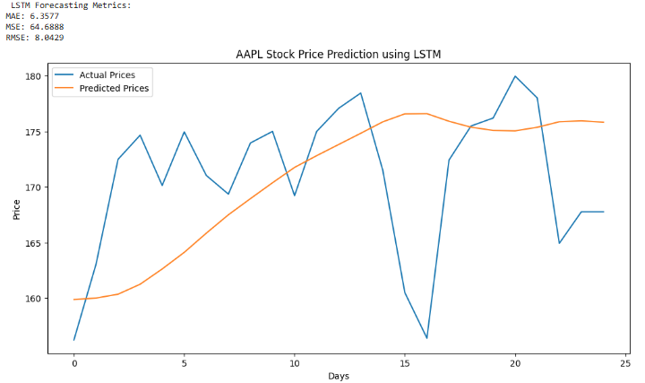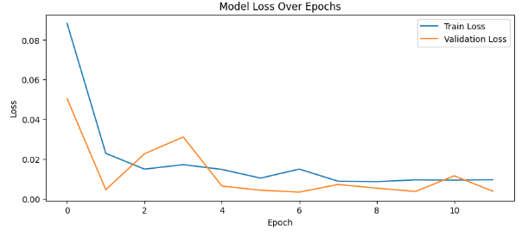

**RESULT:**

Thus the program has been completed and verified successfully.