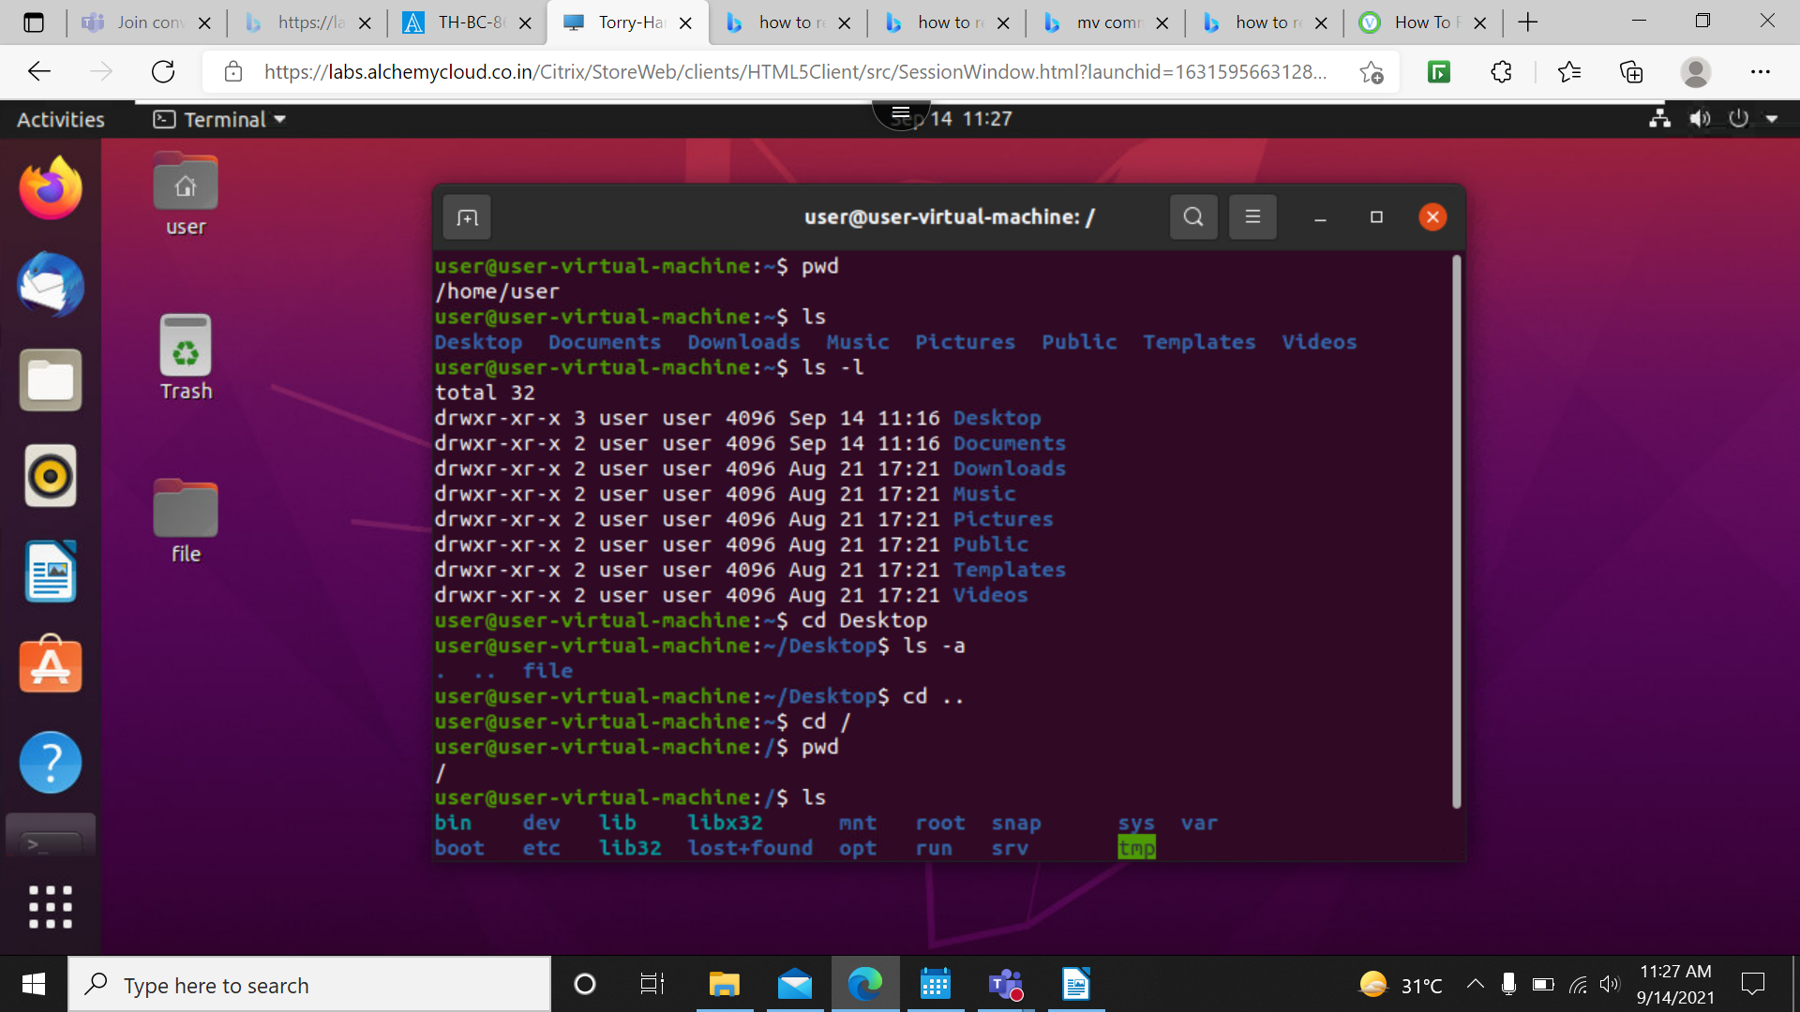
Commands in Linux:
1) pwd → Present working directory. It shows which directory is working at current time. Here is /home/user
2)ls –>list the directories which are present in current working directory.
3)ls -l → long listing the directories and provide detail information of the directories
4)cd –> Changing directory command is used changing the directory path.
5)ls -a –> list the files in that directory includes the hidden files also.
6)cd .. –> Change the directory and moves it to before one step.
7)cd / –> Change home directory to root directory.
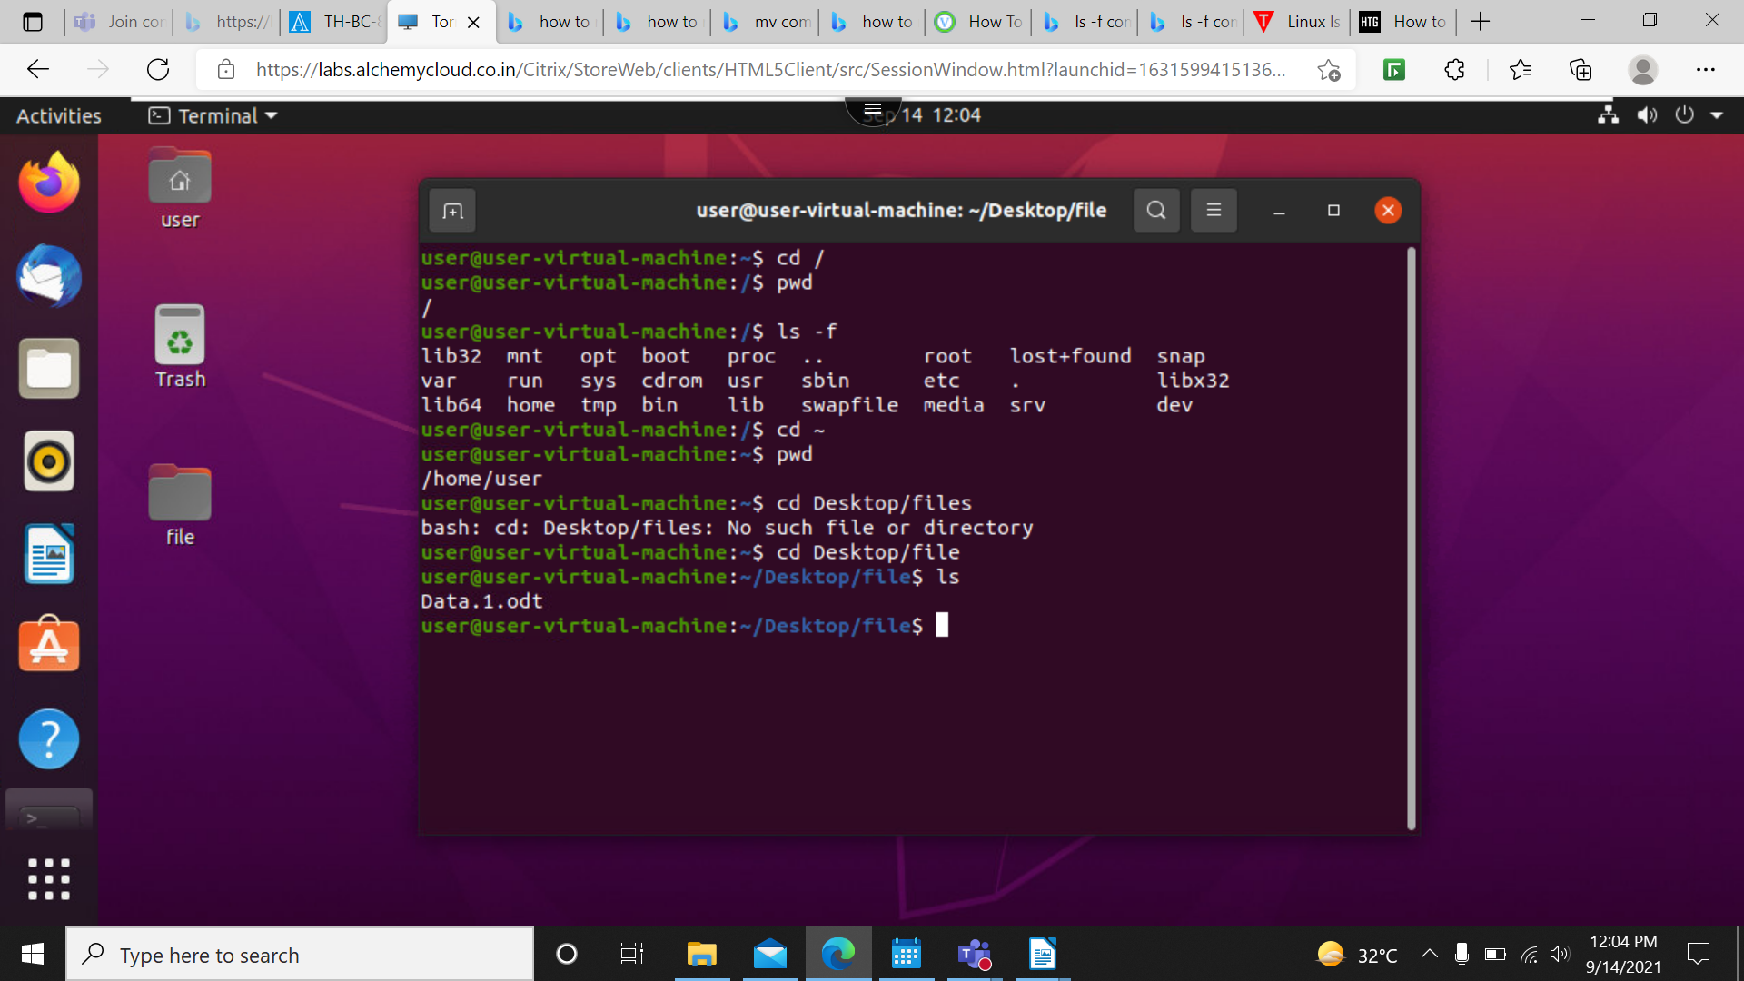

8)ls -f –> It lists all the folder in the directory without any format.
9)cd ~ –> Go back to the home directory
10)cd Desktop/file –> Reaches the new directory.

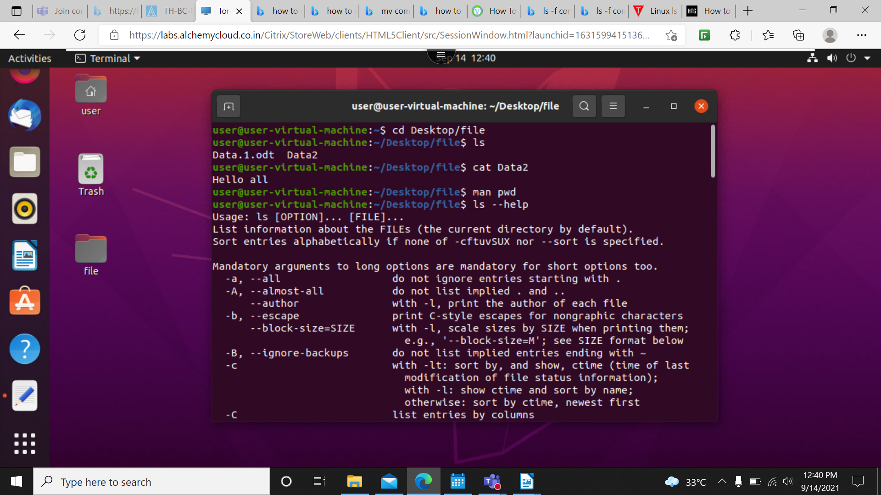
11) cat –> Is used to read text files and also for concatenation purpose. It does not read the word,excel and power point files as this has may features inbuilt in them so cat will consider all and will read everything in that format.
12)man –> used as manual for the described command name.
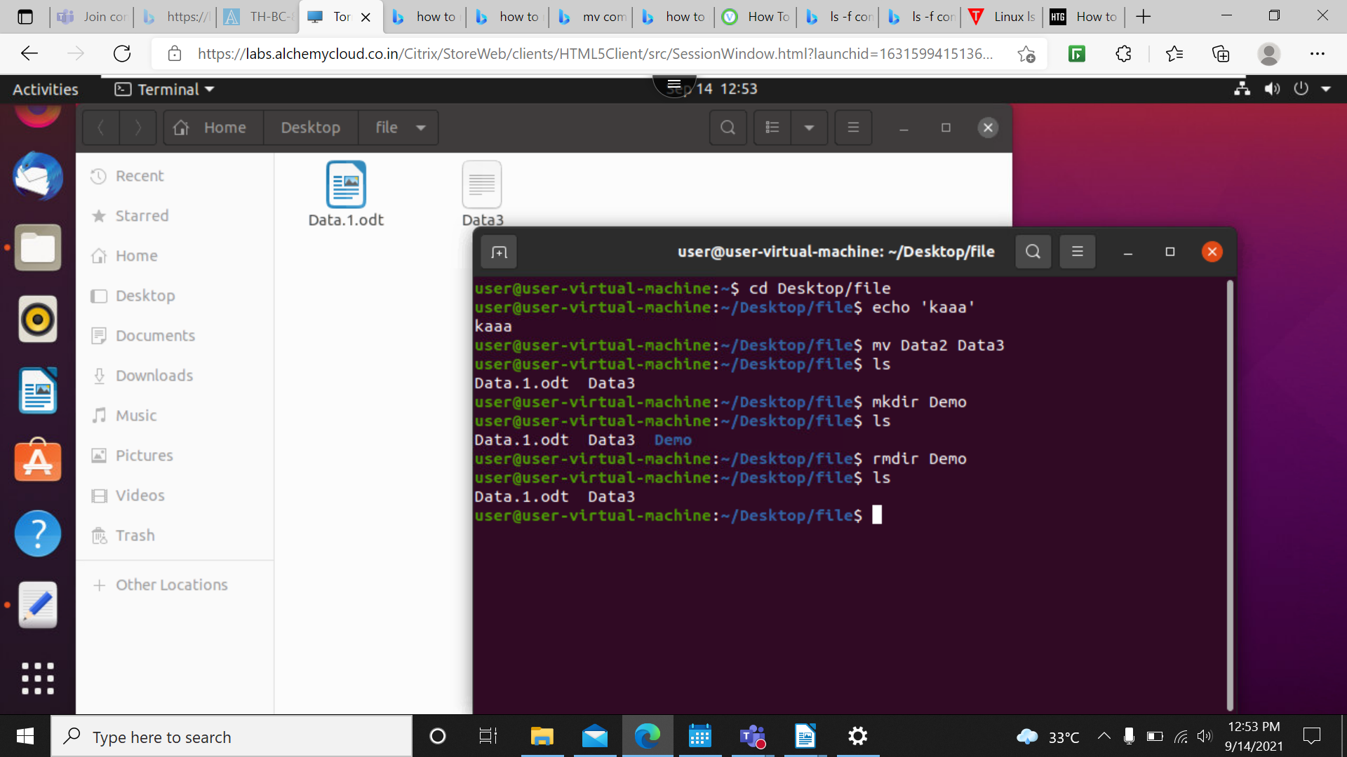
13)ls –help –> provide all details about that command.

14)echo –> Is used to print the inputs which was given.
15)mv – >Is used to move or rename file and directory.
16)mkdir –> Is used to create a new directory.
17)rmdir –> Is used to delete the directory.
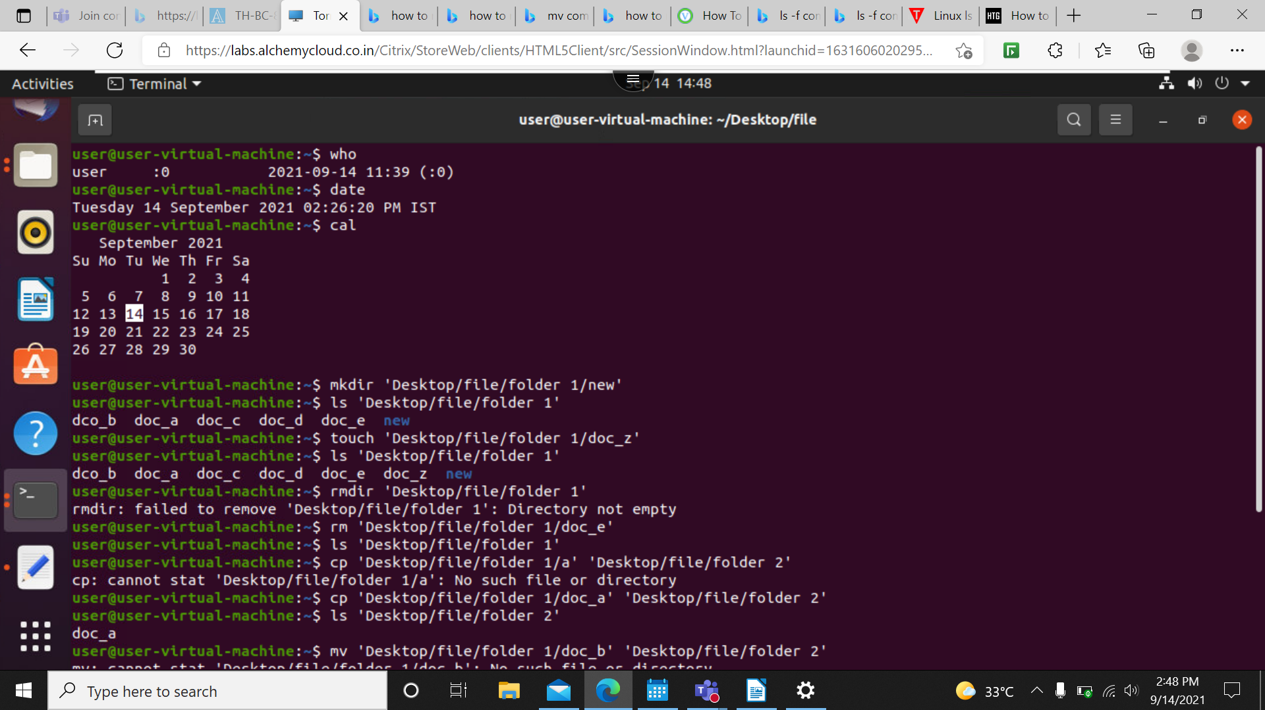
18) who – Is used to find who is the current user of the system.
19)date –> displays present days date.
20)cal –> displays the calendar and highlight today’s date.
21)touch –> Used to create new file inside the folder.
22)rm –> Removes the file.
23)cp –> Is used to copy files between folders.
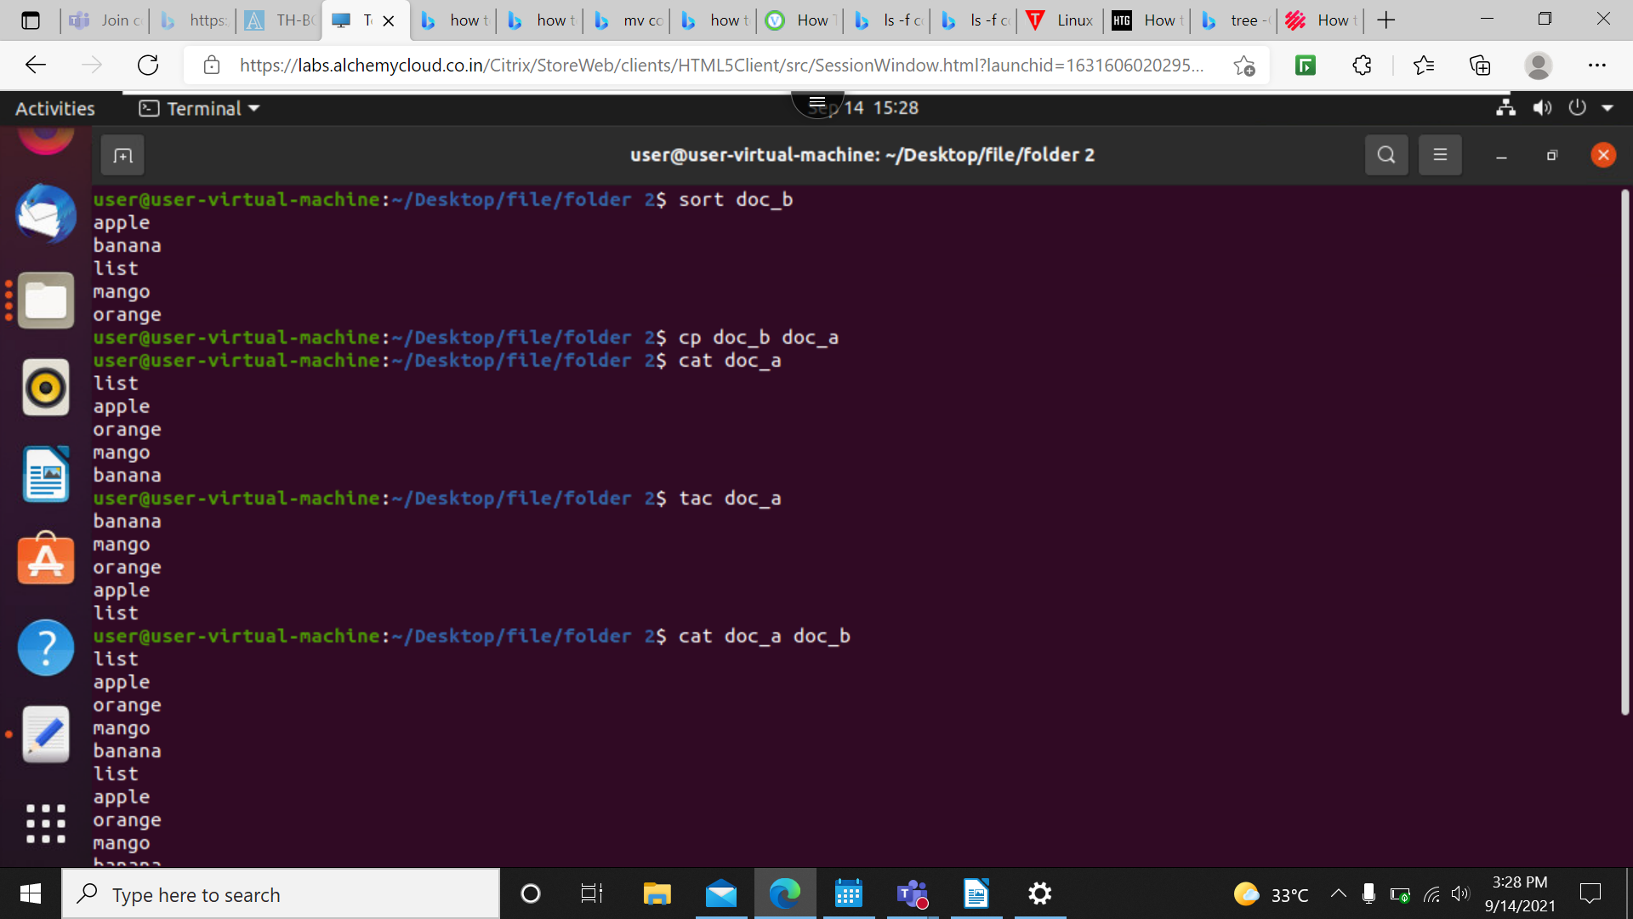
24)mv –> Is used to move files between folders.
25)cat –> It also displays the content present in the file.
26)tac –> It reverse the contents in the file and prints it.
27)sort –> Is used to sort the contents in the file in dictionary format.
28)cat -b –> Is used to number the contents.
29)ls -A –> Is used to display the necessary files without hidden files.
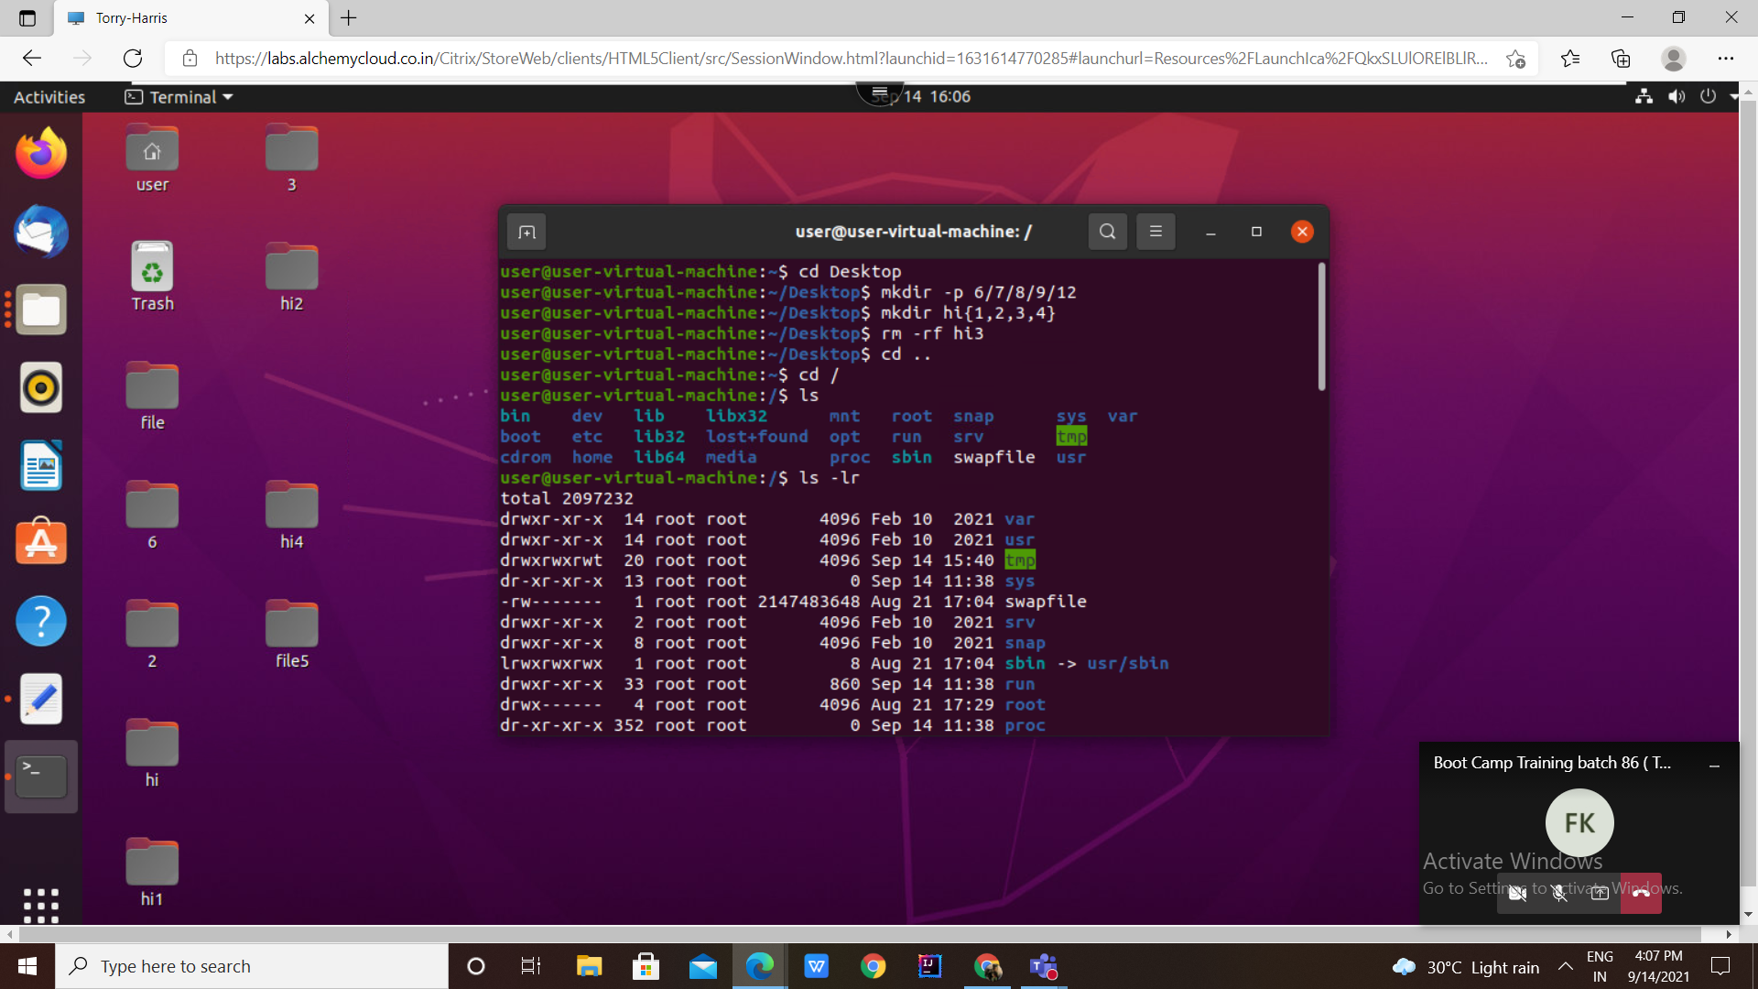
30)mkdir -p –> Creats a file inside another file.
31)mkdir demo{1,2,3,4} –>Create file in the name of demo with 1,2,3,4 numbers.
32)rm -rf demo –> Removes the file in the folder or directory.
33)ls -lr –> Displays the list of directory in recursive order.
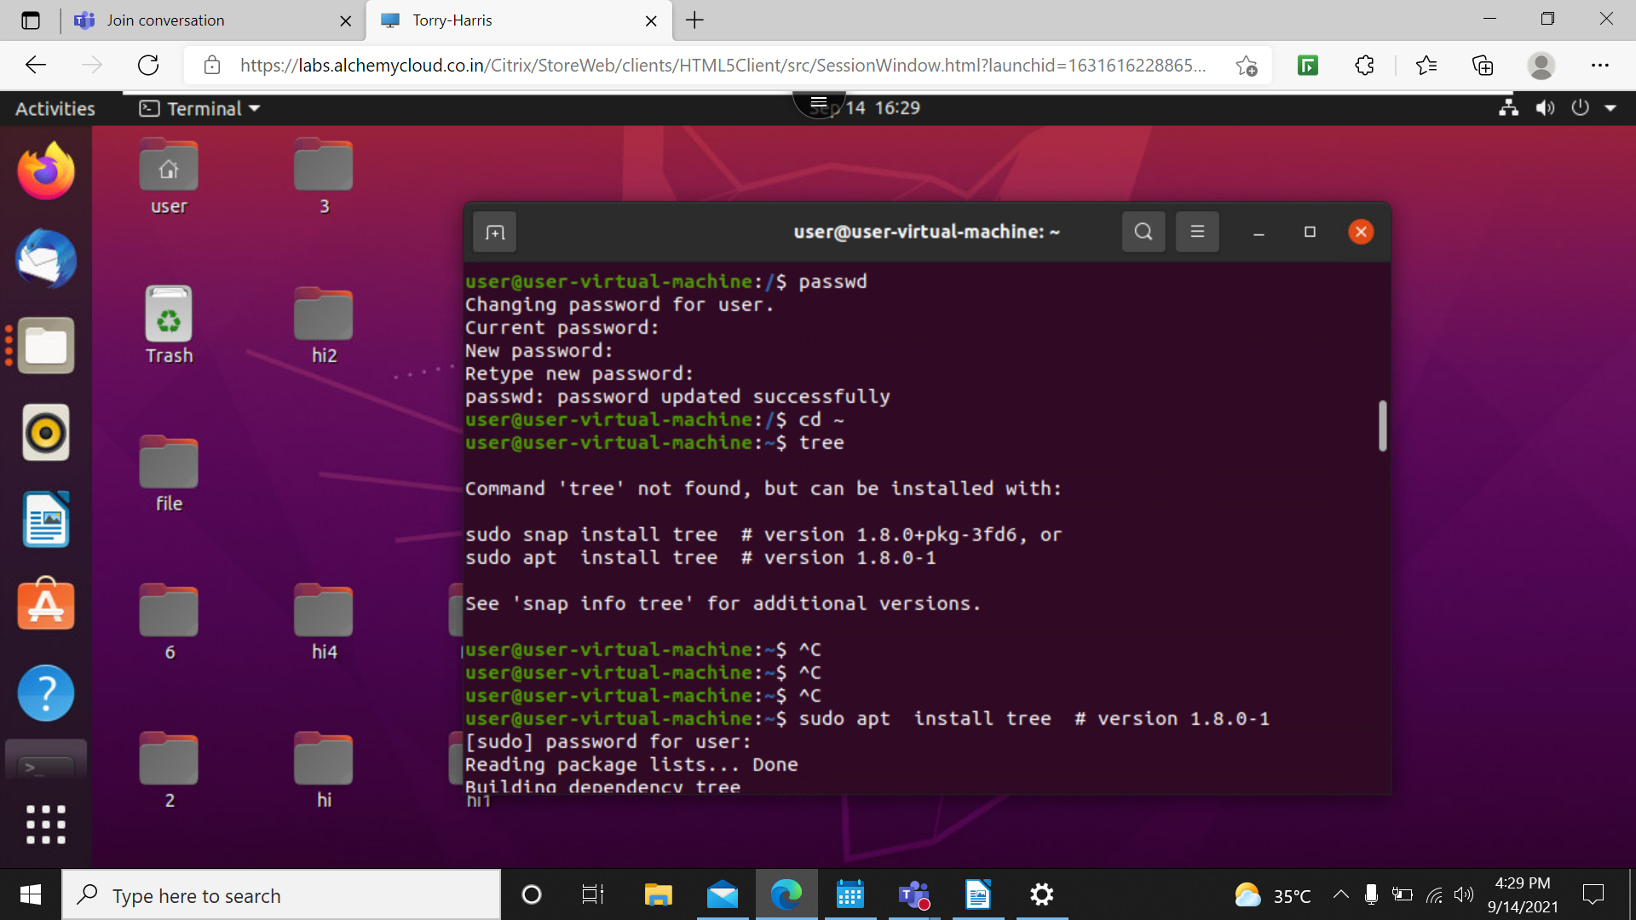
34)ls -lar –> Displays the list in the directory in reverse order.

35)passwd –> Used to change password of our home page.
36) tree –>Shows our data in hierarchical form.
37)~$ Sudo apt install –> Install tree package of suitable version.
38)tree -d –> Shows only the directories present in the desktop.
39)tree -C –> Shows all the files and folders in the directory
40)tree -Cd –> Similar to -d and shows all the directories present in desktop.
41)clear –> clear the terminal without closing it
42) exit –> Close the terminal.


