

PROJECT ASSIGNMENT/LAB
Design Modeling Document

– Hanoi, Sep 2024 –

Table of Contents
I. Record of Changes 3
II. User Interface Design 4
1. Feature Name1 4
1.1 SubFeature Name1.1 4
1.2 SubFeature Name1.2 4
2. User Authentication 4
2.1 User Login 4
2.2 User Register 4
2.3 User Profile 4
3. System Administration 5
3.1 Master Data 5
III. High-Level Design 6
1. Software Architecture 6
1.1 Sub-Systems/Components 6
1.2 External Interfaces 6
2. Package Diagram 7
IV. Database Design 8
1. Database Schema 8
2. Table Definitions 8
2.1 Table: users 8
2.2 Table: jobs 9
2.3 Tables: applications, application_notes, interviews 9
3. Enum / Lookup Values 10
4. Indexing Strategy 10
5. Seed Data 11
5.1 Minimum accounts required: 11
5.2 Minimum domain data required: 11
V. Detailed Design 12
1. <Use Case Name1> 12
1.1 Class Diagram 12
1.2 Sequence Diagram 12
2. <Use Case Name2> 13

I. Record of Changes
Date | A/M/D* | In charge | Description
*A - Added M - Modified D - Deleted

II. User Interface Design
[Provide the requirements or descriptions for the screens (grouped by the features, sub-features), in which you need to provide the screen descriptions, mock-up prototype and the description for the screen fields/components]

1. Feature Name1

1.1 SubFeature Name1.1

1.1.1 Screen Name1
[Content #1: UI layout (Mockup screen prototype)]
[Content #2: brief descriptions of the screen/function, mapped to the relevant use cases]
[Content #3: provide further descriptions for the screen’s components/fields using table format below]
Field Name | Description
Field Name1 | Field description: data type min/max length or value, initial data, etc.
Field Name2 | …
Field Group-Name1
Field Name3 | …
Field Name4 | …
Field Group-Name2
… | …

1.1.2 Screen Name2
…

1.2 SubFeature Name1.2
…

2. User Authentication

2.1 User Login
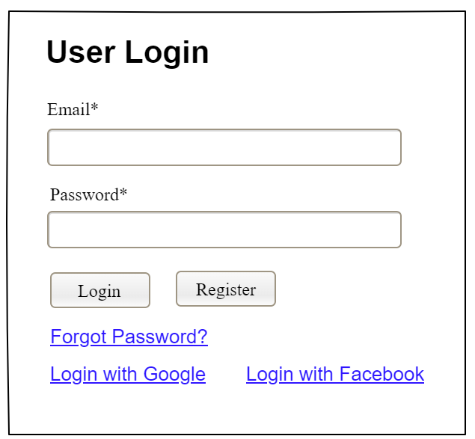
This screen allows system member to:
- Login System: provide email and password to be authenticated to access the system.

2.2 User Register
…

2.3 User Profile
…

3. System Administration

3.1 Master Data

3.1.1 Setting List
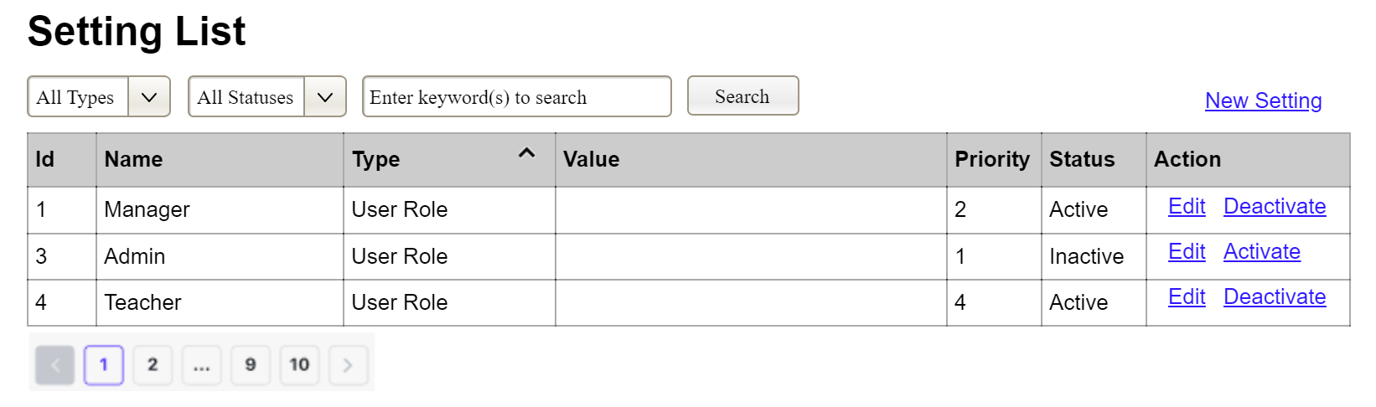
(3)
(2)
(1)
This screen allows the Administrator to:
- View Setting List: view list of current master data.
- Filter Setting List: filter master data by data types, statuses
- Search Settings: enter keyword(s) to search master data by their names or values
- Sort Setting List: sort mater data list (ascending, descending) by clicking column headers
On the screen, s/he can also
- Activate/Deactivate Setting: change status of a specific inactive/active master data
- Choose to go to the Setting Details screens for adding new or updating an existing master data by clicking the New Setting or Edit link.
Field Description
Field Name | Description
(1) | Initial values: all the active setting names with null or blank type  Hover the mouse to show the field name: “Setting Type”
(2) | Initial values: Active, Inactive  Hover the mouse to show the field name: “Setting Status”
(3) | The change-status action is Activate or Deactivate depending on the current status of the relevant setting (Inactive or Active, respectively).

3.1.2 Setting Details
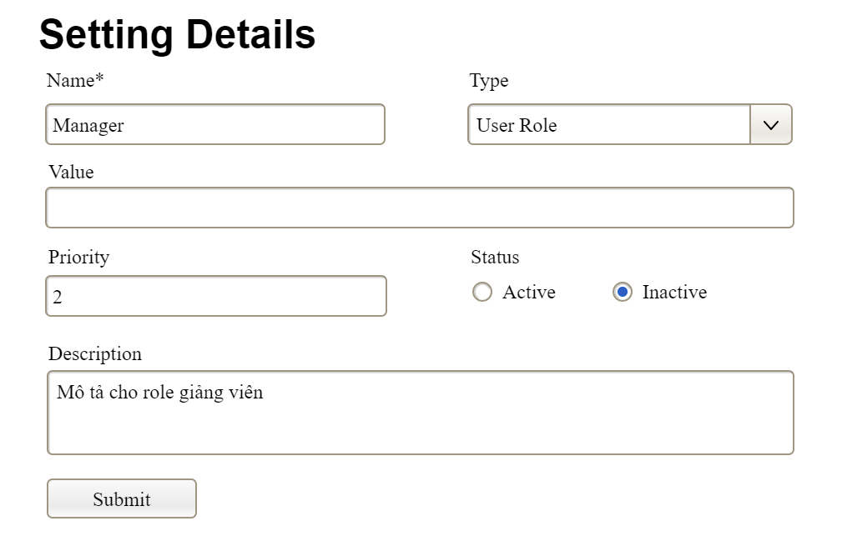
This screen allows the Administrator to:
- Add New Setting: add new master data.
- Update Setting Details: update details of a specific master data
Field Description
Field Name | Description
Name | Data type: non-digit string, max length of 20 characters
Type | Initial data values: all active setting names (with null or blank type)
Value | Data type: any string, max length of 100 characters
Priority | Data type: a positive integer
Description | Data type: any string, max length of 200 characters

III. High-Level Design

1. Software Architecture
[The content of this section includes the overall diagram which includes the sub-systems (with relevant technical libraries/framework), the external systems, and the relationship/connection among them (see sample below). You need also provide the explanation/description of each diagram components (sub-systems/components, external systems, etc.) in the sub sections]
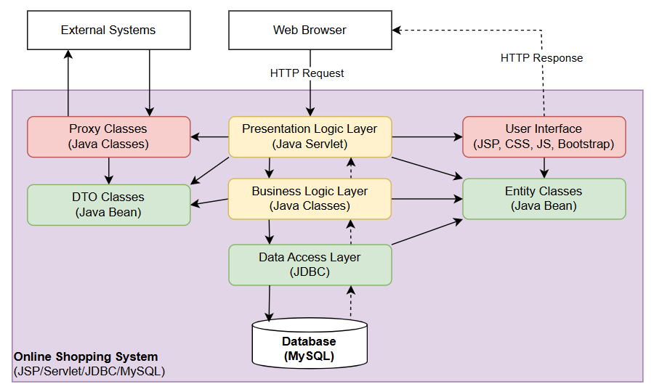

1.1 Sub-Systems/Components

1.1.1 User Interface
…

1.1.2 Presentation Logic Layer
..

1.1.3 …

1.2 External Interfaces

1.2.1 System NameX
..

1.2.2 …

2. Package Diagram
[Provide the package diagram for each sub-system. The content of this section including the overall package diagram, the explanation, package and class naming conventions in each package. Please see the sample & description table format below]
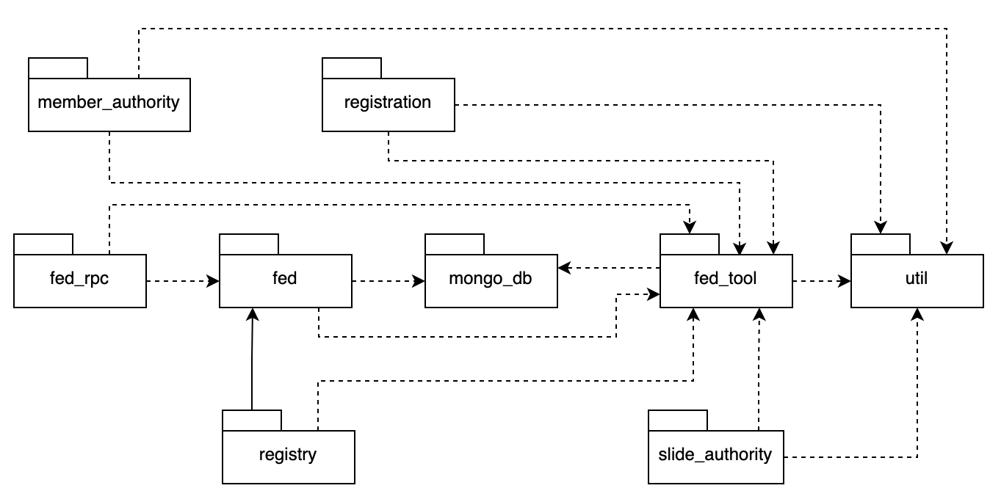
Package descriptions
No | Package | Description
01 | member_authority | <Description of the package>
02 | registration | <Description of the package>
03 | …

IV. Database Design

1. Database Schema
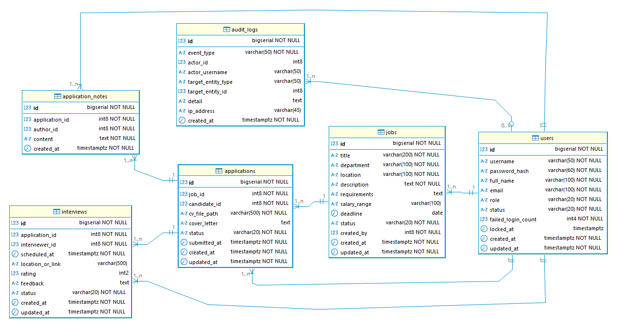

2. Table Definitions

2.1 Table: users
Column | Type | Constraints | Notes
id | BIGSERIAL | PRIMARY KEY | Auto-increment
username | VARCHAR(50) | NOT NULL, UNIQUE | Login identifier; [a-zA-Z0-9_] only
password_hash | VARCHAR(60) | NOT NULL | BCrypt hash; never store plaintext
full_name | VARCHAR(100) | NOT NULL
email | VARCHAR(100) | NOT NULL, UNIQUE
role | VARCHAR(20) | NOT NULL | Enum — see §3.3
is_active | BOOLEAN | NOT NULL, DEFAULT TRUE | FALSE = deactivated (soft delete)
is_locked | BOOLEAN | NOT NULL, DEFAULT FALSE | TRUE = temporarily locked after failed logins
failed_login_count | INT | NOT NULL, DEFAULT 0 | Resets to 0 on successful login
locked_at | TIMESTAMP | NULLABLE | Set when is_locked becomes TRUE
created_at | TIMESTAMP | NOT NULL, DEFAULT NOW()
updated_at | TIMESTAMP | NOT NULL | Set on every write by application code

2.2 Table: jobs
Column | Type | Constraints | Notes
id | BIGSERIAL | PRIMARY KEY
title | VARCHAR(200) | NOT NULL
department | VARCHAR(100) | NOT NULL
location | VARCHAR(100) | NOT NULL
description | TEXT | NOT NULL
requirements | TEXT | NULLABLE
salary_range | VARCHAR(100) | NULLABLE | Free text e.g. '15–20M VND'
deadline | DATE | NULLABLE | Application deadline
status | VARCHAR(20) | NOT NULL, DEFAULT 'DRAFT' | Enum — see §3.3
created_by | BIGINT | NOT NULL, FK → users.id | HR Manager who created the job
created_at | TIMESTAMP | NOT NULL, DEFAULT NOW()
updated_at | TIMESTAMP | NOT NULL

2.3 Tables: applications, application_notes, interviews
Add one table block per additional entity following the same structure.
Column | Type | Constraints | Notes
{{COLUMN}} | {{TYPE}} | {{CONSTRAINTS}} | {{NOTES}}
created_at | TIMESTAMP | NOT NULL, DEFAULT NOW()
updated_at | TIMESTAMP | NOT NULL

3. Enum / Lookup Values
Critical
Values here must match UCS Conventions state machine values exactly — same spelling, same ALL_CAPS convention. Mismatch causes silent data errors.

Table | Column | Allowed Values | Notes
users | role | ADMIN, HR_MANAGER, INTERVIEWER, CANDIDATE | Set on creation; never changes
jobs | status | DRAFT, ACTIVE, CLOSED | One-way; see UCS state machine
applications | status | APPLIED, SCREENING, INTERVIEW, OFFER, HIRED, REJECTED, WITHDRAWN | One-way; see UCS state machine

4. Indexing Strategy
Table | Index Column(s) | Type | Reason
users | username | UNIQUE | Business identity; login lookup
users | email | UNIQUE | Business identity; uniqueness rule
jobs | created_by | BTREE | FK; filter jobs by HR Manager
jobs | (status, deadline) | Composite | Filter active jobs by deadline
applications | job_id | BTREE | FK; list applications per job
applications | candidate_id | BTREE | FK; list applications per candidate
applications | (job_id, candidate_id) | UNIQUE | One application per job per candidate
application_notes | application_id | BTREE | FK; list notes per application
interviews | application_id | BTREE | FK; list interviews per application
interviews | interviewer_id | BTREE | FK; list interviews per interviewer

5. Seed Data
Purpose
Minimum data for all UCS use cases to be testable end-to-end in dev/test. Passwords must be BCrypt hashes — never plain text.

5.1 Minimum accounts required:
Username | Role | Purpose
admin | ADMIN | Test Admin-only features (account management)
hr_manager | HR_MANAGER | Test recruitment pipeline features
interviewer | INTERVIEWER | Test interview assignment and evaluation
candidate_01 | CANDIDATE | Test application submission (no existing application)
candidate_02 | CANDIDATE | Test application tracking (has existing application in SCREENING)

5.2 Minimum domain data required:
Entity | Count | States needed
Job posting | 2 | 1 × DRAFT, 1 × ACTIVE
Application | 3 | 1 × APPLIED, 1 × SCREENING, 1 × INTERVIEW
Interview | 1 | SCHEDULED (linked to the INTERVIEW-stage application)

-- src/main/resources/db/seed/data.sql
-- All passwords = BCrypt hash of "Test@1234" (strength 12)
-- Hash: $2a$12$RHpToERtUxpwgQFI5ySL4uiqjH.kVxTbdRHJAQJOkIMlrkK65OoVi

INSERT INTO users (username, password_hash, full_name, email, role, is_active) VALUES
('admin', '$2a$12$RHpTo...', 'System Admin', 'admin@co.com', 'ADMIN', true),
('hr_manager', '$2a$12$RHpTo...', 'HR Manager', 'hr@co.com', 'HR_MANAGER', true),
('interviewer', '$2a$12$RHpTo...', 'Interviewer', 'int@co.com', 'INTERVIEWER', true),
('candidate_01', '$2a$12$RHpTo...', 'Candidate One', 'cand01@gmail.com', 'CANDIDATE', true),
('candidate_02', '$2a$12$RHpTo...', 'Candidate Two', 'cand02@gmail.com', 'CANDIDATE', true);

INSERT INTO jobs (title, department, location, description, status, created_by) VALUES
('Senior Java Developer', 'Engineering', 'Hanoi', 'Build backend services', 'DRAFT', 2),
('Product Manager', 'Product', 'Hanoi', 'Own product roadmap', 'ACTIVE', 2);

INSERT INTO applications (job_id, candidate_id, cv_file_path, status) VALUES
(2, 4, 'uploads/cv/2/4_cv.pdf', 'APPLIED'),
(2, 5, 'uploads/cv/2/5_cv.pdf', 'SCREENING');

V. Detailed Design

1. <Use Case Name1>
[Provide the detailed design for the use case Use Case Name1: one class diagram and one or more sequence diagram (each sequence diagram for one use case)]

1.1 Class Diagram
[This part presents the class diagram for the relevant feature]
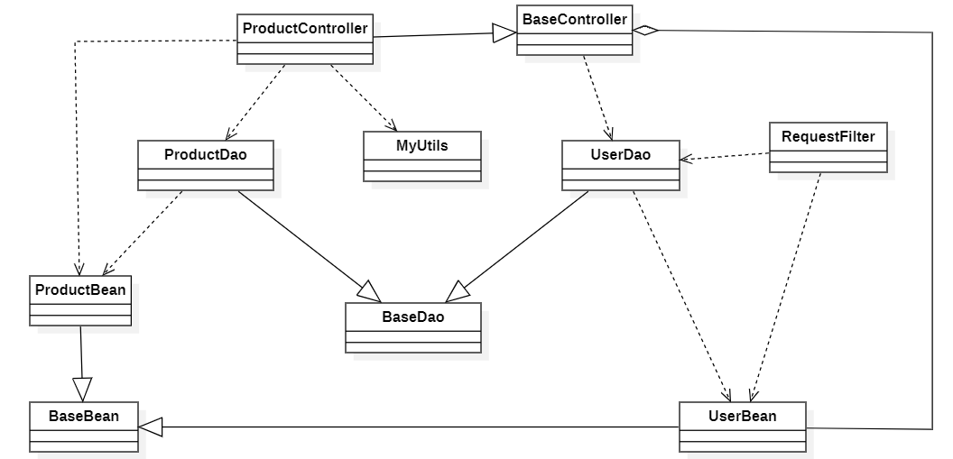

1.2 Sequence Diagram
[Provide the sequence diagram(s) for the feature, see the sample below]
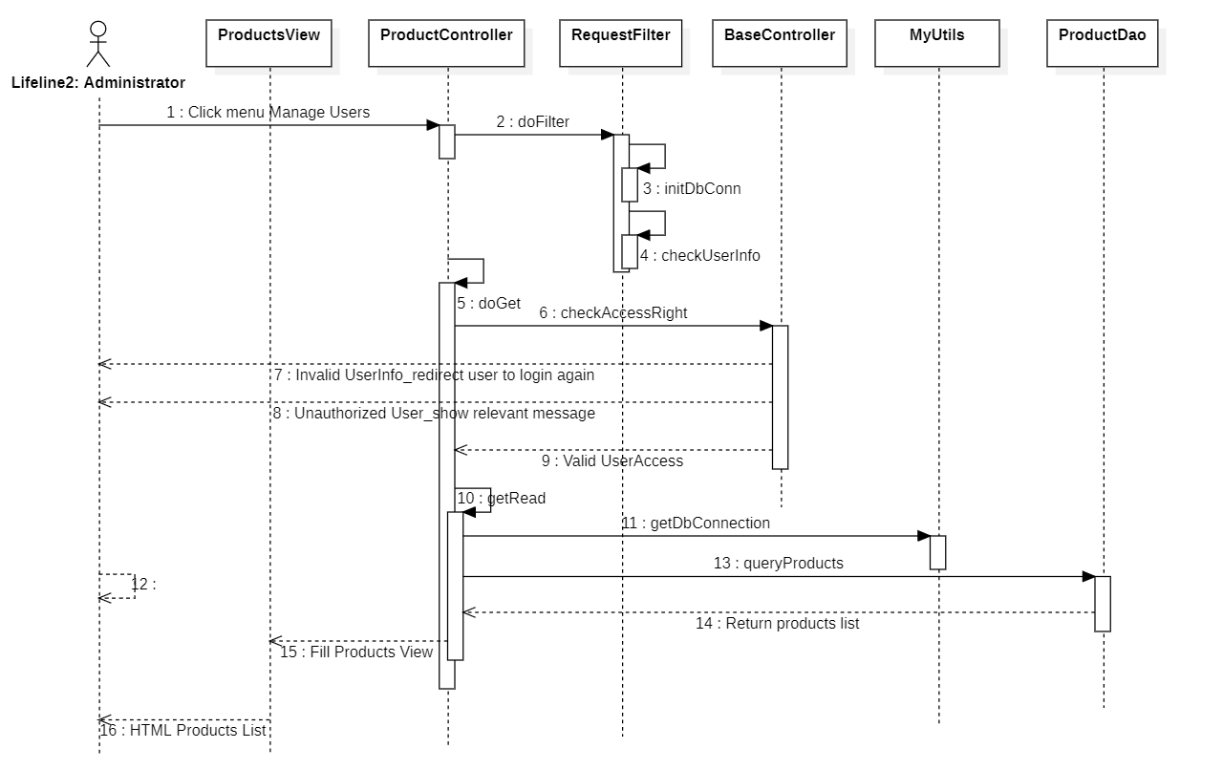

2. <Use Case Name2>
…

