**Name:Kawan Idrees Mawlood.**

**Stage:three.**

**Department:Software & Informatics Engineering.**

**Subject:Network swich & routing I**

**Spanning tree protocol**

Spanning Tree Protocol (STP) is a networking protocol that helps to prevent loops in network topologies. It was originally defined by the IEEE 802.1D standard, and later revised in 802.1w and 802.1s.

The STP algorithm works by electing a root bridge, which becomes the reference point for all other bridges in the network. Each bridge then calculates the shortest path to the root bridge, and disables any redundant paths by placing them in a blocking state. This effectively creates a tree-like structure, where each bridge has only one active path to the root bridge.

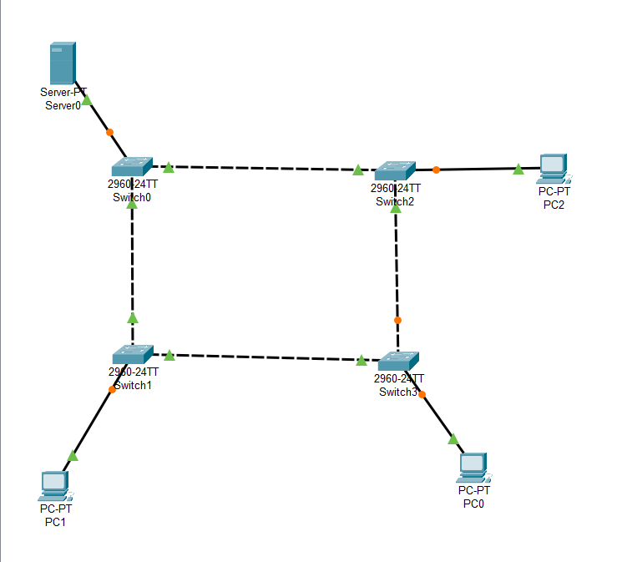

That’s the topology I use as an example I have 4 switches,3 pc and 1 server to prevent the loop in network topology while transfering data through devices I should enable spanning tree and make one of them the root bridge

Switch-0:

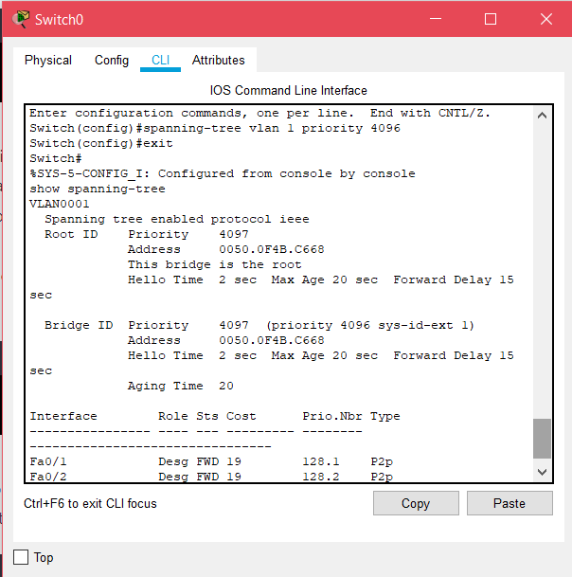

Using spanning-tree vlan 1 priorty 4096 we gave the lowest value to the switch 0 to make it the root bridge, and show spanning-tree telling us that the priorty value is what we set.

Switch-1:

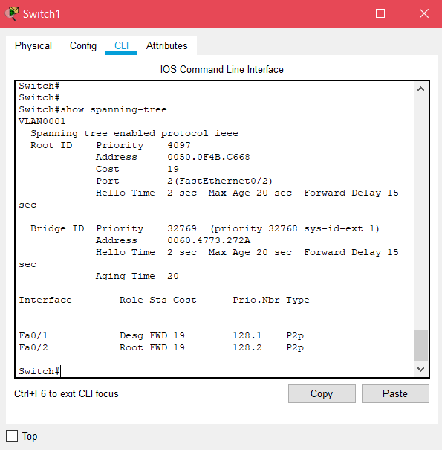

Switch-2:

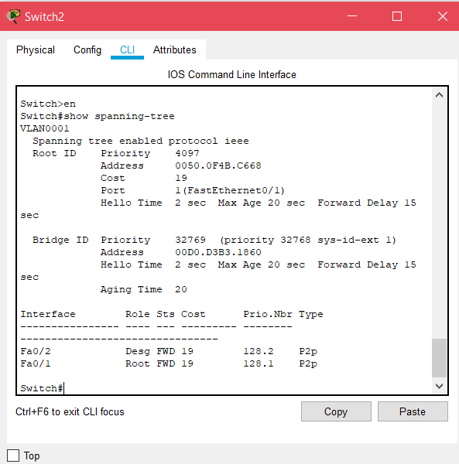

Switch-3:

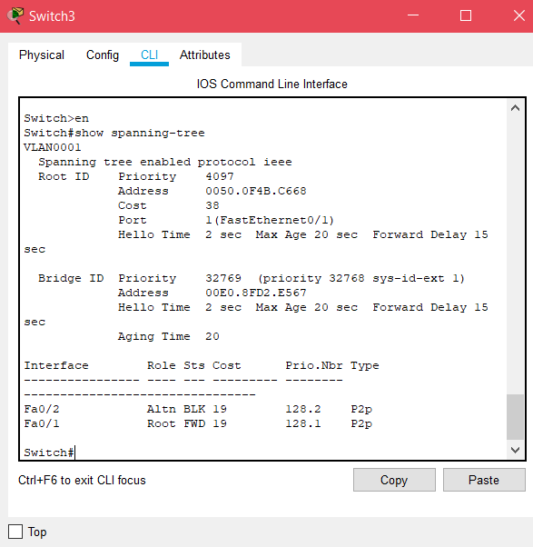

We can also configure the STP mode by using spanning-tree mode [mode] command or configure the port roles spanning-tree portfast and by the end of the configuration we can use show spanning-tree to verify that we enabled.