 | DATA & AI PROGRAMME  Assignment Submission Template

STUDENT NAME | KAREN KAWIRA KINYUA
COHORT | Data & AI – Sept 2026 Cohort 2
WEEK & ASSIGNMENT # | WEEK 1  ASSIGNMENT # 1
ASSIGNMENT TITLE | Web Data Scraping
DATE SUBMITTED | 10/09/2026

How to use this template: Save a copy, fill in the fields above and each section below, then submit it the way your week's Assignment page asks for – upload the file directly for Weeks 1–7, or paste a shareable link (GitHub/Colab) for Weeks 8–12. Full details are on the “Assignment Template & Submission Instructions” page on Moodle.

1. TITLE & OBJECTIVE
My name is Karen kawira kinyua and this assignment is titled web data scraping. It involves data scraping from a live website that was a fake bookstore website that is book.toscrape.com to work through the data understanding and data preparation stages of the data science methodology using real, messy web data.
https://colab.research.google.com/drive/1lBvvbrbu_jaEN5qrAEywMYEEOMLfbew3?usp=sharing

2. SETUP / IMPORTS
The libraries used:
- Requests (to fetch the page's raw HTML over HTTP), Beautiful Soup from bs4 (to parse that HTML into a searchable tree), and pandas (to structure the extracted data into a Data Frame and export it to CSV).
Target page: https://books.toscrape.com/, fetched with requests. Get() and verified with response.raise_for_status() to catch a failed request immediately.
Before scraping, books.toscrape.com/robots.txt was checked and returned 404 that is no robots.txtx exists the page was treated as safe to scrape.
3. MAIN WORK
1. Fetched the page and parsed it with Beautiful Soup(response. Text, "html.parser").
2. Used browser DevTools to find the repeating element wrapping one full book: <article class="product_pod">. soup.find_all("article", class_="product_pod") returned 20 items, matching the 20 books shown on the page.
3. Looped through each item and extracted three fields: title (pulled from the title attribute of the <a> tag inside <h3>, since the visible text is truncated on the page), price (text inside <p class="price_color">) and rating.
4. Built a list of 20 row dictionaries and loaded it into a pandas DataFrame (df).

4. RESULTS & INTERPRETATION
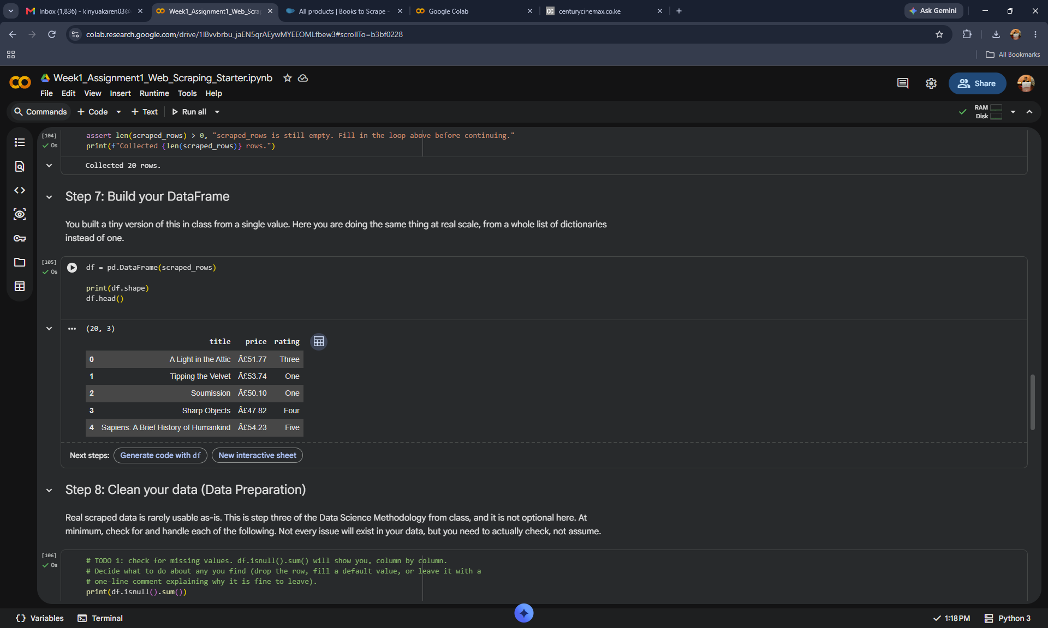

Fig 1: screenshot step 7
At step 7 price was originally text with a garbled "Â£" instead of "£" (an encoding artifact from the scraped page) cleaned with .str.replace() and converted to float64. Cleaned prices range from £13.99 to £57.25. At step 8
rating was originally a word ("One" through "Five") — mapped to integers 1–5 with a dictionary and converted to int64

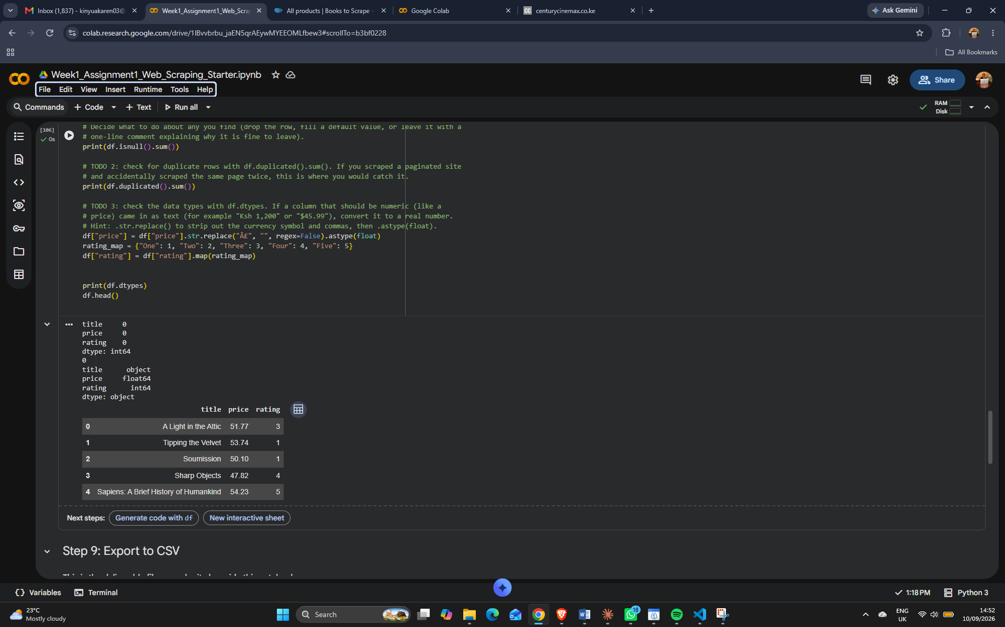
Fig2: screenshot step8
At step 9 Data exported to assignment1_kawira.csv and re-loaded to confirm the save worked: 20 rows, 3 columns matched the original DataFrame.
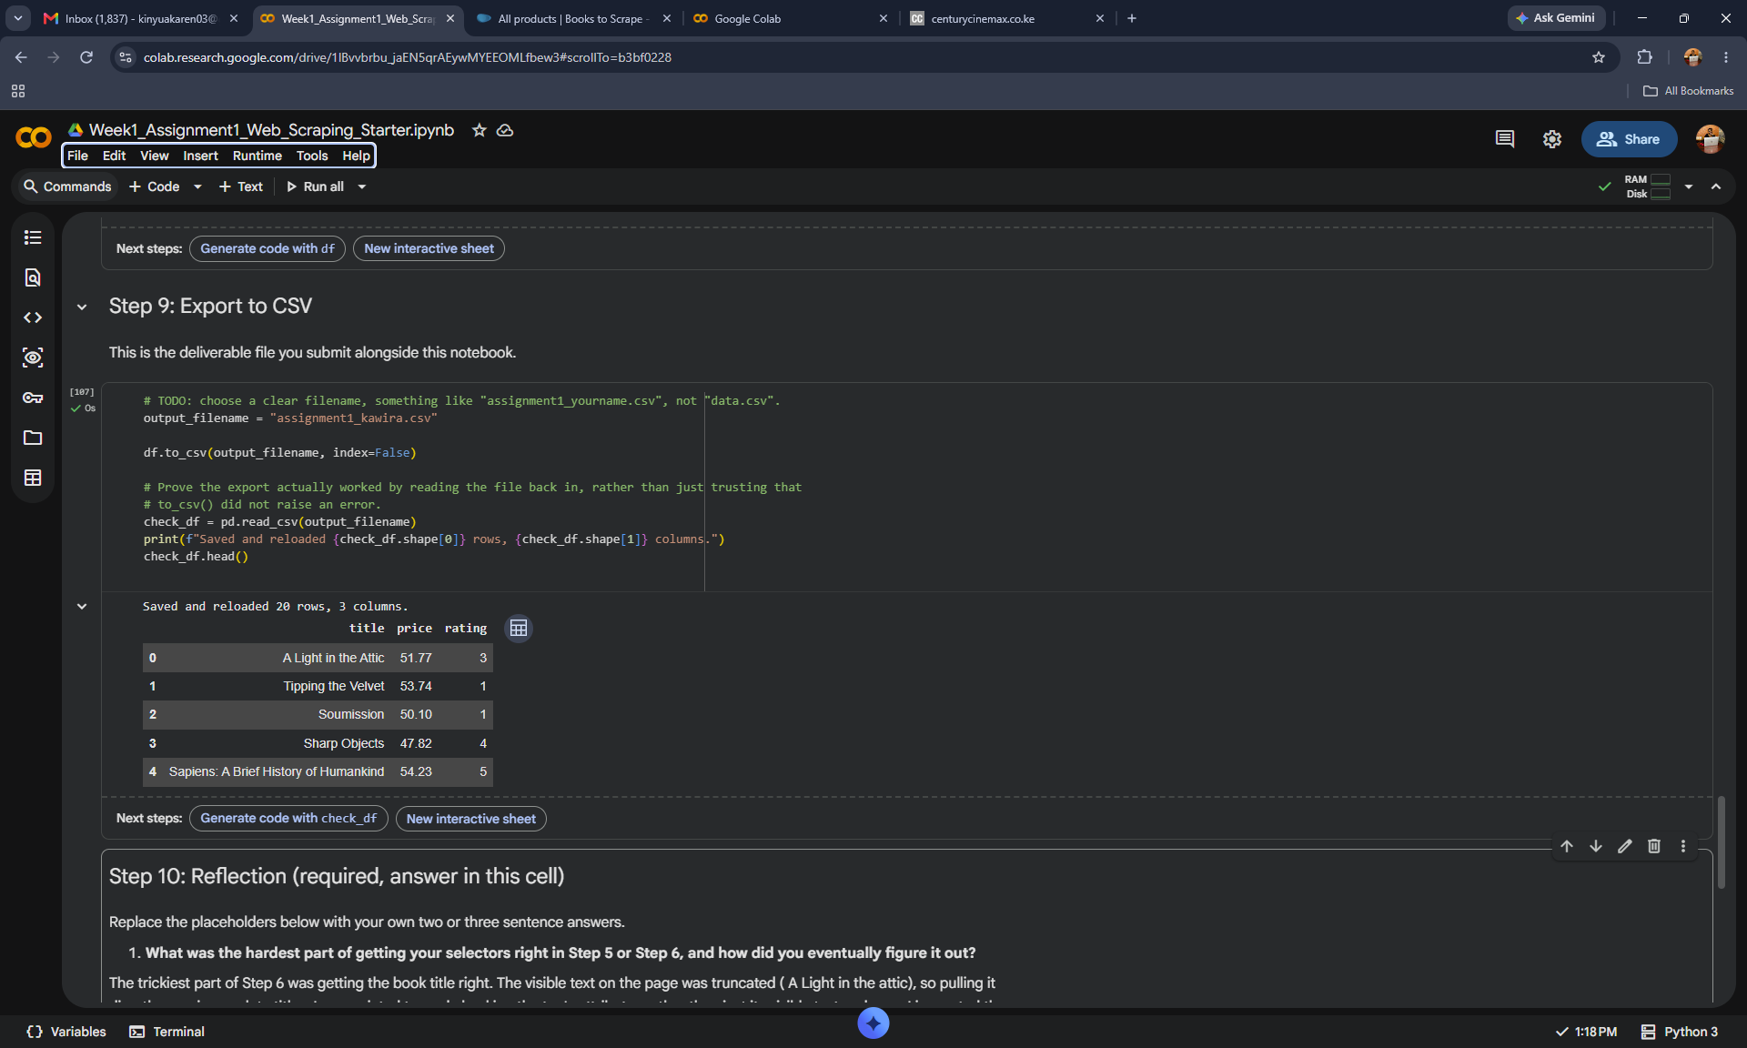
Fig3: screenshot step9
5. CONCLUSION
Key takeaway:
real scraped data needed real cleaning before it was usable an encoding glitch in the price column and word-based star ratings both had to be handled, hence the Data Preparation step isn't optional.
Next steps:
Adding a check for missing fields per item rather than assuming every book has all three would make the scraper more robust.

