Kawsar Islam

Dr. Jayyousi, Thaer W.

Introduction to Programming and Computation: Python - Sec 005

12/1/2021

**In your own words, describe the problem including input and output (3 points).**

In problem 1, the problem is related to the use of dictionary to create a mapping between the letters and their associated morse code. Getting the user input, we loop over each letter and convert it to morse code separating the words with three whitespaces and letters with a single whitespace. The output is the morse code representing the input text.

Converting morse code to normal text requires creating a reverse mapping of the dictionary and get the mapping of the morse code to the letter. Iterate over the morse text, and map each to the corresponding letter. The output is the letters representing the input morse code.

In problem 2, the dictionary data structure is used to create a mapping of the name and the address. The menu allows for specification of data manipulation inside the dictionary. The lookup email function takes a name and returns both the name and the email address. The add email and address add onto the dictionary if the name does not already exist. The change email modifies the email of an existent user. The delete user eliminates the records of a particular user. The input is the name and/or email and the output is a success or error message.

**In your own words, Describe the major steps for solving the problem (3 points)**

In problem 1, the function for loading the email from the text file is critical. The letters and morse code mapping have a pattern and using list slice we can obtain the exact position of the individual letters. Once the dictionary is populated, the converter function from normal to morse code uses the dictionary to map each letter value to the corresponding morse code and return the resultant code.

The reverse converter (From morse code to normal text) caters for the inverse mapping and returns the normal text. The Main is the driver function that has the while loop that allows the user to continually interact with menu till, they can exit

In problem 2, The function has the load email function that is responsible for populating the dictionary that will be used. A check has to be performed to ensure that the text file is not empty. The add email functionality checks if the name and exists and if not inserts the pair. The delete email eliminates the existing records. The lookup email ensures the name exists and returns both the name and the email. The main program drives the logic of the program allowing the user to interact the menu till they exit.

**Test the code and verify that the program works; include a sample output for each problem in the word file (4 points)**

**Question 1**

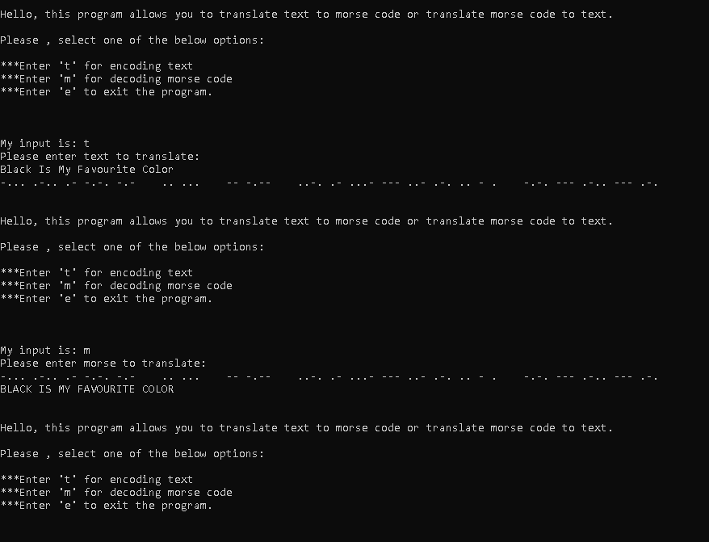

**Question 2**

