**PROJECT ON**

**Hostel Management System**

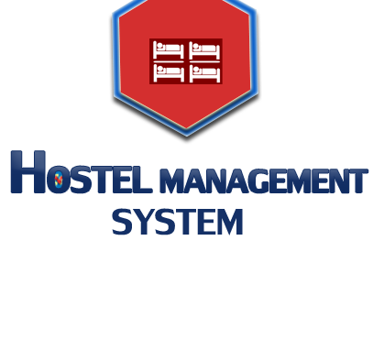



**Submitted by**

##### Md.Kawsher Mahbub

##### ID: 16172103282

**INTAKE: 35 SECTION: 06**

**Amit Das**

**ID: 16172103297**

**INTAKE: 35 SECTION: 06**

**Sikder Md. Saiful Islam ID: 16172103316**

**INTAKE: 35 SECTION: 06**

**Supervised by**

#### NAHID ANWAR

**Lecturer in Computer Science & Engineering Department of Computer Science & Engineering**

First and foremost, we are grateful to the Allah, the Almighty, the Merciful without whose patronage and blessing this project would not have been successfully completed.

This Project is lovingly dedicated to our respective parents who have been our constant source of inspiration. They have given us the drive and discipline to tackle any task with enthusiasm and determination. Without their love and support this project would not have been made possible acknowledged with great thanks to the university authority for providing helpful environment to learn knowledge & organize such a program. We acknowledge with great thanks to our project supervisor “Nahid Anwar” (Lecturer, Department of Computer Science & Engineering, BUBT) for his most valuable suggestions & co-operations. The blessing, help and guidance given by him time to time shall carry a long way in the journey of life on which we about to embark. We also acknowledged with great thanks to our entire family member for their support & aspiration. They always expect our best performance. We wish we could fulfill the aspiration.



Thanks

**Nahid Anwar**

Lecturer in Computer Science & Engineering, Department of Computer Science & Engineering, Bangladesh University of Business & Technology

As the name specifies “HOSTEL MANAGEMENT SYSTEM” is software developed

for managing various activities in the hostel. For the past few years the number of educational institutions is increasing rapidly. Thereby the number of hostels is also increasing for the accommodation of the students studying in this institution. And hence there is a lot of strain on the person who are running the hostel and software’s are not usually used in this context. This particular project deals with the problems on managing a hostel and avoids the problems which occur when carried manually.

Identification of the drawbacks of the existing system leads to the development of computerized hostel management system that will be compatible to the existing system with the system which is more users friendly and more GUI oriented. We can improve the efficiency of the system, thus overcome the drawbacks of the existing hostel management system. Less human error, Strength and strain of manual labor can be reduced, High security, Data redundancy can be avoided to some extent, Data consistency, Easy to handle, Easy data updating, Easy record keeping, Backup data can be easily generated.

### Table of Content

Chapter 01: Introduction 1-2

* 1. Overview… 1
  2. Objective 1
  3. Project Management Approach 2

Chapter 02: Requirement Analysis 3-4

* 1. Introduction 3
  2. Phases of Requirement Analysis 3
  3. Study of the System 4
     1. System… 4
     2. Study of the System 4

Chapter 03: System Requirements 5

* 1. Hardware Requirements 5
  2. Software Requirements 5

Chapter 04: Development 6-7

* 1. Introduction 6
  2. Windows 7

4.2.1 Windows’ key benefits and features 7

Chapter 05: Designing 8-11

* 1. Introduction 8
  2. UML Diagram 9
  3. Use Case Diagram 10
  4. ER Diagram 11

Chapter 06: User Interface 12-19

* 1. Home Page 12
  2. Admin Sign In. 12
  3. Student Sign In 13
  4. Admin Panel 13
     1. Add New Student 14
     2. Student Profiles… 14
     3. Payment… 15
     4. Room …...… 15
  5. Student Options 15
     1. Room Mates 16
     2. Meal 16

Chapter 07: Limitation of the Project 17

Chapter 08: Future of the Project 17

Chapter 09: Conclusion 18

Reference 18

**Chapter 1**

**Introduction**

### Overview

 This Hostel Management System is developed in favor of the hostel management team which helps them to save the records of the students about their rooms and other things. It helps them from the manual work from which it is very difficult to find the record of the students and the information about those ones who had left the hostel years before.

This solution is developed on the plight of the hostel management team, through this they cannot require so efficient person to handle and manage the affairs of the students in the hostel, all you need to do is to login as administrator and you can see the information of all the students who have obtained and registered their hostel form, click verify to ascertain their eligibility and allocate them to the available hostel.

Identification of the problems of the existing hostel management leads to the development of computerized solution that will be compatible to the existing hostel management with the solution which is more users friendly and more GUI oriented. We can improve the efficiency of the hostel management, thus overcome the drawbacks of the existing management.

### Objective

The main objectives of this project work are that:

* Student will no longer apply for their hostels manually.
* The warden can see and access the student’s data.
* This also will reduce the manual work of the persons in admin penal.
* It helps the admin to know the number of students that can leave in a room and a block.
* To ensure that the number of student staying in a room does not exceed specified limit.
* Help the admin to disseminate information to students without calling for a meeting or moving room b room.
* To know the number of items (e.g. bed) given to student staying in the hostel
* To ensure that student remit the hostel property given to them before vacating the hostel.

The system helps the admin to:

* Allot different students to their different hostels.
* Vacate the student from the hostels
* Control the status of the hostel fee payment.
* Edith the details of the students and modify the student’s records.

### Project management approach

##### Software Process Model:

To solve an actual problem in an industry, software developer or a team of developers must integrate with a development strategy that include the process, methods and tools layer and generic phases. This strategy is often referred to a process model or a software developing paradigm.

Our project follows the **waterfall model. The steps of waterfall model are:**

* Requirement Definition
* System and Software Design
* Implementation
* Integration and System Testing
* Operation and Maintenance

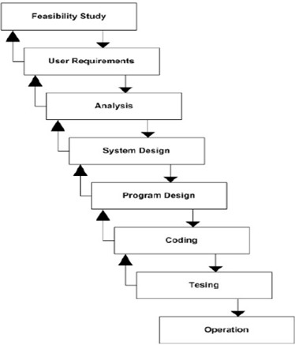



**Fig 1.1: Waterfall Model**

# Chapter 2

## Requirement Analysis

### Introduction

**Requirements analysis** in [systems engineering](http://en.wikipedia.org/wiki/Systems_engineering) and [software engineering](http://en.wikipedia.org/wiki/Software_engineering), encompasses those tasks that go into determining the needs or conditions to meet for a new or altered product, taking account of the possibly conflicting [requirements](http://en.wikipedia.org/wiki/Requirements) of the various [stakeholders,](http://en.wikipedia.org/wiki/Stakeholder_(corporate)) such as beneficiaries or users.

Requirements analysis is critical to the success of a development project. [Requirements](http://en.wikipedia.org/wiki/Requirement) must be documented, actionable, measurable, testable, related to identified business needs or opportunities, and defined to a level of detail sufficient for system design. Requirements can be [architectural](http://en.wikipedia.org/wiki/System_architecture), [structural](http://en.wikipedia.org/wiki/Structure), [behavioral](http://en.wikipedia.org/wiki/Behavior), [functional](http://en.wikipedia.org/wiki/Functional_requirements), and [non-functional](http://en.wikipedia.org/wiki/Non-functional_requirements).

The development of project needs some requirement to make the project perform better and achieves the goal of project. In developing Hostel Management System, the capabilities of computer and hardware plays a big impact on project quality. The project maker should determine the minimum requirements of hardware and also software to be used to develop a good and attractive project.

### Phases of Requirement Analysis

There are two phases of requirement analysis as given below

* + 1. Primary Research: Identifying the user requirements conducting a survey based on a questionnaire.
    2. Secondary Research: Comparing the identified requirements with already existing software having similar functionalities.

Based on these researches the result is defined as the Software Requirement Specification.

### Study of the System

### SYSTEM

* + - * Designing and implementing the new links.
      * Designing and implementing the users.
      * Arranging new links as subject wise.

### Study of the System

System analysis will be performed to determine if it is feasible to design information based on policies and plans of the organization and on user requirements and to eliminate the weaknesses of the present system.

* + - * The new system should be cost effective.
      * To augment management, improve productivity and services.
      * To enhance user / system interface.
      * To improve information, qualify and usability.
      * To upgrade systems reliability, availability, flexibility and growth potential.

# Chapter 3

## System Requirement

### Hardware Requirements(Minimum)

CPU (SPEED) : 1.7 GHz Pentium IV RAM : 512 MB

HARD DISK : 2 GB

### Software Requirements

* + - Operating System: Windows XP Service Pack 1
    - Microsoft Sql Server Management 2017

# Chapter 4

## Development

### Introduction

Software development is the process of conceiving, specifying, designing, programming, documenting, testing, and bug fixing involved in creating and maintaining applications, frameworks, or other software components. Software development is a process of writing and maintaining the source code, but in a broader sense, it includes all that is involved between the conception of the desired software through to the final manifestation of the software, sometimes in a planned and structured process. Therefore, software development may include research, new development, prototyping, modification, reuse, re- engineering, maintenance, or any other activities that result in software products.

Software can be developed for a variety of purposes, the three most common being to meet specific needs of a specific client/business (the case with custom software), to meet a perceived need of some set of potential users (the case with commercial and open source software), or for personal use (e.g. a scientist may write software to automate a mundane task). Embedded software development, that is, the development of embedded software, such as used for controlling consumer products, requires the development process to be integrated with the development of the controlled physical product. System software underlies applications and the programming process itself, and is often developed separately.

The need for better quality control of the software development process has given rise to the discipline of software engineering, which aims to apply the systematic approach exemplified in the engineering paradigm to the process of software development.

There are many approaches to software project management, known as software development life cycle models, methodologies, processes, or models. Thee waterfall model is a traditional version, contrasted with the more recent innovation of agile software development.

Our Hostel Management System is created based on windows system which runs on any computer.

### Windows

Windows is a collection of programs known as an operating system (OS) that controls a PC (personal computer). First produced by Microsoft in November 1985, it has been frequently updated since, as computer memory has got bigger, as processing chips have got faster and, of course, when the internet was invented. Prior to Windows, PCs were operated by a series of text commands.

### Windows' key benefits and features

* + - * Allows the user to interact with the computer (through the keyboard, mouse, microphone, etc.).
      * Controls the storage of data (images, files, music).
      * Controls hardware attached to the computer such as webcams, scanners and printers.
      * Helps to open and close programs (word processors, games, photo editors, etc.), and gives them part of the computer’s memory to allow them to work.
      * Controls what access to a computer different users have and the computer's security.
      * Deals with errors and user instructions, and issues simple error messages.
      * Promotes multitasking by allowing the user to do several things on the computer at once – for example, watch a video while writing a letter.

# Chapter 5

## Designing

### Introduction

The purpose of the design phase is to plan a solution of the problem specified by the requirement document. This phase is the first step in moving from problem domain to the solution domain. The design of a system is perhaps the most critical factor affecting the quality of the software, and has a major impact on the later phases, particularly testing and maintenance. The output of this phase is the design document. This document is similar to a blue print or plan for the solution, and is used later during implementation, testing and maintenance.

Software design is the process of implementing software solutions to one or more sets of problems. One of the main components of software design is the software requirements analysis (SRA). SRA is a part of the software development process that lists specifications used in software engineering. If the software is "semi-automated" or user centered, software design may involve user experience design yielding a storyboard to help determine those specifications. If the software is completely automated (meaning no user or user interface), a software design may be as simple as a flow chart or text describing a planned sequence of events. There are also semi-standard methods like Unified Modeling Language and Fundamental modeling concepts. In either case, some documentation of the plan is usually the product of the design. Furthermore, a software design may be platform- independent or platform-specific, depending upon the availability of the technology used for the design.

### UML Diagram

UML is an acronym that stands for Unified Modeling Language. Simply put, UML is a modern approach to modeling and documenting software. In fact, it’s one of the most popular business process modeling techniques.

It is based on diagrammatic representations of software components. As the old proverb says: “a picture is worth a thousand words”. By using visual representations, we are able to better understand possible flaws or errors in software or business processes.

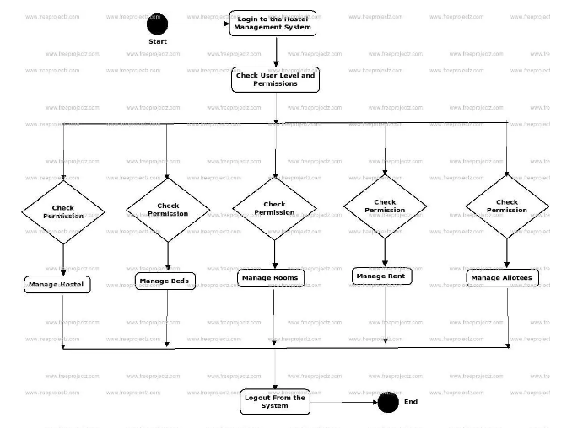



**Fig 5.1: UML Diagram**

### Use Case Diagram

A use case diagram at its simplest is a representation of a user's interaction with the system that shows the relationship between the user and the different use cases in which the user is involved. A use case diagram can identify the different types of users of a system and the different use cases and will often be accompanied by other types of diagrams as well.

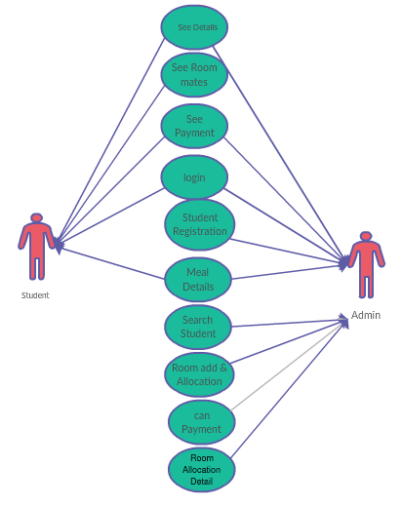



**Fig 5.2: Use Case Diagram**

### ER Diagram

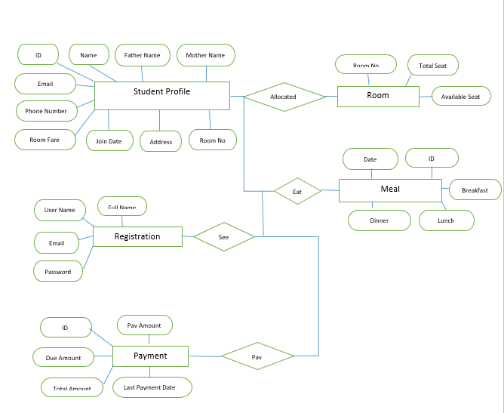



**Fig 5.3: ER Diagram**

### Home Page

**Chapter 6**

**User Interface**

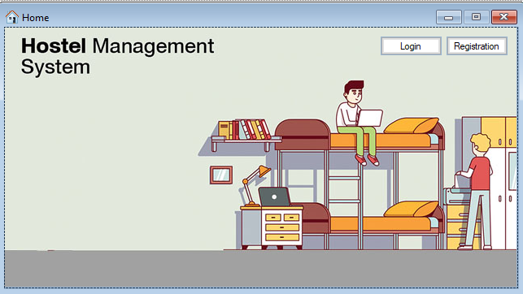

Fig: 6.1

### Login

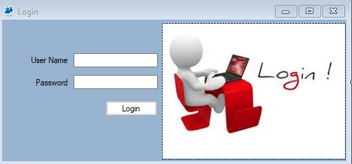

Fig: 6.2

### Admin Panel

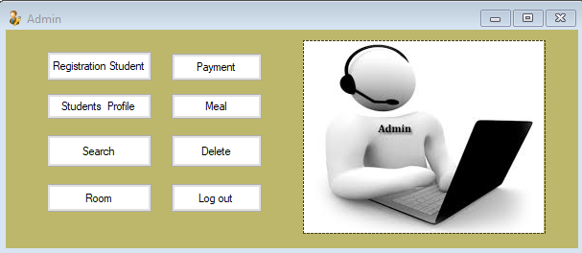

Fig: 6.3

### Student Panel

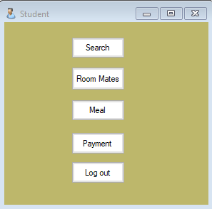

Fig: 6.4

### Student Registration

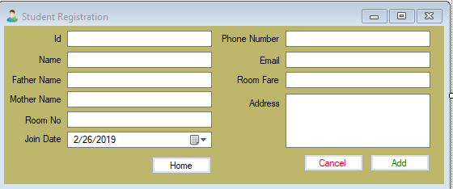

Fig: 6.5

### Student Information

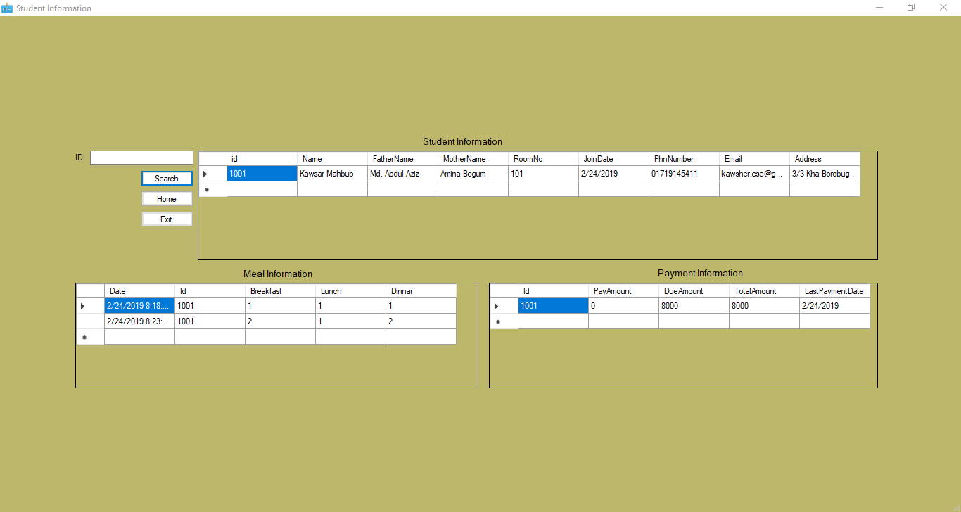

Fig: 6.6

### Payment

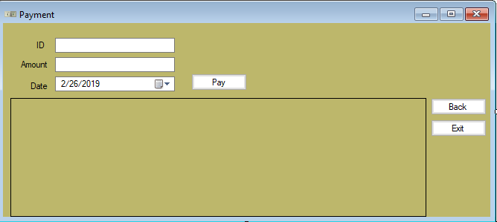

Fig: 6.7

### Room

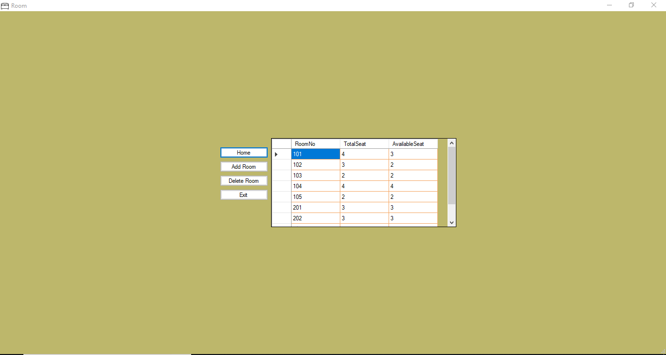

Fig: 6.8

### Room Mate

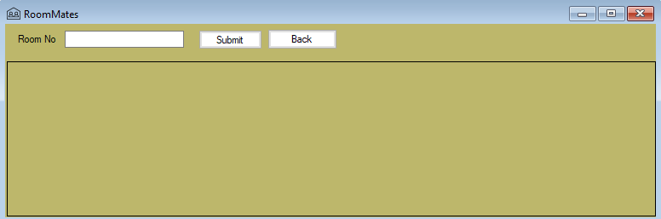

Fig: 6.9

### Meal

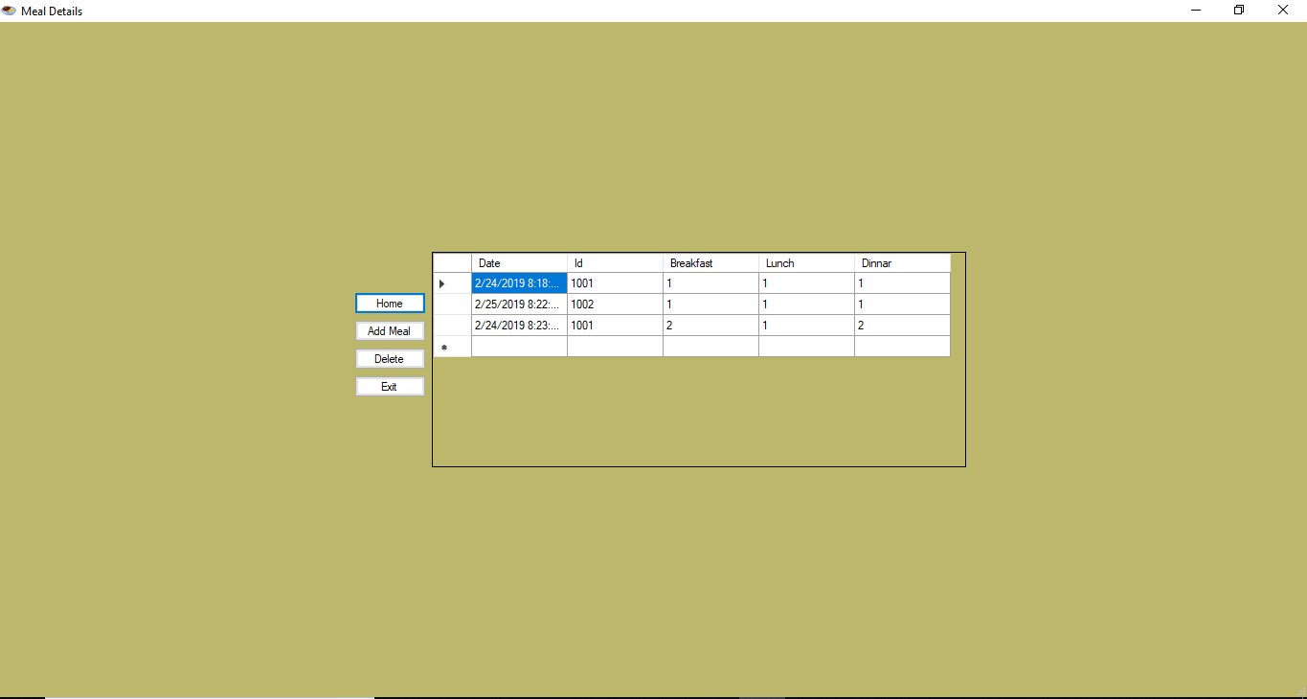

Fig: 6.10

**Chapter 7**

**Limitation of Project**

Though the software presents a broad range of options to the users some intricate option could not be covered into it, partly because of logistic and partly due to lack of sophistication.

These are the Limitations for the project:

* The system has not able to run on online environment.
* The database cannot be converted into centralized
* Multi users are not supported in the system
* The project is on VB environment therefore, its platform dependent
* The system is not able to generate the PDF, CSV reporting.

**Chapter 8**

**Future of the project**

There are many additional features, which can be planned to be incorporated during the future enhancement of this project. The future version of this project can handle the accounting of the hostel. The future version can be improved to provide functionality of working as in a general purpose hotel too.

In future also we can add a module satisfying the restaurant in the hostel

* We can make the database centralized by which multiuser can work on the system.
* PDF, CSV reporting will be integrated for more reliability.
* The project has been design in such manner by which, new changes will be managed by adding a single module.

**Chapter 9**

**Conclusion**

* The development of the hostel management system is a user friendly system to indents to automate the hostel from manual systems.
* It’s a computer based system that will manage all the operations of the hostel.
* This system offers usability, stability and cost effectiveness also flexible and adaptable by any operating system.
* Thus this project can be a guideline for the beginners and can be example for the development of a small program.

References

## References

1. [https://creately.com/app/?tempID=i2yu77yz1&login_type=demo#](https://creately.com/app/?tempID=i2yu77yz1&login_type=demo)
2. <https://www.freeprojectz.com/uml-diagram/hostel-management-system-uml-diagram>
3. <http://dkingsnet.blogspot.com/2013/04/abstract-and-introduction-for-hostel.html>