Membre du groupe :

* Boukhors Ines.
* Bouleam Ikram.
* Rached Kawther.
* Sekhara Rania.

**Deuxième partie**

**Réaliser par (Kawther Rached,Rania Sekhara,Ikram Bouleam,Ines Boukhors )**

1. ***NetAnim installation in ns3:***

a/   To install netanim-3.108, we have to change the location through the utilization of the following commands:

* cd ns-allinone-3.35/netanim-3.108/
* make clean

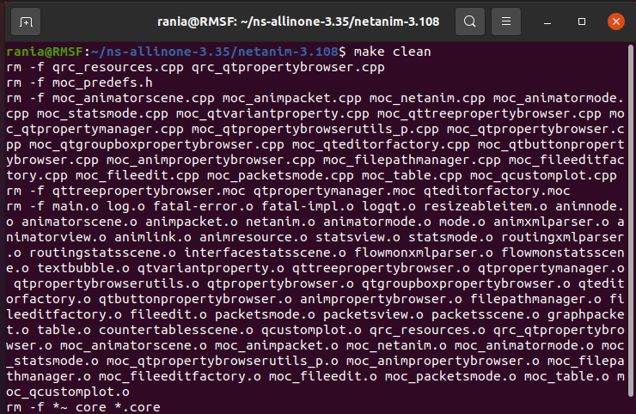

* qmake NetAnim.pro
* make

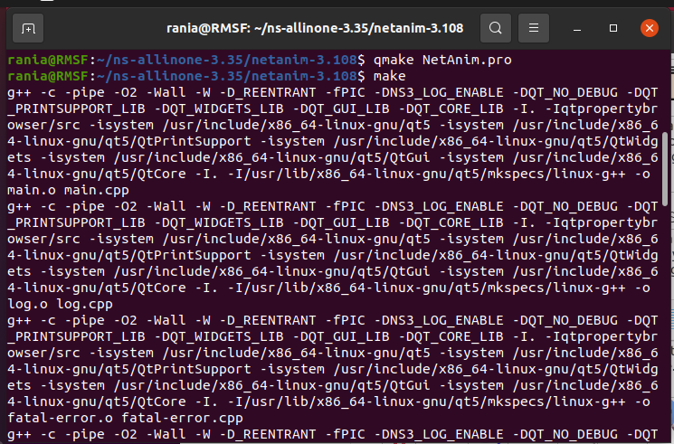

Wait for the installation to complete.

      b/     We have to verify the process of installation through the implementation of the following commands:

* ./NetAnim
* 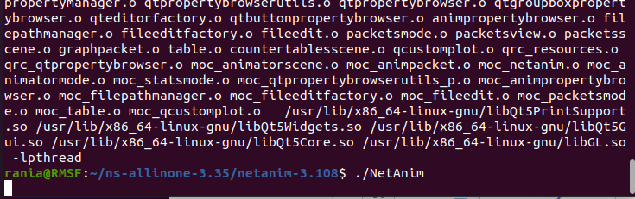

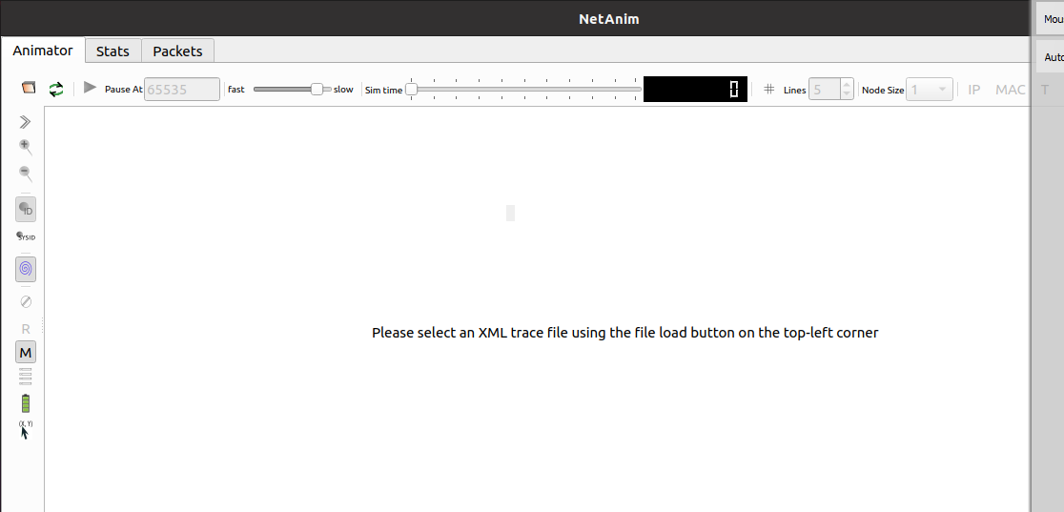

1. ***Running the first file:***

1. Go back to ns-allinone-3.35 directory and move into ns-3.35 using the following commands:

* cd ..
* cd ns-3.35/

1. Next create new file in the scratch folder:

* gedit scratch/myfile.cc

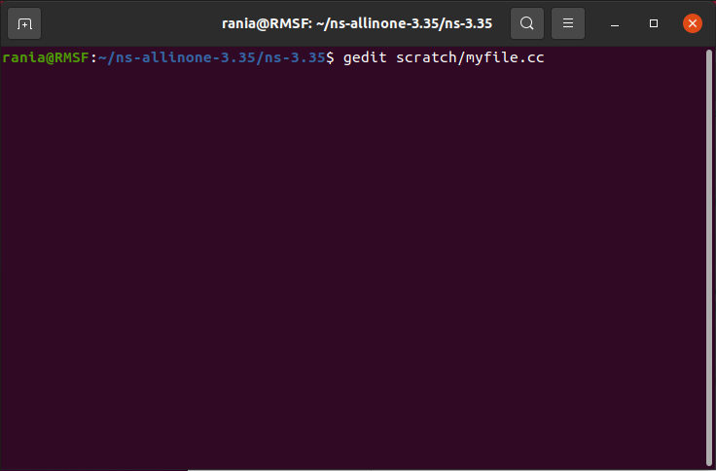

1. Copy and paste the code below to your ‘myfile.cc’ file, then save it and exit from the text editor:

#include "ns3/core-module.h"

#include "ns3/network-module.h"

#include "ns3/internet-module.h"

#include "ns3/point-to-point-module.h"

#include "ns3/applications-module.h"

#include "ns3/netanim-module.h"

using namespace ns3;

int main() {

  // Create a simulation environment

  NodeContainer nodes;

  nodes.Create(2);

  // Configure point-to-point link

  PointToPointHelper pointToPoint;

  pointToPoint.SetDeviceAttribute("DataRate", StringValue("5Mbps"));

  pointToPoint.SetChannelAttribute("Delay", StringValue("2ms"));

  NetDeviceContainer devices;

  devices = pointToPoint.Install(nodes);

  // Configure Internet stack and assign IP addresses

  InternetStackHelper stack;

  stack.Install(nodes);

  Ipv4AddressHelper address;

  address.SetBase("10.1.1.0", "255.255.255.0");

  Ipv4InterfaceContainer interfaces = address.Assign(devices);

  // Enable NetAnim

  AnimationInterface anim("myfile.xml");

  // Create a simple packet sink at the receiving node

  PacketSinkHelper packetSinkHelper("ns3::UdpSocketFactory", InetSocketAddress(interfaces.GetAddress(1), 9));

  ApplicationContainer sinkApps = packetSinkHelper.Install(nodes.Get(1));

  sinkApps.Start(Seconds(1.0));

  sinkApps.Stop(Seconds(5.0));

  // Create a UDP client application and install it on the source node

  OnOffHelper onOffHelper("ns3::UdpSocketFactory", Address(InetSocketAddress(interfaces.GetAddress(1), 9)));

  onOffHelper.SetAttribute("DataRate", StringValue("1Mbps"));

  onOffHelper.SetAttribute("PacketSize", UintegerValue(1024));

  ApplicationContainer clientApps = onOffHelper.Install(nodes.Get(0));

  clientApps.Start(Seconds(2.0));

  clientApps.Stop(Seconds(4.0));

  // Run the simulation

  Simulator::Run();

  Simulator::Destroy();

  return 0;

}

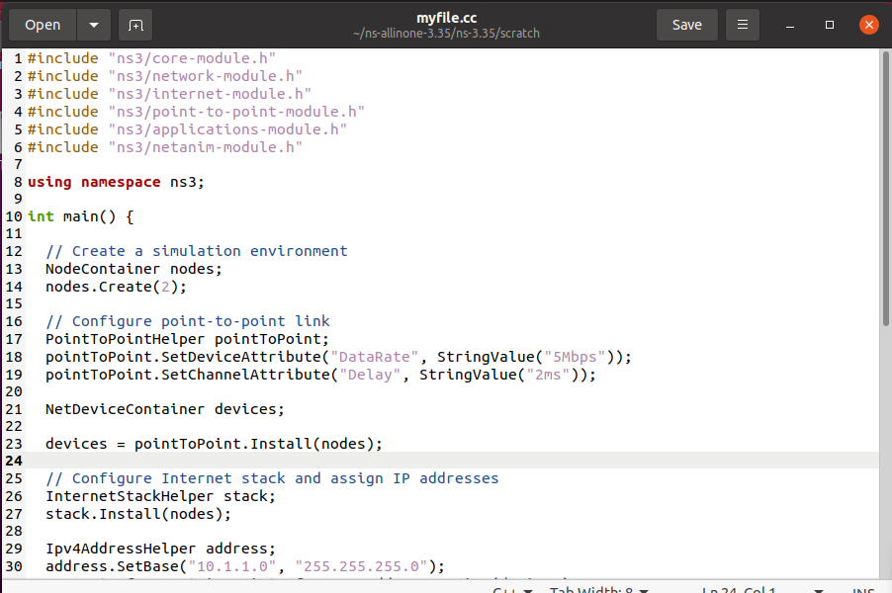

1. Run the command:

* ./waf --run myfile

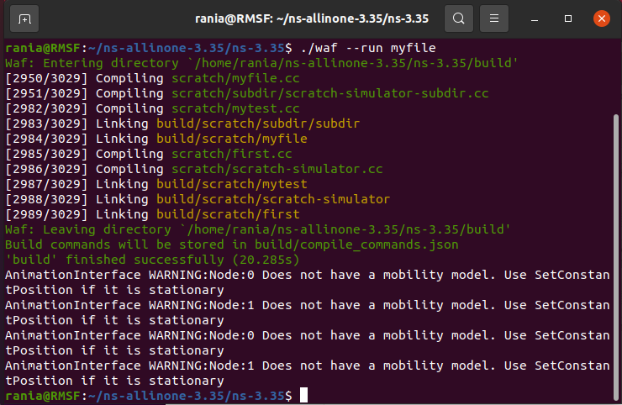

1. now we have the file in ‘ns-3.35’

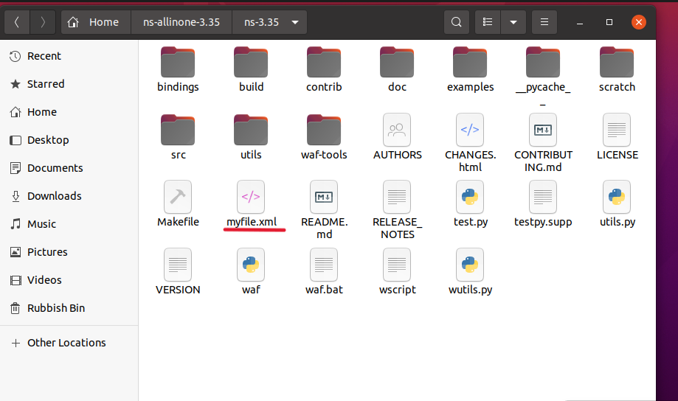

1. Open new terminal tab by pressing Ctrl+Shift+T and move into netanim-3.108 directory:

* cd netanim-3.108/
* ./NetAnim

https://lh6.googleusercontent.com/a6jpkayFUaX-2SGIf0gE9gCtDQgLDvZ-p8C9k3f2eI_VdCLqfDceTg2ACsD8OHs4x4GVP_eoUVfUxL-jvM7Rfl30qpwU6GqXJGelyvx46m6dTwUzWyuR0XtBXqAJa_AvF-9WObPU5CvY-MK5GOObJaA

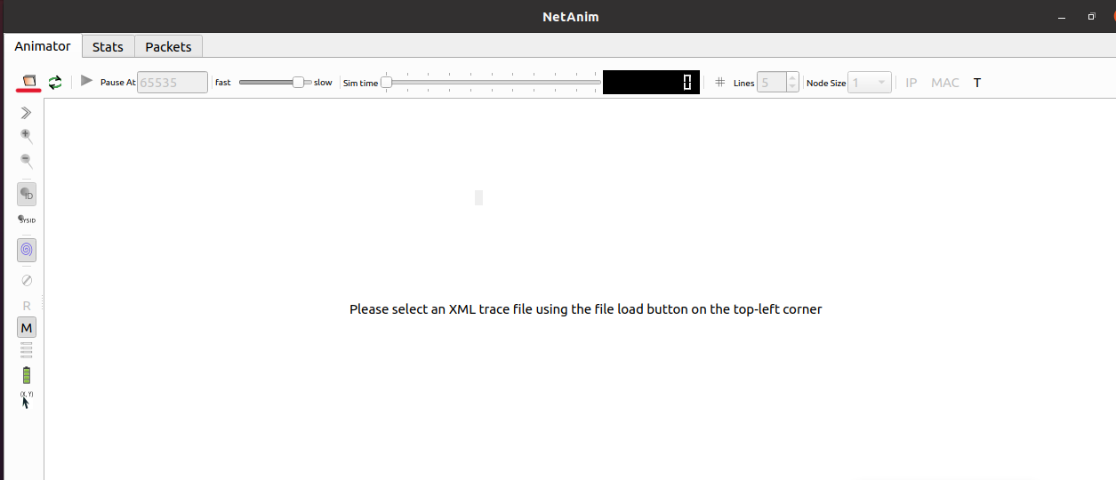

1. Open the ‘myfile.cc’ file which we have created

