Software Requirements Specification

Version 5.0

May 15, 2021

Security services company

Luna Al-aaraj Teamleader

Kawther Alrajab

Gharam Alwanos

Sara Alhaji

**Table of Contents**

Table of Contents......................................................................... i  
List of Figures ............................................................................ ii  
1.0. Introduction......................................................................... 1  
1.1. Purpose ............................................................................... 1  
1.2.Scopeof Project.................................................................... 1  
1.3. Glossary............................................................................... 2  
1.4. References ........................................................................... 2  
1.5. Overview of Document ....................................................... 2  
2.0. Overall Description.............................................................. 4  
2.1 System Environment............................................................. 4  
2.2 Functional Requirements Specification ............................... 5  
2.2.1 client Use Case................................................................ 5  
Use case: Add customer …........................................................ 5  
2.2.2 Guard Use Case……........................................................ 6  
Use case: Add new Guard ……................................................. 6  
2.2.3 Manager Use Case............................................................ 7  
Use case: Modify Old Guard Information................................7  
2.3 User Characteristics.............................................................8  
2.4 Non-Functional Requirements............................................9  
3.0. Requirements Specification ..............................................10  
3.1 External Interface Requirements .......................................11  
3.2 Functional Requirements ................... .............................12  
3.2.1 Add Customer ................................................................13  
3.2.2 Add new Guard...............................................................14

ii  
**List of Figures**Figure 1 - System Environment.............................................................................. 4  
Figure 2 - Article Submission Process ..................................... 6  
Figure 3 - Editor Use Cases.......................................................................................... 8  
Figure 4 - Logical Structure of the Article Manager Data.............................................................................24

**1.0. Introduction  
*1.1. Purpose***The purpose of this document is to present a detailed description of the Security services company Analyzing a system for managing the security services company by finding A set of functional and non-functional requirements of the system It will explain the purpose and features of the system the interfaces of the system, what the system will do, the constraints under which it must operate and how the system will react to external stimuli.

***1.2. Scope of Project***

This program system will be a system for security services, a special system for a security protection company. This system will be designed to increase protection for individuals and companies to the maximum extent.

The system will meet the customers' needs while maintaining the system's ease of use.

The system is designed to allow the customer to request protection and to communicate with the personnel responsible for managing the system.

The system also contains relational database files that contain a list of clients, guards and vehicles.

***1.3. Glossary***

|  |  |
| --- | --- |
| Collection of all the information monitored by this system. | Database |
| A term for a person who uses a computer system, a computer network, or a website. | User |
| A document that completely describes all of the functions of a proposed system and the constraints under which it must operate. For example, this document. | Software Requirements Specification |
| He is the person doing the protection. | Guard |

***1.4. References***IEEE. *IEEE Std 830-1998 IEEE Recommended Practice for Software Requirements  
Specifications.* IEEE Computer Society, 1998.

. ***1.5. Overview of Document***

chapter 1: of this file must be read by all the target groups. This section gives all the information they need to read and understand the rest of the file, in addition to giving it an overview of the problem and the solution and describing how this solution will benefit the library in solving its problems.

Chapter 2: will provide a general description of this document with an overview of the system's functionality and describe the non-functional requirements and are used to create the context for the technical requirements specification in the next chapter.

Chapter Three: Requirements Specifications section as this document is mainly written for developers and describes in technical terms the details and functions of the system.

Both sections of the document describe the whole system but are intended for different audiences and thus use a different language.

**2.0. Overall Description*****2.1 System Environment***

The system on the web contains three active actors and one cooperative system that communicates with the customer through the site, which means that the client's contact with the system is via e-mail, the guard registers an enrollment request via e-mail, and the manager communicates with the entire system directly.



customer



guard

The company's website

protection System on the internet

 

mechanisms

Article Manager

HS DB

Figure 1 - System Environment

***2.2 Functional Requirements Specification***

This section outlines the use cases for each of the active client separately. The client and Guard and mechanisms have only one use case apiece while the manager is main actor in this system.

2.2.1 client Use Case

Use case: Add a customer.

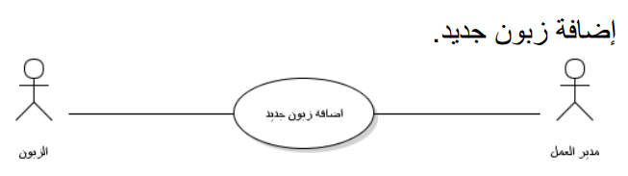

**Brief Description**The customer arrives at the website and registers an order, is aware of the status of the request, or amends his request.

**Initial Step-By-Step Description**

Before this use case begins, the customer has already accessed the company's website over the Internet.

1.The customer logs in using his name and e-mail.

2.The system displays a list of guards and available mechanisms.

3.The customer chooses the guards and the mechanisms he needs.

4.Informing the manager of the customer’s request, and if the customer’s request is approved, an email is sent to him to inform him that the process was successful.

2.2.2 guard Use Case

Use case: add a new guard

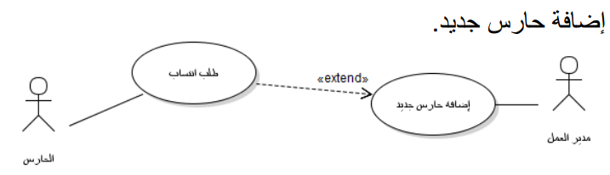

**Brief Description**

After the manager accepts the guardian’s enrollment request, the guard submits periodic reports on the work situation to the director.

**Initial Step-By-Step Description**

Before this use case starts, the guard is already online

Company site.

1.The guard submits the membership application by e-mail.

2.The director's acceptance of the guard's affiliation request.

3.Assign the manager to the guard on missions.

The guard submits periodic reports to the director..4

2.2.3 Manager Use Case  
Use case: Modify old guard information.

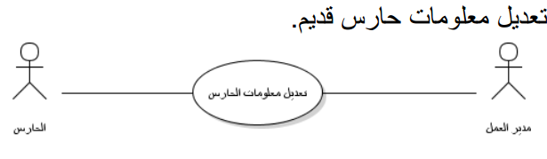

**Brief Description**

The director adjusts the guard's information in case he retires or is busy.

2.2.4 Manager Use Case  
Use case: Add a new mechanism.

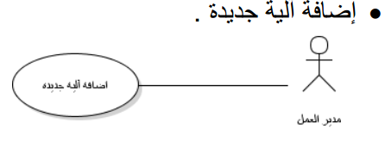

**Brief Description**

The manager is adding new mechanisms.

***2.3 User Characteristics***

The customer is expected to have Internet knowledge. The main screen of the site will contain login and general information about the company's services.

The guards are expected to be Internet-aware and able to use e-mail.

***2.4 Non-Functional Requirements***

The system has the ability to work on a local network, processing speed, ease of use, and high reliability in maintaining customer data, recording times of program use by the work manager, and recording all operations that take place on the program and their times and those responsible for them.

**3.0. Requirements Specification*****3.1 External Interface Requirements***

The Windows interface that the manager, the customer and the guard will deal with in addition to (the possibility of adding a program interface that the customer will deal with in order to request guards or mechanisms and it will be through a website through a browser where the customer will enter the site and choose to display the guards and mechanisms and then choose the guard or the mechanism that he wants to rent He identifies them and sends a request to the manager, who in turn will answer the request and send a confirmation email to the customer to inform him of the successful completion of the process, and then send the guards and vehicles to the desired site.

3.2.Functional Requirements

The Logical Structure of the Data is contained in Section

3.2.1 Add a customer.

|  |  |
| --- | --- |
| add a new customer. | Use Case Name |
| 2.2.1 | XRef |
| Access to this customer's information to facilitate access to him | Trigger |
| That the customer has submitted his addition request. | Precondition |
| 1-Log in with the administrator account  2-Entering the customer register  3-Adding this customer's data | Basic Path |
| Currently there is no other way. | Alternative Paths |
| Adding the customer to the customer record. | Postcondition |
| Canceling the addition process before completion (we forgot to register his mobile number). | Exception Paths |
| - All cases discussed - | Other |

3.2.2 add a new guard

|  |  |
| --- | --- |
| add a new guard | Use Case Name |
| 2.2.2 | XRef |
| Access Ranger information by adding to the reports he provides  To the manager | Trigger |
| The guardian to be added has submitted an application for affiliation with the company | Precondition |
| 1- Log in with the administrator account  2- Entering the guards' register  3- Add data for this guard | Basic Path |
| Currently there is no other way. | Alternative Paths |
| Add a guard to the guards roster | Postcondition |
| Canceling the addition process before completion | Exception Paths |
| - All cases discussed - | Other |

end