Energy Share
USSD Integration
Features Report
Generated: 22 May 2026
Project: Energy Sharing (Power Cred)
Test handset: +256701234567

1. Executive Summary
This report documents the USSD channel implemented for Energy Share. Subscribers dial a short code (e.g. *123#) and navigate text menus to view wallet and meter information, buy electricity units, manage loans, share units with OTP verification, and list active meter tokens. The backend exposes a single entry point compatible with Africa's Talking, and a browser-based simulator is provided for local testing without a physical handset.

2. Architecture
Components:
- USSD provider (Africa's Talking) or web simulator sends sessionId, serviceCode, phoneNumber, text.
- Django endpoint POST /api/v1/ussd/entry/ resolves the user by phone number.
- ussd.UssdSession stores menu context, shortcuts, and deduplicated responses.
- Business logic reuses buy-units, loan scoring, share OTP, and token models from the main app.
Figure 2.1 — USSD Web Simulator (initial screen)
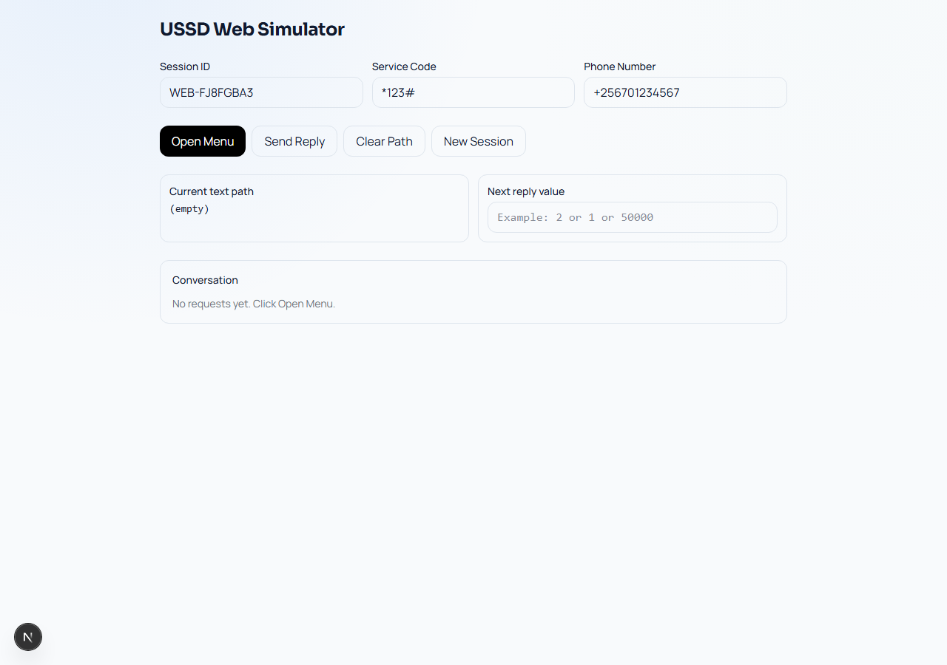

3. Request and Response Contract
Each dial step POSTs JSON (or form fields) with cumulative menu path in text (segments joined by *). Responses are plain text prefixed with CON (continue) or END (terminate).
Example: text "2*1*30000" = Buy Units → Start purchase → 30000 UGX.

4. Main Menu
Opening the session (empty text) returns:
Energy Share
1. Wallet & Meter
2. Buy Units
3. Loans
4. Share Units
5. My Tokens
6. Exit
Figure 4.1 — Main menu (USSD screen)
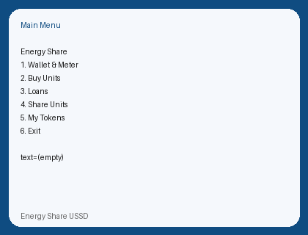

Figure 4.2 — Main menu in web simulator conversation panel
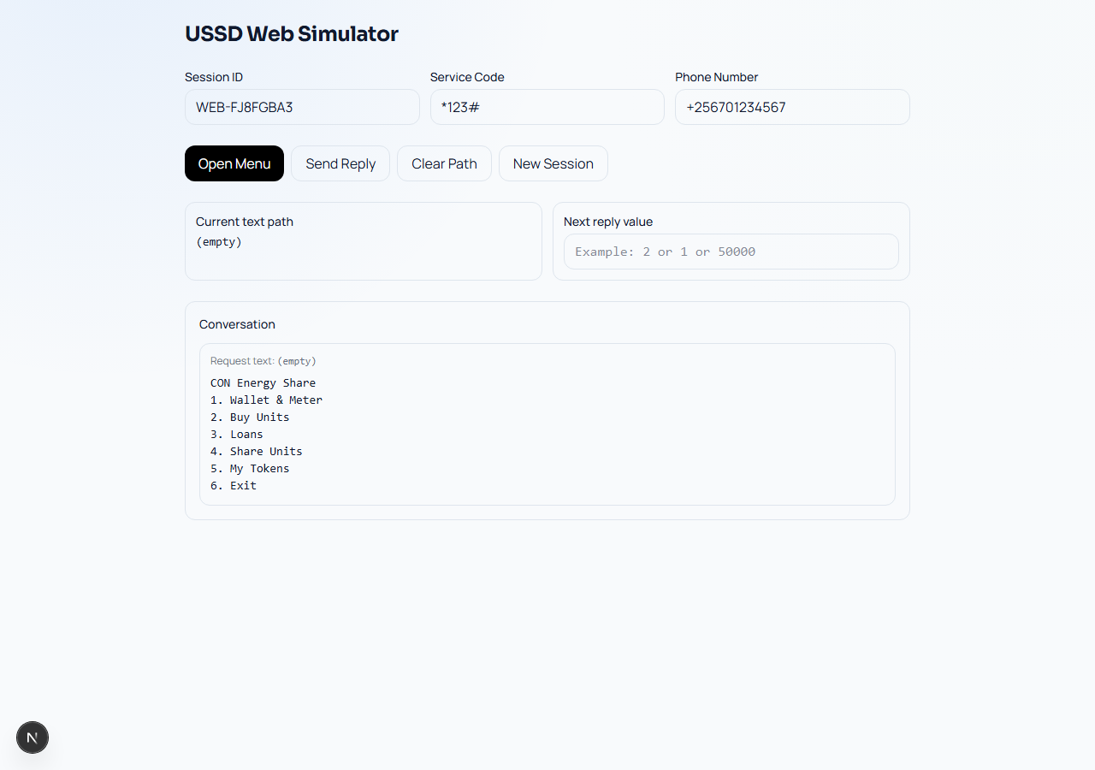

5. Feature: Wallet & Meter (Option 1)
Path: text = 1. One-step END response showing unit wallet balance, registered meter number (or Not registered), and total outstanding on disbursed loans (UGX).
Figure 5.1 — Wallet & Meter response
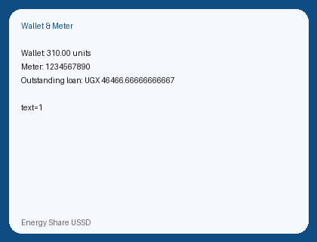

Figure 5.2 — Wallet flow in simulator
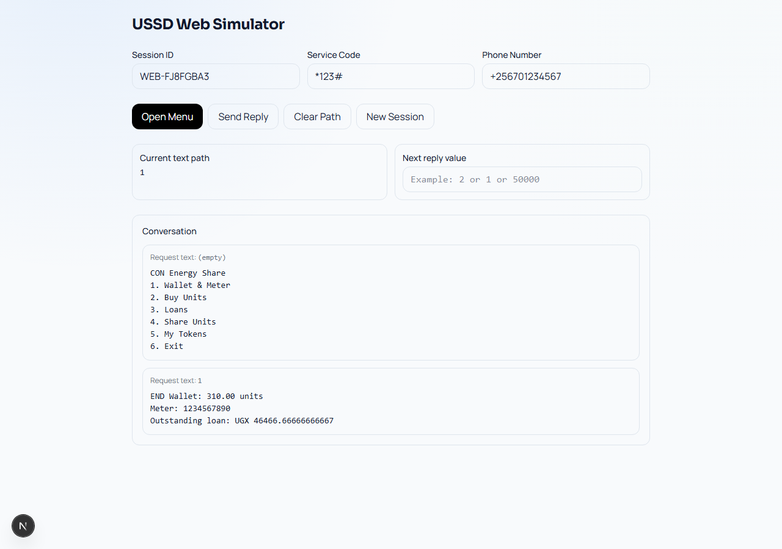

6. Feature: Buy Units (Option 2)
Submenu (text = 2):
- 1. Start purchase
2. Check payment status
Start purchase (2*1*amount): requires registered meter; blocked if user has any loan not COMPLETED or REJECTED. Sandbox mode simulates MoMo payment in ~10 seconds and credits the unit wallet. Check status (2*2*txId) supports shortcut 0 for last transaction in session.
Figure 6.1 — Buy Units submenu
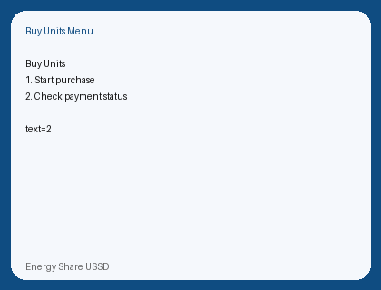

Figure 6.2 — Enter amount prompt
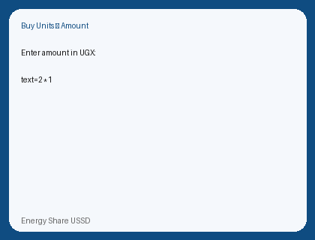

Figure 6.3 — Purchase initiation result
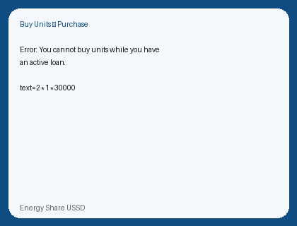

7. Feature: Loans (Option 3)
Submenu (text = 3):
- 1. Latest loan — summary of most recent application
- 2. Apply loan — amount 5000–200000 UGX, credit scoring and tier approval
- 3. Disburse loan — approved loans only; 0 = latest approved
- 4. Repay loan — disbursed loans; LoanID then amount
- 5. Loan stats — pending/active counts and outstanding total
Figure 7.1 — Loans submenu
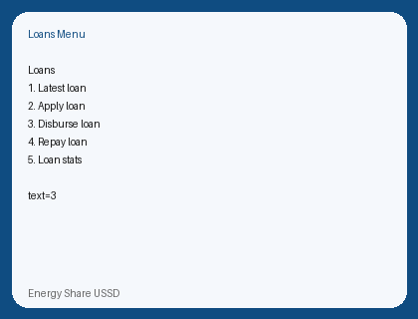

Figure 7.2 — Latest loan details
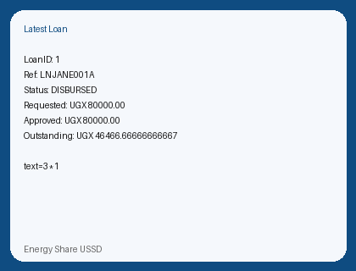

Figure 7.3 — Loan statistics
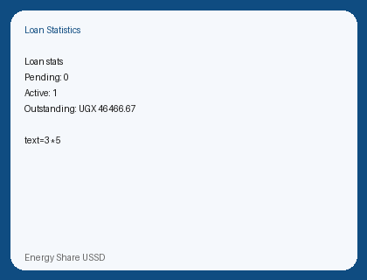

Figure 7.4 — Loans flow in simulator (3 → 1)
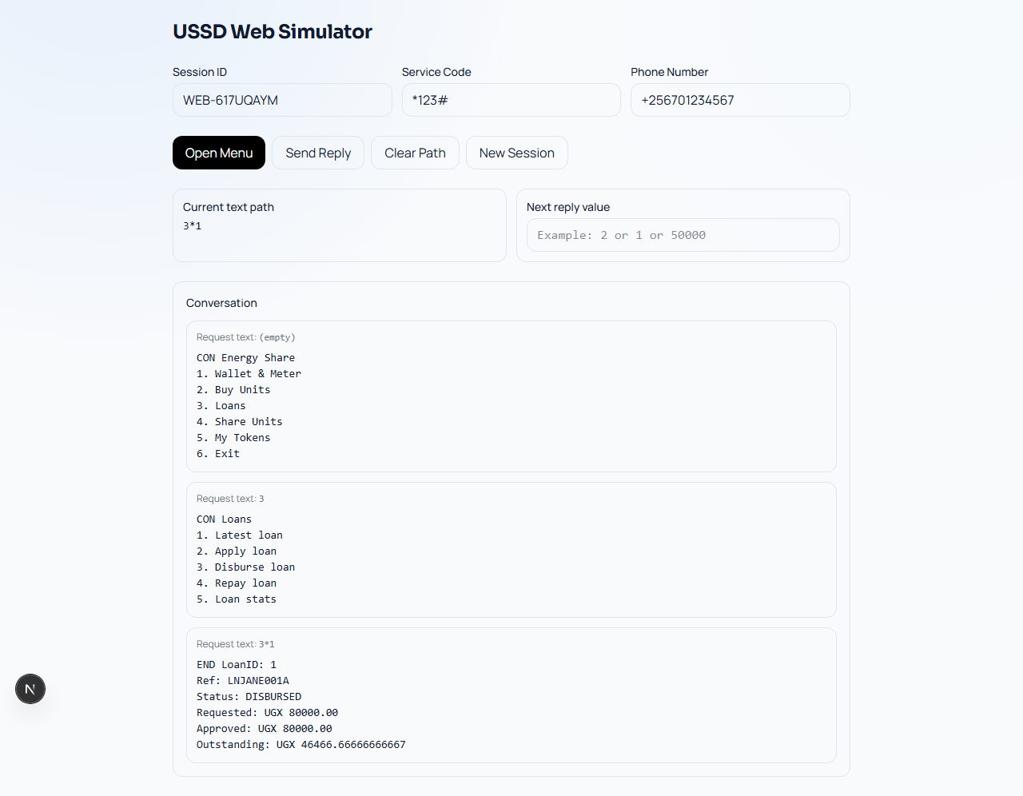

8. Feature: Share Units (Option 4)
Submenu: 1 Initiate share (meter → units, min 2), 2 Verify OTP (ref + 6-digit code). Initiate creates a PENDING ShareTransaction and verification code (purpose share_units). Web flow emails OTP via Celery; USSD initiate currently stores OTP in DB only — verify using admin/DB during testing unless email hook is added. Ref shortcut 0 reuses last share ref.
Figure 8.1 — Share Units submenu
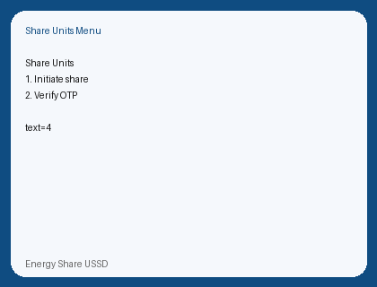

Figure 8.2 — Share initiate completed (END with transaction ref)
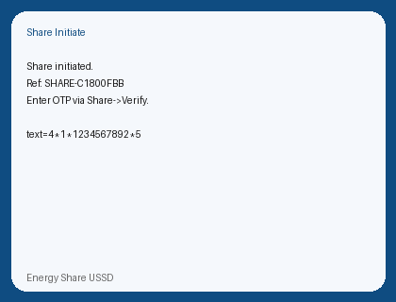

Figure 8.3 — Share OTP verification success
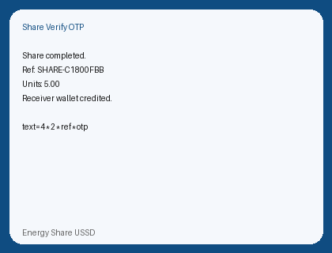

9. Feature: My Tokens (Option 5)
Lists up to three unused meter tokens (token | units | source). END with message if none.
Figure 9.1 — Active tokens list
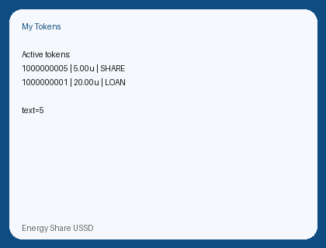

10. Session Management
UssdSession persists sessionId for 15 minutes, stores context (last buy TxID, last share ref), and returns cached last_response when the provider retries the same text — preventing duplicate charges.

11. Features Not on USSD
- Meter transfer (available on web/API only)
- Account registration and login
- Admin operations
- Dedicated USSD MoMo loan repayment channel (web has repay/momo/)

12. Testing and Deployment
Local: Django :8000, Next.js :3000, optional PostgreSQL seed (sample_full_dump_heavy.sql). Production: configure Africa's Talking callback to https://<host>/api/v1/ussd/entry/. Test MSISDN must exist in accounts_user with last-9-digit phone matching.
Figure 12.1 — Dashboard navigation to USSD Simulator
[Screenshot placeholder: Sidebar or account menu link to /ussd-simulator]
Insert screenshot here showing the described screen or simulator step.

Figure 12.2 — Africa's Talking channel configuration
[Screenshot placeholder: AT dashboard showing callback URL and service code]
Insert screenshot here showing the described screen or simulator step.

13. Source Reference
- backend/ussd/views.py — menu handler
- backend/ussd/models.py — UssdSession
- frontend/src/app/ussd-simulator/page.tsx — browser simulator
- USSD_INTEGRATION.md — technical integration guide

