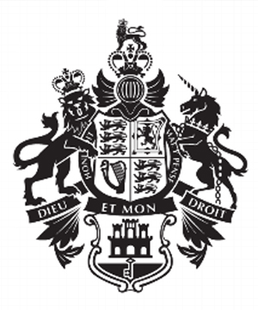.

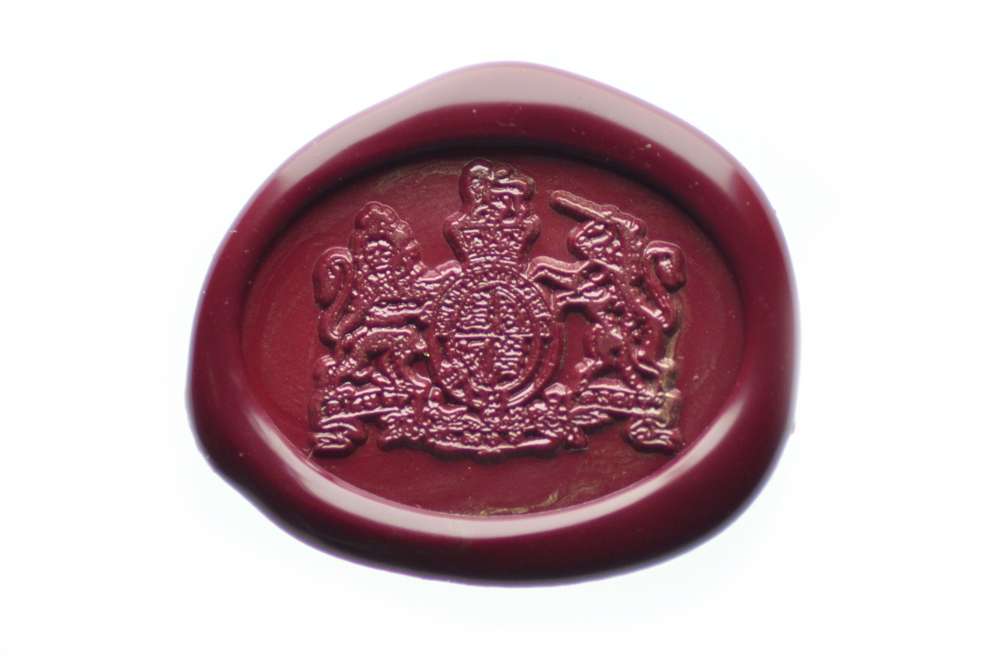

**Mission Brief**

Her Majesty’s Government have reached out to our allies in The Netherlands for the help of the Korps Commandotroepen for assistance on a special mission.

At 21.00 GMT last night, a plane carrying a specialised payload lost contact with its handlers on Vauxhall Street. Military Intelligence Six (MI6) reported the issue immediately.

The plane had limited fuel reserves and so, can only land at a number of locations. The mission needs to recover:

1. The flight number
2. The mission ID
3. The landing location
4. The passcode to the safe to recover the payload.

Her Majesty’s Government have given limited, but special use, of their code cracker file which will be needed to crack the final code which will release the doors to the plane.

Your mission dossier will include all the information needed to complete each mission stage.

You are provided with the following tools:

1. A python cheat sheet
2. Pilot dossier
3. Aircraft dossier
4. A map

The internet can also be used to solve the problems. Alternatively, MI6 have also sent two operatives to assist with the mission.

You have an hour to complete the mission, or the payload and all souls aboard the aircraft will be lost.

Good night, and good luck.

Signed: Commodore Wallington