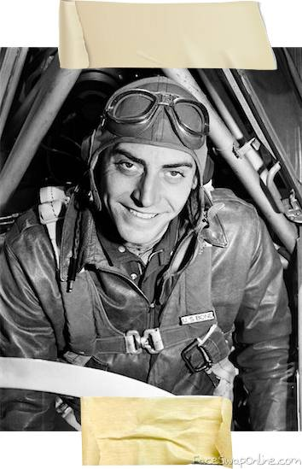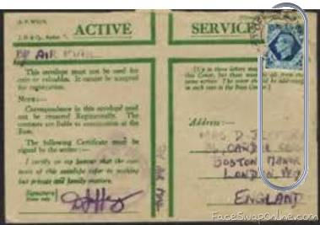Number:

1867

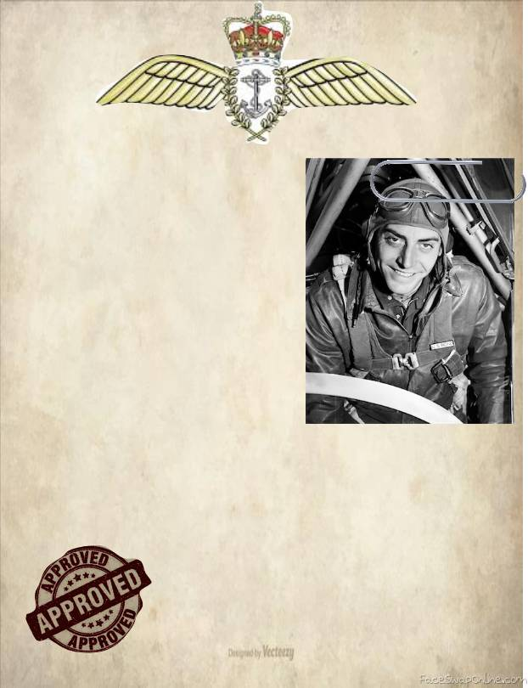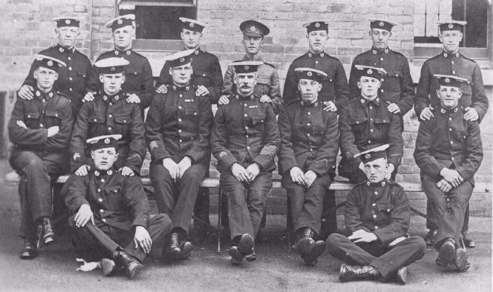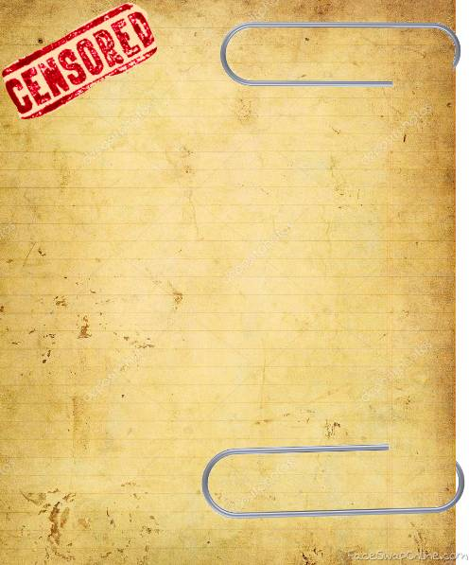

This certificate is to grant

…………………………………….

Full use of all aircraft, both military and civil.

This licence was granted on 18.08.1995 at RM Portsmouth

Signed

……………………………………

Pilot Name: P.P. Cohn

D.O.B: 09.09.1989

Skills: Aviation, Stellar Navigation, Camouflage and Concealment.

Background: Royal Navy Pilot with active experience in Ireland, Yemen and Svalbard.

Current Status: Pilot for the MI6 Special Team

Licence ID No. 1867