Kayleigh Kinsey

10/2024

IT 230 Software Develop with C#.NET

Here is the output of my program:

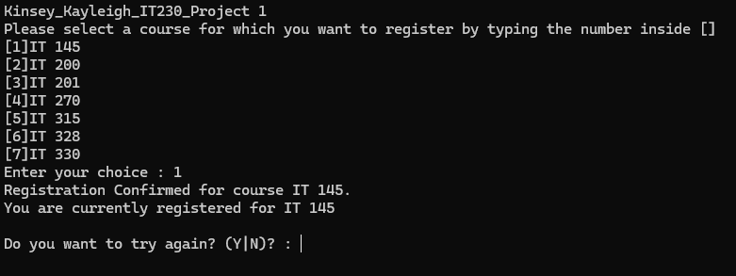

First, I input ‘1’ and get registered for IT 145.

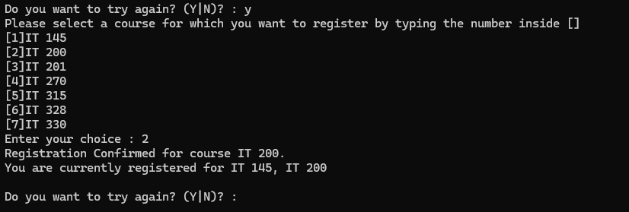

Next, I input ‘2’ and am registered for IT 200 as well. Both my registered courses are displayed in a list.

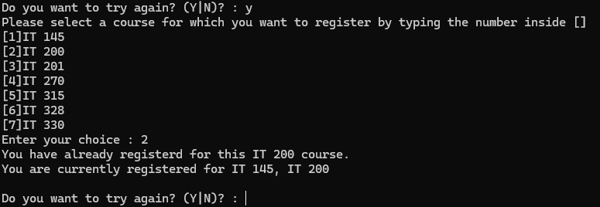

I input ‘2’ again, but am told that I have already registered for IT 200

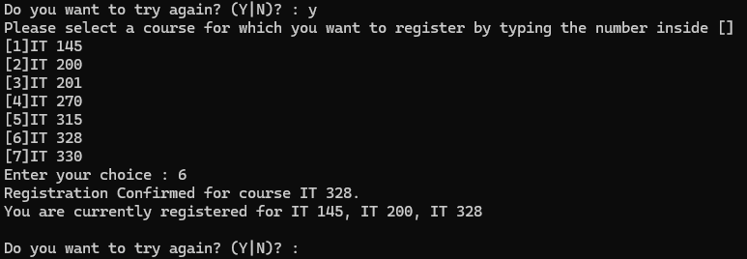

Next, I input ‘6’ and get registered for IT 328. All three of my courses are listed now.

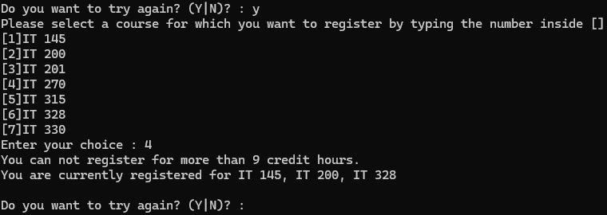

I try to register for IT 270 by inputting ‘4’, but am informed that I cannot register for more than 9 credit hours.

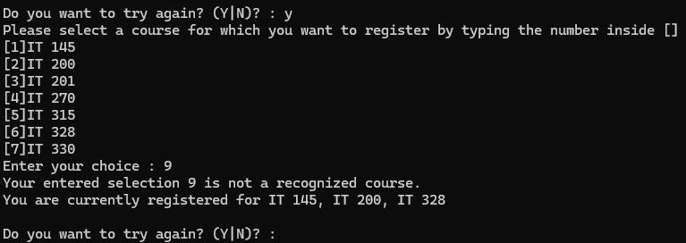

I input ‘9’, but since this is not an option, I am told my input was invalid.

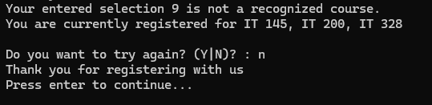

Finally, I tell the program that I do not want to continue. It thanks me for registering and waits for input before closing.

The only non-cosmetic changes I made to the source code were in the ValidateChoice() method. The adjusted code can be seen below, with comments explaining the rationale behind my changes:

int ValidateChoice(int choice, int firstChoice, int secondChoice, int thirdChoice, int totalCredit)

{

// Changed '70' to '7' because there are no more than 7 courses displayed.

if (choice < 1 || choice > 7)

return -1;

// Changed '&&' to '||' because condition should be true if choice == ANY of the previous choices

else if (choice == firstChoice || choice == secondChoice || choice == thirdChoice)

return -2;

// Added 3 to totalCredit before comparison. This ensures that registering for a new course will not push credit hours past limit.

else if ((totalCredit + 3) > 9)

return -3;

// Changed return from -4 to 0 because rest of code assumes 0 when choice is valid

return 0;

}