Kayleigh Kinsey

10/16/24

IT 230 Project 2

Here are the screenshots of my program’s output:

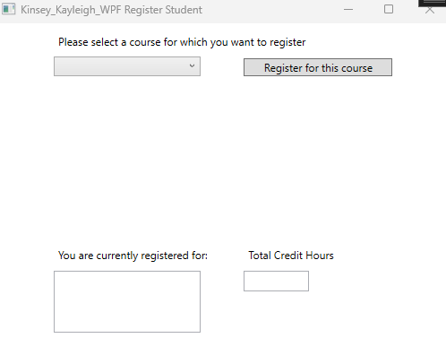

This is the way the application looks when it is first opened.

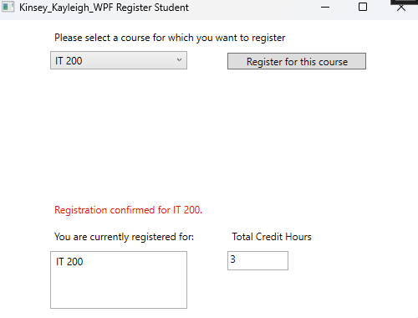

First, I select IT 200. When I click the button, the course is added to the list box, the credit hours text changes to “3”, and the red label confirms that I have registered for IT 200.

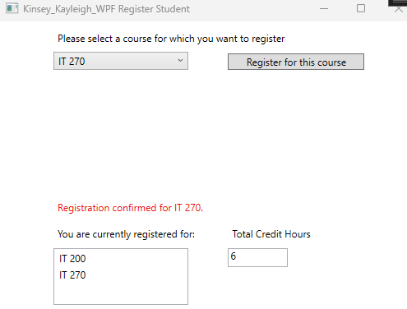

Next, I select IT 270 and click to register. Again, the course is added to the list box, the number of credit hours increases by 3, and the label confirms my registration.

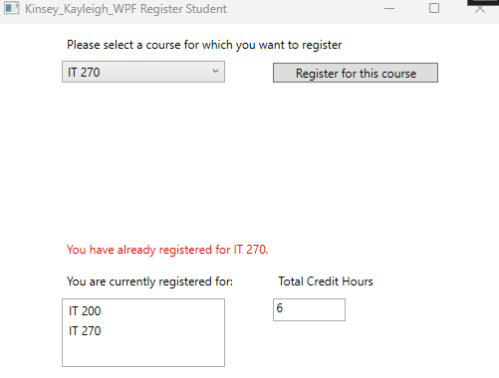

If I try to register for IT 270 again, the red label informs me that I have already registered for that course and no other changes occur.

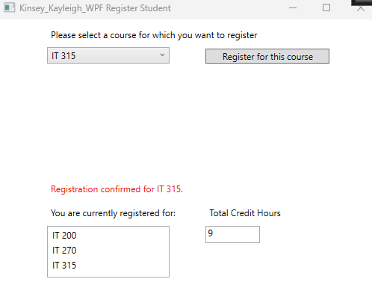

Next, I try to register for IT 315. Again, the listbox, credit hours, and red label update to reflect the new registration.

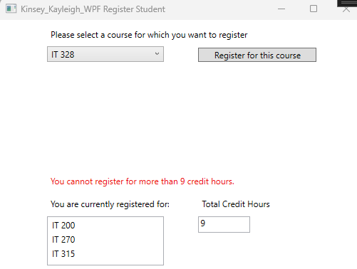

When I try to register for IT 328, the red label informs me that I cannot register for more than 9 credit hours.

Here is the source code for the button_Click method. Outside of this method, the only change I made to the code was the addition of a creditHours int declared just beneath the choice variable in the MainWindow : Window class. I commented all of my additions to explain the purpose of each line.

// Respond to registration button click

private void button_Click(object sender, RoutedEventArgs e)

{

choice = (Course)(this.comboBox.SelectedItem);

// If user is already registered for chosen course

if (choice.IsRegisteredAlready())

{

label3.Content = $"You have already registered for {choice}."; // Display error message

}

// If another registration would exceed credit hour limit

else if (creditHours + 3 > 9)

{

label3.Content = "You cannot register for more than 9 credit hours."; // Display error message

}

// If registration is valid

else

{

label3.Content = $"Registration confirmed for {choice}."; // Confirm registration

choice.SetToRegistered(); // Set choice to registered

listBox.Items.Add(choice); // Add choice to list box

creditHours += 3; // Increase credit hours

textBox.Text = creditHours.ToString(); // Update text box

}

}