

KAY DEV

BUILDING YOUR DIGITAL PRESENCE

|  |
| --- |
|  |

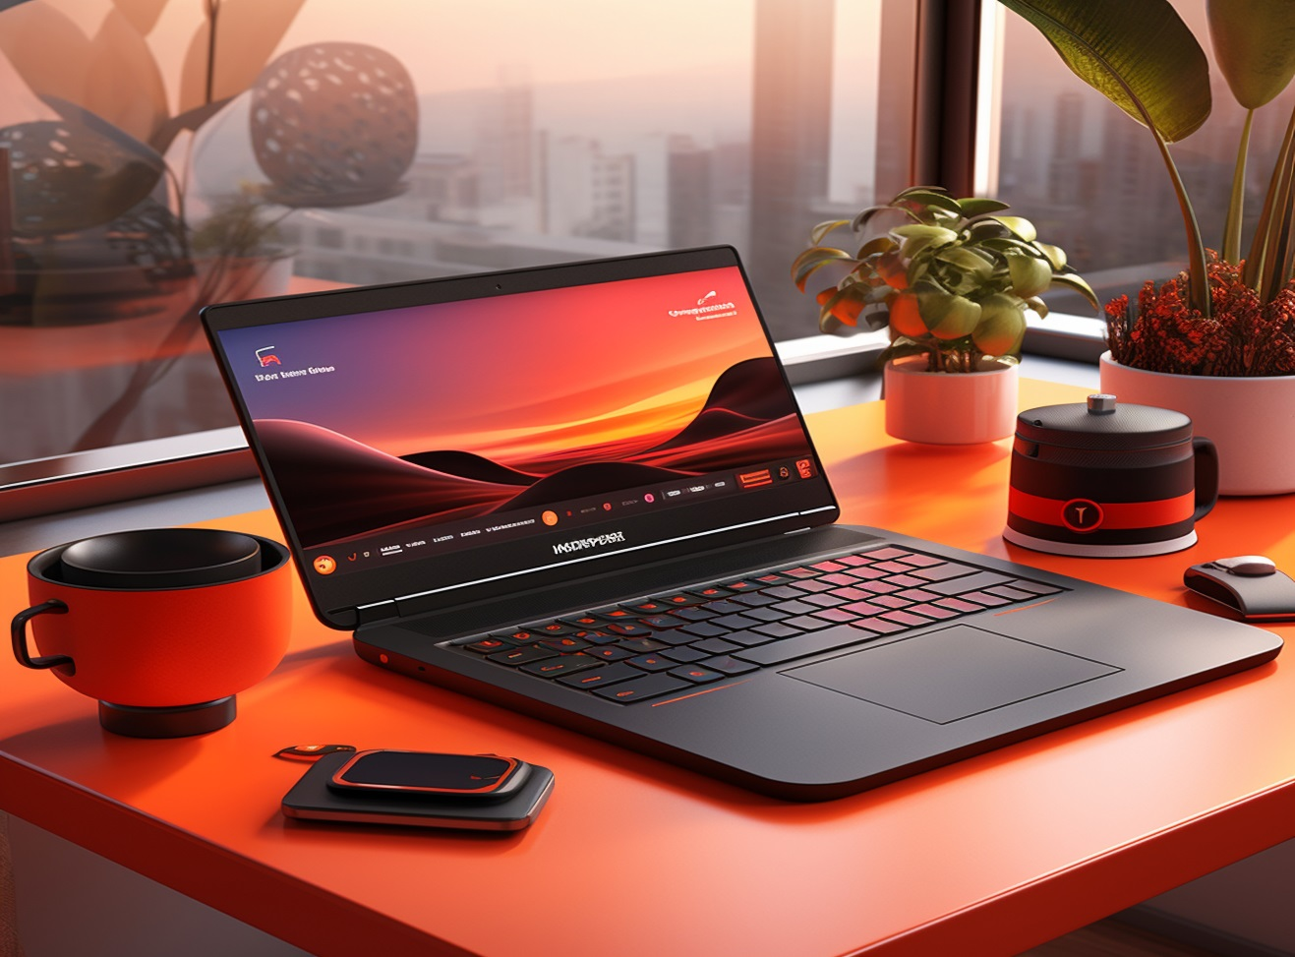

Contact Us

Phone: +233 534 329 262

Email: mailto:kennethamoah530@gmail.com

Welcome to Kay Dev

Your Partner in Website Development

At Kay Dev, we specialize in crafting custom websites that drive results. Our team of experts is dedicated to delivering high-quality solutions that meet your unique needs.

**GRAPHIC DESIGN**

We create custom logos, marketing materials, and branding solutions that establish a strong visual presence for your brand.

**MOBILE APP**

**DEVELOPMENT**

We develop custom and cross-platform mobile apps, tailored to fit your brand’s needs.

**WEB DEVELOPMENT**

We create custom, responsive, and mobile-friendly websites that reflect your brand and are delivered quickly.

Our Services

