Project Deliverables

1. System Service Request
- Objective: Create a formal system service request for the Clinical Management System for the ABC clinic as requested by its manager, John Doe.
- Format: Use the template from Chapter 3, Slide 7, Figure 3.2.

2. Project Charter
- Objective: Develop a professional-scale project charter (1–2 pages) as stipulated by PMBOK® standards.
- Format: Use the template from Chapter 3, Slide 15, Figure 3.7.

3. Feasibility Analysis Document & Spreadsheet
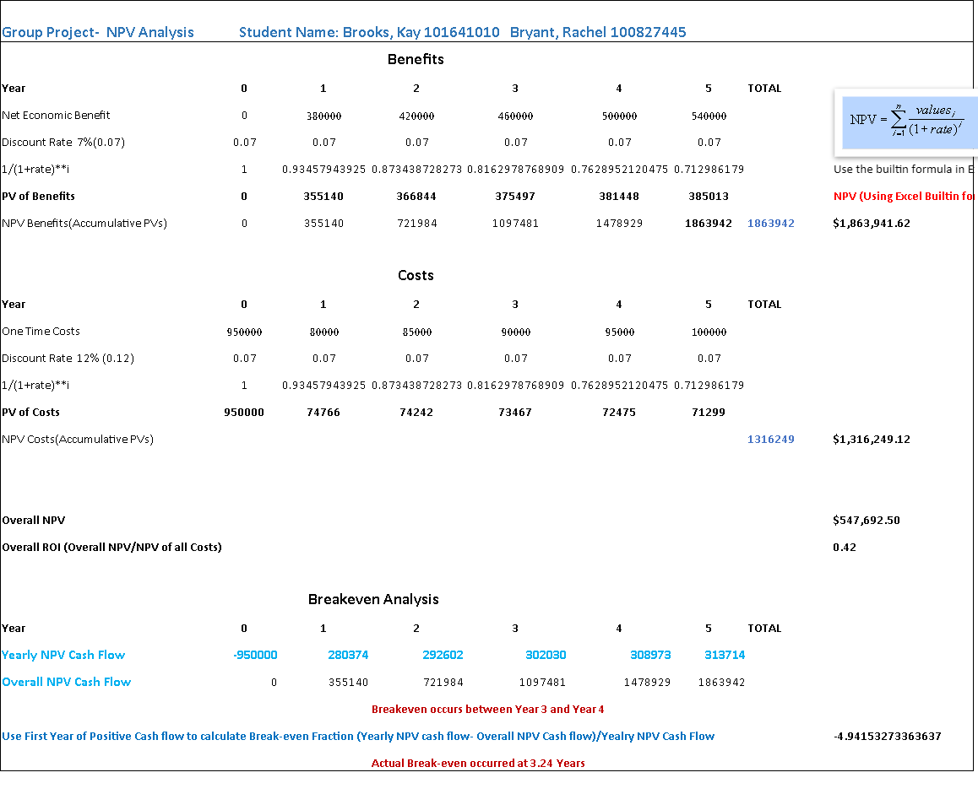

- Objective: Create a 4–5 page Feasibility Analysis document justifying the project based on Economic, Technical, Operational, and other factors as described in Chapter 5.
- Spreadsheet Requirement: Include a separate spreadsheet calculating NPV, ROI, and Payback period using reasonable assumptions for initial and recurring costs and benefits.

4. List of Intangible Benefits

Category | ABC Clinic Specific Intangible Benefit
Competitive Necessity | Ensures strict compliance with government privacy regulations by electronically safeguarding patient records.
More Timely Information | Enables real-time Ministry Health Card verification and instant status updates for the triage walk-in queue.
Better Information Access | Gives clinicians instant access to patient medical histories, past treatments, lab results, and specialist notes.
Clerical Accuracy | Reduces manual data entry errors at check-in/check-out and accurately logs staff shift hours for payroll.
Processing Efficiency | Speeds up front-desk check-ins, nurse vitals entry, e-prescriptions, and electronic lab/specialist transmissions.
Improved Work Process | Increases patient satisfaction via online booking while boosting staff morale by cutting paper administrative friction.
Decision Quality | Enhances doctor diagnosis at point-of-care and ensures rapid follow-up on critical abnormal lab results.
Resource Control | Helps clinic managers streamline shift schedules (doctors, nurses, receptionists) and manage queue flow.
Greener Resource Use | Minimizes paper reliance by digitizing records, utilizing electronic interfaces, and scanning paper documents.
Social Responsibility | Improves GTA community health by delivering efficient primary and urgent triage care for 1,500–2,000 patients weekly.

5. Project Scope Statement
- Objective: Define the boundaries, deliverables, and constraints of the project. Format: Use the example from Chapter 5, Figure 5-10, Slide 34.

6. First-Cut Use Case Diagram
- Objective: Perform textual analysis of the ABC clinic business description to identify candidate actors and use cases. Output: Produce the initial use case diagram.

7. Textual Analysis Table Screenshot
- Objective: Provide an image/screenshot of the table created during the textual analysis process. Key Columns: Must include Candidate Class, Extracted Text, and Type columns (among others).

8. Written Use Cases (Kite Level)
- Objective: Pick any five (5) use cases from your project and write detailed descriptions at the Kite Level (bird's-eye view). Format: Follow the examples in Appendix 7-A of the textbook.

9. Activity Diagrams
- Objective: Create three (3) Activity Diagrams for any three core business processes belonging to your project. Format: Follow the examples in Appendix 7-B of the textbook.

10. Refined and Detailed Use Case Diagram
- Objective: Modify the first-cut use case diagram using additional details derived from your written use cases and activity diagrams. Requirements: Incorporate <<include>>, <<extend>>, and <<generalization>> relationships.

11. Context Level Data Flow Diagram (DFD)
- Objective: Capture the overall scope and external entities of your project. Format: Use the example in Chapter 7 of the textbook (Figure 7-4 on Slide 13).

12. Level-0 DFD (Level-1)
- Objective: Decompose the context-level data flow diagram into a Level-0 DFD (referred to as Level-1 in Visual Paradigm tutorials).

13. BPMN Diagram
- Objective: Select any one business process from the clinic and model it using a Business Process Model and Notation (BPMN) diagram.

14. Conceptual Data Model (ERD)
- Objective: Create a conceptual Entity-Relationship model. Requirements: Incorporate entity generalization hierarchies and explicitly state business rules for overlap and disjoint.

15. Physical Data Model
- Objective: Create an ER model representing fully normalized relations (Physical Data Model).

16. UML Class Diagram
- Objective: Design a class diagram displaying class names, attributes, associations, and relationships. Requirements: Include generalization, composition, and aggregation.

17. Wireframes
- Objective: Create UI wireframes for the following specific tasks using the example in Figure 10-3A (Chapter 10, Slide 11):
  - A. Appointment booking form for an existing (permanent) patient.
  - B. Change sequence in the Queue form for an emergency walk-in patient.
  - C. Create Staff Schedule report for any given week.
  - D. Store Patient Visit history form (using a single sample patient).
  - E. Patient Payment Entry form (one unified form for all types of payments, such as doctor notes, uninsured services, etc.).

18. Dialogue Diagram
- Objective: Create a dialogue diagram for any one actor/scenario. Format: Use the example from Chapter 11, Figure 11-19, Slide 45.

19. Testing Strategy
- Objective: Produce a one-page testing strategy document outlining test types and the testing process. Format: Use information provided in Chapter 12.

