**ASSIGNMENT:**

**1.Find the functional dependencies for the below and normalize it till BCNF :**

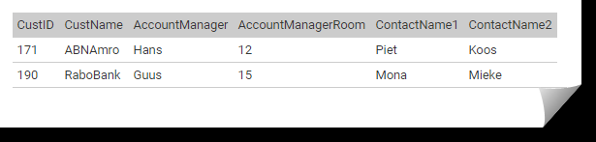

**Solution:** The table is already in 1 NF form because each attribute has atomic values.

The table is already in 2 NF form because there is no partial dependency.

The dependencies are as follows :

Custid 🡪 CustName, AccountManager, AccountManagerRoom, ContactName1, ContactName2

AccountManager 🡪 AccountManagerRoom

So there is no partial but transitive dependency , hence we split the table into two , making it in 3NF

|  |  |  |  |  |
| --- | --- | --- | --- | --- |
| Custid (primary key) | CustName | AccountManager  (foreign key) | ContactName1 | ContactName2 |

|  |  |
| --- | --- |
| AccountManager | AccountManagerRoom |

**2. Draw an ER diagram for a hospital management system.**

**3.**

**Consider a relation Student (StudentID, ModuleID, ModuleName, StudentName, StudentAddress, TutorId, TutorName). Each student is given a StudentID and each module given a ModuleID. A student can register more modules and a module can be registered by more students. TutorID is the ID of the student's personal tutor, it is not related to the modules that the student is taking. Each student has only one tutor, but a tutor can have many tutees. Different students can have the same name. Different students can be living at the same address.**

**Find all the functional dependencies holding in this relation and normalize the table to 3NF.**