dependantpermissionid是啥意思？

看个例子

|  |
| --- |
| ID=OCSMS_AccNA_Co（OC SMS 1）  echo "dn: ${DN}=${ID}, $SEARCHBASE">>$1.ldif;  echo "./delObj \"${DN}=${ID}\" \"$SEARCHBASE\" ">>$1.backout;  echo "presentationorder: 0010">>$1.ldif;  echo "presentationlabel: OC SMS 1">>$1.ldif;  echo "presentationlabeltag: 4367">>$1.ldif;  echo "permissiongroupid: OCSMS_Company_Region_Group">>$1.ldif;  echo "objectclass: tsipermissioncode">>$1.ldif;  echo "dependentpermissionid: SMSOC_SERD001">>$1.ldif;  echo "dependentpermissionid: ANM_Analyzer_Co">>$1.ldif;  “SMS Subject Area - ANM (OCSMS) Grey Route”  echo "objectclass: top">>$1.ldif;  echo "nqproductid: SMS">>$1.ldif;  echo "subjectarea: 188">>$1.ldif;  echo "productuid: MD-1">>$1.ldif;  echo "">>$1.ldif; |

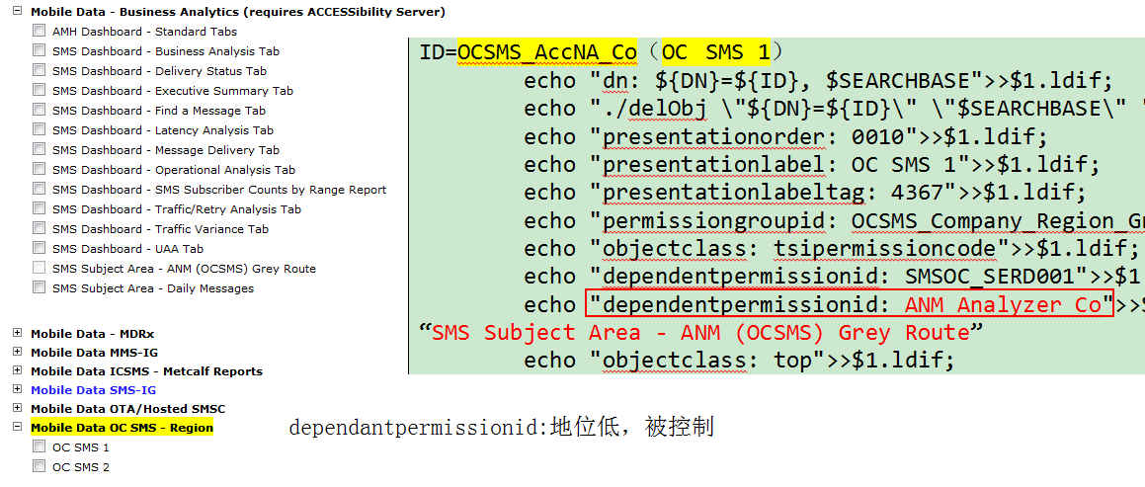

RSRC_TO_RSRC_REL中，地位低的“dependantpermissionid”，反而是rsrc_id2