|  |  |  |
| --- | --- | --- |
| RSRC_ID | PRSNTTN_ID | PRSNTTN_LABEL |
| 5381 | Subscriber_File_Upload_Status | File Upload Status |
| 5379 | Subscriber_Common_Profile_Menu | Common Subscriber Profile |
| 2982 | Subscriber_Menu | Top Level Subscriber Menu |
|  |  |  |

5381(File Upload Status)，父菜单5379(Common Subscriber Profile, resc_typ_cd 4)

最高级菜单5379(Common Subscriber Profile, resc_typ_cd 4)，它的上级

2982(Top Level Subscriber Menu)

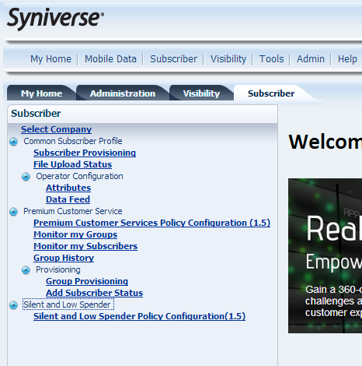

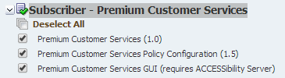



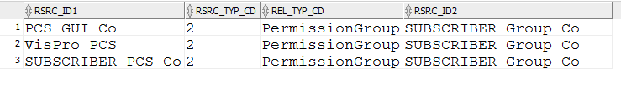

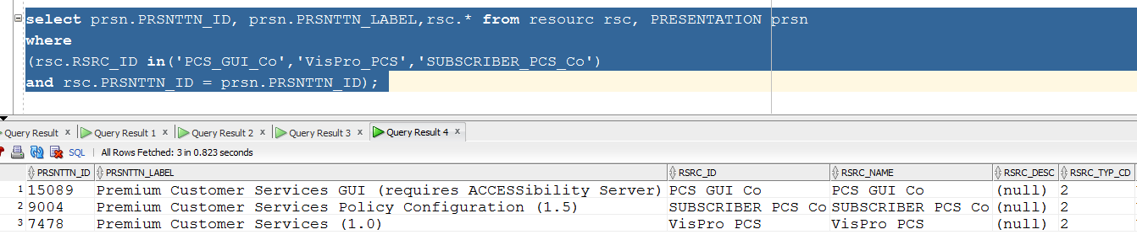

我们来看下，n permission要怎么加上select prsn.*,rsc.* from resourc rsc, PRESENTATION prsn

where

( rsc.rsrc_id in (select RSRC_ID1 from RSRC_TO_RSRC_REL where RSRC_ID2 in('VisProactive_GTPC') )

and rsc.PRSNTTN_ID = prsn.PRSNTTN_ID);

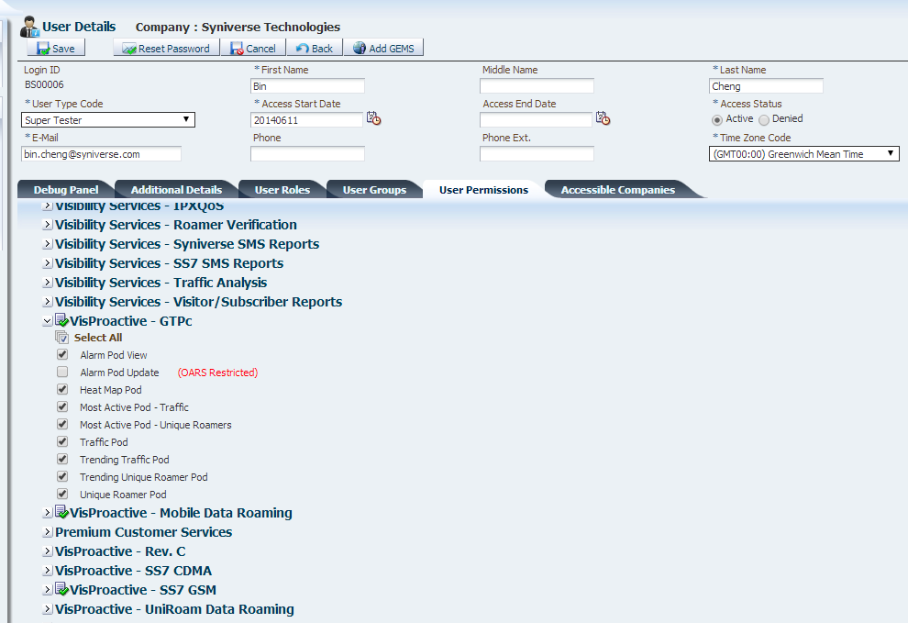



这步，应该是给 company permission来加上 rel的关系

|  |
| --- |
| select prsn.PRSNTTN_ID, prsn.PRSNTTN_LABEL,rsc.* from resourc rsc, PRESENTATION prsn  where (rsc.RSRC_ID in('Common_Subscriber_Profile_Co') and rsc.PRSNTTN_ID = prsn.PRSNTTN_ID); |

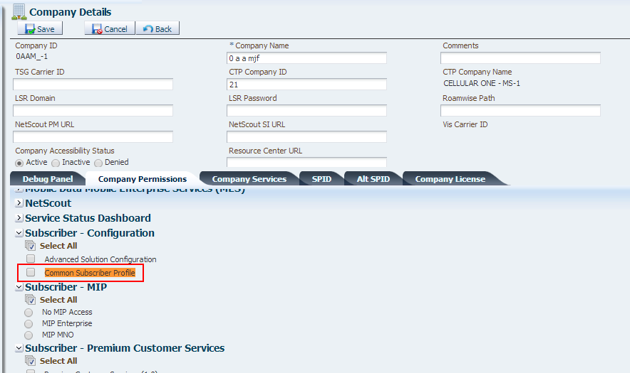

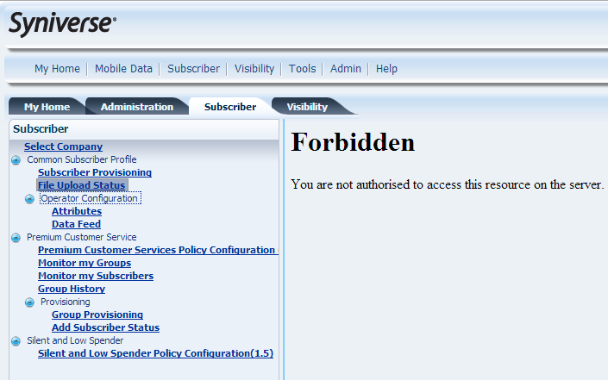

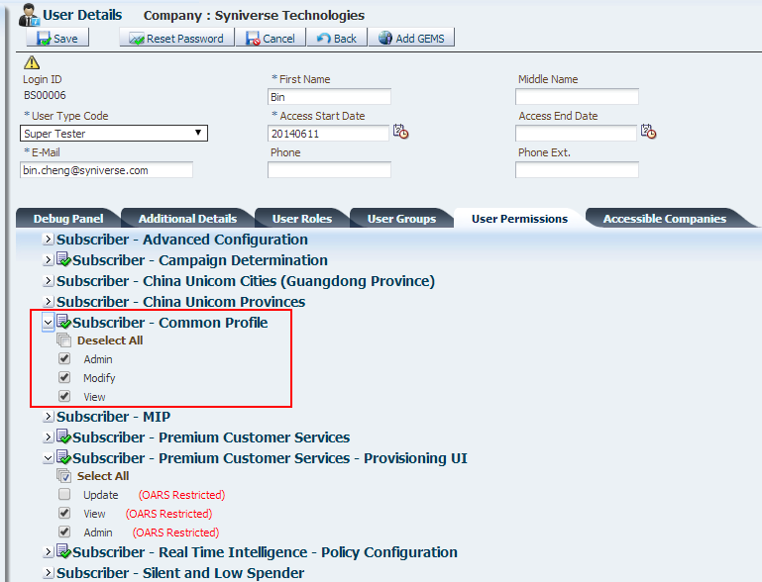

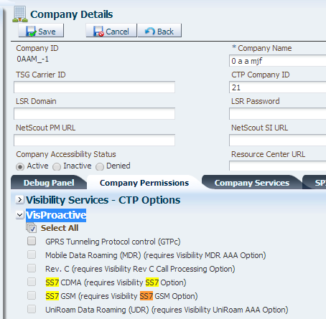

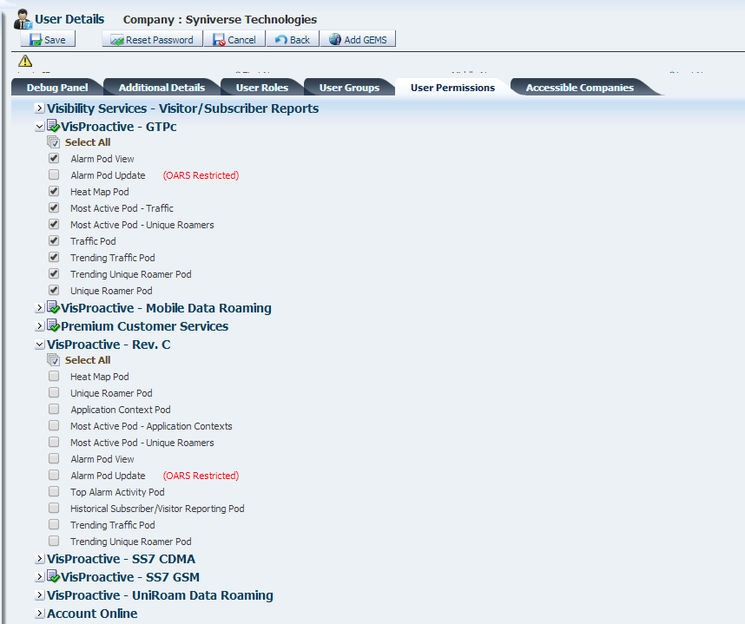

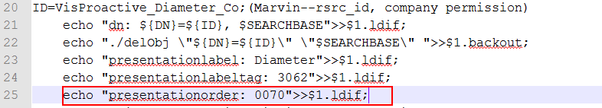

|  |
| --- |
| select prsn.PRSNTTN_ID, prsn.PRSNTTN_LABEL,rsc.* from resourc rsc, PRESENTATION prsn  where  (rsc.RSRC_ID in( select rsrc_id1 from RSRC_TO_RSRC_REL where rsrc_id2 in('VisProactive_Co'))--VisProactive_Co是公司权限的rsrc_id  and rsc.PRSNTTN_ID = prsn.PRSNTTN_ID); |