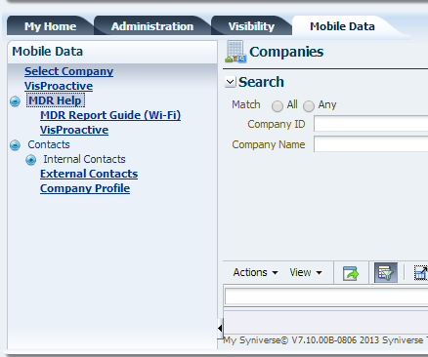

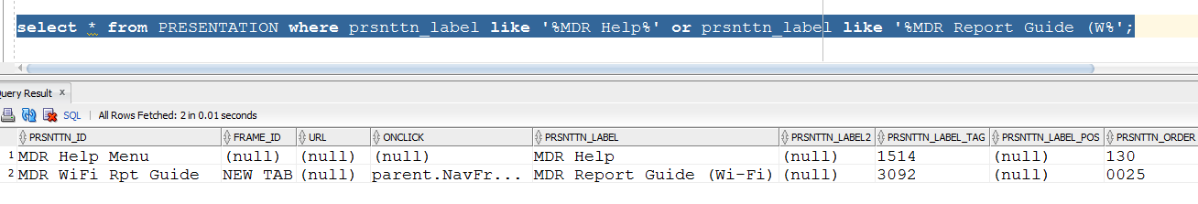

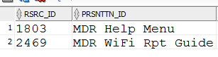

RSRC_TO_RSRC_REL中的关系是这样的

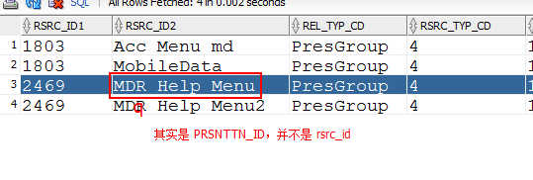

6.0的设置

首先通过admin账号，设置P002368

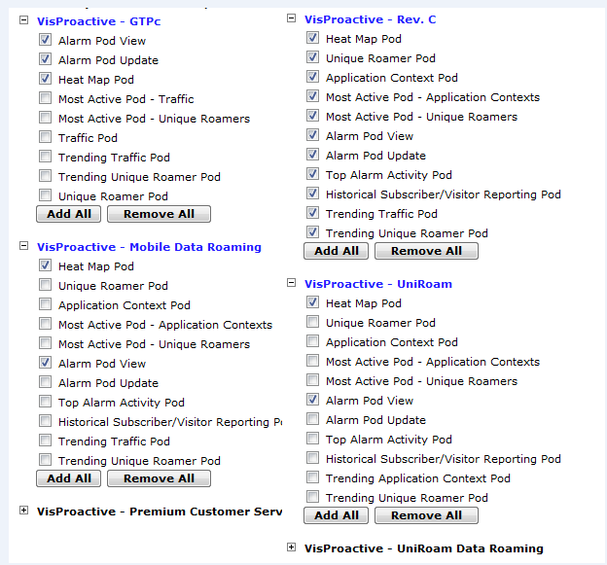

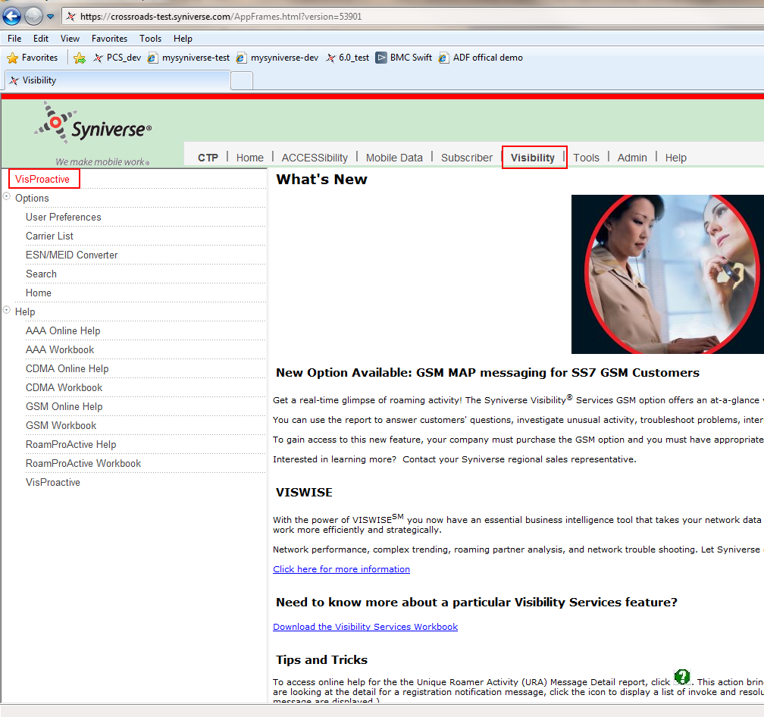

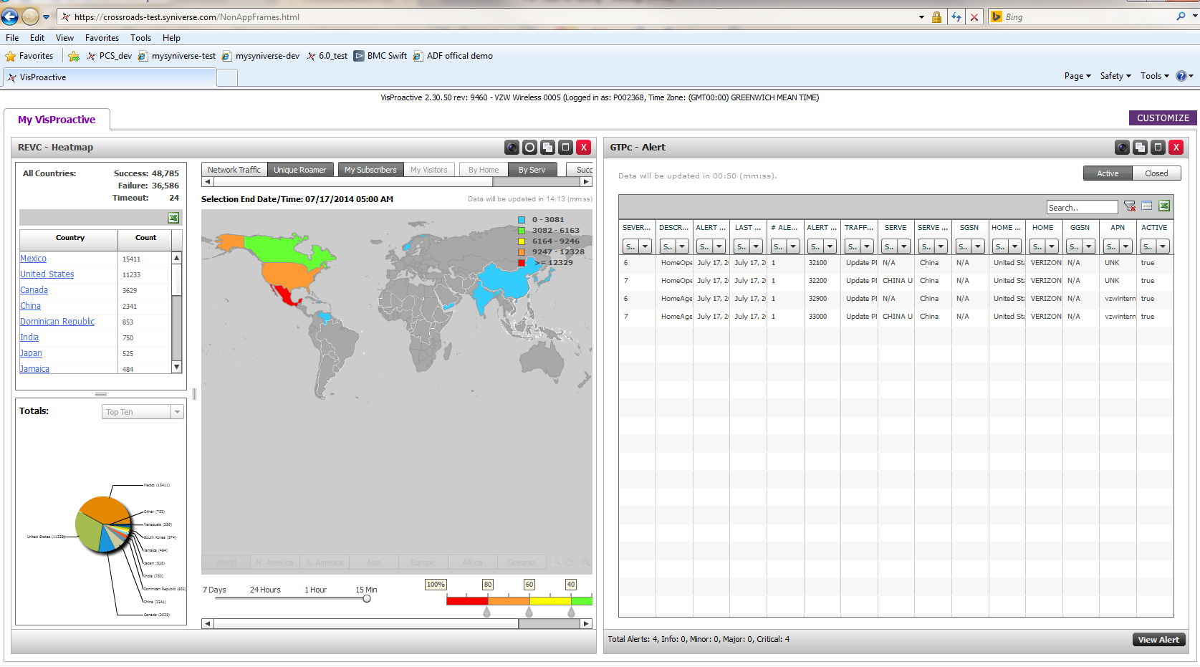

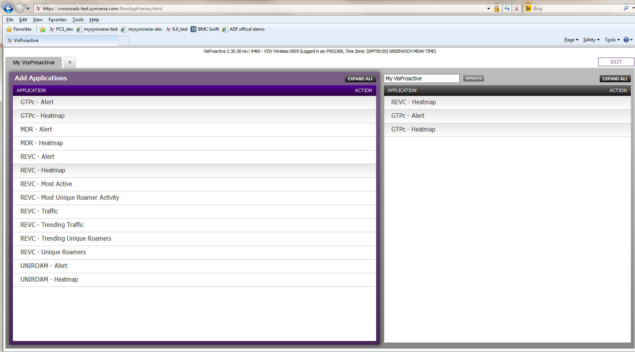

1. Login with admin user, and add to P002368 two permissions for VisProactive Diameter

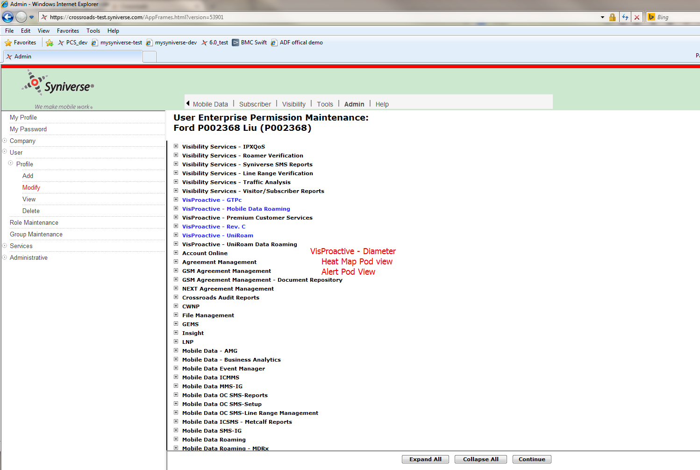

1. Login with P002368, add we’ll see Diameter as well as its two menu items

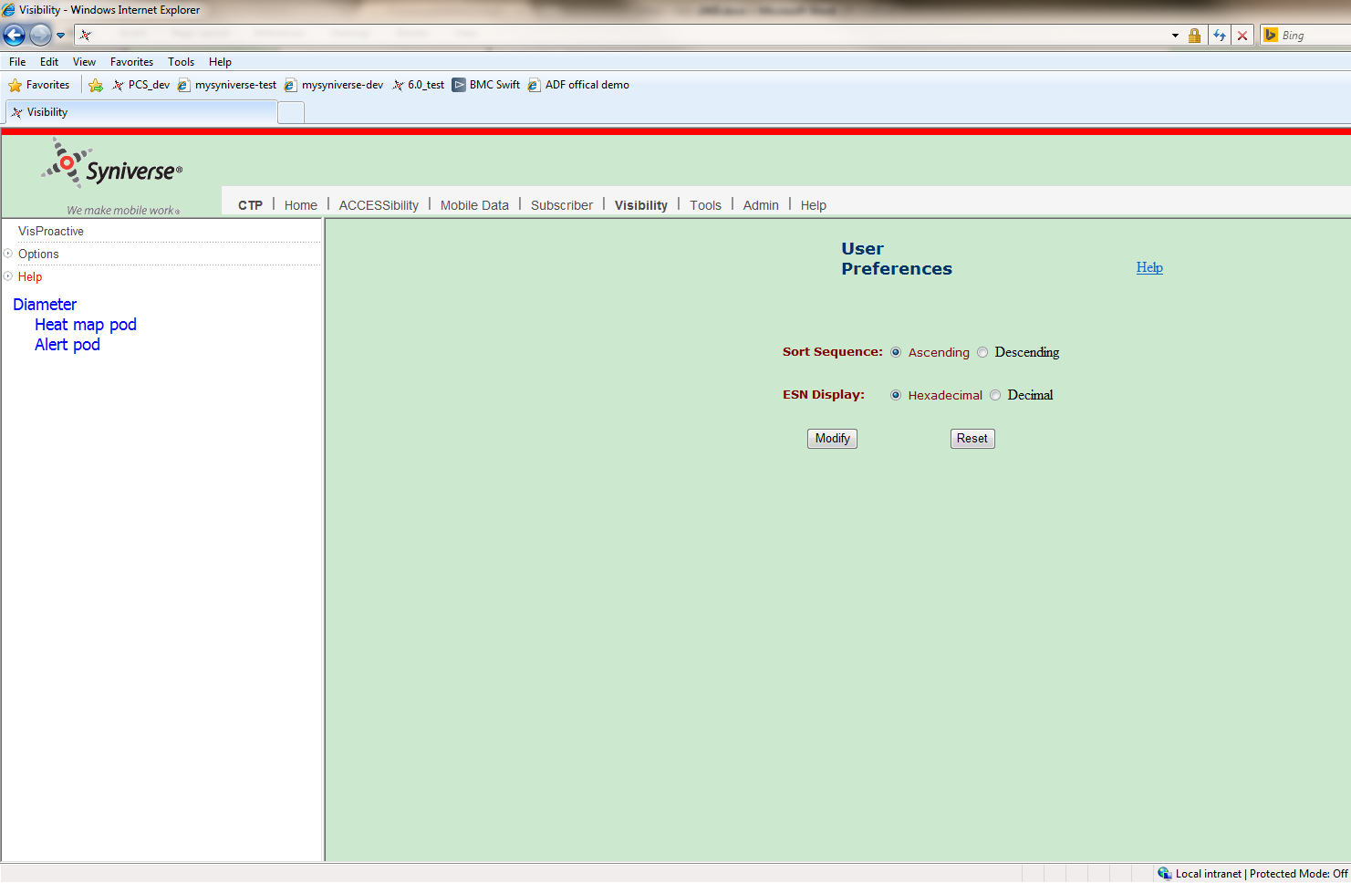

1. When user clicks “Heat map pod”/”Alert Pod”, the content will be shown on the right side instead of popup a new window

