# Integrate VisProactive-Diameter into crossroads6.0

## How to generate SQL&LDIF files

Suppose script file generating SQL&LDIF file is VisPro_Diameter, the server on which executing addLDIF is $host, and the directory is $dir

|  |  |
| --- | --- |
| NO. | Commands |
| Step1 | Copy VisPro_Diameter to $dir on $host |
| Step2 | Generate SQL&LDIF. 4 files will be generated (VPD.sql, VPD.ldif, VPD.backout.sql, VPD.backout)  $ chmod 777 VisPro_Diameter  $ ./VisPro_Diameter VPD |
| Step3 | Running VPD.sql in sqldeveloper |
| Step4 | Add LDIF file  ./addLDIF VPD.ldif -e VPD.rejects |

## How to validate the script takeing effect

Logon xroads6.0 with syniverse administrator user

1. Company permission, Diameter, is shown

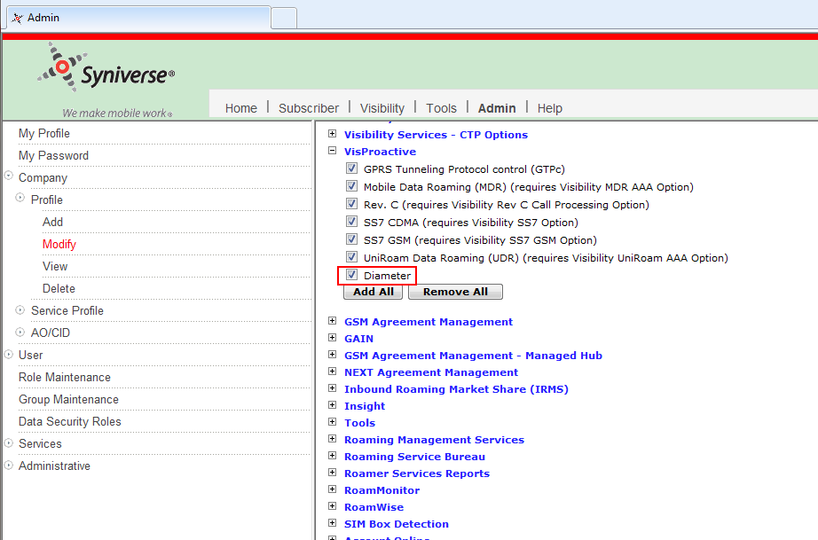

1. User permissions, Alarm Pod view and Heat Map Pod, are shown. Select these two user permission, and click Continue

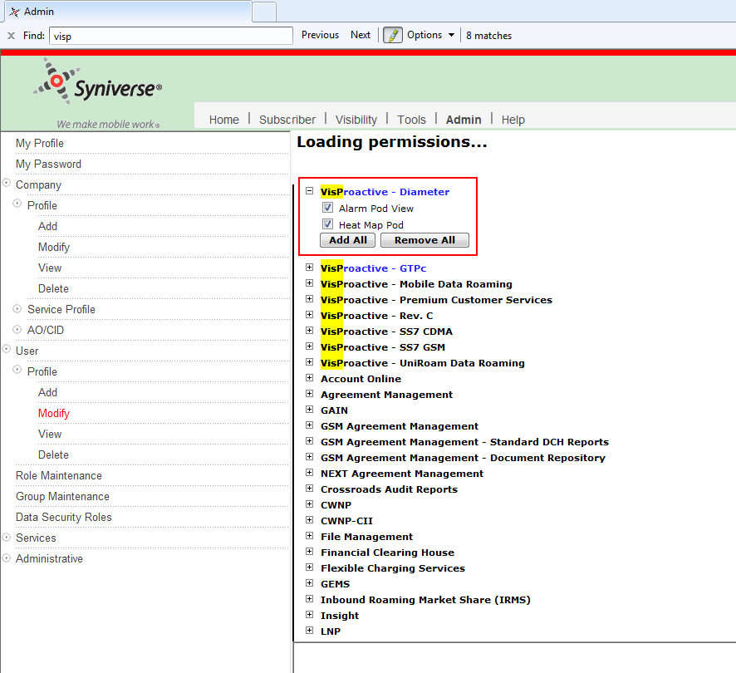

1. Open a new tab in IE, input the following URL, press Enter

<https://crossroads-test.syniverse.com/jsp/ResetMenus.jsp?allServers=N>

Input VisPro_Diameter_Menu_prsn and click Reset

1. Login out current user, and relogon. Go to Visibility, Diameter menu is shown

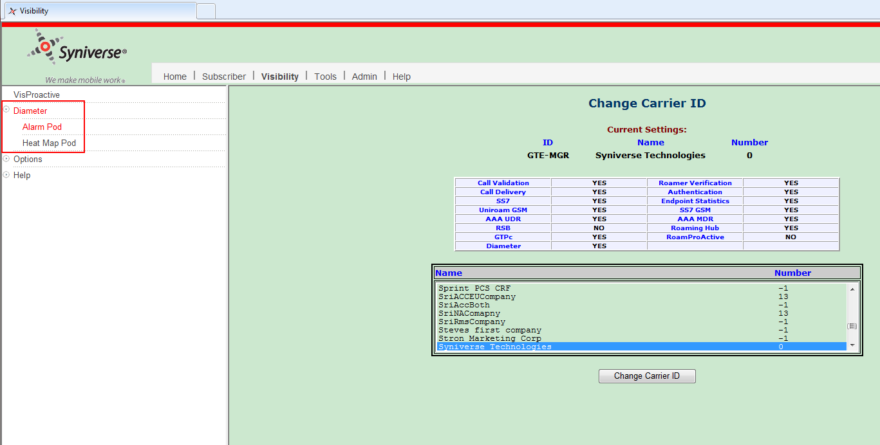

Validation done