BAUHAUS-UNIVERSITÄT WEIMAR

Faculty of Civil and Environmental Engineering
Chair of Intelligent Technical Design
Project Report
Parametric Pedestrian Bridge
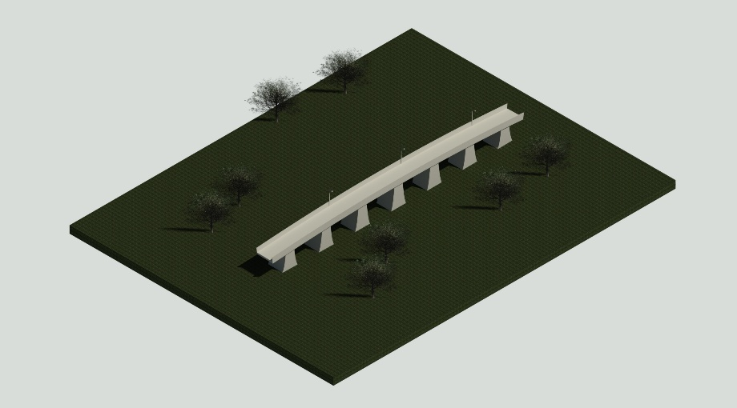

Advanced Building Information Modelling
Summer-Term 2025

Date
16.07.2025

Submitted to: Prof. Dr.-Ing. Christian Koch
M.Sc. Jakob Taraben
M.Sc. Judith Krischler

Submitted by: Kuntal Pawan Dive
127002
Digital Engineering

Abhishek Dilip Patil
127126
Digital Engineering

Swaraj Sudhakar Sonawane
127114
Digital Engineering

Table of Contents
Table of Contents II
List of Figures II
List of Tables III
List of Abbreviations III
1. Motivation 1
a. Initial idea 1
b. Feedback 1
2. Revit Model 1
a. Parametric family 1
b. Custom families 2
3. Application of the Dynamo script 3
4. Experience with Interface to DesiteMD 3
a. Exporting to IFC format 3
b. Working on the project for 4D animation 3
5. BPMN process map 4
6. Conclusion 4
7. References 5
Declaration 6

List of Figures
Figure 1: Bridge element (parametric family) 1
Figure 2: Pillar (sub-parametric family) 2
Figure 3: Railing 2
Figure 4: Streetlamp 2
Figure 5: Dynamo script 3
Figure 6: Time Schedule 3
Figure 7: BPMN process map^{[7]} 4

List of Tables
Table 1: List of parametric dimensions 2

List of Abbreviations
Abbreviation | Explanation
BIM | Building Information Modelling
IFC | Industry Foundation Classes
4D | 3D Geometry + Time (Schedule Integration)
Revit | Autodesk Revit (BIM software)
RFA | Revit Family File (.rfa)
RVT | Revit Project File (.rvt)
Dynamo | Visual Programming Extension of Revit
BPMN | Business Process Model and Notation

Motivation

Initial idea
When thinking of an idea for the project, many ideas were discussed like creating building models. We understood that Bridges are relatively hard to model in REVIT. So, to gain experience through the project, a parametric bridge with the BIM process was decided.
The initial idea was to make a bridge with modular segments or arcs which can adapt to user inputs. The usage of parametric family and Dynamo will help to reduce time for modelling.^{[1][2]} Basic aim was to create a standard family like beam, column, etc. with only dimensions and the bridge path as input. The width, height, and length were user inputs.

Feedback
While the idea was accepted at the idea presentation. Feedback of implementing a curve in the bridge was given.

Revit Model

Parametric family
The very first issue began with the Idea Paper itself. Since, as mentioned above, modelling a Bridge in REVIT is more challenging that a building structure due to absence of proper standard families. We came up with a Generic model Adaptive family was used to create a bridge element consisting of the bridge deck and the pillar/pier. The pillar is the sub family (also adaptive). The main aim of using adaptive family is that the model has adaptive points, and all the geometry is in reference to those points.^{[1]} This was the breakthrough for making a bridge with a curve.^{[6]}
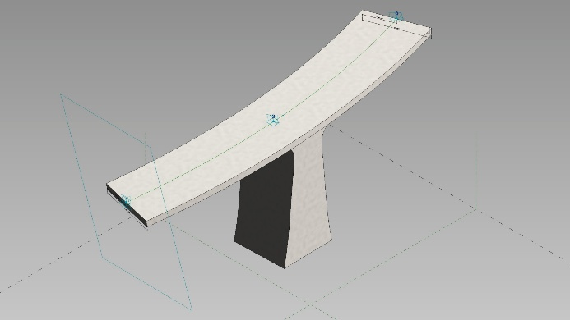
Figure 1: Bridge element (parametric family)
The deck width, pillar height and deck thickness are the parametric dimensions, which can be changed. Although the pillar height is automated by Dynamo, other dimensions can be put as per the user requirement.
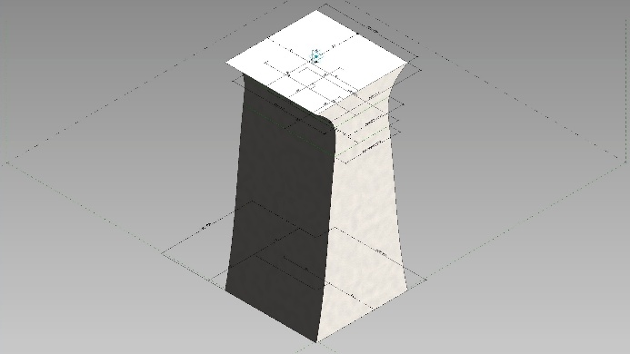
Figure 2: Pillar (sub-parametric family)
Parametric parameter | Family
width | Bridge element
thickness | Bridge element
Depth | Pillar
Table 1: List of parametric dimensions

Custom families
Two more custom families of Railing and streetlamp are created to use on the bridge.
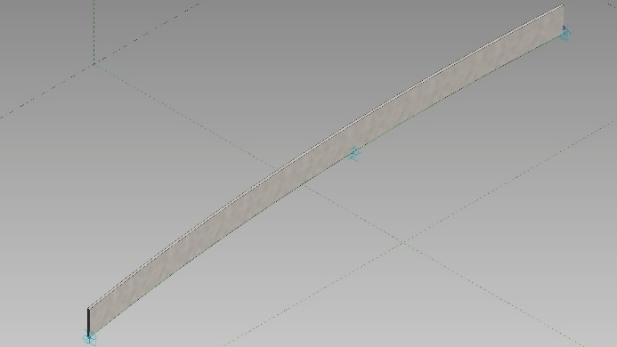
Figure 3: Railing
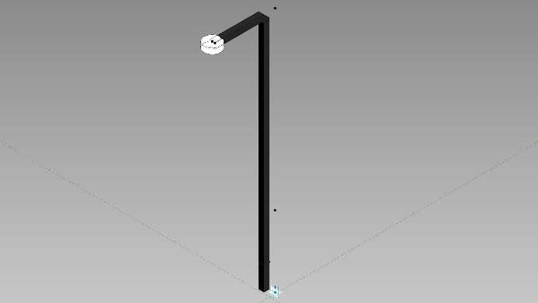
Figure 4: Streetlamp

Application of the Dynamo script
While creating the Dynamo script, splitting of the array of points on the spline was cumbersome as the array consisted of subarrays and the elemental array needed to have only three consecutive points. The scripting went through lot of trial and error to find the right combination of command blocks. The Dynamo script automates the process of applying the bridge element along a spline in a project.^{[2]} The user must select the spline and enter the number of elements to be used along the length of the spline. The Dynamo script also automates the height of the pillars starting from level 0 to the exact height of the bridge at that point. This helps to have different elevations or ramp on the bridge.
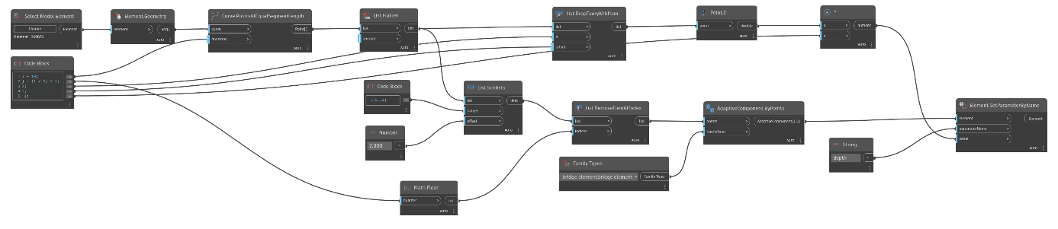
Figure 5: Dynamo script

Experience with Interface to DesiteMD

Exporting to IFC format
During working on exporting data from REVIT to Dynamo, the required project parameters were not being exported needed for 4D animation. Although with troubleshooting and going through the reference documents given in the exercises, all the data then was exported successfully.^{[4]}

Working on the project for 4D animation
After importing the IFC file, the custom selection sets were made to create the 4D animation of the construction of the bridge. In the “Activities” tab a schedule was created for it. Then the model was linked to the schedule. Despite of all the roadblocks we faced in the project, 4D simulation went smoothly.
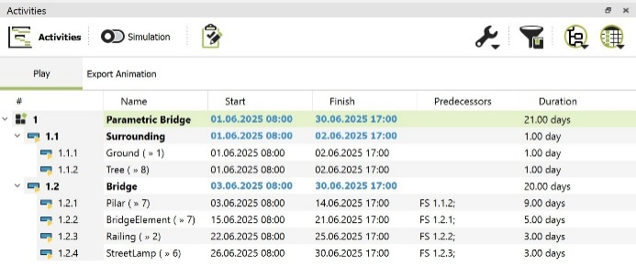
Figure 6: Time Schedule

BPMN process map
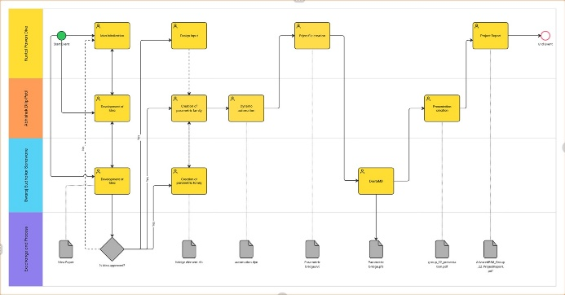
Figure 7: BPMN process map^{[7]}
All the team members collectively worked on the parametric family which was the main part of the project.
-Kuntal Pawan Dive had the initial idea. Moreover, the final Revit project file was created by importing the families and adding the surrounding. Lastly, the final report and the elevator pitch was done.
-Abhishek Dilip Patil created the Dynamo automation script and the presentation pdf.
-Swaraj Sudhakar Sonawane had major role in creating the Idea paper and the interfacing with DECITEmd and the 4D simulation.
All the individual work done by the team members were done independently to each other while also simultaneously helping with other’s tasks. Reason being having varying schedules throughout the semester. The flow of the work went well when it came to stitch together all the aspects of the project in the final stages.
Each team member’s contribution played a crucial role in completion of the project. The process flow can be seen in the above Figure 7: BPMN process map.

Conclusion
The project demonstrates the potential of BIM to create adaptable and efficient modular infrastructure through the parametric bridge. Instead of using conventional grid-based or linear spacing for pattern creation, we developed a custom pattern using a spline, allowing for greater flexibility in layout. Additionally, we utilized adaptive families to introduce both elevation changes and curvature into the bridge design—an approach that differed significantly from the standard methods used in the exercises.
The Dynamo and DECITEmd were successfully implemented along with REVIT being the base for modelling. Last but not least, the Teamwork was monumental throughout the project. A better understanding of families in REVIT has been gained through the project.^{[3]}

References
- Autodesk, 2023. Revit 2024 User Guide. [online] Available at: https://help.autodesk.com/view/RVT/2024/ENU/.

- Dynamo BIM, 2023. Dynamo Primer – Computational Design with Revit. [online] Available at: https://primer.dynamobim.org/.

- Eastman, C., Teicholz, P., Sacks, R. and Liston, K., 2011. BIM Handbook: A Guide to Building Information Modeling for Owners, Designers, Engineers, Contractors, and Facility Managers. 2nd ed. Hoboken, NJ: Wiley.

- Solibri, 2022. IFC File Structure and OpenBIM Interoperability. [online] Available at: https://www.solibri.com/resources/ifc-guide.

- BIM it, 2023. Create Your First Parametric Bridge in Revit using Dynamo [YouTube video]. Available at: https://www.youtube.com/watch?v=kLLnOSEGSTw.

- Learn Revit with Brett Casson, 2023. Revit Dynamo Parametric Bridge Design Tutorial [YouTube video]. Available at: https://www.youtube.com/watch?v=wy62cYaihBE.

- Miro, 2025. Online Collaborative Whiteboard Platform. [online] Available at: https://miro.com/.

- OpenAI, 2025. ChatGPT (v2.0, GPT-4-turbo). [online] Available at: https://chat.openai.com/.

Declaration

I hereby certify that I/we have prepared this report independently and without outside help, and that I/we have marked all passages taken verbatim from other authors, as well as those closely based on the ideas of other authors, and that I/we have cited the sources.
The thesis has not yet been published in the same or a similar form and has not yet been submitted to an examination authority.

Weimar, 16.07.2025

