**DNS Resolution:**

When a user enters "www.google.com" in their browser, the Domain Name System (DNS) translates this human-readable domain name into an IP address.

**TCP/IP Communication:**

The user's computer establishes a connection with Google's server using the Transmission Control Protocol/Internet Protocol (TCP/IP) suite, orchestrating packetization, addressing, transmission, routing, and reception of data.

**Securing Communication (HTTPS/SSL):**

The communication between the user's browser and Google's server is secured through HTTPS/SSL, which encrypts the data transmitted, ensures its integrity, and authenticates the server.

**Load Balancing:**

Traffic is efficiently managed using load balancers, distributing incoming requests across multiple Google servers to optimize resource utilization, ensure high availability, and prevent server overload.

**Application Server Processing:**

The request reaches Google's application servers, where it is processed. This involves handling business logic, generating responses, interacting with databases or external services, managing sessions, and error handling.

**Database Interaction:**

The application server communicates with Google's databases to retrieve or store data required to fulfil the user's request. This includes query processing, data retrieval, transaction management, indexing, and security measures.

**Response Generation and Delivery:**

After processing the request and retrieving necessary information, Google's servers generate a response. The response is formatted, rendered, and encrypted, then sent back through the network to the user's browser.

**Rendering the Webpage:**

The user's browser receives the encrypted response, decrypts it, and renders the content as a web page, allowing the user to interact with Google's search engine or other services.

This complex series of steps involves multiple layers of technology, from DNS resolution to secure communication, traffic management, server-side processing, database interaction, and finally, the presentation of the web content to the user, enabling seamless access to [www.google.com.](http://www.google.com.)

**Visual guide on requesting from a google server:**

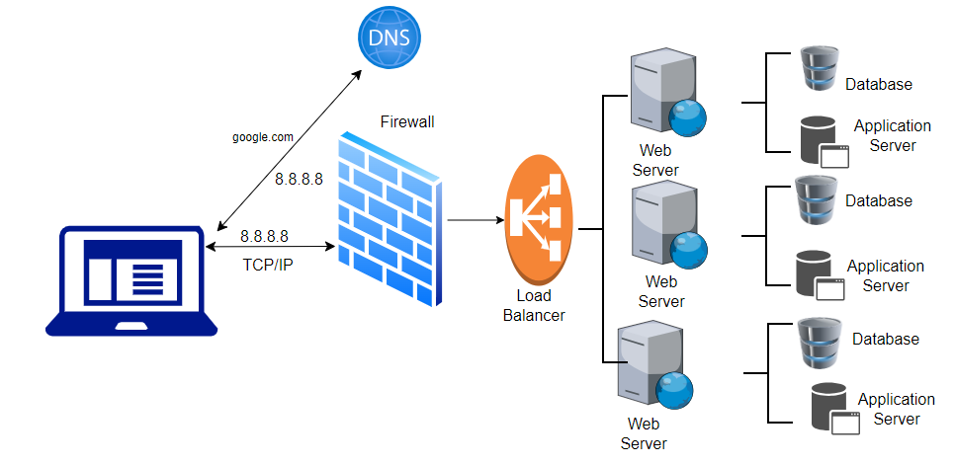

**Summary:**

When a client initiates a request to Google's server, a sequence of meticulously orchestrated steps unfolds. Initially, the client seeks the server's location through DNS resolution, translating the domain name to an IP address. Subsequently, a TCP connection is established, ensuring reliable data transmission. If HTTPS is employed, an SSL/TLS handshake occurs, securing the channel. The client then dispatches an HTTP request to the server, specifying the desired content. On receipt, Google's server processes the request, retrieves the requested data, and formulates an HTTP response. This response, comprising the requested content, headers, and status information, is sent back to the client. Upon reception, the client interprets the data and renders it accordingly, culminating in the user's interaction with the retrieved content. This tightly choreographed series of interactions enables seamless data retrieval and content presentation between the client and Google's server.