GCC/G++

CLANG

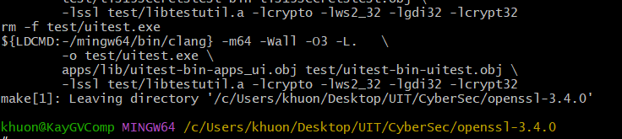

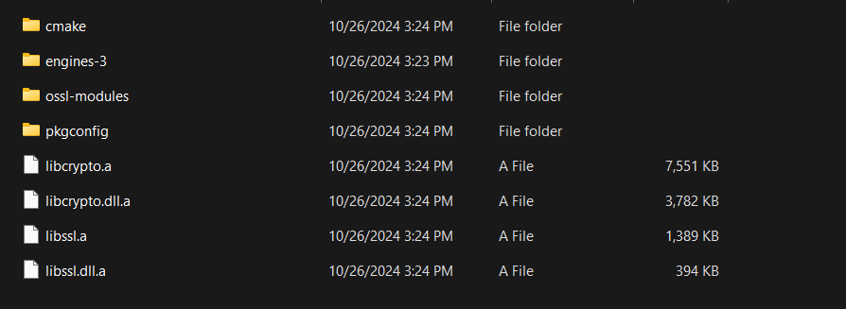

MSVC



