Game Project 2023

**Frogger**

Author Kay Gabriel

Date Jan 20th, 2023

Copyright Information

Version 0.1(draft) October 10, 2005

By Mark Baldwin

Baldwin Consulting

http://baldwinconsulting.org

The Game Design Document (GDD) it the blueprint from which a computer or video game is to be built. As such, every single detail necessary to build the game must be addressed in the document (or support documents). If it’s not in the document, then it probably won’t be in the game.

Below you will find an outline for a generic Game Design Document. The problem is that no generic GDD will be able to address all the various genres for which a game may be created. For example, consider the games PacMan, SimCity and Doom. All three games required detailed design documents, but if you think about it, those documents would be entirely different! As such, when using the outline below you will find sections that will be totally meaningless to your game. But also, there will be sections that your GDD requires to describe the game. Just because it’s not in my outline, it doesn’t mean that it doesn’t belong.

The GDD is a reference document. Members of the development team will constantly be using the document to find specific information for their specific needs. Consider the size such a document may grow to in order to document every piece of the game. We don’t want the GDD to cause information overload and then become a prop under somebody’s wobbly desk. As such it is important that you organize and format the document to make it easy to use. Also note that some of these sections might not appear in the GDD itself but instead would appear in supplemental documents such as an Art Bible or Test Plan. This helps make the overall document more manageable and readable.

One last comment, a game design document is meant to be a living document. Just as when the artist changes the design of his painting every time he takes his brush to the canvas, a computer or video game evolves as code and art are created. The GDD then is the communication tool from which all the members of the team can follow that evolution.

**Document Revision history:**

|  |  |  |  |
| --- | --- | --- | --- |
| Version | Date | Author(s) | Changes |
| 0.2 | January 16, 2013 | Emile Cormier |  |
| 0.3 | January 05, 2016 | David Burchill |  |
| 0.4 | January 20, 2023 | Kay Gabriel | First iteration of design document |
| 0.5 | April 12th, 2023 | Kay Gabriel | Final iteration of design document |
|  |  |  |  |
|  |  |  |  |
|  |  |  |  |

*(Use word’s “update table of contents” to generate / regenerate a table of contents. )*

Table of Contents

1. Section I - Game Overview 7

1.1. Game Concept 7

1.2. Design History 7

1.3. Feature Set 7

1.4. Genre 7

1.5. Target Audience 7

1.6. Game Flow Summary 7

1.7. Look and Feel 7

1.8. Project Scope 8

1.8.1. Number of locations 8

1.8.2. Number of levels 8

1.8.3. Number of NPC’s 8

1.8.4. Number of weapons 8

2. Section II - Gameplay and Mechanics 8

2.1. Gameplay 8

2.1.1. Game Progression 8

2.1.2. Mission/challenge Structure 9

2.1.3. Puzzle Structure 9

2.1.4. Objectives – What are the objectives of the game? 9

2.1.5. Play Flow – How does the game flow for the game player 9

2.2. Mechanics 9

2.2.1. Physics 10

2.2.2. Movement 10

2.2.3. Objects 10

2.2.4. Actions 10

2.2.5. Combat 11

2.2.6. Economy 11

2.3. Screen Flow 11

2.3.1. Screen Flow Chart 11

2.3.2. Screen Descriptions 11

2.4. Game Options 11

2.5. Replaying and Saving 11

2.6. Cheats and Easter Eggs 11

3. Section III – Story, Setting and Character 12

3.1. Story and Narrative 12

3.1.1. Back story 12

3.1.2. Plot Elements 12

3.1.3. Game Progression 12

3.1.4. License Considerations 12

3.2. Game World 12

3.2.1. General look and feel of world 12

3.2.2. Area #1 12

3.2.3. Area #2 13

3.2.4. Area #3 13

3.2.5. Area #4 13

3.3. Characters 14

3.3.1. Character #1 14

3.3.2. Character #2 15

3.3.3. Character #3 16

3.3.4. Character #4 16

4. Section IV – Levels 17

4.1. Level #1 17

4.1.1. Synopsis 17

4.1.2. Introductory Material (Cut scene? Mission briefing?) 17

4.1.3. Objectives 17

4.1.4. Physical Description 18

4.1.5. Map 18

4.1.6. Critical Path 18

4.1.7. Encounters 18

4.1.8. Level Walkthrough 18

4.1.9. Closing Material 18

4.2. Level #2 18

4.3. Training Level 18

5. Section V - Interface 18

5.1. Visual System 18

5.1.1. HUD - What controls 18

5.1.2. Menus 19

5.1.3. Rendering System 19

5.1.4. Camera 19

5.1.5. Lighting Models 19

5.2. Control System 19

5.3. Audio 19

5.4. Music 19

5.5. Sound Effects 19

5.6. Help System 19

6. Section VI - Artificial Intelligence 19

6.1. Opponent AI 19

6.2. Enemy AI 20

6.3. Non-combat Characters 20

6.4. Friendly Characters 20

6.5. Support AI 20

6.5.1. Player and Collision Detection 20

6.5.2. Pathfinding 20

7. Section VII – Technical 20

7.1. Target Hardware and operating system 20

7.2. Supported game controllers and peripherals 21

8. Section VIII – Game Art 21

8.1. Concept Art 21

8.2. Style Guides 21

8.3. Characters 21

8.4. Environments 22

8.5. Equipment 22

8.6. Cut scenes 22

8.7. Miscellaneous 22

# Section I - Game Overview

## Game Concept

Frogger is a retro action game which is played on one map, the complete map is seen to the player from a top-down view.   
The player starts from the bottom of the level in a safe zone and must cross a busy four lane road where cars, trucks and racing cars move left to right and right to left.  
The player will reach a save zone after the road where it is possible to take a breath, but a snake is moving in that zone, and you must move as quick as possible.  
The second part of the game is a river filled with turtles, crocodiles, and logs. The player must jump on the logs or the turtles to get over the river and must avoid the crocodiles and the diving turtles.

## Design History

All designs and sprites were found on the internet.

## Feature Set

The game will have multiple sound sources including a death sound, hop sound, jumped in river sound and a background music.

## Genre

Frogger is a retro action game from the 80s published by Konami on the Atari 5200.

## Target Audience

This game has an age restriction of 6+ due to the death scenes of the main character.

## Game Flow Summary

Starting from the bottom of the map / level the player must cross a busy road and avoid any danger. Getting hit by any vehicle on the road will result in a loss of life and a reset to the starting point for the player.   
The same happens in the safe zone before the river if the player gets hit by the snake.  
On the river the player must jump on logs or the swimming turtles to get into the finish line at the top of the level, the player must avoid jumping on the crocodile and the diving turtles to not get reset to the starting point of the game.

## Look and Feel

The look of the game is 80s retro, colors are intense, and the music is throwing back the player into time.  
The feel of the game is old-school, only a few buttons are needed to play the game.

## Project Scope

* Write the Design Document.
* Implement a menu the user can use.
* Get the application open the level.
* Test pause menu and implement the correct labels.
* Spawn the player model at the correct location
* Spawn the first enemies in the right places.
* Test death system
* Test collision on objects and sounds.
* Implement the next enemy and test collision and sounds.
* Implement objects and enemies into the last area and test sounds.
* Implement pink frog and test Collison.
* Test scoring system.
* Overall application test.

### Number of locations

Frogger has two locations and is always played on the same map.  
Location one is the four-lane road filled with trucks, cars, and racing cars.  
Location two is the dangerous four-lane river filled with logs, crocodiles, and turtles.

### Number of levels

The game has one level which is split into two locations with different dangers.

### Number of NPC’s

The game has one NPC, this NPC is a pink frog spawning on a log at the river location.  
This NPC grants the player bonus points.

### Number of weapons

The game has no weapons.

# Section II - Gameplay and Mechanics

## Gameplay

### Game Progression

The player will progress easily if he/she understands how the opponents react and move in the world. It seems to be easy, but it is not going to be.   
Crossing the road is the first milestone to beat, cars traveling in all directions and in different spacing between each other will make it hard to find the perfect timing to move forward.  
The first milestone is reached when the player gets to the safe zone but be aware of the snake which is not your friend, move quickly and do not spend too much time thinking.   
The next milestone is going to be the river, here the player faces other challenges. The first one is the crocodiles swimming in the river do not jump on them or you get reset to the beginning of the game. Other dangers are the turtles, some swim above the water level, others are just diving, and you must avoid these creatures while diving.  
You win the game when you arrive at the finish line better known as home.

### Mission/challenge Structure

The mission is to get home without getting crushed, eaten, or drowning.

Challenges are all over the place, it starts with cars, trucks, and racing cars. Then you have the evil snake which is lurking around the safe area after the road.   
The next challenge is crossing the river filled with crocodiles, turtles, and drowning points if the player misses logs or jumps on the diving turtles.  
A pink frog can spawn randomly on a log and saving it gets the player some extra points.  
These are not all challenges the player must face, a timer is creating some pressure and the player must hurry to get home and gain points.  
Every run of a player has three to seven lives (determined later) if the player loses all their lives the game is over.

### Puzzle Structure

### Objectives – What are the objectives of the game?

The main objective is to get the frog home safely without losing all their lives.  
On the way to safety the player can save a pink frog to gain even more points for the high score, this is optional, but can motivate to get the best result each run.

### Play Flow – How does the game flow for the game player

## Mechanics

What are the rules to the game, both implicit and explicit. This is the model of the universe that the game works under. Think of it as a simulation of a world, how do all the pieces interact? This actually can be a very large section.  
  
The rules of this game are easy to understand:  
- Get over the road without getting hit by cars, trucks or racing cars.  
- Do not get eaten by the snake patrolling on the riverfront.  
- Jump on floating turtles and wooden logs and try to save Lily the pink frog for bonus points.  
- Do not jump on the crocodile or on the diving turtles.  
- Getting hit by vehicles or jumping on crocodiles or on diving turtles result in a loss of lives.  
- Losing all lives results in a game over end screen.

Cars, trucks, and racing cars are moving in predefined directions but not all are going in the same direction, some go from left to right, other lanes go from right to left.   
The same applies to the river; some of the turtles, logs and crocodiles' lanes are going in the other direction so it is important to understand the pattern.

The player starts with multiple lives (determined later) and must get home multiple times to win the game and get bonus points.  
It is like a repeating universe until all home cubes are filled with frogs or until the player loses all their lives.

### Physics

### Movement

#### General Movement

Movement in frogger is simple, the player can move up, down, left, and right using the arrow keys or W, A, S, D.

#### Other Movement

There is no other movement to this game.

### Objects

#### Picking Up Objects

The player can pick up a pink frog which spawns randomly on one of the logs at the river, picking up this npc grants bonus points if the player manages to get to the finish line.

#### Moving Objects

The game consists of multiple moving objects such as cars, trucks, racing cars, wood logs, turtles, crocodiles. All objects move at a specified speed and move in specified directions.  
Some of the objects move from right to left and others in the opposite direction.

### Actions

Enter: To accept the selected option

W or up arrow: moves the character upwards.

S or down arrow moves the player downwards.

A or left arrow: moves the player to the left.

D or right arrow: moves the player to the right.

ESC or P: Opens the pause menu.

#### Picking Up, Carrying and Dropping

Picking up the pink frog NPC happens automatically so the user does not have to worry about missing the bonus points.

#### Talking

No talking involved.

#### Reading

No reading involved.

### Combat

### Economy

In Frogger no economy is implemented.

## Screen Flow

### Screen Flow Chart

This game has two different screens the user can interact with.   
The first screen is the main menu and the other one is the pause screen if the user wants to take a quick break from playing.

### Screen Descriptions

The main menu lets the player see a title screen with music and the user can choose to play or quit the application.  
The pause menu purpose is to pause the game so the user can take a break or quit the application if not needed anymore.

#### Main Menu Screen

The main menu consists of two different labels, the first label will be to start the game, the second option is to quit and close the application.

#### Pause Screen

The pause screen consists of two labels, the first label will be the continue option for the player to resume the paused game anytime.  
The second option is quit, and this is to close the application.

#### Etc.

## Game Options

There is no option menu to change settings in the game.

## Replaying and Saving

The user can replay and restart the game as often as wanted.  
No saving is implemented.

## Cheats and Easter Eggs

# Section III – Story, Setting and Character

## Story and Narrative

In Frogger the user takes control of a frog called Frogger. This anthropomorphic frog must get home before the time runs out or loses all lives, on the way home Frogger must save his girlfriend Lily she is represented by a pink frog.

### Back story

Frogger finds himself away from home on a busy and extremely dangerous road, he needs to get back home and find his girlfriend on the way.  
The road is one of many dangers you must encounter, the frog eating snakes are waiting for you, the last danger is the river take care of Frogger get his girlfriend and get home safely.

### Plot Elements

The plot is that Frogger finds himself near a dangerous road. Getting him over it will make him face the next challenge, a river with new dangers and his girlfriend Lily trapped on a log swimming in the river.

### Game Progression

First area: This is the starting area at the bottom of the screen here the player is safe until the first move.  
 Second area: The second and first wide area is a four-lane road where cars, trucks and other vehicles move from right to left and left to right.  
 Third area: This area resembles the first, but is not safe for long, a frog eating snake is waiting for you.

Fourth area: This area is a river with swimming logs, turtles, and crocodiles also Froggers girlfriend trapped on one of the logs.  
 Fifth area: this is the final area of the game and the last milestone in the game, when the player arrives here

### License Considerations

Frogger is a game from Konami, due to the nature of this project I do not need licenses.

etc.

## Game World

### General look and feel of world

The world is in a retro neon style, it consists of five areas in total.  
The player will feel nostalgic while playing due to the art style and the look of the world.  
The game has two specific areas, an urban style road and a natural river.

### Area #1

#### General Description

Area one is a busy four-lane road with dangerous vehicles such as cars, trucks, and racing cars. You must avoid contact with these vehicles.

#### Physical Characteristics

#### Levels that use area

Only one level uses this area, the game consists of one level with this area implemented in it.

#### Connections to other areas

This area is connected to the starting area and the riverfront area.

### Area #2

***3.2.3.1. General Description***  
Area two is a tiny area that is connected to the first and third area of the game. In this area, the player has only a few seconds to move on because a frog eating snake is patrolling it.

***3.2.3.2. Physical Characteristics***

***3.2.3.3. Levels that use area***

Only one level uses this area, the game consists of one level with this area implemented in it.

***3.2.3.4 Connections to other areas***

This area connects with the first (road) and third (river) area of the level

### Area #3

#### General Description

Area three is the four-lane river on the top of the level, this area is filled with animals such as crocodiles and turtles in the same area you will notice large logs of wood swimming in the river which you need to jump on to win the game.

#### Physical Characteristics

#### Levels that use area

Only one level uses this area, the game consists of one level with this area implemented in it.

#### Connections to other areas

This area relates to the second (riverfront) and the last (finish) area of the game.

### Area #4

#### General Description

The last area is the finish line or Froggers home. Arriving at this area the player wins and gets points and if he manages to secure Lily, he gets a bonus of points.   
Sometimes a fly can spawn in one of the cubes if the user manages to pick it up a points bonus is granted.  
The finish has multiple little cubes where the player must jump into to win the game.

#### Physical Characteristics

#### Levels that use area

Only one level uses this area, the game consists of one level with this area implemented on the top of the level.

#### Connections to other areas

The home or finish line is connected to the river area. The player must get into one of the cubes to finish the game.

## Characters

### Character #1

#### Back story

Frogger is the main character of the game, he finds himself on a busy road without knowing how he came to that place. The only thing he knows is that he needs to get over the road and the river to get home safely with his girlfriend.  
He has a girlfriend who he needs to rescue in the river area.

#### Personality

Frogger is a happy, courageous frog who loves adventures, but he always wants to protect his girlfriend from any dangers in the world.

#### Look

##### Physical characteristics

Frogger is a green anthropomorphic frog which means he has feelings or other characteristics like these.

##### Animations

Frogger has multiple animations depending on the movement the user is inputting.  
Move up, move down, move left, move right all these actions have their own respective animations such as its own death animation.

#### Special Abilities

No special abilities are implemented.

#### Relevance to game story

He is the main character of the game and the only character the player is using.

He is important and must rescue his girlfriend and get them home safely.

#### Relationship to other characters

Frogger is in a relationship with Lily the pink frog.

#### Statistics

No special statistics are in the game.

### Character #2

#### Back Story

Lily is froggers girlfriend just like him she wakes up in a dangerous situation. She finds herself injured on a log on the river she cannot get home without the help of her boyfriend Frogger.

#### Personality

Lily the pink frog is a tuff girl who wants to prove herself at any time, but she knows when something gets out of hands, and she needs help.

#### Look

##### Physical characteristics

Just like Frogger Lily is an anthropomorphic frog she defers from others because she is pink and sparkles.

##### Animations

Unlike Frogger she has no special animations, only one animation is given to her.

#### Special Abilities

No special abilities are implemented.

#### Relevance to game story

Lily found herself injured and needs help from the player as soon as possible, saving her grants the player bonus points.

#### Relationship to other characters

She is the main character's girlfriend.

#### Statistics

No special statistics are in the game.

### Character #3

#### Back Story

Charlie the crocodile is one of the main villains, he always hated the frogs and wants them gone forever.   
He hates Frogger because the frog has destroyed one of family items while playing at the riverfront with his friends.

#### Personality

He is aggressive and will eat Frogger whenever he can.

#### Look

##### Physical characteristics

The crocodile is big, massive and has a brown color, and he has sharp teeth.

##### Animations

Two different animations are implemented in the game.  
The swimming animation shows the whole character model while he floats in the river.  
The lurking animation is shown when Charlie is waiting in one of the safe cubes at the end.

#### Special Abilities

The crocodile will eat the frog when jumped on him.

#### Relevance to game story

The crocodile is relevant to the game story due to the past of him and Frogger.

#### Relationship to other characters

Charlie has no relationship with any of the other characters.

#### Statistics

No special statistics are in the game.

### Character #4

#### Back Story

Snape the snake is the second villain in the game, he wants no one to be in his area so he patrols along the riverfront.

#### Personality

The snake is aggressive and sees anybody as a threat and will attack if in the way.

#### Look

##### Physical characteristics

The snake is green and is slightly bigger than the frog.

##### Animations

The snake has three different animations which are played repeatedly while patrolling the area.

#### Special abilities

The snake eats the frog if standing in its way.

#### Relevance to game story

It has no real relevance to the game's story, but it is a challenge for the player to keep going and not waste time.

#### Relationship to other characters

No relationship to other characters in the game.

#### Statistics

No special statistics are in the game.

# Section IV – Levels

## Level #1

### Synopsis

### Introductory Material (Cut scene? Mission briefing?)

No cut scene or Mission briefing is given to the user.   
The game is self-explanatory to every user.

### Objectives

The game has multiple objectives.  
The first objective Is to cross the road without being crushed to death by any vehicle.  
The second objective is to survive the attack of the snake waiting for the user in the riverfront zone.  
The third objective has two objectives, one is to get over the river and get home safely, but to get the best outcome (points) the user must save the pink frog.

### Physical Description

The whole level is split into multiple areas, all these areas can be seen by the player the complete time.  
The road, the riverfront, the river and even the safety cubes have dangers to avoid.

### Map

### Critical Path

The user has no set path to take to succeed, every time the game is played you have the choice to choose which way you want to go.

### Encounters

While playing the level the user will encounter multiple dangers such as cars, trucks, racing cars, these dangers are encountered on the road area.  
A snake is encountered at the riverfront, this snake is patrolling this area and will attack the player when in sight.  
A crocodile, and turtles can be encountered in the river area, the crocodile is swimming in the river or is waiting at the safety cubes at the end. Turtles can be jumped on only if they float on the river.

Another important encounter is the pink frog named Lily, who picks her up and gets bonus points.  
Touching any other encounters results in a loss of life.

### Level Walkthrough

### Closing Material

## Level #2

etc.

## Training Level

# Section V - Interface

## Visual System

### HUD - What controls

The HUD has multiple elements for the use.  
The player can see a timer running down at the bottom right of the screen.  
A High score is displayed on the top of the window.  
The lives of the players are displayed at the bottom left of the screen.

### Menus

The user will encounter two different menus, one of the menus is the main menu which is displayed at the start of the game and has two options “Play” and “Quit”.  
The other menu is the paus menu, this menu has two option “Continue” and “Quit”

### Rendering System

### Camera

The game is played from a top-down view and the camera does not change its position throughout the game.

### Lighting Models

## Control System

The main menu can be controlled with the “W” and “S” to move up and down and to select one of the options the user must use the “E” key.

The pause menu is displayed if the user presses the “ESC” or “P” key and can be controlled with the same buttons as the main menu.

## Audio

## Music

The game has different music or audio elements.  
The main menu has retro style music, and the main game has its own 80s action game music theme.

## Sound Effects

The game has multiple sound Effects depending on the action happening.  
Getting crushed by any vehicle will get its own sound (crushing sound/death sound)  
Getting eaten by the snake or crocodile will start another different death sound.

## Help System

No help system implemented.

# Section VI - Artificial Intelligence

## Opponent AI

Active enemies in the game are the vehicles on the road, they do not attack the player on sight, but they do not slow down or stop if the player is near them, getting crushed by them concludes in a loss of life.  
  
Another active enemy is the Snake in the riverfront zone it is patrolling this area and will eat the frog if it is in this way.  
  
The last enemy is the crocodile, it is swimming in the river and can float, swim or wait in the finish area. Do not jump on it or you will be eaten.

## Enemy AI

## Non-combat Characters

The game includes two non-combat characters, one of them is the pink frog called Lily she is Froggers girlfriend and needs him to get back home.

The other non-combat characters are swimming turtles, they do not harm you if they float on the river.

## Friendly Characters

The game has two friendly characters.  
The pink frog called Lily is the friendliest character of the game, she needs Froggers help to get home pick her up and bring her to safety.  
The turtles are also friendly characters only if they are floating on the river the player can jump on them.

## Support AI

### Player and Collision Detection

The collision is going to be calculated within a custom-made function.   
It is calculated if the player is crushed by any vehicle, has been eaten by the crocodile or snake or is just drowning to a missed jump in the river.

### Pathfinding

The player has unlimited options to reach the top of the level.   
No specific pathfinding needed.

# Section VII – Technical

## Target Hardware and operating system

Windows:

● Windows 11 (Desktop)

● Windows 10

● Windows 8

● Windows 7

Mac OS X:

● Intel-based Mac running Mac OS X 10.8.3+, 10.9+

## Supported game controllers and peripherals

No game controllers are usable in this game only the keyboard is supported.

# Section VIII – Game Art

Only show concept art here (rough sketches)

## Concept Art

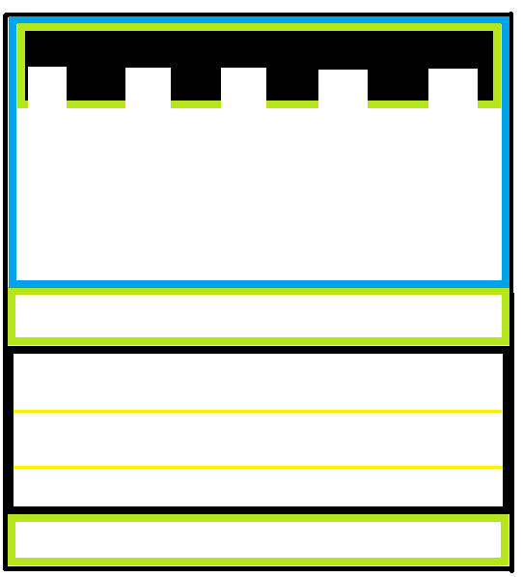

## Style Guides

## Characters

Frogger:



Pink frog (Lily):



Snake:   


Crocodile:   
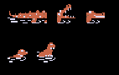

Turtles:



## Environments

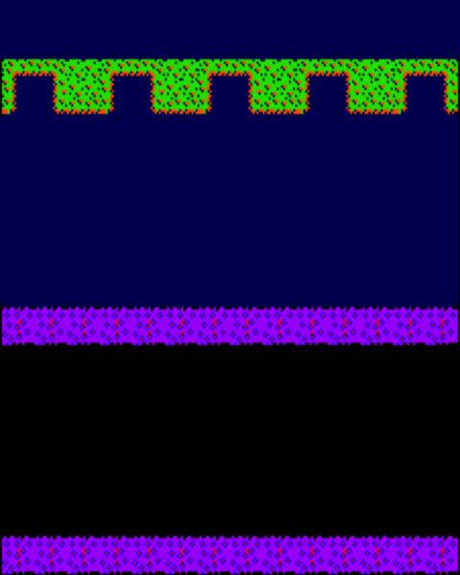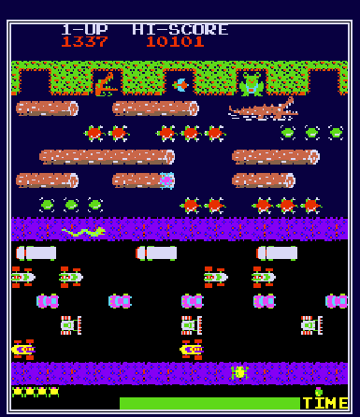

## Equipment

## Cut scenes

## Miscellaneous

Timer:



Wooden log:  
