[WORK IN PROGRESS]

The Expected Value

of an

NBA Draft Pick

Kay Zhang

Dec 2020

**Abstract**

This paper aims to use historical data to find the value of an NBA Draft pick given the draft position.

1. **Introduction**

The game of basketball is forever changing. The modern draft format (lottery) has existed since 1989. I have pulled 16 draft classes (1989 to 2005) as my sample set.

To measure the “value” of each player, I am using a statistic I found on BoxScoreGeeks.com a while back; these were referred to as (Prime Wins). I will use a player’s **five** “best” seasons looking at two different measures: Value Over Replacement Player (**VORP**) and Win Shares (**WS**).

1. **Analysis**

**VORP**:

Prime VORP = (-0.19416939651282972 * Draft Position) + 9.163119718162564

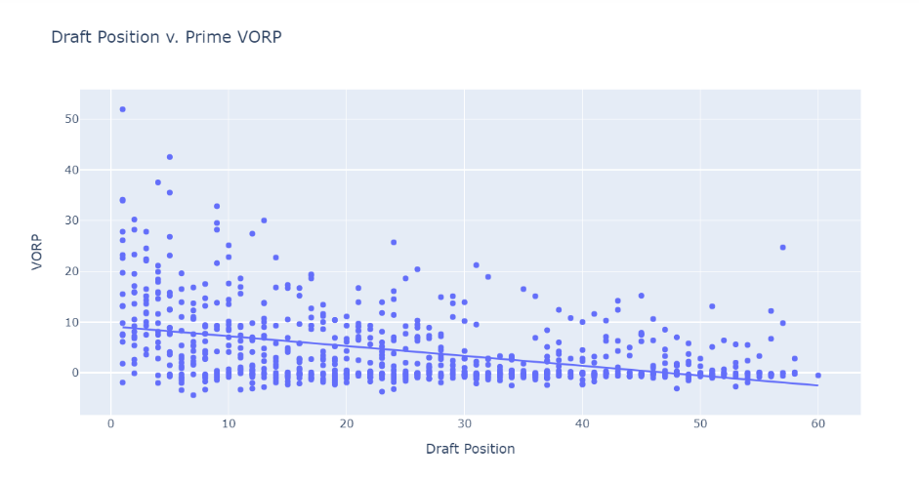  
**WS**:

Prime WS = (-0.5052076170548425 * Draft Position) + 27.62069701702975

Prime WS = (-0.5044054333270456 * Draft Position) + 27.40692594880401

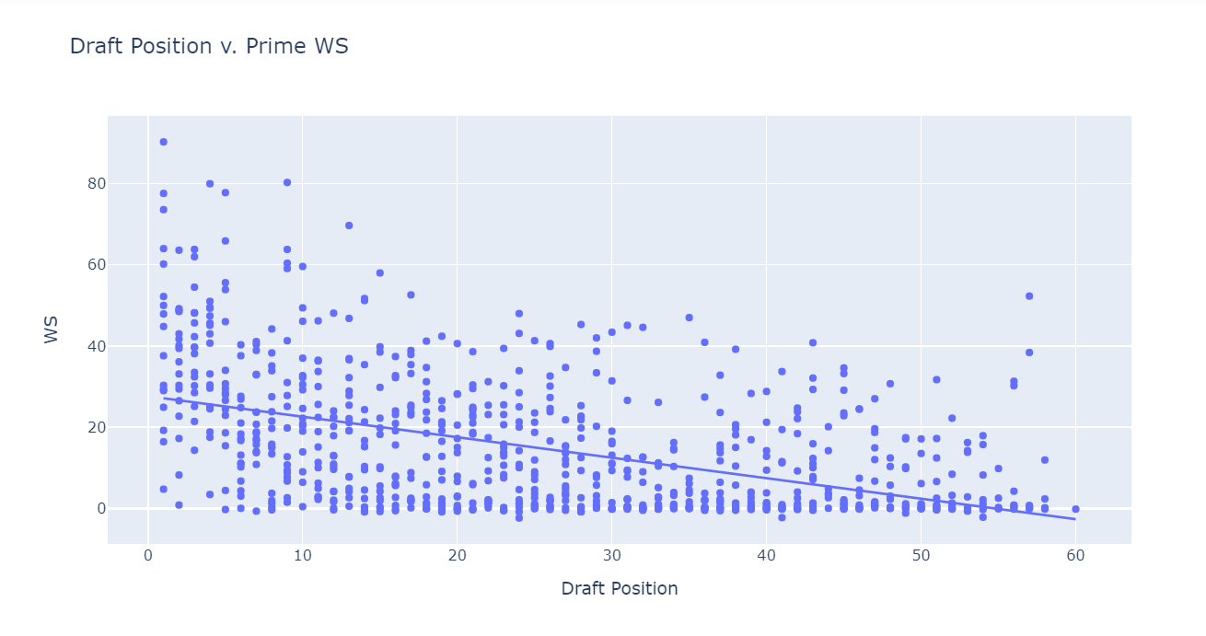

The strongest trendline that we can apply to our data is an inverse logarithmic relationship. The resulting equation indicates that the difference in draft position earlier on is relatively more impactful on career performance than differences in draft position later in the selection process.

If we think about the draft, this should not be too surprising. There are many hours that go in to scouting, and many prospects are on NBA radars years before they come in to draft night. For a highly productive player to slip into the later rounds, multiple teams and organizations would have to misjudge a prospect’s future performance.

This certainly is not to say that if a team is outside the lottery, the draft pick is worthless, quite the opposite in fact.

1. **Limitations**

Because we are not adjusting for pace/minutes played, we cannot discount the fact that higher draft picks will likely have greater investment placed into them and will therefore get more minutes and have higher VORP/WS. Higher draft picks also get paid more allowing the players to invest in themselves more.

We also must acknowledge that higher draft picks, by design, are supposed to go to worse teams. Again, allowing higher draft picks to play more minutes and establish themselves as high impact players early on in their careers.

From a minutes’ perspective, you could argue what is the point of drafting a player, if not to play them minutes?

1. **Sources**

Kaggle: Player Data

Basketball Reference: Draft Data

1. **Considerations**

* Draft Pick forfeiture: shift remaining draftees up one position if draft had skipped 29 (ex: 2001, 2002 drafts classes)
* Players that were drafted but never played: treat as a 0
* Players that played less than 5 seasons: treat missing seasons as 0
* Mid-Season Trades: lead to multiple rows for a single season & therefore leads to potential for double counting (removed duplicate rows that split up a single season)
* There are 2 players named “Michael Smith”: Rename 2nd one to “Michael Smith2”