Assignment Code: C.L.P00022

Assignment Name: Manage student

Student Name: Nguyễn Quốc Hưng

Time/Date: 23h05, 22/11/2019

**Approach**

We use Struct to store four values: student name, student code and student birthday, student point. We sort students information ascending order by students name then save it to a file. Then using a loop to find the student have the name you want then print the student's information.

**Flowchart**

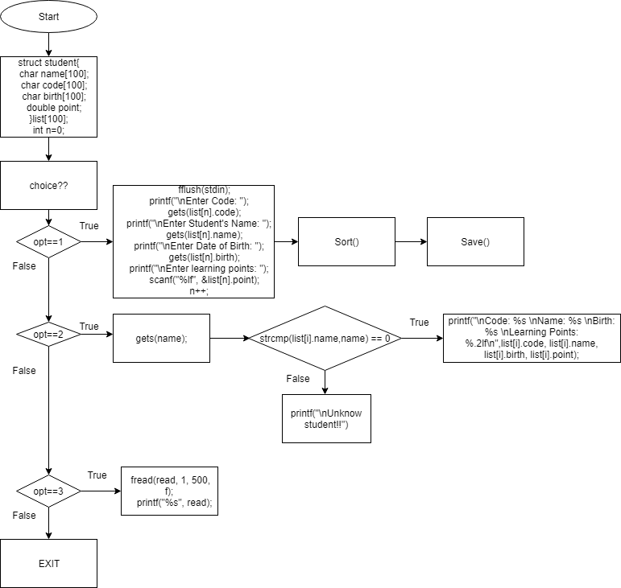

**Source code**

#include <stdio.h>

#include <string.h>

struct student{

char name[100];

char code[100];

char birth[100];

double point;

}list[100];

int n=0;

void AddStudent(){

fflush(stdin);

printf("\nEnter Code: ");

gets(list[n].code);

printf("\nEnter Student's Name: ");

gets(list[n].name);

printf("\nEnter Date of Birth: ");

gets(list[n].birth);

printf("\nEnter learning points: ");

scanf("%lf", &list[n].point);

n++;

}

void FindStudent(){

fflush(stdin);

int check=0;

char name[100];

printf("\nEnter student name that you want to find : ");

gets(name);

for (int i=0;i<n;i++)

if (strcmp(list[i].name,name) == 0){

printf("\nCode: %s \nName: %s \nBirth: %s \nLearning Points: %.2lf\n",list[i].code, list[i].name, list[i].birth, list[i].point);

check=1;

}

if (check==0) printf("\nUnknow student!!");

}

void Sort(){

struct student temp;

for (int i=0; i<n; i++){

for (int j=i+1; j<n; j++){

if (strcmp(list[i].name, list[j].name) == 1){

temp=list[i];

list[i]=list[j];

list[j]=temp;

}

}

}

}

void studentlist(){

char read[400];

FILE *f = fopen("Student.txt","r");

fread(read, 1, 500, f);

printf("%s", read);

fclose(f);

}

void Save(){

FILE *f=fopen("Student.txt","w+");

for (int i=0; i<n; i++){

fprintf(f,"\nCode: %s \nName: %s \nBirth: %s \nLearning Points: %.2lf\n",list[i].code, list[i].name, list[i].birth, list[i].point);

}

fclose(f);

}

int main(){

int choice;

double point;

FILE* f;

printf("\nWelcome to Students Management Program");

printf("\n1-Add Students");

printf("\n2-Look upStudents");

printf("\n3-Display the student list");

printf("\n4-Exit");

do{

printf("\nWhich option do you want\n");

scanf("%d", &choice);

switch(choice)

{

case 1:AddStudent();

Sort();

Save();

break;

case 2: FindStudent(); break;

case 3: studentlist(); break;

case 4: printf("Exited!!"); break;

}

}

while (choice!=4);

}

**Result**

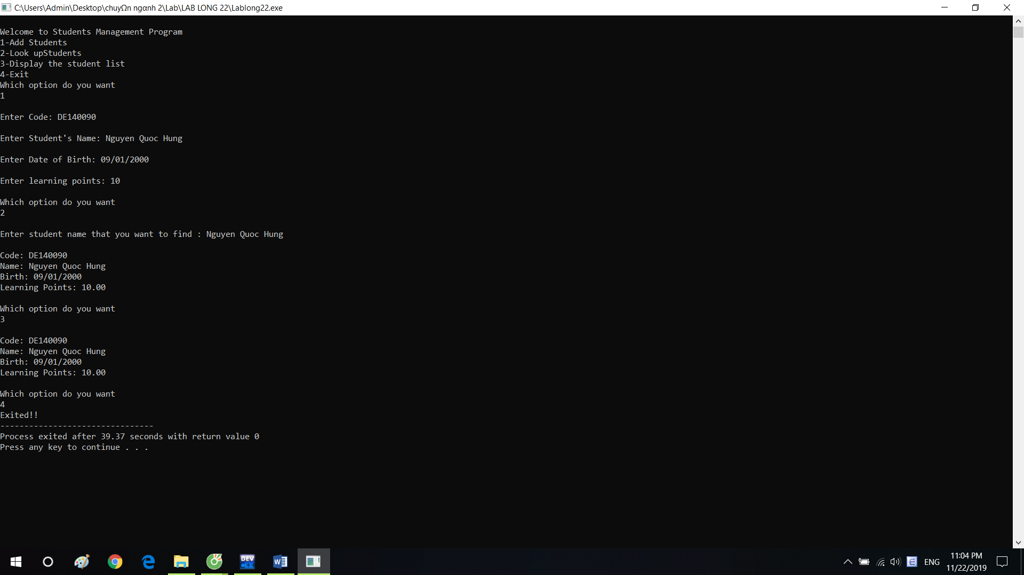

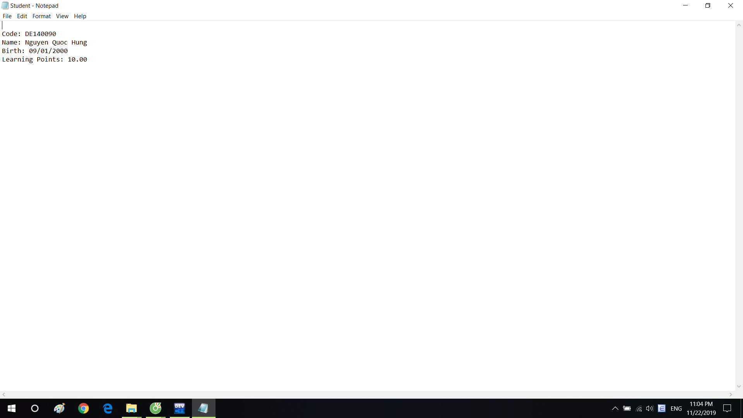

**Reference**