Functional Requirement Document
IAS Dray Management

Document status: open

Author: Sign: Kaviyarasan S
Kaviyarasan Sadasivam

Accepted by: Sign: Ramesh Raja
Development Team

Client Name: Sign:

Revision History

Date | Version | Author | Changes/Comments
05/07/2018 | V 1.0 | Kaviyarasan

Contents
1. INTRODUCTION 3
1.1 Purpose 3
2. List of Developments 3
3. User Types 3
4. Project Overview 3
5. Project Main Screen 3
6. List of pages 4

6.1 Login Page 4
6.2 Dashboard 4
6.3 Doc Receipt Upload 5
6.4 Shipment Upload 5
6.5 Shipment Creation Page 5
6.6 Mail Inbox and Outbox Page 6

INTRODUCTION

Purpose

The functional requirements document (FRD) is a formal statement of an application’s functional requirements. It serves the same purpose as a contract. The developers agree to provide the capabilities specified. The client agrees to find the product satisfactory if it provides the capabilities specified in the FRD.

List of Developments

Below mentioned are the list of development pages. Date for Demo1, Demo2, Demo3 are 14/07/2018,21/07/2018,287/07/2018 respectively. The complete project must be made to IAS Dray Management on or before 30/09/2018

User Types
- Admin Users(Kevin)
- IAS Users

Project Overview

- The dashboard page list all the shipments.
- User can able to create new shipment and comments for shipment.
- The user can also add dock receipt.
- Additionally, Only Admin user can upload shipment details and send mail.

Project Main Screen

Home Page

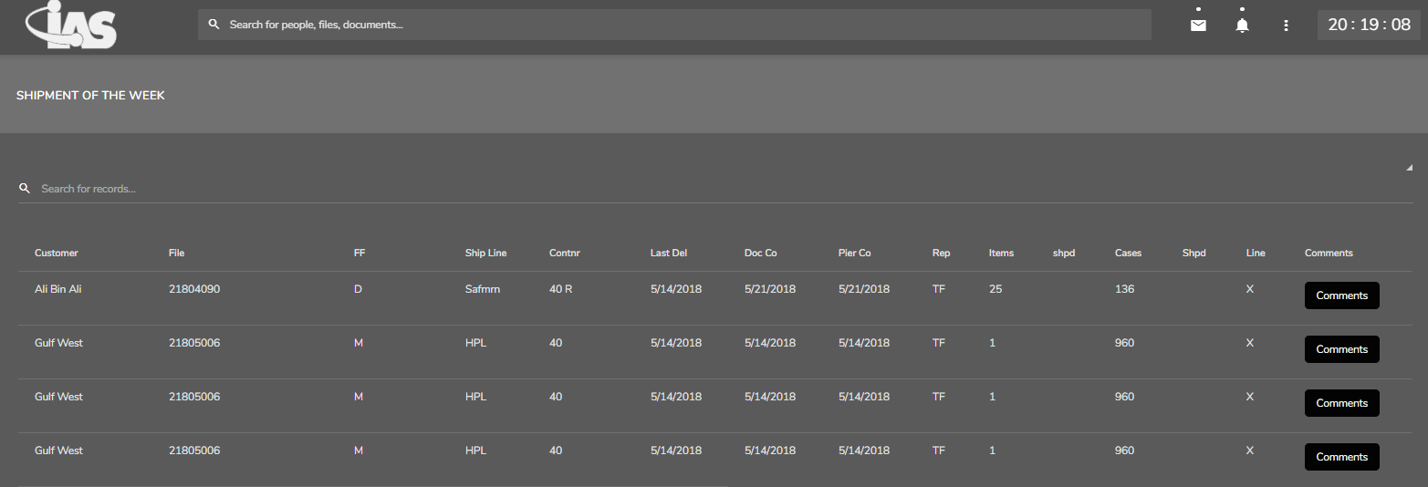

- Home page screen will have following tabs for users:
- Kevin’s Mail Inbox
- Kevin’s Mail Outbox
- User profile(Logout)

- Home page screen for admin users.
Admin additionally having the below two tabs:
- Shipment Upload
- Send Mail

List of pages for user

6.1 Login Page



The login page is authenticating users by their email and password. Then the user can redirect to dashboard page.

6.2 Dashboard

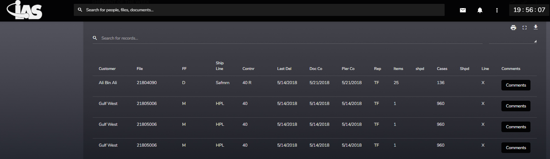

- The dashboard page has all the shipments details.
- The user can able to add comment by clicking on the comment button in the list.
- By clicking the file number in the shipment list the user are redirecting to upload doc receipt page.
- There is Kevin’s inbox button and it redirects to mail box page.
- Admin has all the features as normal users. Additionally, admin only view upload receipt button.

6.3 Doc Receipt Upload

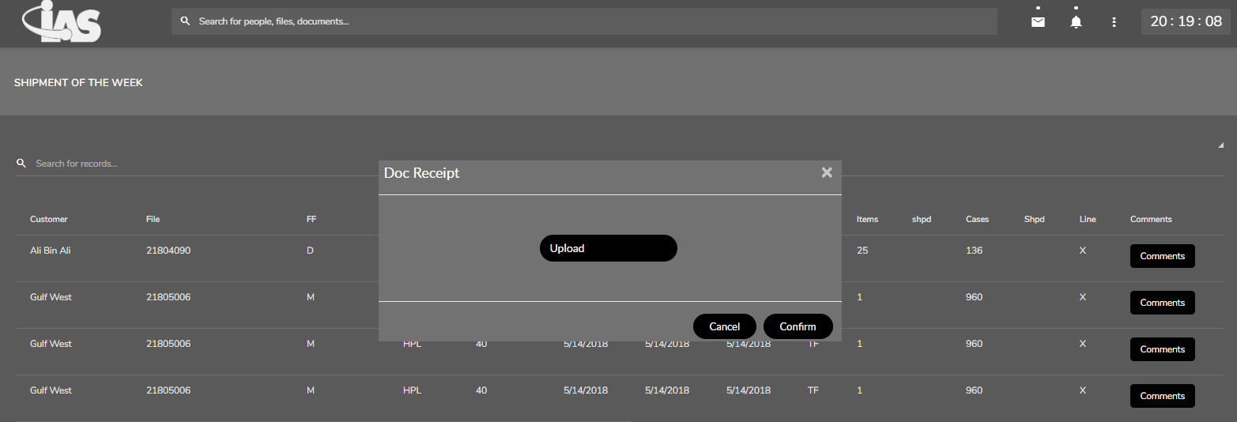

- The file upload page has the option to upload the dock receipt of particular shipment

6.4 Shipment Upload

- Only admin can upload shipment details for the week and it is listed in dashboard page.

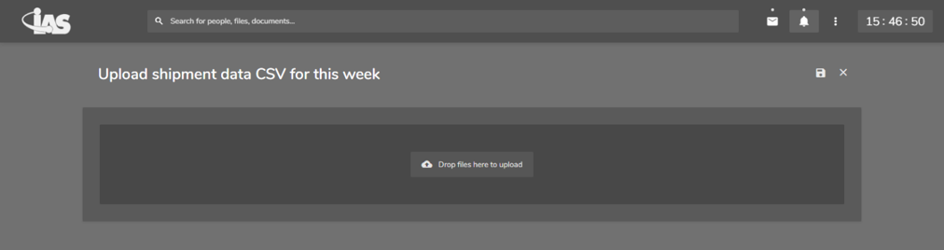

6.5 Shipment Creation Page

- This page has forms with all the required fields for shipment. The user must enter data and submit. The submitted shipment record is listed in dashboard page.

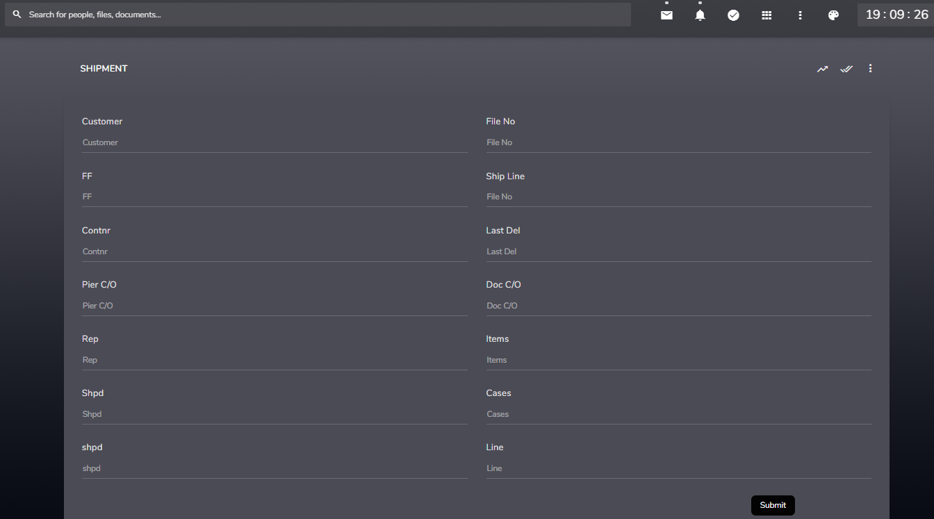

6.6 Kevin’s Mail Inbox & Outbox

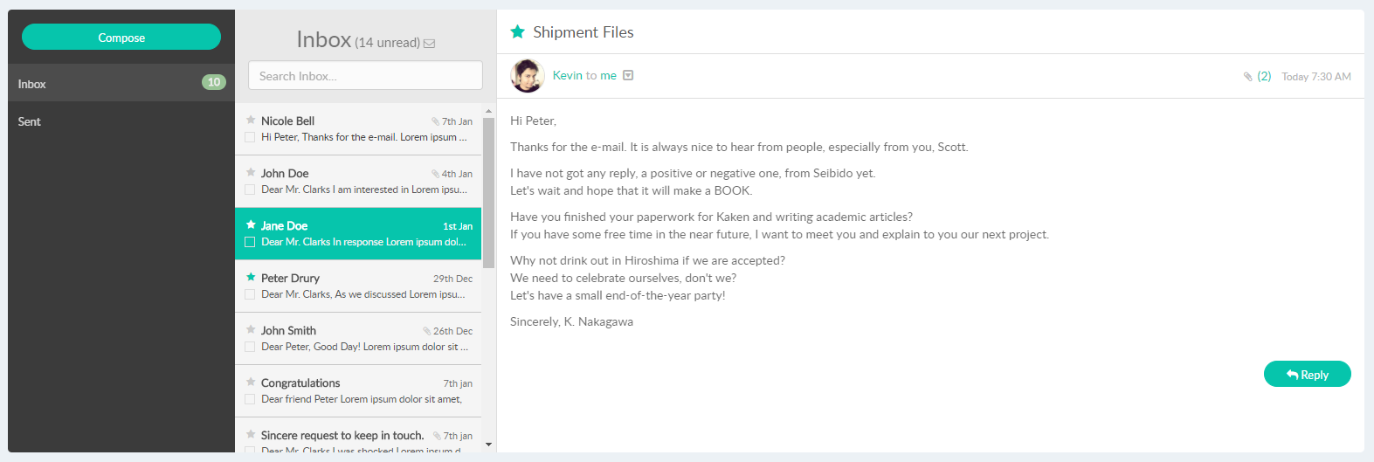

- In this page the user can see the Kevin’s inbox and outbox.
- Only admin can send mail.

