**Compartments and Variables**

Defining compartments and dynamic variables in our model:

* S(t): Number of **Susceptible** individuals at time t.
* E(t)): Number of **Exposed** individuals (infected but not yet infectious) at time t.
* I(t): Number of **Infectious** individuals at time t.
* R(t): Number of **Recovered** individuals at time t.
* V(t): Number of **Vaccinated** individuals at time t.
* y(t): **Willingness to vaccinate**, a dynamic variable in the range [0,1] at time t.

**Parameters**

* **β**: Transmission rate
* **σ**: Rate of progression from exposed to infected
* **γ**: Recovery rate
* **κ**: Social learning rate (influences speed of behavior change)
* **v₍**base**₎**:Baseline vaccination rate
* **N**: Total population

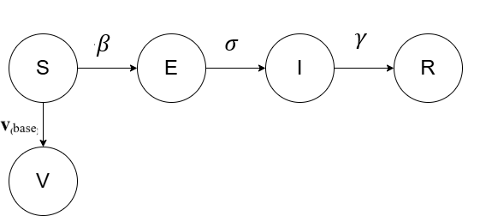

**1. Susceptible Individuals**

Sₜ₊₁ = Sₜ − β × (Sₜ × Iₜ) / N − v_base × yₜ × Sₜ

**2. Exposed Individuals**

Eₜ₊₁ = Eₜ + β × (Sₜ × Iₜ) / N − σ × Eₜ

**3. Infectious Individuals**

Iₜ₊₁ = Iₜ + σ × Eₜ − γ × Iₜ

**4. Recovered Individuals**

Rₜ₊₁ = Rₜ + γ × Iₜ

**5. Vaccinated Individuals**

Vₜ₊₁ = Vₜ + v_base × yₜ × Sₜ

Converting the above equations into Differential Equations (Epidemic):

Now, **willingness to vaccinate**, y(t) ∈ [0,1], is influenced by:

* Real-time infection (awareness)
* Misinformation (doubt/fear)
* Campaigns (trust or encouragement)
* False beliefs (cognitive/social resistance)

Let us define Score(t) –

Where:

• I(t)/N(t): Infection prevalence = awareness

• M(t): Misinformation index (0 to 1)

• C(t): Campaign impact (0 to 1)

• F(t): False belief system strength (0 to 1)

• : Weights for each term

Thus, to model rate of change of willingness:

* People become more willing (or less) based on the net social signal
* The logistic shape captures **self-limiting growth** and **population pressure.**
* This ensures y(t) ∈ [0,1], thus keeping a **logistic imitation-type** dynamic.

**Interpretation of Each Influence**

| **Factor** | **Symbol** | **Role** | **Expected Effect on y(t)** |
| --- | --- | --- | --- |
| Infection | I/N | Higher perceived threat awareness | ↑ |
| Misinformation | M(t) | Reduces trust in vaccines | ↓ |
| Campaign | C(t) | Builds confidence/trust | ↑ |
| False Beliefs | F(t) | Cognitive bias/resistance to vaccines | ↓ |

Thus, the final rate of change of willingness: