ATM Simulator

Submitted as Mini Project for Special Topics: Programming with C++ Semester III

**BACHELOR OF TECHNOLOGY**

in

Computer Science and Engineering

Sukanya Harshavardhan

PES1201700214

Kayan K Katrak

PES1201700092

Under Guidance of

Prof. Jamuna S Murthy

BE (CSE), M.Tech (SSE)

Assistant Professor

**Aug 2018- Dec 2018**

**Department of Computer Science and Engineering**

**PES UNIVERSITY**

Outer Ring Rd, Banashankari 3rd Stage, Banashankari, Bengaluru, Karnataka 560085

[www.pes.edu](http://www.pes.edu)

**ATM Simulator**

**Research Focus**: Object Oriented Programming in C++

This program aims to simulate the facilities provided by an automated teller machine using object oriented programming in C++. No database has been previously fed into the memory hence making it necessary to create accounts and generate cards before performing any other function. Only one card is allowed per account and the details are stored in an array. Each account has two types of bank deposit accounts: savings and checkings. Savings account is meant to store large sums of money which would not be frequently disturbed. The checkings account is meant to hold money that could be required on a daily basis. On the creation of an account, all the deposited money is stored in the savings account. It can be transferred from savings to checkings account and vice versa so long as the balance in the savings account does not recede the minimum account (10000). Money can be deposited or withdrawn from either accounts so long as the minimum is not reached. Customers can view account and card details. In terms of functionality it closely performs the same services as an ATM.

**ReadMe**

ATM Simulator

The program to simulate the functionalities of an ATM using object-oriented programming in C++.

The imported libraries used with standard namespace are iostream, stdlib, conio.h, string, stdio.h, iomanip and ctime.

Three classes were created on the basis of public inheritance.

A menu is displayed, from which the user must choose an action to perform. To create an account, user must enter details regarding name and cash to be deposited which must not be less than Rs. 10000. An account number, card number and cardpin are randomly generated. The money in its entirety is stored in the savings deposit account. The user is asked to change crad pin for ease of remembrance.

Money can be withdrawn or deposited into the savings or checkings account once user has logged in with correct card details. All such transactions provide the option to generate receipt with final account balance and time-date stamp.

Money can be transferred from savings account to checking account and vice-versa. These transactions may also generate a receipt.

User is given option to view account details upon rendering card details.

Once action is completed, the user is given the option to quit or perform an action again.

1. Basic home page of the project where one can choose which task they would like to perform

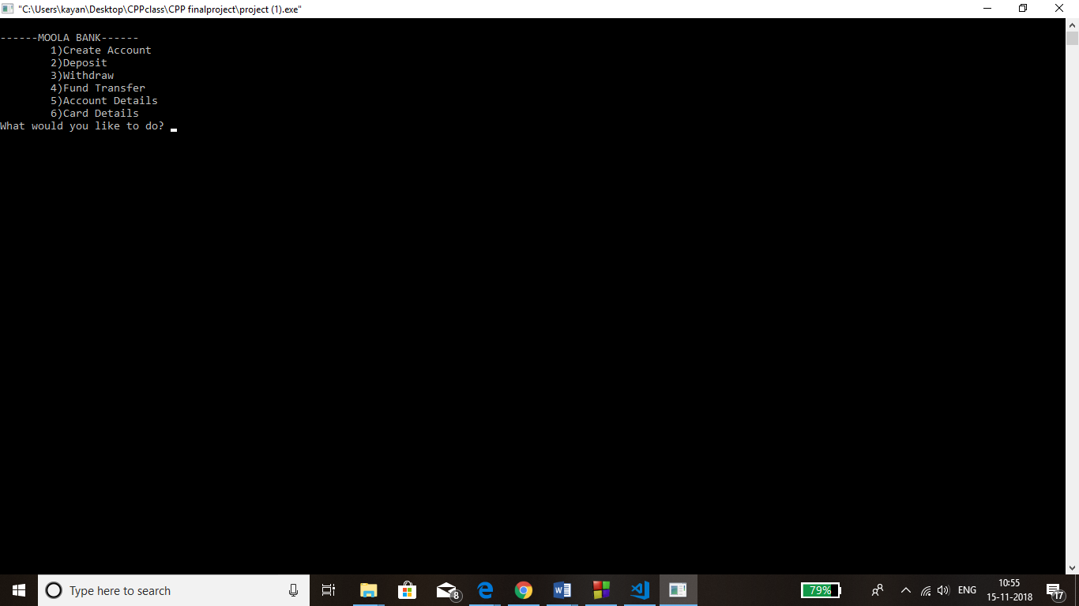

1. The first option is creating an account, where one must enter their firstname and the amount they would like to deposit into the account. (>=10000) and the minimum account must always be maintained. An account number and card number is randomly generated for you along with a default password, which one must reset to his own. Invalid inputs can only be taken in twice, the third leads to an INVALID! Which then signs out of the account.

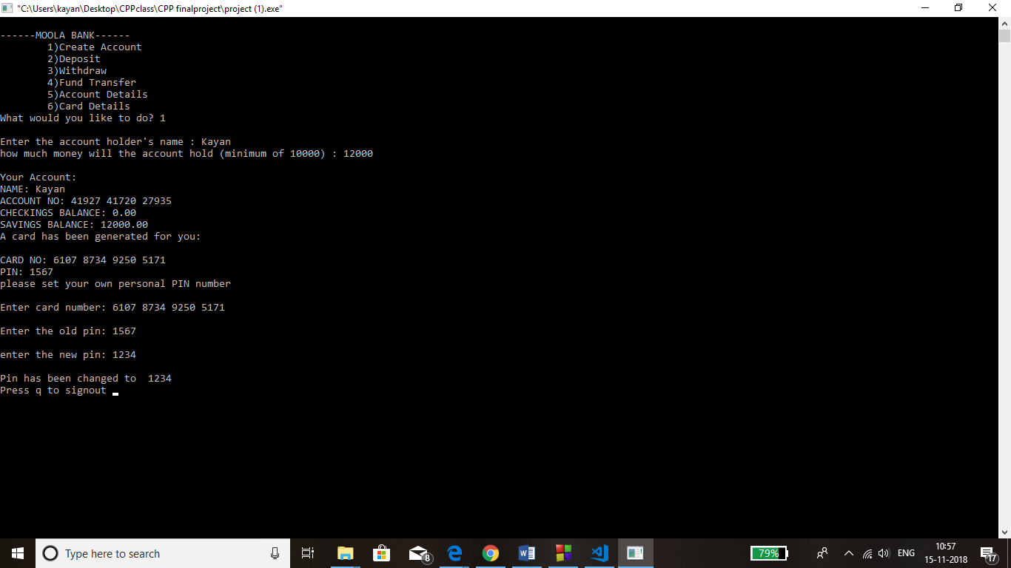

1. Option 2 is deposit where one can deposit cash into their savings/checkings account. But only after signing up to their account with the card number and password.

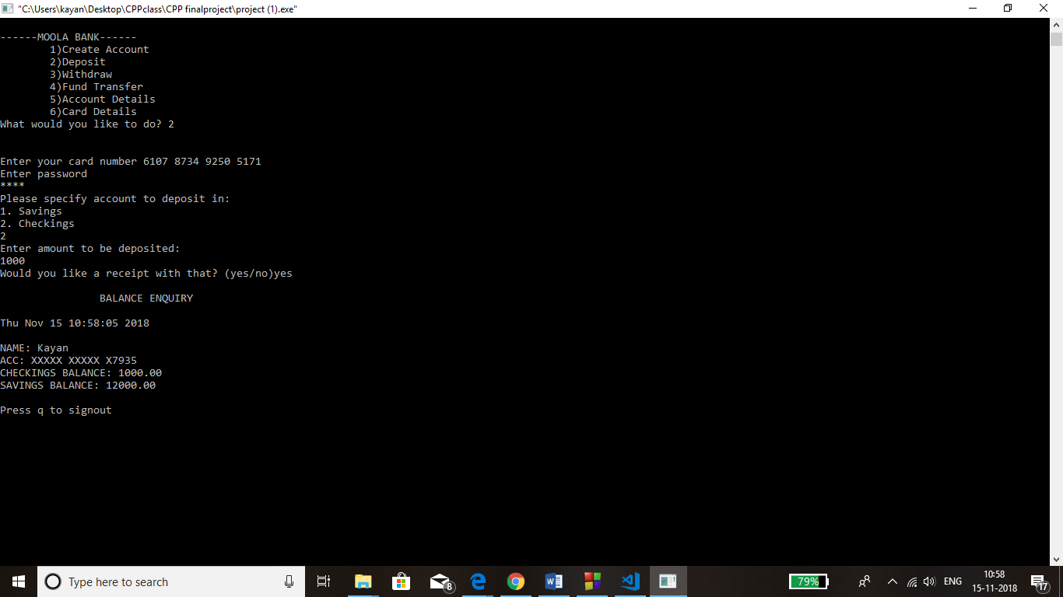

1. Withdraw has the same steps to follow as Deposit does, but with an extra condition that a balance of 10000 is maintained in the savings account.

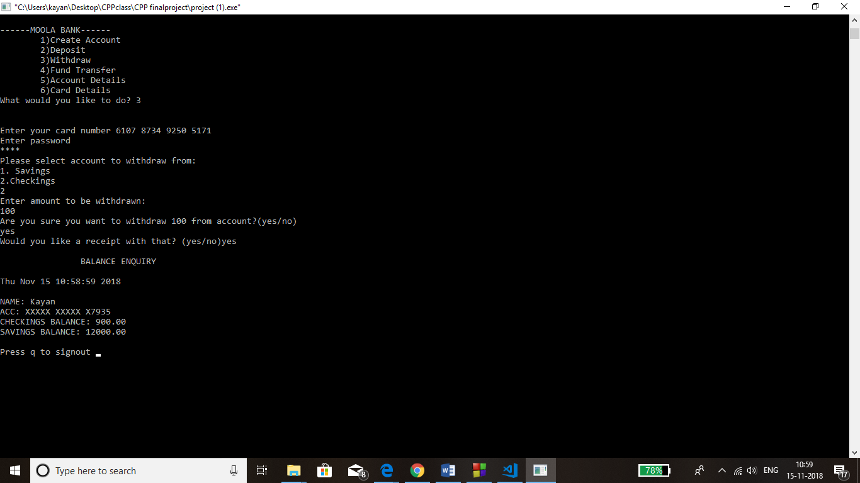

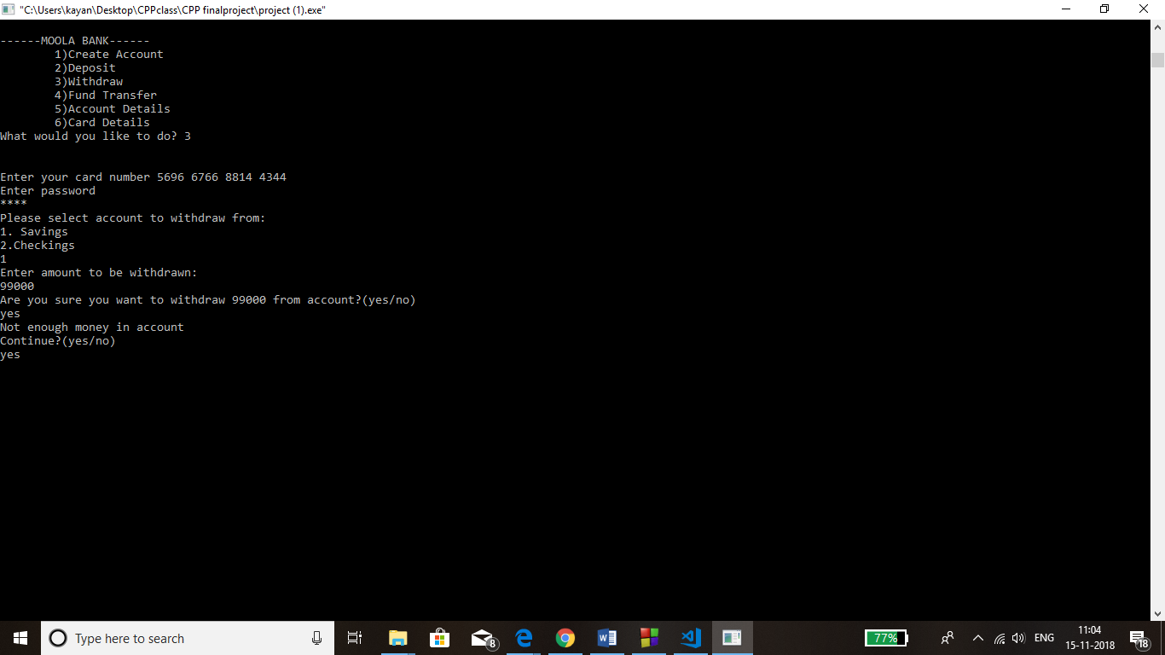

1. Fund transfer is where we can transfer money from savings to checkings and vice-versa.

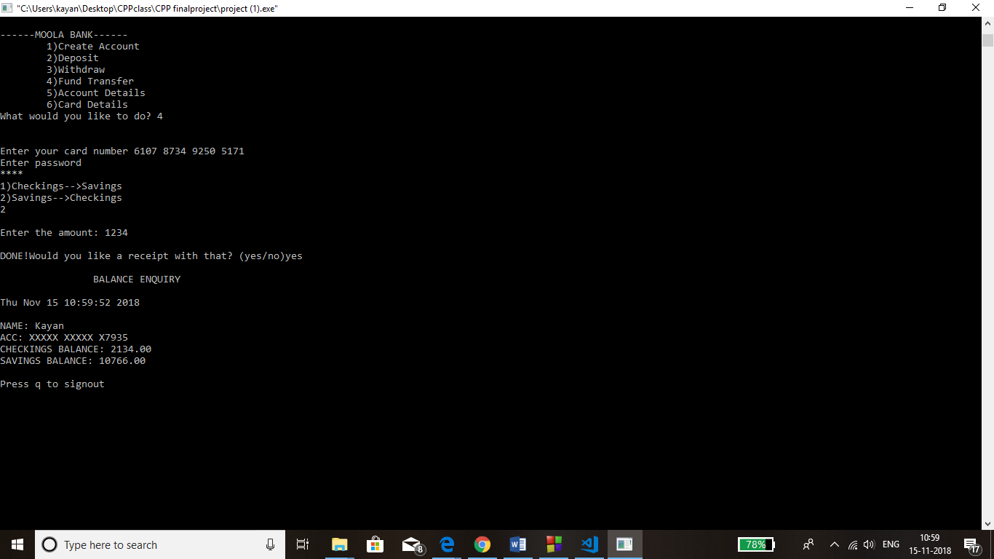

1. One can view their account details too, but only after they sign-in.

