1. Start by reviewing the data.gov home page. What is included?
   1. Most Viewed Data Sets, Recently Added Data Sets, Data Sets by Organization, Data Repositories, Federal Data Strategies, Geospatial data, etc.
2. Go to Most Viewed Datasets. How many datasets are listed?
   1. 300,420 datasets
3. Find the Topic Category for Human Health. Review the range of data  
   sources available for this topic. Why do you think these were tagged with  
   the Human Health category?
   1. I think all of this information is included because all listed sets have something to do with the preservation or consideration of human life (food, water, climate, air quality, and demographics).
4. Go to the Food Price Outlook. Review the catalog page for this dataset.  
   How can you navigate to additional datasets from the USDA?
   1. At the top there is a folder/tree. Click on the section that says Department of Agriculture
      1. Or Under **Publisher** select Economic Research Service, Department of Agriculture
5. Go back to the data.gov home page. This time, click on Datasets by  
   Organization.
6. Try searching for your city, county, and state. What organizations are  
   returned?
   1. Chicago = City of Chicago (993 Datasets)
   2. Cook County = Cook County of Illinois (506 Datasets)
   3. Illinois = Cook County of Illinois, Lake County Illinois (1474 Datasets), and State of Illinois (0 Datasets)
7. Search for USDA and click into the result.
8. Within the USDA datasets, search for food composition.
9. Notice that the top three results are all datasets concerning nutrition  
   information. Try searching the USDA page for nutrition. How does that  
   affect your results?
   1. Nutrition seems to be a broader term, generating 215 results to the 13 that were provided through searching “food composition”. A lot of programs are listed at the top in order of relevance.
10. Go back to the results for food composition, and click on Food Data  
    Central. Review the catalog page for this data source, then click on the  
    button for Visit Page.
11. Take some time to explore the FoodData Central website.
    1. Try searching for butter, or any of your favorite foods. What kind of  
       results do you get? What happens when you click on a result?
       1. Watermelon (not many entries)= List of nutrients (option to update portion), common measurements, and scientific name

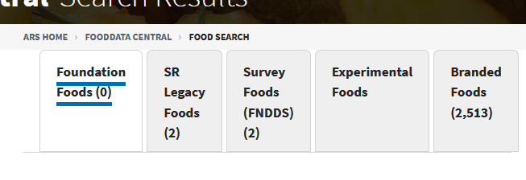

* + 1. Butter = Many entries, different types of butter to choose from, similar to nutrients/common measurements of watermelon

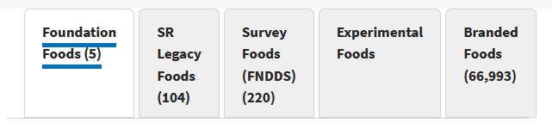

* 1. Go back to the home page. Find Foundation Foods, and click on  
     Downloads. What kind of data can you find on this page? How big are  
     these files? Where can you find more information on the data types  
     available?
     1. Download files for data contained currently and previously in the FoodData Central site from USDA.
     2. Files range from kilobytes to gigabytes and data ending in “M” (not quite sure but I think this means Megabytes from Googling)
     3. Data Type Documentation on the bottom of the page