Project: Financial control

DB: MongoDB (file or docker)

Technologies:
SpringBoot
SpringCloud
Хз -зачем но будет нужно потом:
ELASTIC STACK - ELK - https://www.elastic.co/what-is/elk-stack
Для вычислений с деньгами использовать: BigDecimal
Много модульный проект на Maven.
Architecture: Micro-service architecture

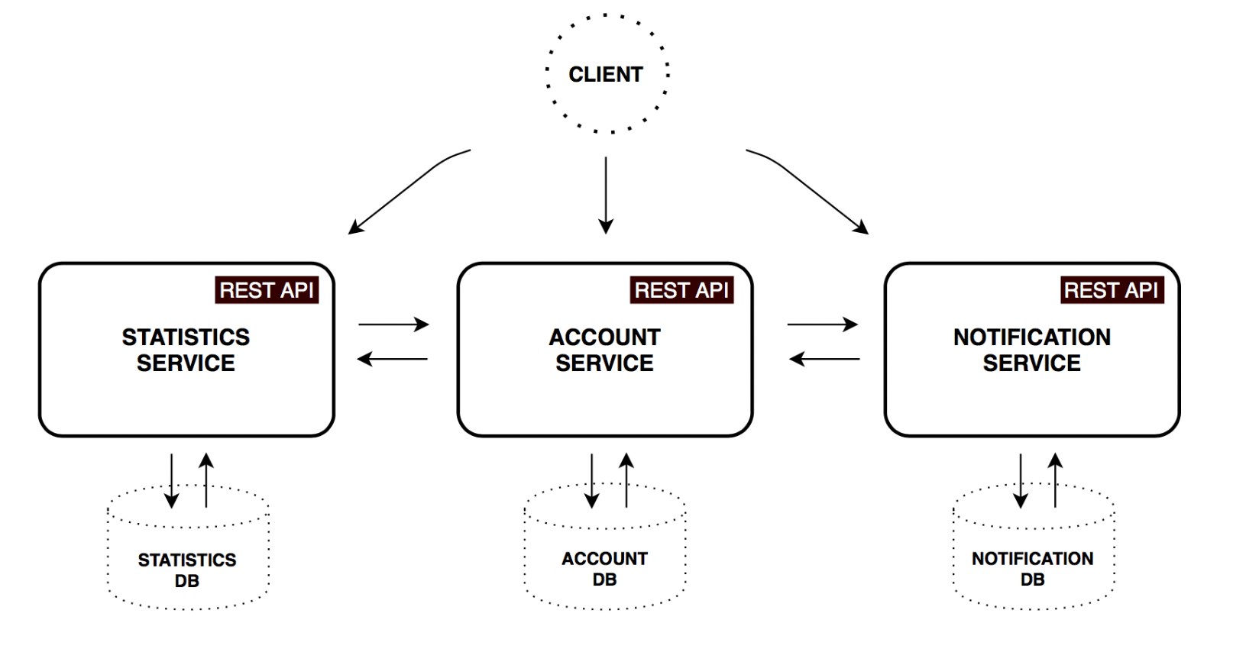
Account Service

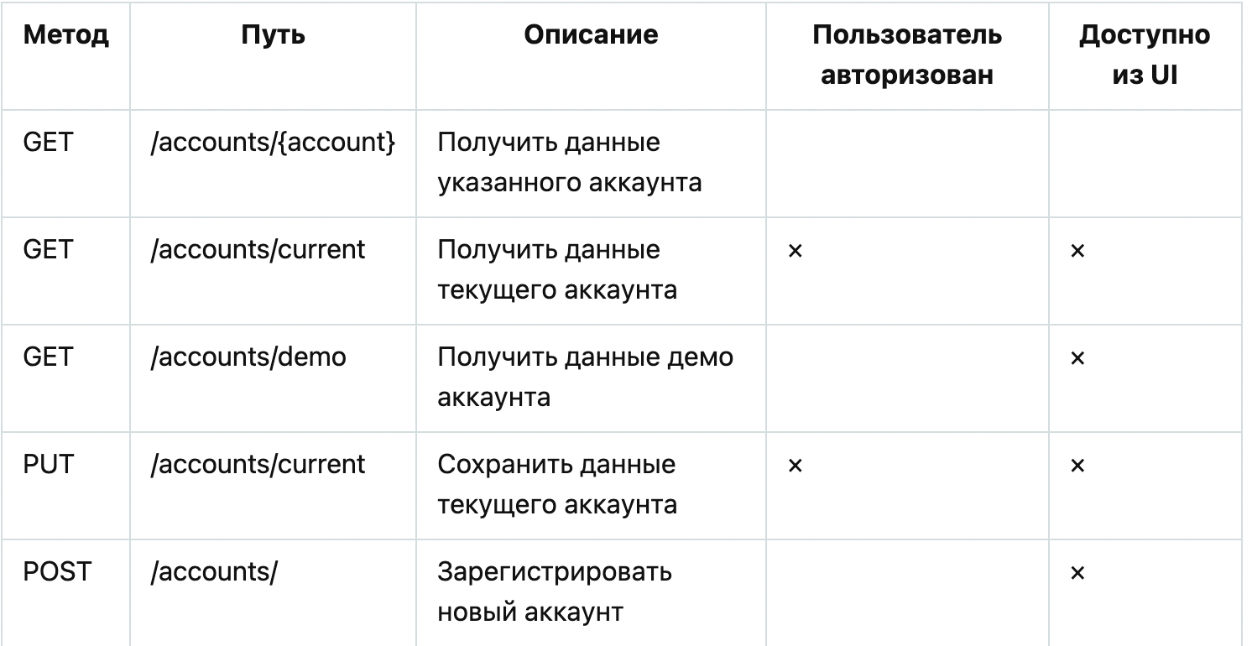

Account
Name
Description
Date last Seen
Incomes - array of {
Title
Amount
Currency
Time period
}
Expanses - array of {
Title
Amount
Currency
Time period
}
Saving {
Amount
Currency
Interest
Deposit true or false
Capitalisation true or false
}

Statistics Service

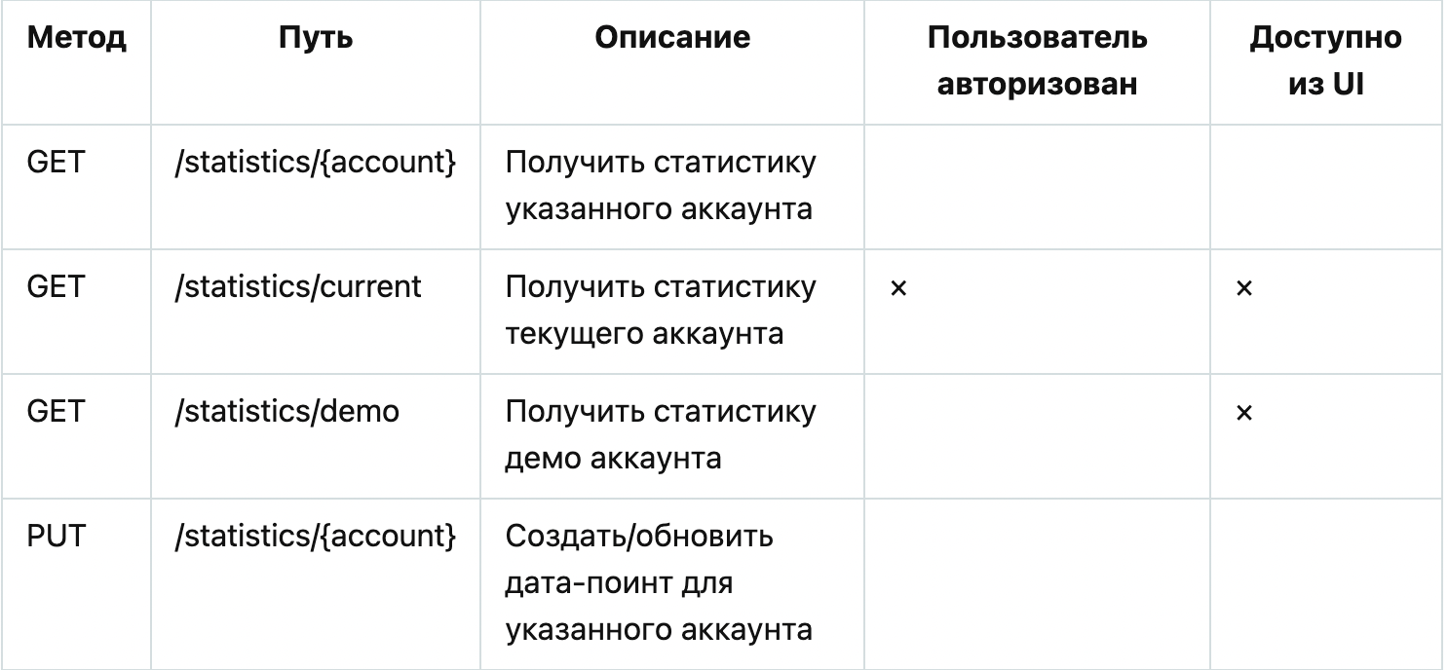

Notification Service
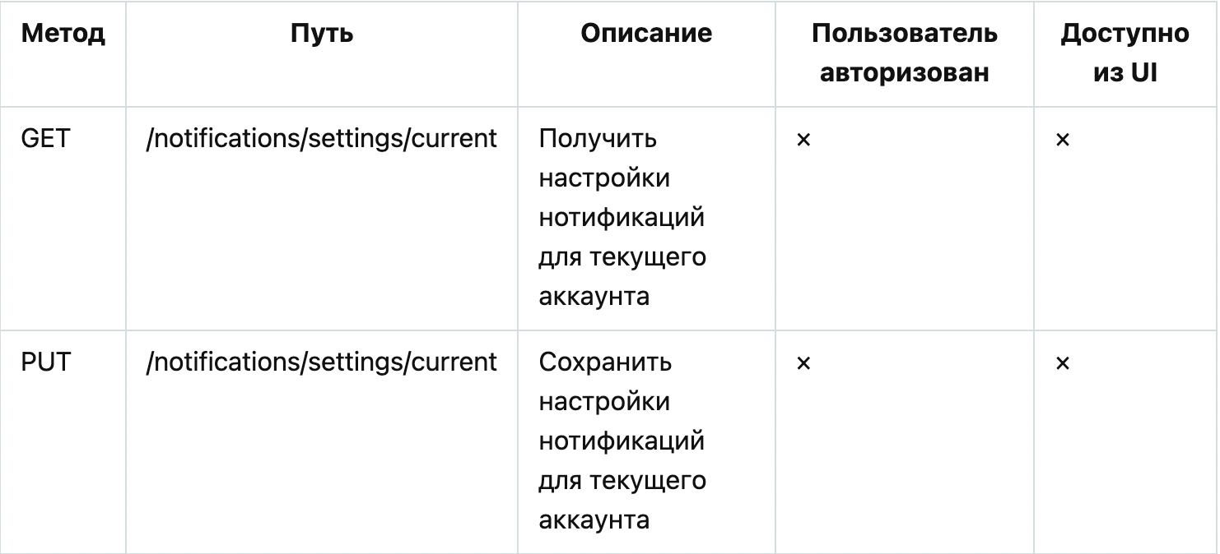

Serviсe discovery – service который знает что не все умерло
Log Analysis храни все логи

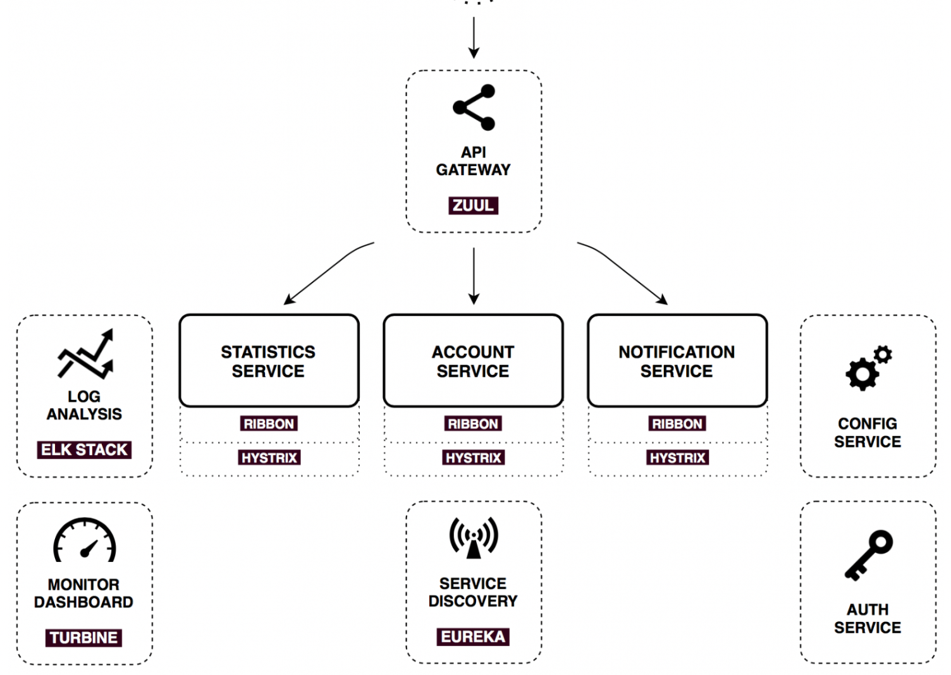
What is a hystrix circuit breaker?
Circuit Breaker pattern prevents failure cascading and gives a default behavior when services fail. Netflix Hystrix allows us to introduce fault tolerance and latency tolerance by isolating failure and by preventing them from cascading into the other part of the system building a more robust distributed application.

