**四位无符号数乘法器**

**一、设计分析：**

四位无符号数乘法器：

两个输入信号：a_in，b_in 四位无符号数

一个输出信号：c_out 八位无符号数

运算：c_out = a_in × b_in

**二、代码设计：**

library IEEE;

use IEEE.std_logic_1164.all;

use IEEE.std_logic_arith.all;

use IEEE.std_logic_unsigned.all;

entity mul_4 is

port(a_in,b_in:in std_logic_vector(3 downto 0);

c_out:out std_logic_vector( 7 downto 0));

end entity mul_4;

architecture behavior of mul_4 is

signal temp1 :std_logic_vector(3 downto 0);

signal temp2 :std_logic_vector(4 downto 0);

signal temp3 :std_logic_vector(5 downto 0);

signal temp4 :std_logic_vector(7 downto 0);

begin

temp1<=a_in when b_in(0)='1' else "0000";

temp2<=a_in&'0' when b_in(1)='1' else "00000";

temp3<=a_in&"00" when b_in(2)='1' else "000000";

temp4<='0'&a_in&"000" when b_in(3)='1' else "00000000";

c_out<=temp4+temp3+temp2+temp1 ;

end architecture behavior;

**三、逻辑图**

四位无符号乘法器逻辑图：

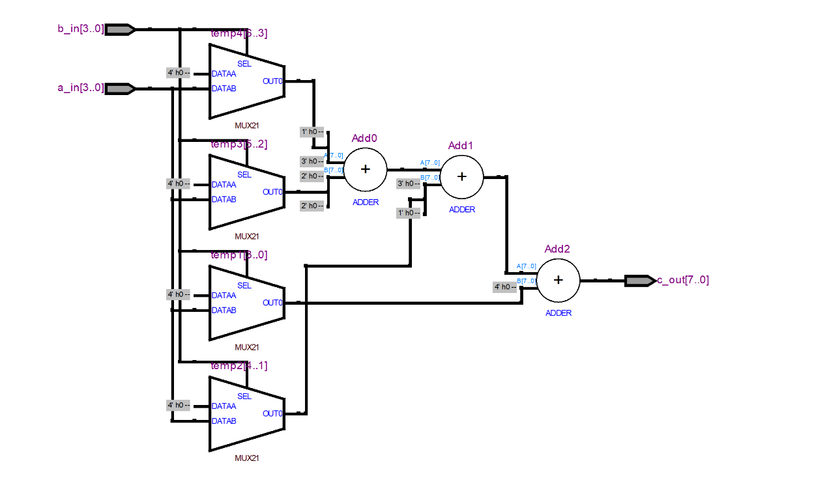

**四、波形仿真**

测试数据：

|  |  |  |
| --- | --- | --- |
| 输入：a_in | 输入：b_in | 输出：c_out |
| 0000 | 0000 | 0000 0000 |
| 0001 | 0001 | 0000 0001 |
| 0010 | 0010 | 0000 0100 |
| 0011 | 0011 | 0000 1001 |

四位全加器仿真波形图：

