


College of Computing Education
Bachelor of Science Information Technology
[IT5L - 3412]

Food Ordering System

Submitted by:
[Rayver John Licayan]
Section: [Section]

Submitted to:
[Evan Bonso]

[Date Submitted]
Table of Contents
1. Introduction 4
2. Objectives 4
General Objective 4
Specific Objectives 4
3. Project Description 5
Major Features 5
Types of Users 6
Scope 6
Limitations 6
4. System Features 7
Sign Up (Account Registration) 7
Login 7
Reset Password 7
Menu Browsing, Category Filter, and Search 7
Shopping Cart 8
Checkout and Order Types 8
Input Validation and Error Handling 8
Order Confirmation 8
Admin Login 8
Admin Dashboard 9
Order Management 9
Menu Management 9
Customers 9
Reports 9
Settings (Change Admin Password) 10
5. Tools and Technologies Used 10
6. Flowchart / System Design 11
System Flowchart 11
Figure 1. System Flowchart of the Food Ordering System 11
Program Flow 12
Data Flow Diagram 13
Figure 2. Data Flow Diagram (Level 0) 13
Module Diagram (UML Style) 14
Figure 3. Module and Class Relationship Diagram 14
7. Database (Data Storage) Design 14
accounts.txt 14
admin_credentials.json 15
admin_orders.json 15
Menu Item Structure 15
8. Source Code Explanation 16
menu.py: Menu Data 16
logic.py: Search and Filter 16
logic.py: Cart Class 17
logic.py: Totals and Validation 17
logic.py: Place Order 18
logic.py: Password Security 18
gui.py: Main Window and Responsive Menu 19
gui.py: Placing an Order 19
gui.py: AppController 20
admingui.py: Order Storage and Status 20
admingui.py: Reports Algorithm 20
Algorithms and Techniques Used 21
9. Screenshots of the System 22
Figure 4. Login Interface 22
Figure 5. Sign Up Form 22
Figure 6. Reset Password Form 23
Figure 7. Main Menu (Customer Ordering Screen) 23
Figure 8. Search and Category Filter 24
Figure 9. Cart and Checkout Form 24
Figure 10. Order Confirmation 25
Figure 11. Error Handling: Checkout Validation 25
Figure 12. Error Handling: Login Error 26
Figure 13. Admin Login 26
Figure 14. Admin Dashboard 27
Figure 15. Order Management 27
Figure 16. Menu Management 28
Figure 17. Add/Edit Menu Item Dialog 28
Figure 18. Customers Page 29
Figure 19. Reports Page 29
Figure 20. Settings: Change Admin Password 30
10. Testing and Results 31
Logic and Data Tests 31
Interface Tests 32
11. Problems Encountered 33
12. Conclusion 34
What Was Learned 34
Skills Developed 34
Importance of the Project 34
Recommendations for Future Improvements 34
13. References 35

1. Introduction
The Food Ordering System is a desktop application developed using the Python programming language and the PyQt6 graphical user interface (GUI) toolkit. It allows customers to browse a restaurant menu, add food items to a cart, and place an order, while allowing the restaurant administrator to monitor, manage, and report on those orders from a separate admin dashboard.
The project was created to replace manual order taking, which is slow and prone to mistakes in recording items, quantities, and totals. By automating menu browsing, cart computation, input validation, and order recording, the system makes ordering faster, more accurate, and easier to track.
The project was also created as a practical application of programming concepts learned in class, such as functions, classes, file handling, data validation, modular program design, and GUI development.
The project benefits the following users:
- Customers, who can order food through a simple and clear interface;
- Restaurant owners and staff, who can view and update orders and monitor sales;
- Restaurant administrators, who can manage the menu and review reports; and
- Students and developers, who can use the project as a reference for building a modular Python and PyQt6 application.

2. Objectives

General Objective
To develop a desktop-based Food Ordering System using Python and PyQt6 that allows customers to place food orders and allows administrators to manage orders, menu items, and sales reports efficiently.

Specific Objectives
- To apply Python programming concepts such as functions, classes, dictionaries, and modules in building a complete working system.
- To design a user-friendly graphical interface using PyQt6 for both customers and administrators.
- To implement file handling using plain text and JSON files for storing accounts, admin credentials, and orders.
- To implement secure account handling by storing passwords as salted PBKDF2-SHA256 hashes instead of plain text.
- To create features for searching and filtering the menu, managing a shopping cart, validating customer input, and recording orders.
- To provide an admin dashboard for order status updates, menu management, customer viewing, and sales reports.
- To practice problem-solving, debugging, and separating the user interface from the business logic.

3. Project Description
Main purpose. The Food Ordering System is a desktop application that lets customers browse a restaurant menu, build a cart, and place an order, while giving the administrator tools to process orders, maintain the menu, view customers, and generate sales reports. The application is written in Python 3 with PyQt6 for the interface.

Major Features
- Customer account registration, login (by username or email), and password reset
- Menu browsing with category filters and a search box
- Shopping cart with add, increase, decrease, remove, and clear actions
- Checkout with order type (Dine-in, Takeout, Delivery), payment method, and order notes
- Automatic computation of subtotal, delivery fee, and total in Philippine pesos
- Input validation with clear error messages and an order confirmation receipt
- Separate admin login and an admin dashboard with orders, menu management, customers, reports, and settings

Types of Users
User | Description
Customer | Creates an account, signs in, browses the menu, fills the cart, and places an order.
Administrator | Signs in through the admin login, updates order status, manages menu items, views registered customers and reports, and changes the admin password.

Scope
- Local desktop application that runs on a single computer
- Customer ordering for Dine-in, Takeout, and Delivery orders
- Order recording and status tracking (Pending, Completed, Cancelled)
- Basic sales reporting: total revenue, revenue by payment method, orders by type, and popular items
- Local data storage using a text file (accounts) and JSON files (orders and admin credentials)

Limitations
- Menu changes made in the admin panel are kept in memory only, so they are lost when the program is closed.
- The order number counter restarts at FO-0001 every time the program is launched, so order numbers can repeat across sessions.
- Payment methods (Cash, GCash, Credit/Debit Card) are recorded as labels only; no real payment processing is performed.
- Menu items do not display images (the image field is reserved but not yet used).
- Customers cannot view their past orders or track the status of an order.
- Password reset only requires an existing username or email and does not use email verification.
- The system is not networked, so it cannot take orders from multiple computers at the same time.

4. System Features

Sign Up (Account Registration)
What it does: Allows a new customer to create an account with a username, email, and password.
How it works: The register_user() function in logic.py checks that all fields are filled, that the username has 3 to 20 letters, numbers, or underscores, that the email has a valid format, that the password has at least 6 characters, and that both passwords match. It then checks that the username and email are not yet used. The password is combined with a random 16-byte salt and hashed using PBKDF2-SHA256, and the account is saved as one line in accounts.txt.

Login
What it does: Lets a registered customer sign in using either the username or the email address.
How it works: login_user() finds the account (not case sensitive), hashes the entered password with the stored salt, and compares the result with the stored hash using hmac.compare_digest(). On success the main ordering window opens; on failure the message "Incorrect username/email or password." is displayed.

Reset Password
What it does: Lets a customer set a new password for an existing account.
How it works: reset_password() verifies the new password length and confirmation, finds the account by username or email, generates a new salt, and saves the new hash to accounts.txt.

Menu Browsing, Category Filter, and Search
What it does: Displays the 15 menu items as cards and lets the customer narrow them down.
How it works: The sidebar contains the categories All, Meals, Burgers, Snacks, and Drinks. The search box matches part of an item name. Both are applied together by logic.filter_menu(). The grid recalculates the number of columns from the window width so the layout stays responsive.

Shopping Cart
What it does: Lets the customer collect the food items to order.
How it works: The Cart class keeps a dictionary of {item_id: quantity}. Each item card has an Add button, and each cart row has increase, decrease, and remove controls, plus a Clear Cart option. Decreasing a quantity to zero removes the item. Subtotals are recomputed whenever the cart changes.

Checkout and Order Types
What it does: Collects the customer details and computes the final amount.
How it works: The customer enters name, contact number, order type, payment method, and optional notes. The delivery address field is enabled only for Delivery orders. A fee of ₱50.00 is added to Delivery orders, while Dine-in and Takeout have no fee.

Input Validation and Error Handling
What it does: Prevents invalid or incomplete orders and accounts from being saved.
How it works: validate_customer() requires a name of at least 2 characters, a contact number with 7 to 13 digits (spaces, dashes, plus signs, and parentheses are ignored), and an address for Delivery. place_order() also rejects an empty cart. Errors are shown in the status area and in a warning message box.

Order Confirmation
What it does: Shows a receipt after a successful order.
How it works: place_order() builds the order (number, time, customer, items, totals) and clears the cart. The order is saved through admingui.record_order(), and a confirmation message box shows the formatted receipt created by format_order_confirmation(). The checkout form is then reset.

Admin Login
What it does: Restricts the management panel to the administrator.
How it works: The admin credentials are stored in admin_credentials.json as a username, salt, and PBKDF2 hash. The admin account is created once with the command python admingui.py --setup. verify_admin() compares the hash of the entered password to the stored hash.

Admin Dashboard
What it does: Gives an overview of the restaurant's activity.
How it works: DashboardPage.refresh() reads all orders and shows stat cards (today's revenue, total orders, pending, completed, cancelled, menu items, and customers) and a table of the 20 most recent orders.

Order Management
What it does: Lets the administrator search, filter, and update orders.
How it works: OrdersPage lists every order with its details. Orders can be searched by order number or customer name and filtered by status. Pending orders show Complete and Cancel buttons that call update_order_status() to save the new status to admin_orders.json.

Menu Management
What it does: Lets the administrator add, edit, and delete menu items.
How it works: MenuPage shows the menu in a table with Edit and Delete buttons. A MenuItemDialog collects the name, category, price, and description and validates that the name is not empty and the price is a number. Deleting asks for confirmation. Changes update menu.MENU_ITEMS in memory.

Customers
What it does: Lists the registered customer accounts.
How it works: CustomersPage reads accounts.txt through logic.load_accounts() and shows each username and email. Passwords are never shown.

Reports
What it does: Summarizes sales information.
How it works: ReportsPage.refresh() loops through all orders to total the revenue, group revenue by payment method, count orders by order type, and rank items by quantity sold with their revenue (Popular Items).

Settings (Change Admin Password)
What it does: Allows the administrator to change the admin password.
How it works: SettingsPage._change_password() verifies the current password, requires a new password of at least 8 characters that matches its confirmation, and then saves a new salted hash to admin_credentials.json.

5. Tools and Technologies Used
Tool/Technology | Purpose
Python 3.13 | Main programming language of the system
PyQt6 | GUI development (windows, buttons, tables, dialogs, layouts, and style sheets)
Visual Studio Code | Code editor used to write and run the program
Roboto font (TTF files) | Application typeface loaded at start-up for a consistent interface
JSON files | Storage for orders (admin_orders.json) and admin credentials (admin_credentials.json)
Plain text file | Storage for customer accounts (accounts.txt)
hashlib, hmac, secrets | PBKDF2-SHA256 password hashing, safe hash comparison, and random salt generation
re (regular expressions) | Validation of usernames, emails, and phone numbers
datetime | Order time stamps and the "today" filter for daily revenue
argparse | Command-line option --setup for creating the admin account
Graphviz | Creating the flowchart, data flow diagram, and module diagram
Microsoft Word | Writing and formatting this documentation

6. Flowchart / System Design

System Flowchart
Figure 1 shows the overall flow of the program, from start-up at the Auth Window to the customer ordering process and the admin dashboard.

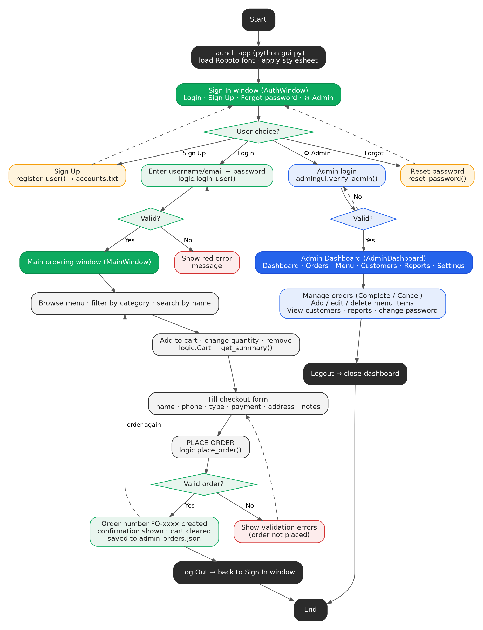
Figure 1. System Flowchart of the Food Ordering System
The program starts at the authentication window. A customer who signs in with valid credentials reaches the main window, builds a cart, and checks out. The order is validated, saved, and confirmed. An administrator uses the admin icon to open the admin login and, once verified, the dashboard.

Program Flow
- The program starts in gui.py. main() loads the Roboto font, applies the style sheet, and AppController shows the AuthWindow.
- The customer signs up, signs in, or resets a password. These actions call functions in logic.py, which read and write accounts.txt.
- After a successful login, AppController opens the MainWindow, which displays the menu from menu.py and an empty cart.
- The customer filters or searches the menu and adds items. Each action updates the Cart object and refreshes the cart panel and totals.
- On Place Order, logic.place_order() validates the input. If valid, the order is recorded through admingui.record_order() into admin_orders.json and a receipt is shown.
- Alternatively, the administrator opens the admin login from the AuthWindow, which is verified against admin_credentials.json, and the AdminDashboard opens.

Data Flow Diagram
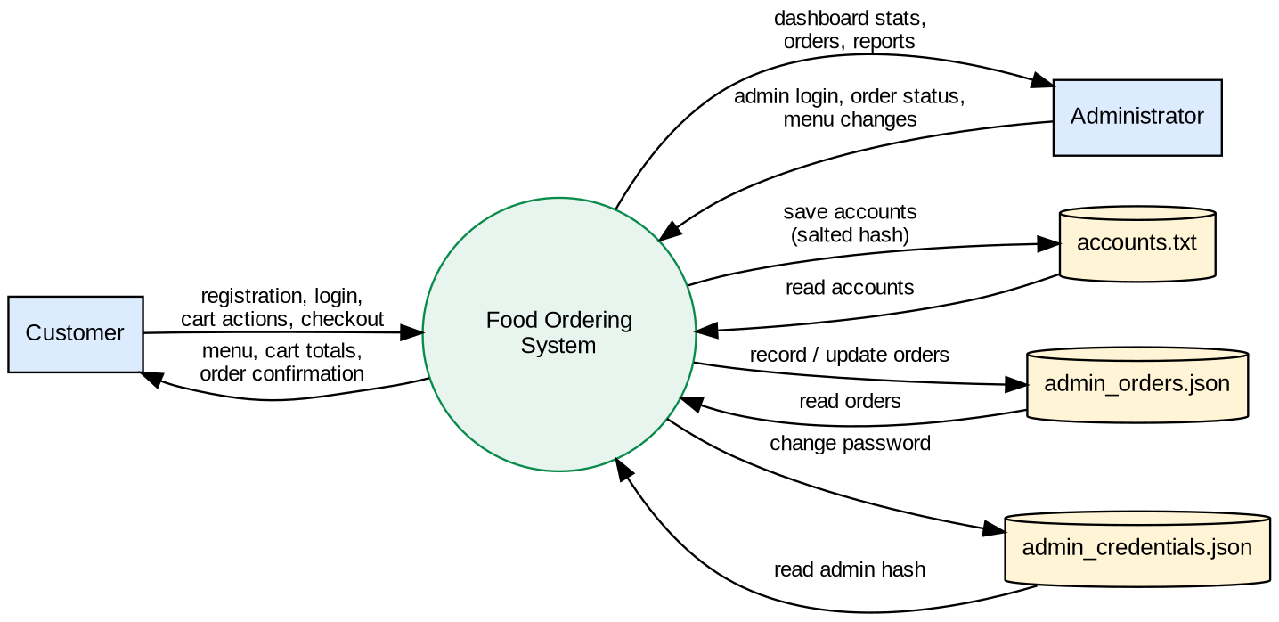
Figure 2. Data Flow Diagram (Level 0)
The Customer and the Administrator interact with the Food Ordering System. The system reads and writes three data stores: accounts.txt, admin_orders.json, and admin_credentials.json.

Module Diagram (UML Style)
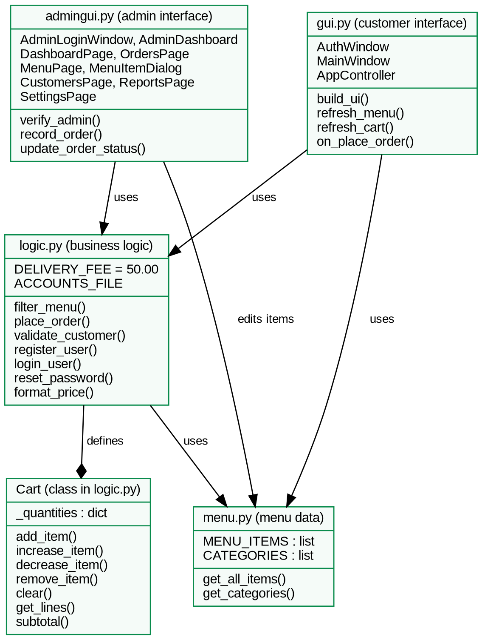
Figure 3. Module and Class Relationship Diagram
gui.py is the customer interface and depends on logic.py and menu.py. logic.py contains the Cart class and the business rules and depends on menu.py. admingui.py is the administrator interface and uses logic.py and menu.py. The customer interface also calls admingui.record_order() to save each placed order.

7. Database (Data Storage) Design
The system does not use a database server. It stores its data in three files located in the same folder as the program. The structure of each file is shown below.

accounts.txt
One customer account per line, with fields separated by the | character.
Field | Description
username | Unique account name (3 to 20 letters, numbers, or underscores)
email | Unique email address
salt | Random 16-byte value in hexadecimal, generated for each password
password_hash | PBKDF2-SHA256 hash (100,000 iterations) of the password

admin_credentials.json
Stores the single administrator account with the fields username, salt, and hash (PBKDF2-SHA256, 200,000 iterations).

admin_orders.json
A list of orders. Each order is a JSON object with the following fields.
Field | Description
order_number | Order ID such as FO-0001
time | Date and time the order was placed
customer, phone | Customer name and contact number
order_type, address | Dine-in, Takeout, or Delivery, and the delivery address (empty if not Delivery)
payment, notes | Payment method and optional notes
lines | List of ordered items, each with id, name, price, quantity, and subtotal
subtotal, delivery_fee, total | Computed amounts in pesos
status | Pending, Completed, or Cancelled (new orders start as Pending)

Menu Item Structure
Menu items are dictionaries in menu.py with the keys id, name, description, category, price, and image. The default menu has 15 items in four categories: Meals (4), Burgers (3), Snacks (4), and Drinks (4).

8. Source Code Explanation
The project is divided into four Python modules. The user interface is kept separate from the business logic so that the program is easier to read, test, and maintain.
File | Role
menu.py | Stores the menu data and category list. Imports nothing from the other modules to avoid circular imports.
logic.py | Business logic: menu search, Cart class, totals, validation, order processing, and account handling. Does not import PyQt6.
gui.py | Customer interface: AuthWindow, MainWindow, AppController, and main().
admingui.py | Admin interface: admin login, dashboard pages, order storage, and the --setup command.

menu.py: Menu Data
MENU_ITEMS = [
{"id": 1, "name": "Chicken Adobo Rice Meal",
"description": "Tender chicken simmered in soy-vinegar sauce...",
"category": "Meals", "price": 149.00, "image": None},
...
]

def get_all_items():
return MENU_ITEMS
Explanation: Every menu item is a dictionary stored in a list. get_all_items() gives the other modules access to the list, so the interface and the logic always read the same data.

logic.py: Search and Filter
def filter_menu(search_text="", category="All"):
search_text = search_text.strip().lower()
results = []
for item in get_all_items():
if category != "All" and item["category"] != category:
continue
if search_text and search_text not in item["name"].lower():
continue
results.append(item)
return results
Explanation: This function loops through the menu and skips items that do not match the chosen category or the search text. The search is case-insensitive and matches part of the name. It uses a linear search, which is suitable for a small menu.

logic.py: Cart Class
class Cart:
def __init__(self):
self._quantities = {} # {item_id: quantity}

def add_item(self, item_id):
if get_item(item_id) is None:
return
self._quantities[item_id] = self._quantities.get(item_id, 0) + 1

def decrease_item(self, item_id):
if item_id in self._quantities:
self._quantities[item_id] -= 1
if self._quantities[item_id] <= 0:
del self._quantities[item_id]
Explanation: The Cart class stores only item IDs and quantities in a dictionary. Prices and names are looked up from the menu when get_lines() builds the cart rows, so the cart never holds outdated prices. Other methods include increase_item(), remove_item(), clear(), item_count(), and subtotal().

logic.py: Totals and Validation
def get_delivery_fee(order_type):
return DELIVERY_FEE if order_type == "Delivery" else 0.0

def validate_customer(name, phone, order_type, address):
errors = []
...
digits = re.sub(r"[\s\-+()]", "", phone.strip())
if not phone.strip():
errors.append("Contact number is required.")
elif not digits.isdigit() or not (7 <= len(digits) <= 13):
errors.append("Contact number must contain 7 to 13 digits.")
if order_type == "Delivery" and not address.strip():
errors.append("Delivery address is required for Delivery orders.")
return errors
Explanation: get_delivery_fee() adds ₱50.00 only to Delivery orders. validate_customer() removes spaces and symbols from the phone number with a regular expression and then checks that only 7 to 13 digits remain. It returns a list of error messages; an empty list means the input is valid.

logic.py: Place Order
def place_order(cart, name, phone, order_type, address, payment, notes=""):
global _order_counter
errors = []
if cart.is_empty():
errors.append("Your cart is empty. Please add some food first.")
errors += validate_customer(name, phone, order_type, address)
if errors:
return {"success": False, "errors": errors}
summary = get_summary(cart, order_type)
_order_counter += 1
order = {"order_number": f"FO-{_order_counter:04d}", ...}
cart.clear()
return {"success": True, "order": order}
Explanation: This is the main order-processing function. It collects all errors first and returns them together if any exist. If everything is valid, it creates an order number, builds the order dictionary from the cart summary, clears the cart, and returns the order to the interface.

logic.py: Password Security
def _hash_password(password, salt_hex):
return hashlib.pbkdf2_hmac("sha256", password.encode("utf-8"),
bytes.fromhex(salt_hex), 100_000).hex()

# inside register_user():
salt = secrets.token_hex(16)
accounts.append({"username": username, "email": email, "salt": salt,
"hash": _hash_password(password, salt)})

# inside login_user():
attempt = _hash_password(password, acc["salt"])
if hmac.compare_digest(attempt, acc["hash"]):
return True, "Login successful.", acc["username"]
Explanation: Passwords are never stored as plain text. A random salt is generated for each account and combined with the password using PBKDF2-SHA256 with 100,000 iterations. At login, the entered password is hashed with the stored salt and compared with hmac.compare_digest(), which prevents timing attacks.

gui.py: Main Window and Responsive Menu
class MainWindow(QMainWindow):
def __init__(self, username=""):
super().__init__()
self.cart = logic.Cart()
self.current_category = "All"
self.build_ui()
self.refresh_menu()
self.refresh_cart()

def refresh_menu(self):
items = logic.filter_menu(self.search_box.text(),
self.current_category)
clear_layout(self.menu_grid)
width = self.menu_scroll.viewport().width()
self.columns = max(1, width // (CARD_WIDTH + 12))
for index, item in enumerate(items):
row, col = divmod(index, self.columns)
self.menu_grid.addWidget(self.make_food_card(item), row, col)
Explanation: MainWindow creates a Cart from logic.py and builds the top bar, category sidebar, menu grid, and cart panel. refresh_menu() rebuilds the grid every time the search text, category, or window size changes. The number of columns is computed from the available width, and divmod() converts each item's position into a grid row and column.

gui.py: Placing an Order
def on_place_order(self):
result = logic.place_order(self.cart, self.name_input.text(), ...)
if not result["success"]:
text = "\n".join(f"• {e}" for e in result["errors"])
self.set_status(text, error=True)
QMessageBox.warning(self, "Cannot place order", text)
return
order = result["order"]
import admingui as _ag
_ag.record_order(order)
QMessageBox.information(self, "Order Confirmed", ...)
Explanation: The window only passes the typed values to logic.place_order() and reacts to the result. On failure it shows every error message; on success it saves the order for the admin and displays the confirmation. This keeps the validation rules out of the interface code.

gui.py: AppController
class AppController:
def show_auth(self):
self.auth = AuthWindow()
self.auth.logged_in.connect(self.show_main)
self.auth.show()

def show_main(self, username):
self.main = MainWindow(username)
self.main.logged_out.connect(self.show_auth)
self.main.show()
self.auth.close()
Explanation: AppController switches between the login window and the main window using PyQt6 signals. When the AuthWindow emits logged_in, the main window opens, and when the MainWindow emits logged_out, the login window returns.

admingui.py: Order Storage and Status
def record_order(order: dict):
orders = _load_orders()
entry = dict(order)
entry.setdefault("status", "Pending")
orders.append(entry)
_save_orders(orders)

def update_order_status(order_number: str, status: str):
orders = _load_orders()
for o in orders:
if o["order_number"] == order_number:
o["status"] = status
break
_save_orders(orders)
Explanation: Orders are saved by loading the JSON list, appending the new order with the default status Pending, and writing the list back. update_order_status() searches the list for the matching order number and changes its status.

admingui.py: Reports Algorithm
for o in orders:
by_payment[pm] = by_payment.get(pm, 0) + o.get("total", 0)
by_type[ot] = by_type.get(ot, 0) + 1
for line in o.get("lines", []):
prev = item_counts.get(name, (0, 0))
item_counts[name] = (prev[0] + qty, prev[1] + sub)

sorted_items = sorted(item_counts.items(), key=lambda x: -x[1][0])
Explanation: A single pass through all orders accumulates revenue per payment method, the number of orders per type, and the quantity and revenue per item using dictionaries. The items are then sorted by quantity sold, highest first, to produce the Popular Items table.

Algorithms and Techniques Used
- Linear search and filtering: used in filter_menu() and the admin order filter.
- Dictionary accumulation: used by the Cart and the Reports page to total quantities and revenue.
- Salted hashing (PBKDF2-SHA256): used to protect customer and administrator passwords.
- Regular expressions: used to validate usernames, emails, and phone numbers.
- Sorting with a key function: used to rank popular items.
- Signal and slot event handling: used by PyQt6 to connect button clicks and window changes to functions.

9. Screenshots of the System
Each figure below shows one screen of the system with a short explanation. Run the program with python gui.py (customer) or python admingui.py (administrator) to capture the screens.

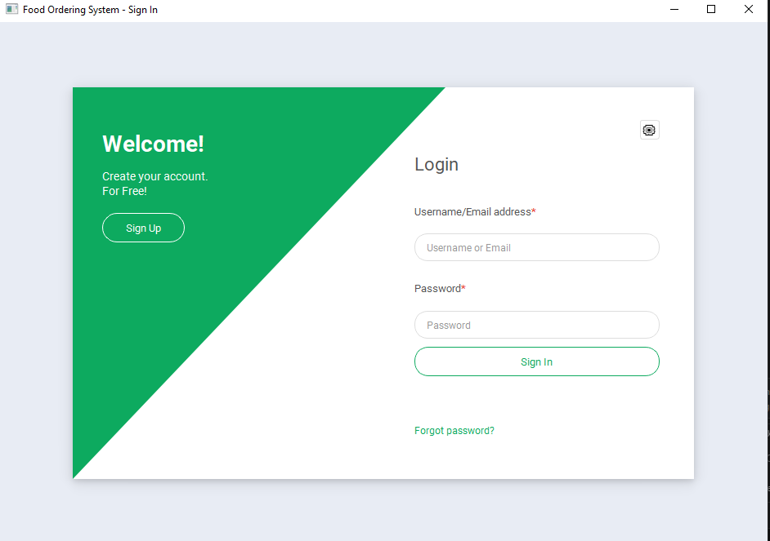
Figure 4. Login Interface
This page allows registered customers to sign in using their username or email and password. It also provides links to create an account, reset a password, and open the admin login.
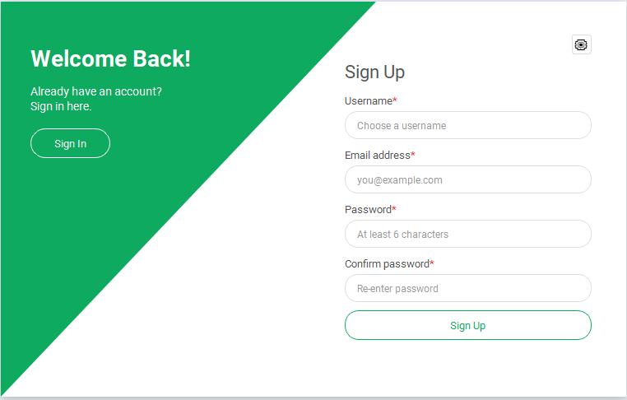
Figure 5. Sign Up Form
This form lets a new customer register by entering a username, email, password, and password confirmation.
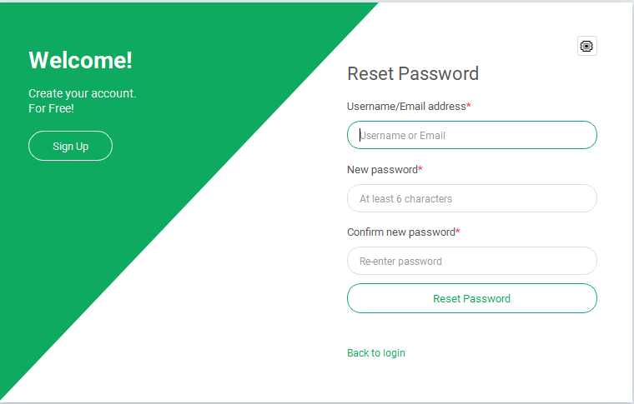
Figure 6. Reset Password Form
This form lets a customer set a new password by entering their username or email and the new password twice.
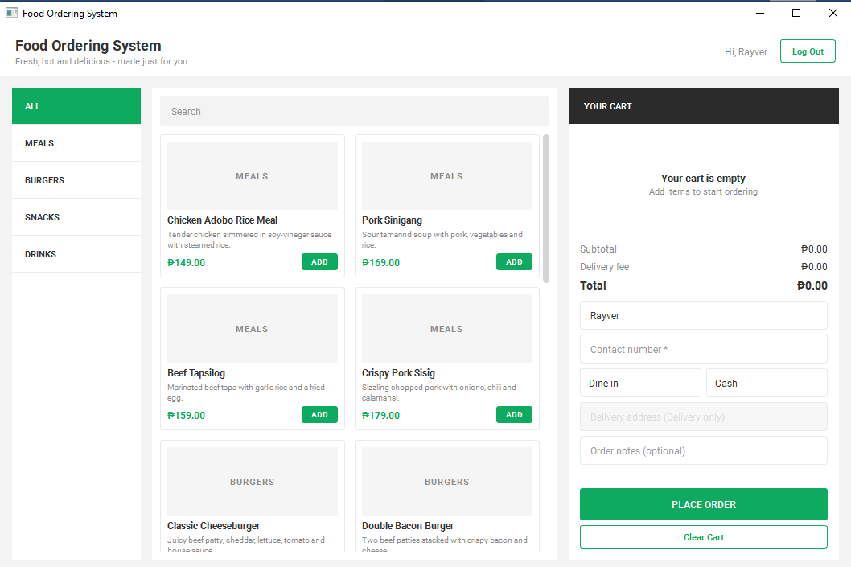
Figure 7. Main Menu (Customer Ordering Screen)
This is the main screen after login. The left sidebar lists the categories, the center shows the food cards with prices and Add buttons, and the right panel shows the cart.
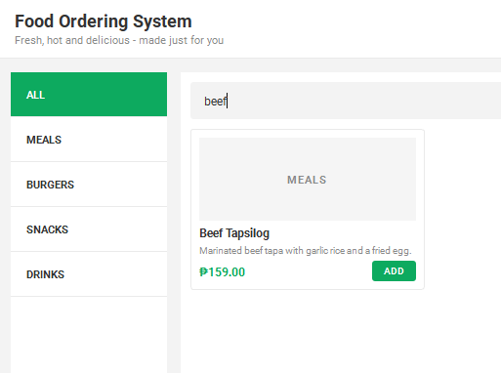
Figure 8. Search and Category Filter
The menu is narrowed down using the search box and category buttons. Only items that match both are displayed.
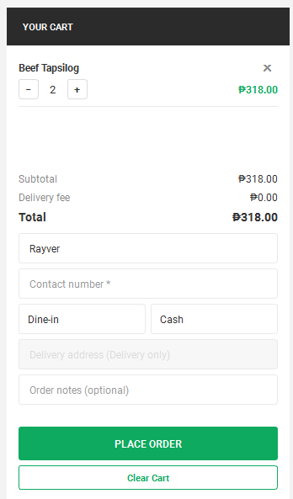
Figure 9. Cart and Checkout Form
The cart panel lists the chosen items with quantity controls, shows the subtotal, delivery fee, and total, and contains the checkout form for name, contact number, order type, payment method, and notes.
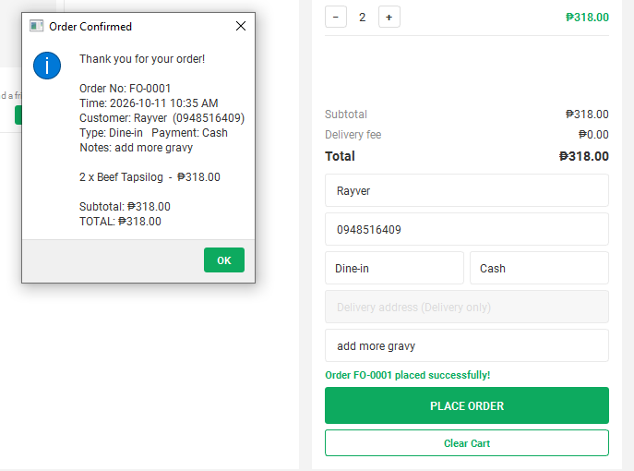
Figure 10. Order Confirmation
After a successful order, a receipt shows the order number, time, customer details, items, and total amount.
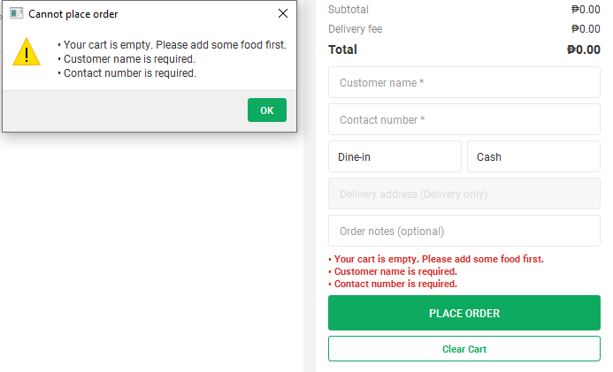
Figure 11. Error Handling: Checkout Validation
When the cart is empty or the customer details are invalid, the system lists every error and does not save the order.
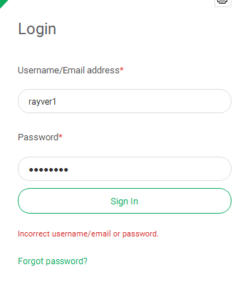
Figure 12. Error Handling: Login Error
When the entered credentials do not match an account, an error message is displayed and the user stays on the login page.
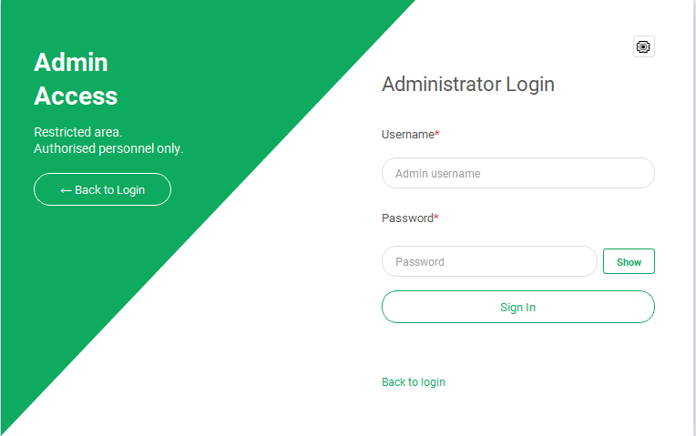
Figure 13. Admin Login
This page restricts the management panel to the administrator by requiring the admin username and password.
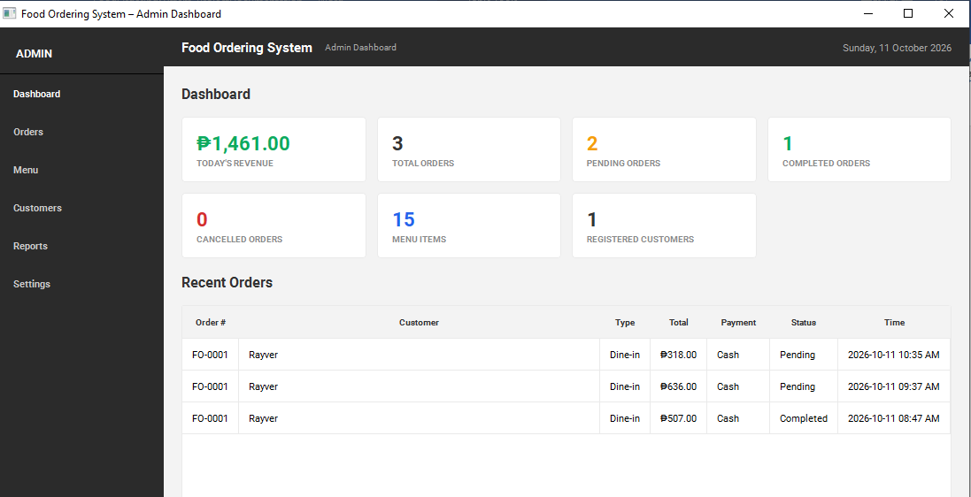
Figure 14. Admin Dashboard
The dashboard shows today's revenue, order counts by status, the number of menu items and customers, and the 20 most recent orders.
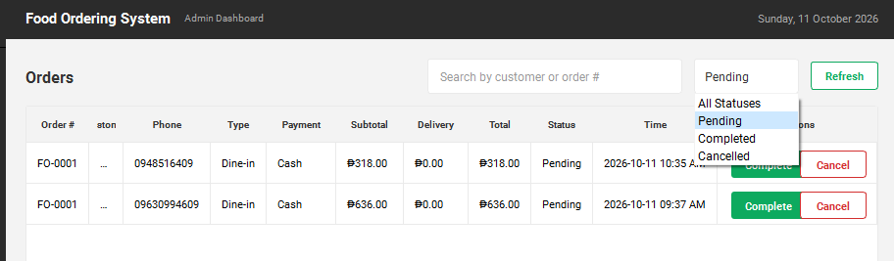
Figure 15. Order Management
The administrator can search orders, filter by status, and mark pending orders as Completed or Cancelled.
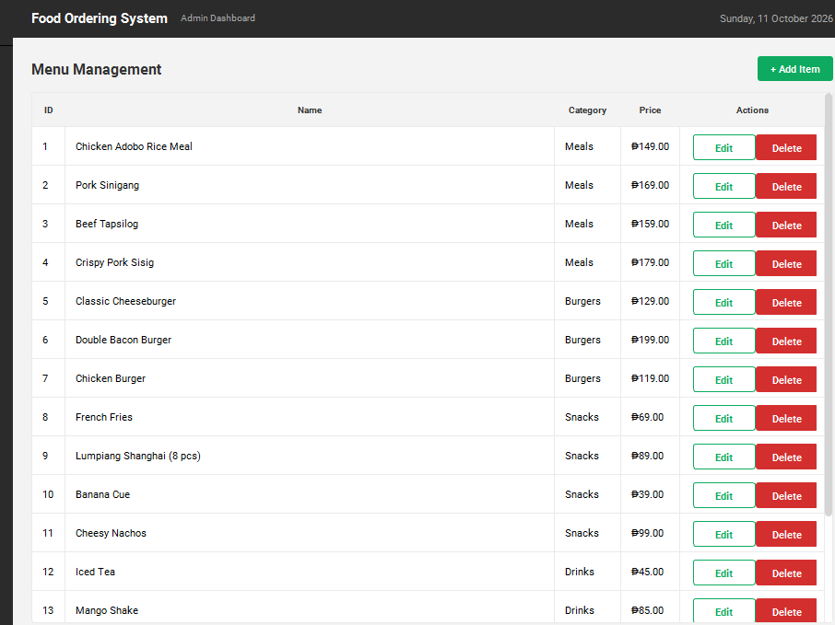
Figure 16. Menu Management
This page lists all menu items and allows the administrator to add, edit, or delete items.
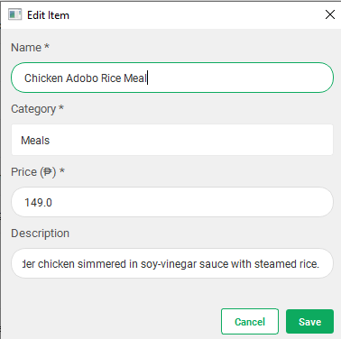
Figure 17. Add/Edit Menu Item Dialog
This dialog collects the item name, category, price, and description and shows an error message when the name is empty or the price is not a number.
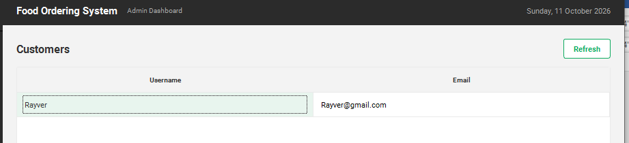
Figure 18. Customers Page
This page lists the usernames and emails of all registered customers.
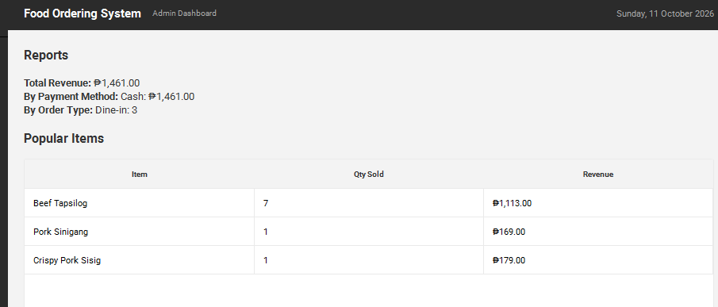
Figure 19. Reports Page
This report shows total revenue, revenue by payment method, orders by type, and the most popular items by quantity sold.
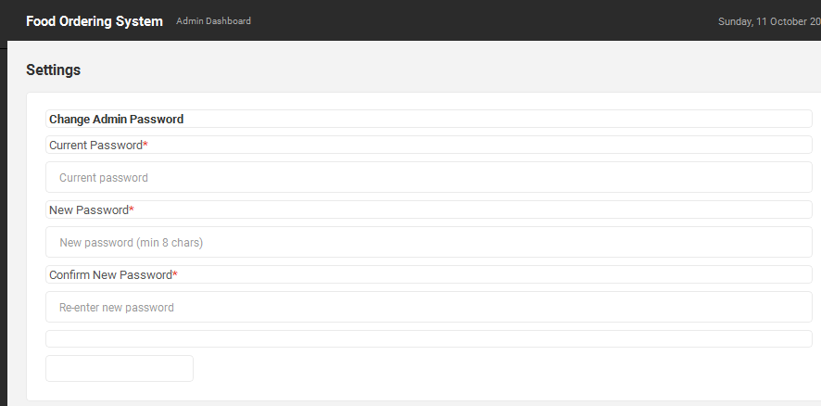
Figure 20. Settings: Change Admin Password
This page lets the administrator change the password after verifying the current one.

10. Testing and Results
The system was tested by running its logic functions (logic.py) with valid and invalid input and comparing the results with the expected output. The tests below cover the cart, validation, order processing, search, and account functions. Interface tests are listed after them.

Logic and Data Tests
Test Case | Expected Result | Actual Result | Status
Add items to cart (item 1 twice, item 8 once) | 3 items in cart | 3 items in cart | Passed
Compute cart subtotal | ₱367.00 | ₱367.00 | Passed
Decrease quantity of item 1 | 2 items in cart | 2 items in cart | Passed
Remove all items | Cart is empty | Cart is empty | Passed
Place order with empty cart | Order rejected | Order rejected | Passed
Place order with blank name | "Customer name is required." | "Customer name is required." | Passed
Place order with phone "abc" | "Contact number must contain 7 to 13 digits." | "Contact number must contain 7 to 13 digits." | Passed
Delivery order without address | "Delivery address is required for Delivery orders." | "Delivery address is required for Delivery orders." | Passed
Delivery order, Classic Cheeseburger (₱129) | Total ₱179.00 (with ₱50 fee), FO-0001 | Total ₱179.00, FO-0001 | Passed
Dine-in order, Double Bacon Burger (₱199) | Total ₱199.00 (no fee), FO-0002 | Total ₱199.00, FO-0002 | Passed
Cart after successful order | Cart is cleared | Cart is cleared | Passed
Search "cheese" in All | Classic Cheeseburger | Classic Cheeseburger | Passed
Filter category Drinks | 4 items | 4 items | Passed
Search "pizza" | No items | No items | Passed
Register valid account | Account created | Account created | Passed
Register duplicate username | "That username is already taken." | "That username is already taken." | Passed
Register username "ab" | Username rule error | Username rule error | Passed
Register email "bad" | "Please enter a valid email address." | "Please enter a valid email address." | Passed
Register password "123" | "Password must be at least 6 characters." | "Password must be at least 6 characters." | Passed
Register mismatched passwords | "Passwords do not match." | "Passwords do not match." | Passed
Login using username | Login successful | Login successful | Passed
Login using email | Login successful | Login successful | Passed
Login with wrong password | "Incorrect username/email or password." | "Incorrect username/email or password." | Passed
Login with empty fields | "Please enter your username/email and password." | "Please enter your username/email and password." | Passed
Reset password, then login with new password | Password updated, login successful | Password updated, login successful | Passed
Reset password for unknown account | "No account found with that username or email." | "No account found with that username or email." | Passed

Interface Tests
The following interface test cases should be performed on the running application, and the actual result and status recorded in the table.
Test Case | Expected Result | Actual Result | Status
Sign in with a valid account | Main ordering window opens
Click a category button | Only items of that category are shown
Click Add on a food card | Item appears in the cart and totals update
Choose Delivery order type | Address field is enabled and ₱50.00 fee is added
Place a valid order | Confirmation receipt shown and order saved
Sign in as admin and click Complete on a pending order | Status changes to Completed

Summary: All 26 logic and data tests produced the expected results and passed.

11. Problems Encountered
The following challenges were faced during development and how they were solved.
Problem | Solution
Circular imports between modules when the menu data, logic, and interface imported each other. | The menu data was placed in menu.py with no imports from other project files, and logic.py was kept free of PyQt6 and gui.py imports.
Business rules mixed with interface code made the program hard to read and test. | All calculations, validation, and account handling were moved to logic.py, and the windows only call those functions.
Storing passwords as plain text was unsafe. | Passwords are stored as salted PBKDF2-SHA256 hashes and compared with hmac.compare_digest().
The menu grid did not fit different window sizes. | The number of columns is computed from the viewport width and the grid is rebuilt on resize.
Orders placed by customers needed to be visible to the administrator after the program closes. | admingui.record_order() saves each order to admin_orders.json, and the admin pages read from that file.
Invalid input such as blank names, wrong phone numbers, or a missing delivery address. | validate_customer() returns a list of error messages which are shown to the user before any order is saved.
Inconsistent fonts and colors across windows. | A shared style sheet and the Roboto font are loaded once in main(), and admingui.py reuses the same colors.

12. Conclusion

What Was Learned
Through this project I learned how to design and build a complete desktop application in Python. I learned how to organize code into modules, create classes and functions, store data using text and JSON files, validate user input, and secure passwords using salted hashing. I also learned how to build a graphical interface with PyQt6 using layouts, widgets, tables, dialogs, and signals.

Skills Developed
- Python programming and modular design
- GUI development with PyQt6
- File handling with JSON and text files
- Input validation and error handling
- Debugging and problem solving
- Technical documentation and diagramming

Importance of the Project
The system shows how a small restaurant can digitize ordering, reduce encoding mistakes, and keep an organized record of orders and sales. It also serves as a practical example of applying programming concepts to a real-world problem.

Recommendations for Future Improvements
- Save menu changes to a file or database so they are not lost when the program closes.
- Generate order numbers from the saved orders so that they never repeat.
- Use a database such as SQLite instead of text and JSON files.
- Add an order history and order status tracking for customers.
- Add menu item images and real online payment integration.
- Add email verification for password reset.
- Add printable receipts and exportable reports (PDF or Excel).
- Package the application as an executable so it can be installed without Python.

13. References
Python Software Foundation. (n.d.). Python 3 documentation. https://docs.python.org/3/
Python Software Foundation. (n.d.). hashlib: Secure hashes and message digests. https://docs.python.org/3/library/hashlib.html
Python Software Foundation. (n.d.). json: JSON encoder and decoder. https://docs.python.org/3/library/json.html
Python Software Foundation. (n.d.). re: Regular expression operations. https://docs.python.org/3/library/re.html
Riverbank Computing. (n.d.). PyQt6 reference guide. https://www.riverbankcomputing.com/static/Docs/PyQt6/
The Qt Company. (n.d.). Qt documentation. https://doc.qt.io/
Google Fonts. (n.d.). Roboto. https://fonts.google.com/specimen/Roboto
Microsoft. (n.d.). Visual Studio Code documentation. https://code.visualstudio.com/docs
Graphviz. (n.d.). Graphviz documentation. https://graphviz.org/documentation/

