4-Bit Arithmetic Logic Unit (ALU) using Verilog

Tools Used
Language: Verilog HDL
Software/IDE: Xilinx Vivado

Kayilainathan J
Linkedin

Description
This project focuses on the design, implementation, and behavioral simulation of a 4-Bit Arithmetic Logic Unit (ALU). The ALU is a purely combinational digital circuit capable of performing eight distinct arithmetic and bitwise logical operations. The design was developed using Verilog HDL and validated through the Xilinx Vivado Design Suite to ensure logical accuracy across various input stimuli.

ALU
An Arithmetic Logic Unit (ALU) is the fundamental building block of a Central Processing Unit (CPU). It serves as the primary engine for mathematical calculation and logical decision-making within a computer system.
- Role in CPU: The ALU receives data from CPU registers, performs an operation based on an "opcode" (selection signal), and outputs the result back to a register.
- Arithmetic Operations: It handles fundamental math such as addition and subtraction.
- Logical Operations: It performs bitwise comparisons (AND, OR, XOR) and shifts, which are essential for data processing and conditional branching.

Functional Table
The ALU accepts two 4-bit inputs (a, b) and a 3-bit selector (select).
Select Code | Operation | Verilog Operator | Description
000 | Addition | a + b | Adds inputs.
001 | Subtraction | a - b | Subtracts B from A.
010 | AND | a & b | Bitwise AND.
011 | OR | a | b | Bitwise OR.
100 | XOR | a ^ b | Bitwise Exclusive OR.
101 | NOT | ~a | Bitwise Inversion of A.
110 | Shift Right | a >> 1 | Logical Right Shift (Divide by 2).
111 | Shift Left | a << 1 | Logical Left Shift (Multiply by 2).

(Note: If the selection is outside the specified range, the result defaults to 0000).

Hardware Architecture (RTL)
The synthesis results confirm a parallel architecture. As seen in the schematic below, the inputs feed into all operation blocks (RTL_ADD, RTL_SUB, RTL_AND, etc.) simultaneously. The RTL_MUX at the end ensures stable output selection.
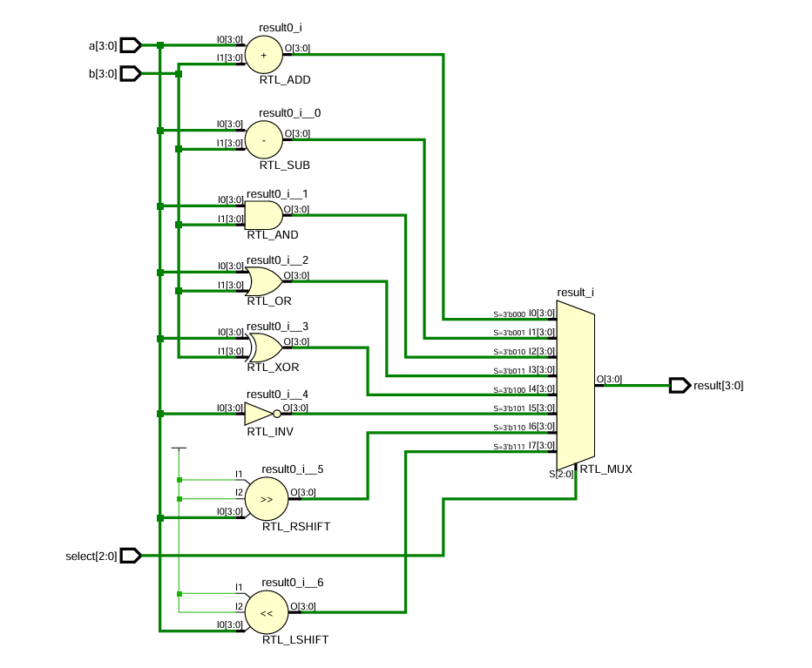

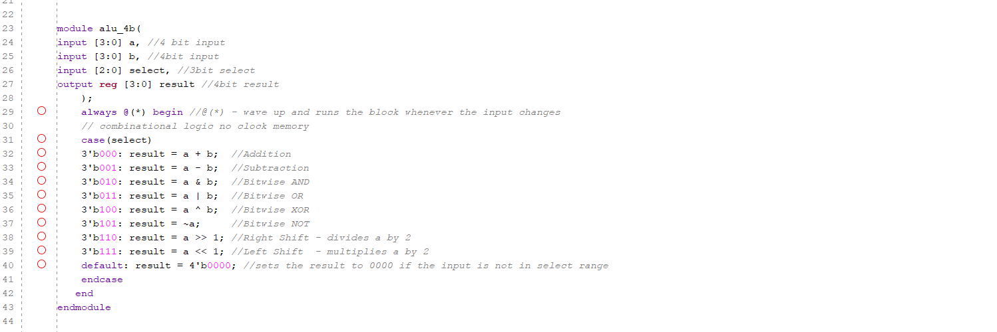
Code
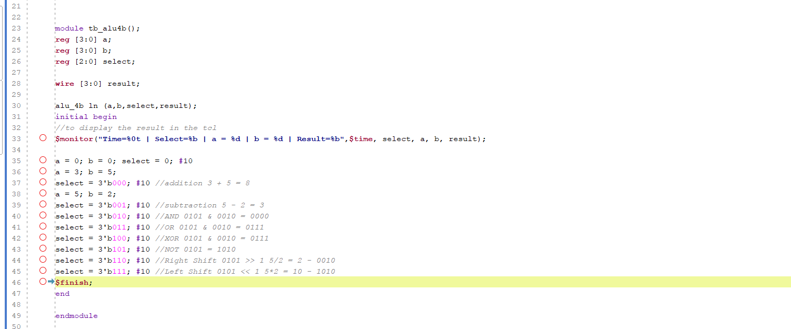
Testbench
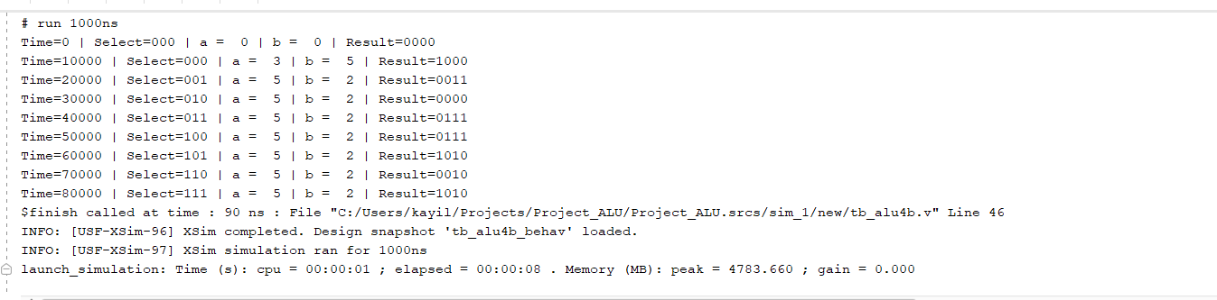
Console Log

Simulation & Analysis
The design was verified using behavioral simulation in Vivado.
Key Observation: Unsigned vs Signed Output In the waveform below, the addition of 3 + 5 results in 8 (Binary 1000).

- Unsigned View: 1000 is correctly displayed as 8.
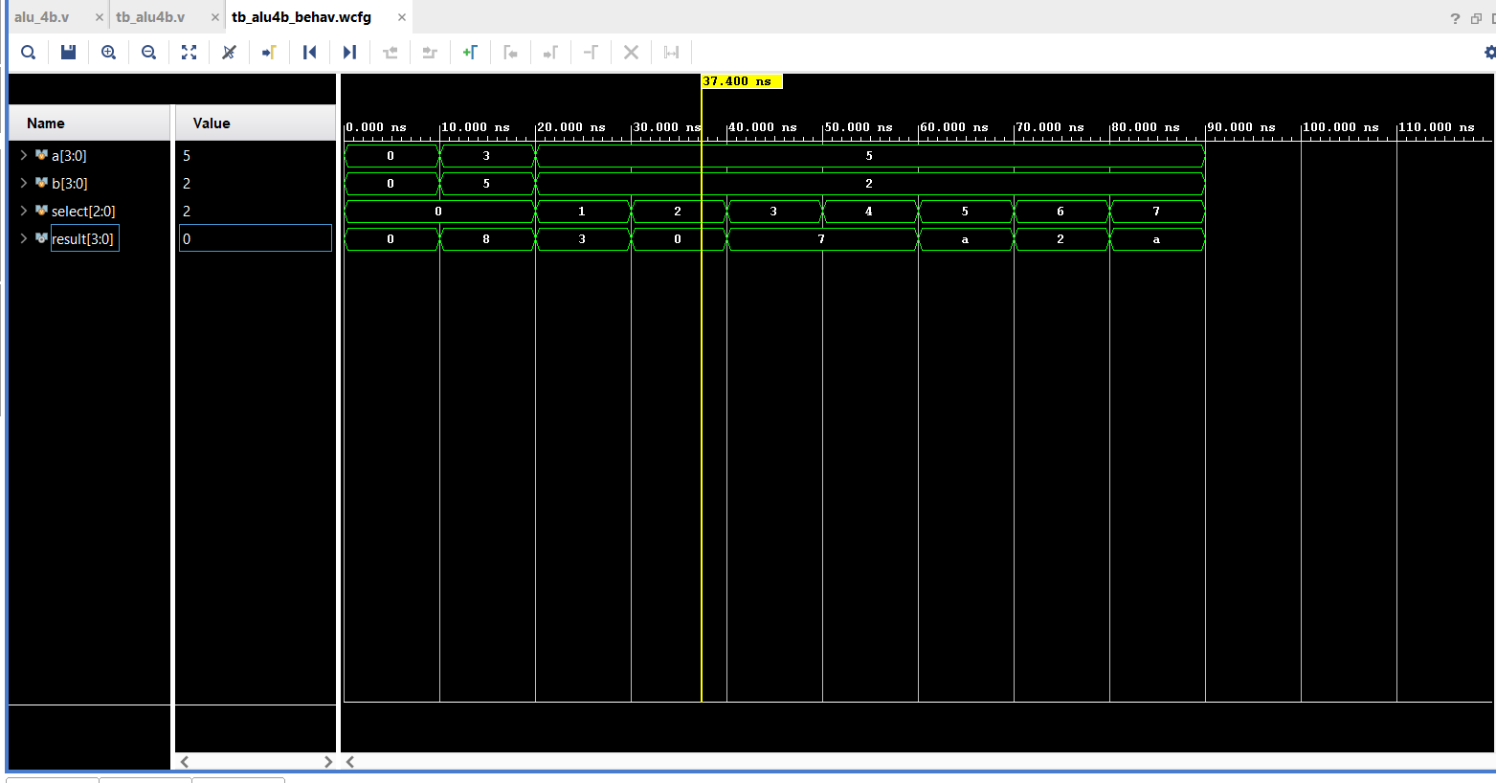
- Signed Context: If interpreted as a 4-bit signed number, 1000 represents -8 (Overflow), as the magnitude exceeds the 4-bit signed limit (+7).
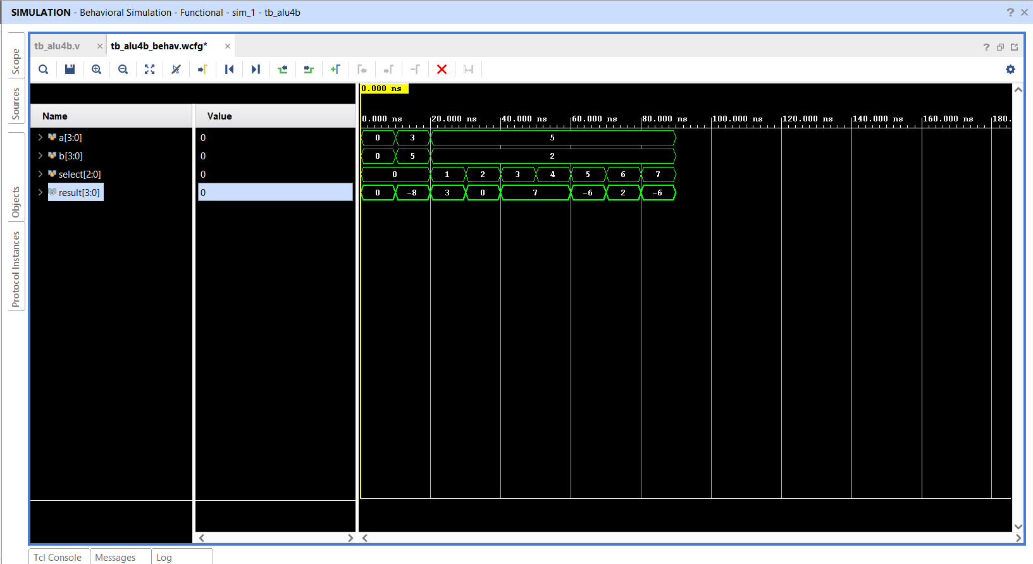

Constraints
- Arithmetic Overflow: Since the output is limited to 4 bits, adding a=3 and b=5 results in 1000. In a 4-bit signed system, the range is -8 to +7, meaning the positive result "8" overflows into the negative range.
Room for Improvement
5th Bit Necessity (Signed & Unsigned)
- The Problem: In the current 4-bit implementation, adding 3 + 5 results in the binary value 1000.
- Unsigned Issue: While the mathematical result is 8, a 4-bit output can only represent up to 15. If a carry occurs at the MSB (e.g., 8+9), the data is lost because there is no 5th bit to store the carry-out.
- Signed Issue: In 2's complement, 1000 is interpreted as -8. Because the result exceeded the 4-bit signed maximum of +7, it "overflowed" into the negative range, leading to an incorrect result for positive addition.
- The Solution: Expanding the result bus to 5 bits allows the ALU to capture the carry bit for unsigned math (representing up to 31) and provides the necessary headroom to represent +8 in signed math without flipping the sign bit.

