**Stock Market**

**# Introduction**

**Investments**

* **Popular types:**
  + Fixed income instruments (Bonds, corporate bonds, Treasury bills, Public Provident Fund)
  + Equity
  + Real states
  + Commodities (bullion gold, silver)

**How exchange of shares happens?**

* **Broker**
  + A corporate entity, registered with a stock exchange
  + Holds a stock broker license
  + Follows SEBI
  + Here, users buys/sells stocks using web/app
  + Services
    - Access to market
    - Provides margin for trading
    - Provides support for call and trade
    - Issue contract notes for the transaction
    - Facilitates fund transfer
    - Broker charge (Brokerage)
* **Exchange**
  + Let’s you trade shares
  + NSE(National Stock Exchange) & BSE(Bombay Stock Exchange)
* **Clearing Corporation**
  + Makes sure shares are exchanged properly with broker
  + Two corporations are:
    - **NSCCL**
      * National Securities Clearing Corporation Limited
      * For NSE
    - **ICCL**
      * Indian Clearing Corporation Limited
      * For BSE
* **Depository**
  + Makes sure shares are deposited with information
  + **NSDL**
    - National Securities Depository Limited
    - For NSE
  + **CDSL**
    - Central Depository Services Ltd
    - For BSE
* **SEBI (Regulator)**
  + Securities and Exchange Board of India
  + Regulates the market
  + Rules, regulations are drafted here
  + RBI of Share market
  + In general, SEBI ensures:
    - *The stock exchange conducts its business fairly*
    - *Stockbrokers conduct their business fairly*
    - *Participants don’t get involved in unfair practices*
    - *Corporates don’t use the markets to benefit themselves*
    - *Small investors’ interests are protected*
    - *Large investors with mega cash piles should not manipulate the markets*
    - *Overall development of markets*

**Why companies list?**

* Suppose a startup is starting
  + Some **angel investor** is investing in it.
    - ***Angel investor*** *means, some wealthy person investing in any business or startup in initial stages*
    - *They have ownership level position coz money is unsecure*
  + After some growth, **venture capitalists** will invest in it
    - ***Venture capitalists****, are people/org. who take equity by giving money*
  + After expanding and years later, they start **IPO** for public so they can invest in companies
    - *IPO, initial public offering*
    - For IPO
      * Companies have a **merchant banker**
      * Merchant banker checks if company is eligible for listing or not by applying to **SEBI**
        + ***SEBI****, Securities and exchange board of India*
      * Then SEBI checks and nods the company
      * Now, companies will final its price and do the listing

**Why companies price fluctuate?**

* Depends on supply and demand.
* If people are buying at given price, price will go up
* Else if people are selling at given price, price will get lower

**Clearing and Settlement process**

* When you buy stock, broker first checks
  + If you have enough funds
  + You have margin/money
  + Now, order is exchanged and transaction is done.
* The day transaction happens, ***T-Day***
* **Buying:**
  + Let’s say we bought some stock on Monday,
  + Now, funds are block till evening
  + T+1 day, Tuesday
  + T+2 day, Wednesday
    - This day we’re credited with share
* **Selling:**
  + Let’s say we are selling some stock on Thursday (T-day)
  + After selling we get **80%** of the money
    - Can’t credit this money (settlement is not complete)
    - But we can buy other shares
  + Similarly, after T+2 days we can withdraw (80+20)% money (settlement is completed) which is Monday coz sat and sun is holiday

**Terminologies**

* **Dividends**
  + Some portion of profit given to shareholders by company
  + Not mandatory
  + Can be done in given time
  + If it’s unscheduled, it’s called special or extra dividends
  + Example:
    - If a person but **100 shares** worth **5rs** each
    - Total **500**
    - Now, company gets profit and announces **dividends of 1rs** per share
    - Hence, that person will get dividends of **+100*1**
* **Bonus**
  + It means extra shares given to shareholders without changing values.
  + Example:

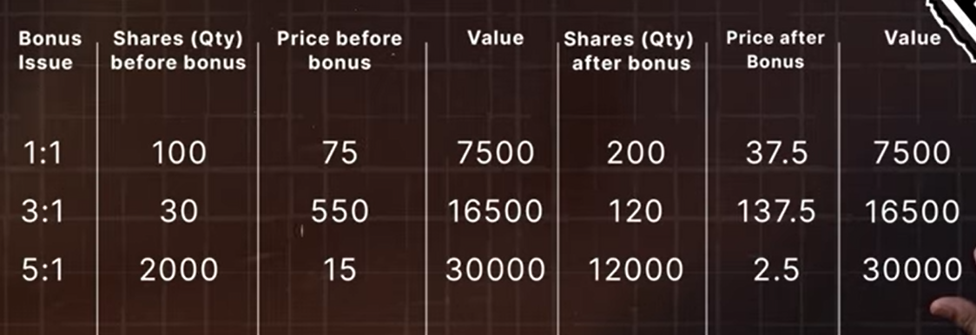

* + - In 1:1 example, from 100 we get 100 extra shares i.e. total 200
    - But value is exactly same i.e. 7500
* **Buybacks**
  + A method used by companies to buy back its share from other investors in market.
  + Reduces the number of shares in the market.
  + Reasons to do it:
    - Improve the profitability in the market
    - Prevent company from take-over
    - Support share prices from declining
  + Main important reason is to show confidence in the company
* **Right issue**
  + Done by company to do something as second IPO
  + It’s for existing shareholders to buy company shares at price lower than the market

**Order types**

1. **CnC**
   * Stands for ***Cash n Carry***
   * Used for long-term or delivery
   * Here, we can buy/sell orders in market value (market order) or limit order(price in which we want to buy/sell)
2. **MIS**
   * Stands for **Margin Intraday Square-off**
   * Used for intraday
     + Follows T+2 selling
   * **Longing**
     + Buying stock in specific value
     + Selling it in greater value
     + So that difference is the profit
   * **Shorting**
     + Selling stock in specific value
     + Buying it in smaller value
     + So that the difference(respectively) is the profit
   * **Entry order**
     + Buys stock in the specified value we set in the stock
   * **Stop-Loss order**
     + Sells stock if it goes to this value
     + Example:
       - We bought stock in 100rs
       - We set SL value 90rs
       - So, if stock price goes to 90rs
       - Due to SL order, stock gets sold
   * **Cover order**
     + Entry order + Stop-Loss order
   * **GTT order**
     + Stands for good till triggered
     + Executes order if it reaches the specified price

**# Fundamental Analysis**

Analyzing a company based on their qualitative and quantitative approach.

**Qualitative approaches** can be:

* **Corporate governance** (system by which companies are governed/operate)
* **Moat of the business** (distinct advantage of a company over its compitition)
* **Competition landscape** (list of options a user can choose from rather than your product)
* **Regulatory environment** (that part of the firm's external marketing environment on which legal and political forces act to change regulations which affect the marketing effort)
* **Promoter background** (helps raise money for some investment)

**Quantitative approaches** can be:

* **Profit and Loss**
* **Cash flow**
* **Balance sheet** (a financial statement that reports company’s assets, liability and shareholder equity)

**Reading Annual Report of a company**

* It includes financial and non-financial statements of a company
* It’s important to know what is important what is not
* For example:
  + Management discussion and analysis
  + Share holder information
  + Consolidated financial info.

**Understanding P&L statement**

* We’ve to focus on every section.
* Total income
  + Revenue + other incomes
* Expanses
* Tax
* Operating Profit = (Total income - expanses)
* Profit after Tax(PAT) = Operating Profit – Tax
* **To look in P&L Statement:**
  + Revenue
  + Significant Expenses
  + Effective tax rates
  + PAT(Profit after Tax)

**Understanding Balance Sheet**

* Consist of Assets and Liabilities.
* **Assets**
  + Any resource that has an economic value that can be used for the future.
  + Two types
    - **Non-current Assets**
      * Long term assets
      * Example:
        + Land, property, machinery, etc
    - **Current Assets**
      * Short term assets
      * Can be converted into cash and it can be selled within a year
* **Liabilities**
  + A future sacrifice of resources by an entity which is obliged to make due to its past transaction of money or service.
  + Two types
    - **Non-current Liabilities**
      * Long term loans, EMIs
    - **Current Liabilities**
      * Enterprise or organization’s dept or obligation that is due within a year
* **To look in Balance Sheet:**
  + Borrowing
  + Account Receivable (money customer owes for receiving goods and services that they haven’t paid yet)
  + Cash available at hand or bank

**Cash Flow Statement**

* Consist of activities:
  + **Operating**
    - Resources used in operating the company
      * Example:
        + Machinery operating cost in the factory
  + **Investing**
    - Investing resources in order to generate more resources for the organization
    - Can be reinvesting in itself in order to increase resource of the organization
  + **Financing**
    - Transaction between company, its lenders and owner to get return on investment
    - It can be debt, dividends, equity
  + **To look in Cash Flow Statement:**
    - Operating
    - Investing
    - Financing

**Financial Ratio**

1. **Profitability Ratios**
   * **Operating profit margin**
     + = (EBITDA) / (Revenue from operations)
       - EBITDA = Total Income – Total Expenses
   * **Profit after Tax(PAT) margin**
     + - = PAT / (Total income)
   * **Return on Equity(ROE)**
     + Ratio measure efficiency with which a company generates profits from each unit of shareholder’s equity
     + = PAT / (Shareholder’s equity)
   * NOTE:
     + We should check PAT and EBITDA margin growing each year
     + **ROE >= 25%**
2. **Leverage Ratios**
   * **Interest Coverage ratio**
     + It tells us how much company is EARNING with respect to INTEREST burden it has
     + = EBITDA / Financial cost (interest obligation)
   * **Debt to Equity ratio**
     + = Debt / Equity
     + Ratio = 1, debt = equity
     + Ratio > 1, debt > equity
     + **Ratio < 1**, debt < equity (**lower it is the better it is**)
3. **Valuation Ratios**
   * It tells us how much a stock is valued and how we react to it
   * **Price to sales ratio**
     + = (current share) / (sales per share)
       - Sales per share = total share / no. of share
   * **Price to Book ratio**
     + Book value = Tangible assets – Liabilities
     + Book value = total equity / total outstanding shares
     + Higher ratio
       - Company is overvalued wrt company’s equity/book value
     + Lower ration
       - Company is undervalued wrt company’s equity/book value
   * **Price to Earning ratio**
     + Earning per share(EPS) = PAT / Total outstanding shares
     + The more it is the more consumers are willing to pay for it

**How to value a company?**

* **Intrinsic value**
  + Discounted cash flow analysis model
    - Considers,
      * Cash flow
      * Growth of cash flow
      * Risk
* **Relative value**
  + Here, we compare different companies of same sector
  + Based on cash flow, price to sales, price to book, debt to equity
* **Option based value**
  + Little complex!!

**# Technical Analysis**