AUTO PARTS
SALES PERFORMANCE ANALYTICS
Microsoft Fabric End-to-End 專案文件
OneLake → Lakehouse → Delta Tables → SQL Endpoint → PySpark → Pipeline → Direct Lake → Report
項目 | 內容
Prepared for | Kay-King Wo
Project period | 2024–2025 synthetic automotive parts sales data
Fabric workspace | AutoParts Analytics - Kay-King Wo
Documentation focus | Fabric 資料工程流程、程式碼、驗證、語意模型與面試說法

本文件記錄本專案在 Microsoft Fabric 中的實作：將四個 CSV 落地至 OneLake，轉成 Delta Tables，透過 SQL Analytics Endpoint 與 PySpark Notebook 建立可重複驗證的商業資料層，再由 Data Pipeline 自動執行轉換，最後建立 Direct Lake Semantic Model 與雲端驗證報表。所有資料皆為合成資料，不含真實公司或客戶資訊。

文件導覽
章節 | 內容重點
1 | 專案摘要、商業目標與最終交付物
2 | Fabric 架構與資料層設計
3 | Workspace、Trial Capacity 與 Lakehouse 建置
4 | CSV 載入、Delta Tables 與 SQL 驗證
5 | PySpark Gold Transformation 與資料品質檢查
6 | Data Pipeline 自動化
7 | Direct Lake Semantic Model 與 DAX Measures
8 | Fabric 驗證報表與跨層 KPI reconciliation
9 | 問題排除、設計取捨與面試說法
Appendix | 完整 SQL、PySpark、DAX 與項目清單

一句話專案描述
Built an end-to-end automotive sales analytics workflow in Microsoft Fabric using OneLake, Lakehouse Delta tables, SQL Analytics Endpoint, PySpark, Data Factory Pipeline, Direct Lake semantic modeling, and Power BI reporting.

最終狀態
- Fabric Trial Capacity：North Europe；Workspace 成功配置至 Fabric 試用容量。
- 四張來源 Delta Tables：dbo.orders（12,000）、dbo.customers（500）、dbo.products（72）、dbo.monthly_targets（96）。
- Reusable SQL View：dbo.vw_sales_details。
- Business-ready Gold Table：dbo.gold_sales_details（12,000 rows, 26 columns）。
- Pipeline：PL_AutoParts_Gold_Refresh，首次執行成功，約 1 分 20 秒。
- Direct Lake Semantic Model：SM_AutoParts_DirectLake；六個核心 Measures。
- Fabric validation report：RPT_AutoParts_Fabric_Validation。

1. 專案摘要與商業目標
本專案模擬一家汽車零件公司的 Sales Performance Analytics 解決方案。前一階段已在 SQL Server 建立關聯式資料庫，並於 Power BI Desktop 完成四頁互動式 Dashboard；Fabric 階段的目標，是將原始資料與商業邏輯移至雲端分析平台，展示資料落地、轉換、自動化、語意模型與報表交付的完整鏈路。
核心問題
管理層需要一致回答：營收與毛利如何、哪些產品與客群貢獻最大、配送準時率是否健康，以及所有 KPI 在 SQL、PySpark 與 Power BI 之間是否使用同一套 business rules。

1.1 Dataset Snapshot
資料表 | 筆數 | 主要用途
orders | 12,000 | 交易事實、折扣、狀態與配送天數
customers | 500 | 客戶名稱、Segment、Country、Region
products | 72 | 產品、Category、Brand、StandardCost
monthly_targets | 96 | 2024–2025 月份 × Region 營收目標

1.2 Fabric Items 與命名規則
類型 | 名稱 | 角色
Workspace | AutoParts Analytics - Kay-King Wo | 所有 Fabric items 的專案容器
Lakehouse | AutoParts_Lakehouse | OneLake Files、Delta Tables 與 SQL Endpoint
SQL View | dbo.vw_sales_details | SQL 可重複使用的商業明細層
Notebook | NB_AutoParts_Gold_Transformation | PySpark Join、計算與 QA
Pipeline | PL_AutoParts_Gold_Refresh | 自動執行 Notebook 並重建 Gold Table
Gold Table | dbo.gold_sales_details | 分析就緒的單表資料層
Semantic Model | SM_AutoParts_DirectLake | Direct Lake + DAX Measures
Report | RPT_AutoParts_Fabric_Validation | Fabric-native KPI 驗證報表

命名中的 NB、PL、SM、RPT 分別代表 Notebook、Pipeline、Semantic Model、Report。這種前綴讓工作區中的項目可快速辨識，也便於在面試或 README 中描述。

2. Fabric 架構與資料層設計
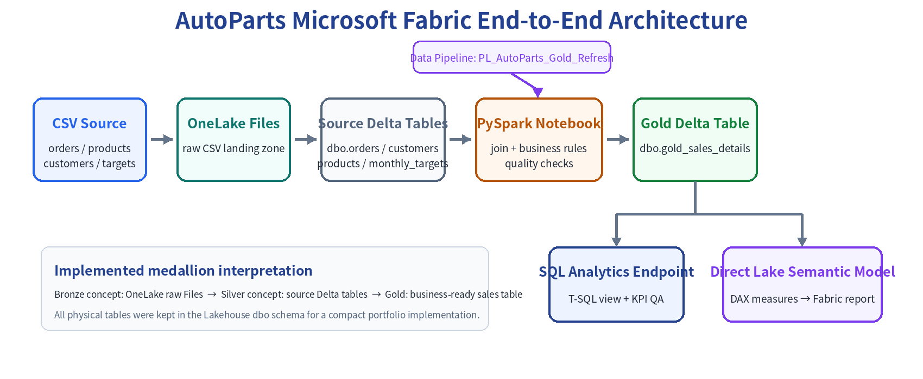
Figure 1. AutoParts Microsoft Fabric end-to-end architecture

2.1 資料層概念
層次 | 本專案實作 | 目的
Raw / Bronze concept | OneLake Files 中的四個原始 CSV | 保留未轉換的來源檔，便於追溯與重載
Source / Silver concept | dbo.orders、customers、products、monthly_targets | 將 CSV 轉為可供 Spark、SQL、Power BI 共用的 Delta Tables
Gold | dbo.gold_sales_details | 完成 Join、business rules 與資料品質檢查的分析就緒資料

實作取捨
本專案以作品集規模在單一 Lakehouse 的 dbo schema 中實作，沒有額外建立 bronze / silver / gold schemas。文件使用 medallion 概念描述資料成熟度，但不誇大實際物理結構。

2.2 本機 Power BI Import 與 Fabric Direct Lake 的差異
面向 | Power BI Desktop 版本 | Fabric 版本
資料來源 | 本機 SQL Server | OneLake Lakehouse Delta Tables
模型模式 | Import model in PBIX | Direct Lake Semantic Model
資料工程 | SQL staging / views | Lakehouse + PySpark Notebook + Pipeline
更新考量 | 發布後本機 SQL 通常需要 Gateway | 資料與模型同在 Fabric / OneLake
報表角色 | 完整四頁作品集 Dashboard | 精簡 Fabric-native validation report

3. Fabric 環境與 Workspace 建置
專案使用 Fabric + Power BI 60 天 Trial Capacity，建立於 North Europe。工作區建立時選擇 Fabric 試用版容量，確保 Lakehouse、Notebook、Pipeline 與 Direct Lake 等 Fabric workloads 可用。
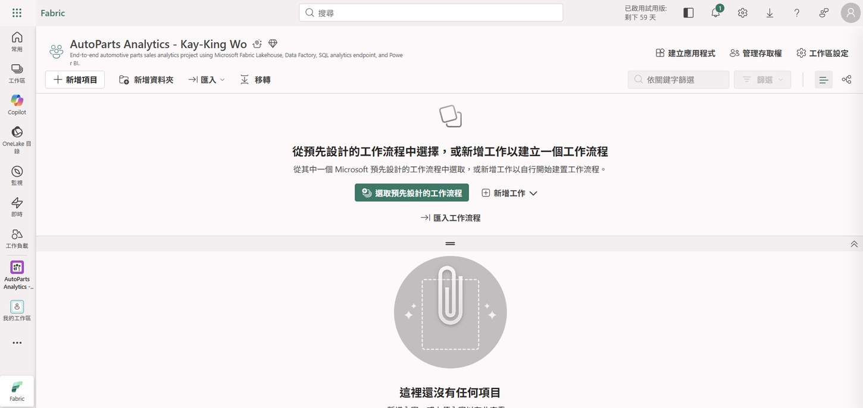
Figure 2. Fabric Workspace with project description and Trial capacity

3.1 Workspace 設定
設定 | 值 / 決策
Name | AutoParts Analytics - Kay-King Wo
Description | End-to-end automotive parts sales analytics project using Microsoft Fabric Lakehouse, Data Factory, SQL analytics endpoint, and Power BI.
Capacity | Fabric Trial – North Europe
Domain | 留空；作品集不需要組織網域
Template app | 不啟用

重要實務：Workspace 即使可使用 Power BI Pro，也必須配置到 Fabric capacity 才能建立 Lakehouse、Notebook 與 Pipeline。

4. Lakehouse、CSV 載入與 Delta Tables

4.1 Raw Files Landing
在 AutoParts_Lakehouse 的 Files 區上傳 customers.csv、monthly_targets.csv、orders.csv、products.csv。此步保留原始檔案；後續「載入至資料表」另建立 Delta Tables，不會刪除原始 CSV。
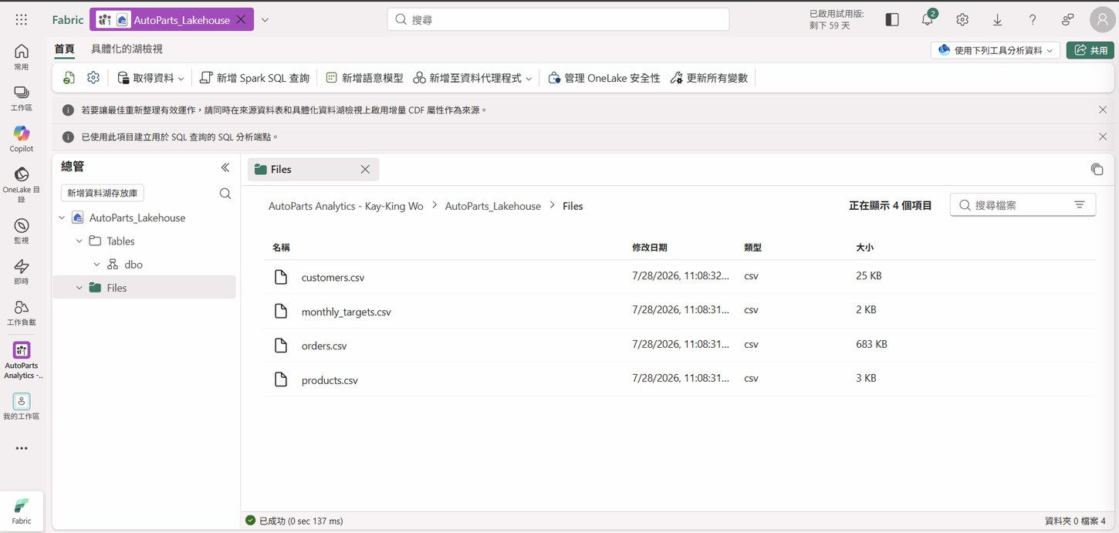
Figure 3. Four source CSV files stored in the Lakehouse Files area

4.2 CSV → Delta Tables
每個 CSV 使用 Load to Tables → New table，Schema 選 dbo，勾選 column header，分隔符號為逗號。Fabric 自動推斷欄位型別；因此載入後需逐表檢查筆數與型別。
Table | Rows | Selected type checks
dbo.customers | 500 | CustomerID integer；SignupDate date
dbo.products | 72 | StandardCost / ListPrice decimal
dbo.monthly_targets | 96 | YearMonth datetime；RevenueTarget decimal
dbo.orders | 12,000 | OrderDate date；DeliveryDays nullable integer；UnitPrice / DiscountPct decimal

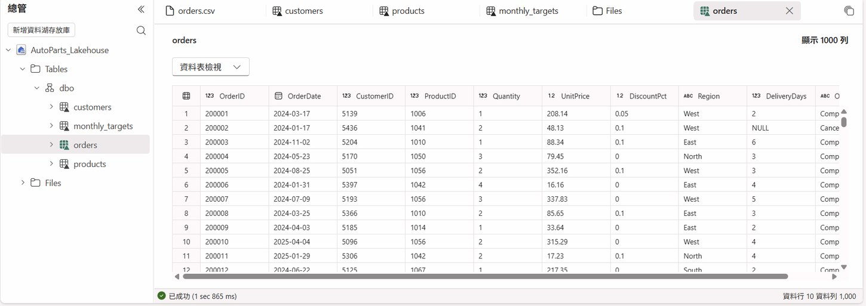
Figure 4. Orders Delta Table preview and inferred data types
預覽筆數陷阱
Orders 預覽右上角顯示 1,000 rows，只代表預覽上限，不代表實際只載入 1,000 筆。實際筆數必須用 SQL COUNT(*) 或 Spark count() 驗證。

4.3 SQL Analytics Endpoint：來源筆數驗證
SELECT 'customers' AS TableName, COUNT(*) AS TotalRows
FROM dbo.customers
UNION ALL
SELECT 'products', COUNT(*) FROM dbo.products
UNION ALL
SELECT 'monthly_targets', COUNT(*) FROM dbo.monthly_targets
UNION ALL
SELECT 'orders', COUNT(*) FROM dbo.orders;

TableName | TotalRows
customers | 500
products | 72
monthly_targets | 96
orders | 12,000

第一次查詢曾使用 RowCount 作為 alias，Fabric T-SQL 回報 Incorrect syntax near the keyword RowCount。改用 TotalRows 後成功；這提醒我們避免將 T-SQL 關鍵字直接作為未加括號的欄位別名。

5. SQL 商業 View 與 KPI Reconciliation

5.1 dbo.vw_sales_details
SQL View 將 orders、customers、products 以 LEFT JOIN 組合，並封裝 Revenue、EstimatedCost、GrossProfit、IsOnTime 等商業欄位。其定義與先前 Power BI Measures 使用相同 business rules。
Business field | Definition
GrossSales | Quantity × UnitPrice
DiscountAmount | GrossSales × DiscountPct
NetSalesBeforeStatus | Quantity × UnitPrice × (1 − DiscountPct)
Revenue | Completed 訂單才計入 NetSalesBeforeStatus；其他為 0
EstimatedCost | Completed 訂單才計入 Quantity × StandardCost；其他為 0
GrossProfit | Completed 訂單：Revenue − EstimatedCost；其他為 0
IsOnTime | 非 Completed = NULL；Completed 且 DeliveryDays ≤ 4 = 1；否則 0

Business-rule consistency
SQL View、PySpark Gold Table 與 Direct Lake DAX 使用相同 KPI 定義，因此不同技術層的數字能互相 reconciliation，而不是各自產生「另一個版本的真相」。

5.2 核心 KPI 驗證結果
KPI | Result | Interpretation
Total order rows | 12,000 | 來源資料粒度：一列一張訂單
Completed Orders | 10,527 | 只計算 OrderStatus = Completed
Total Revenue | 約 4.33 million | Completed 訂單折扣後營收
Gross Profit | 約 1.71 million | Revenue − Estimated Cost
Gross Margin | 39.5% | Gross Profit ÷ Revenue
On-Time Delivery Rate | 72.6% | IsOnTime = 1 ÷ Completed Orders

6. PySpark Notebook：Gold Transformation
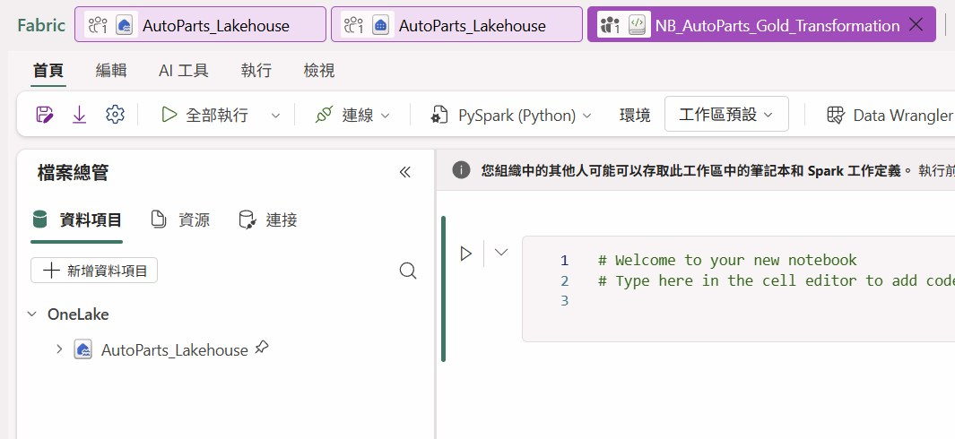
Figure 5. Notebook connected to AutoParts_Lakehouse using PySpark

6.1 讀取來源 Delta Tables
orders_df = spark.table("dbo.orders")
customers_df = spark.table("dbo.customers")
products_df = spark.table("dbo.products")
monthly_targets_df = spark.table("dbo.monthly_targets")
print(f"Orders row count: {orders_df.count():,}")

Notebook 以 schema-qualified 名稱 dbo.table 讀取同一 Lakehouse 的 Delta Tables。第一次執行 Spark session 可能需要啟動時間，但成功後 orders_df.count() 回傳 12,000。

6.2 Join 與可重複使用計算 expression
gross_sales_expr = F.col("o.Quantity") * F.col("o.UnitPrice")
discount_amount_expr = gross_sales_expr * F.col("o.DiscountPct")
net_sales_expr = gross_sales_expr * (F.lit(1.0) - F.col("o.DiscountPct"))
estimated_cost_expr = F.col("o.Quantity") * F.col("p.StandardCost")
joined_df = (
orders_df.alias("o")
.join(customers_df.alias("c"), F.col("o.CustomerID") == F.col("c.CustomerID"), "left")
.join(products_df.alias("p"), F.col("o.ProductID") == F.col("p.ProductID"), "left")
)

將商業運算先抽成 expressions，可避免 Revenue、Gross Profit 等欄位重複寫出不一致公式。LEFT JOIN 保留所有 Orders，並透過後續 QA 檢查是否存在 unmatched customer/product。

6.3 Gold 欄位設計
Group | Selected columns
Order | OrderID, OrderDate, OrderYear, OrderMonth, Quantity, UnitPrice, DiscountPct, DeliveryDays, OrderStatus
Customer | CustomerID, CustomerName, CustomerSegment, Country, Region
Product | ProductID, ProductName, Category, Brand, StandardCost
Calculated | GrossSales, DiscountAmount, NetSalesBeforeStatus, Revenue, EstimatedCost, GrossProfit, IsOnTime

6.4 Data Quality Gate
quality_summary = gold_sales_df.agg(
F.count("*").alias("TotalRows"),
F.countDistinct("OrderID").alias("DistinctOrderIDs"),
F.sum(F.when(F.col("CustomerName").isNull(), 1).otherwise(0)).alias("MissingCustomerMatches"),
F.sum(F.when(F.col("ProductName").isNull(), 1).otherwise(0)).alias("MissingProductMatches"),
F.sum(F.when((F.col("OrderStatus") == "Completed") & F.col("DeliveryDays").isNull(), 1).otherwise(0))
.alias("CompletedOrdersMissingDeliveryDays")
)

Check | Expected / Result | Why it matters
TotalRows | 12,000 | Join 後沒有少資料
DistinctOrderIDs | 12,000 | Join 沒有把訂單重複放大
MissingCustomerMatches | 0 | 所有 CustomerID 均能匹配
MissingProductMatches | 0 | 所有 ProductID 均能匹配
CompletedOrdersMissingDeliveryDays | 0 | 準時率分母具備可靠配送資料

6.5 寫入 Gold Delta Table
target_table = "dbo.gold_sales_details"
(
gold_sales_df.write
.format("delta")
.mode("overwrite")
.option("overwriteSchema", "true")
.saveAsTable(target_table)
)
saved_gold_df = spark.table(target_table)
print(f"Row count: {saved_gold_df.count():,}")

mode("overwrite") 讓 Pipeline 每次執行時重建目前版本的 Gold Table；overwriteSchema 允許欄位結構依 Notebook 邏輯更新。這適合目前全量 refresh 的小型作品集資料。
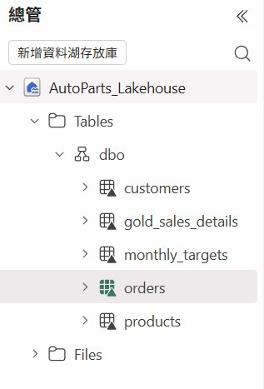
Figure 6. Gold table visible under the Lakehouse dbo schema

7. Data Pipeline 自動化
Pipeline PL_AutoParts_Gold_Refresh 只包含一個 Notebook Activity：Run_Gold_Transformation。Activity 綁定 NB_AutoParts_Gold_Transformation，執行整本 Notebook，完成來源讀取、Join、QA 與 Gold Table overwrite。
Pipeline setting | Value
Activity name | Run_Gold_Transformation
Activity status | Enabled
Workspace | AutoParts Analytics - Kay-King Wo
Notebook | NB_AutoParts_Gold_Transformation
Base parameters | None
First run | Succeeded; approximately 1 minute 20 seconds

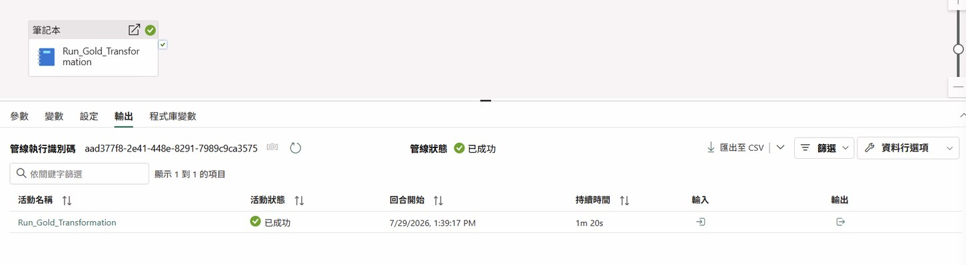
Figure 7. Successful Fabric Pipeline execution history
Operational meaning
Notebook 是 transformation logic；Pipeline 是 orchestration layer。把 Notebook 放進 Pipeline 後，流程可以重複執行、監控、查看歷史，也可在未來加入 schedule 或其他 activities。

8. Direct Lake Semantic Model 與 DAX
從 Lakehouse 建立 SM_AutoParts_DirectLake，僅選取 dbo.gold_sales_details。此模型作為精簡 Fabric-native validation layer，不重做原本四頁 Power BI Desktop Dashboard，也未納入 monthly_targets，因此不包含 Revenue Target / Achievement measures。
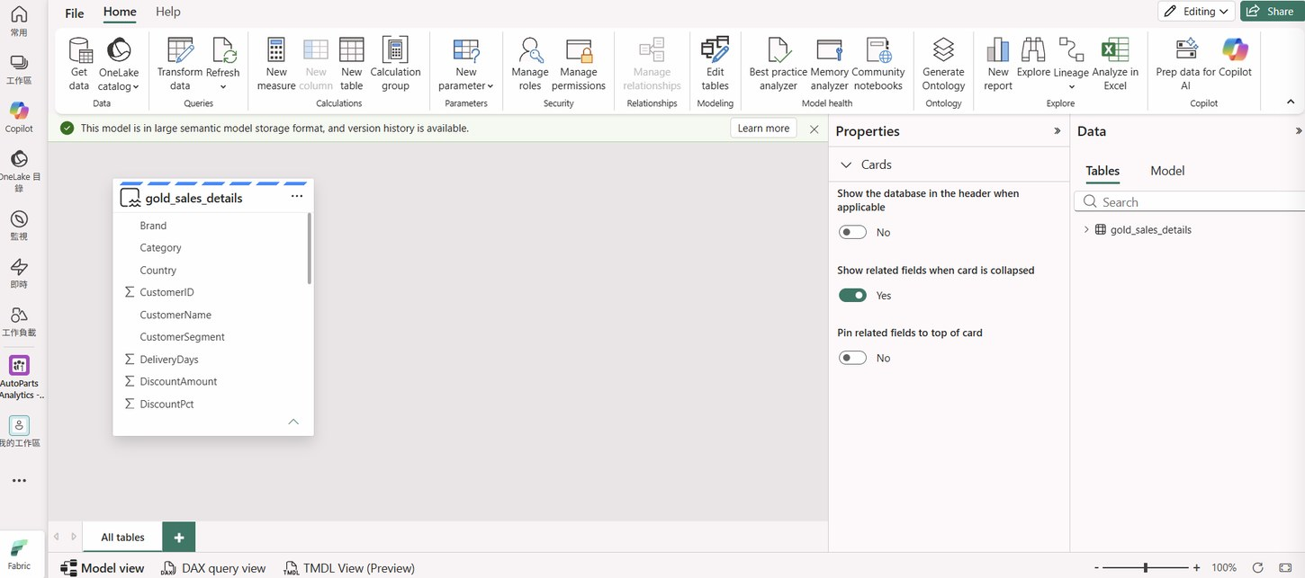
Figure 8. Direct Lake semantic model containing gold_sales_details

8.1 核心 Measures
Measure | DAX / Purpose
Total Revenue | SUM(gold_sales_details[Revenue])
Gross Profit | SUM(gold_sales_details[GrossProfit])
Gross Margin % | DIVIDE([Gross Profit], [Total Revenue], 0)
Completed Orders | DISTINCTCOUNT(OrderID), filtered to OrderStatus = Completed
On-Time Deliveries | DISTINCTCOUNT(OrderID), filtered to IsOnTime = 1
On-Time Delivery Rate | DIVIDE([On-Time Deliveries], [Completed Orders], 0)

Revenue 與 Gross Profit 的 DAX 比 Desktop 版本更簡單，因為 Gold Table 已在 PySpark 層把非 Completed 訂單的值設為 0。這是將 business logic 前移至資料層的結果。

8.2 為何仍保留 Measure，而不是直接拖欄位
- Measure 會依 report filter context 重新計算，適合作為正式 KPI。
- 欄位名稱與顯示格式可集中管理。
- Gross Margin 與 On-Time Rate 屬於比例，必須透過 Measure 計算，不能直接加總原始列。
- DISTINCTCOUNT(OrderID) 可降低未來資料粒度改變造成重複計算的風險。

9. Fabric Validation Report
RPT_AutoParts_Fabric_Validation 以六張 KPI Card 驗證 Direct Lake 模型：Total Revenue、Gross Profit、Gross Margin %、Completed Orders、On-Time Deliveries、On-Time Delivery Rate。此報表的目標是證明 Fabric-native chain 正常，不取代已完成的四頁作品集 Dashboard。
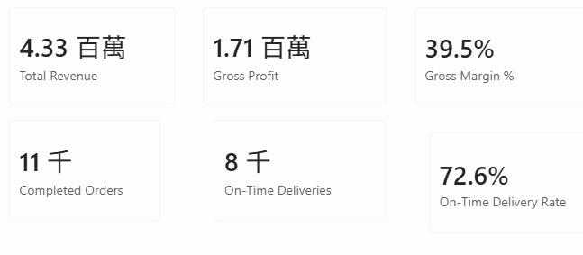
Figure 9. Fabric validation report with six Direct Lake KPI cards
格式取捨
網頁版 Card 將 10,527 顯示為「11 千」、On-Time Deliveries 顯示為「8 千」。因為這是技術驗證頁，而核心 KPI 已於 SQL 與 Power BI 完整核對，所以未額外投入時間微調顯示單位。作品集主視覺仍以 polished Power BI Desktop 四頁報表為主。

10. 跨層 KPI Reconciliation
KPI logic | SQL View | PySpark Gold | DAX Measure
Revenue | CASE WHEN Completed THEN net sales ELSE 0 | when Completed → net_sales_expr, else 0 | SUM(Revenue)
Estimated Cost | Completed → Quantity × StandardCost | 相同條件與公式 | 可由 Gold 欄位加總
Gross Profit | Revenue − Estimated Cost | net_sales_expr − estimated_cost_expr | SUM(GrossProfit)
Completed Orders | Completed order rows / distinct IDs | Gold 保留 OrderID 與 status | DISTINCTCOUNT filtered Completed
On-Time | Completed and DeliveryDays ≤ 4 | IsOnTime = 1 / 0 / NULL | DISTINCTCOUNT filtered IsOnTime = 1
On-Time Rate | On-time ÷ Completed | 可由 Gold 欄位重算 | DIVIDE(On-Time, Completed)

驗證結果：Gold Delta Table 與 SQL View 的 TotalRows、CompletedOrders、TotalRevenue、TotalGrossProfit、OnTimeDeliveryRatePct 完全一致；Direct Lake report 亦顯示相同的 4.33M Revenue、1.71M Gross Profit、39.5% Gross Margin、10,527 Completed Orders、72.6% On-Time Rate。
面試亮點
I reconciled KPI definitions across SQL, PySpark, and DAX to prevent metric drift. Revenue only includes completed orders after discount, and on-time delivery is defined as completed orders delivered within four days.

11. 問題排除與實務學習
Issue | Observed behavior | Resolution / Lesson
RowCount alias | Incorrect syntax near keyword RowCount | 改用 TotalRows；避免未加括號的保留字
Orders preview | 只顯示 1,000 rows | 預覽上限；用 SQL COUNT(*) / Spark count() 驗證 12,000
New Gold table not visible immediately | SQL Endpoint 或 Explorer 尚未出現 | Refresh / 等待 Lakehouse metadata sync
First Pipeline run queued | Activity 顯示 queued / in progress | 等待 Spark resources 啟動，不重複送出執行
Card display units | 10,527 顯示為 11 千 | 屬視覺格式；驗證頁可接受，正式 Dashboard 已有完整格式
SQL vs DAX order count | SQL row count 與 DAX distinct count 概念不同 | 先確認 grain；目前一列一訂單，未來多明細列應用 DISTINCTCOUNT

11.1 技術設計取捨
- 使用單一 Gold Table 建立 Direct Lake model，降低 portfolio scope，專注證明雲端資料鏈路。
- 保留原本 Power BI Desktop 星型模型與四頁 Dashboard 作為主要視覺作品，不在 Fabric 重複建置。
- 使用全量 overwrite，而非 incremental load；對 12,000 筆合成資料更簡潔且容易說明。
- SQL View 與 Gold Table 並存，用來展示 T-SQL 與 PySpark 可以對同一 business rules 進行交叉驗證。

12. 履歷、Portfolio 與面試使用方式

12.1 Resume Bullets（English）
- Built an end-to-end automotive sales analytics workflow in Microsoft Fabric, ingesting CSV data into OneLake and Lakehouse Delta tables, transforming 12,000 orders with PySpark, and orchestrating refreshes through a Data Factory pipeline.
- Created a business-ready Gold sales table and reconciled revenue, gross profit, completed-order, and on-time-delivery KPIs across T-SQL, PySpark, and DAX to ensure consistent metric definitions.
- Developed a Direct Lake semantic model and Fabric-native Power BI validation report, complementing a four-page Power BI Desktop dashboard connected to SQL Server.

12.2 60 秒面試說法
Interview pitch
I started with four synthetic automotive sales CSV files and loaded them into a Microsoft Fabric Lakehouse. I converted them into Delta tables, validated them through the SQL Analytics Endpoint, and created a reusable sales view. In a PySpark notebook, I joined orders with customer and product dimensions, calculated revenue, cost, gross profit, and delivery KPIs, then added quality checks to prevent duplicate or unmatched records. I saved the result as a Gold Delta table and automated the notebook with a Fabric pipeline. Finally, I built a Direct Lake semantic model with DAX measures and reconciled the results against my SQL and Power BI implementation.

12.3 誠實能力定位
可描述為 hands-on portfolio experience with Microsoft Fabric：能理解並操作 Lakehouse、Delta Tables、SQL Analytics Endpoint、PySpark Notebook、Pipeline、Direct Lake Semantic Model 與 Power BI 報表。這不等同於多年 production Fabric 經驗；面試時應強調端到端實作、資料品質思維與跨層 KPI consistency。

Appendix A. SQL 程式碼

A.1 CREATE VIEW dbo.vw_sales_details
CREATE VIEW dbo.vw_sales_details AS
SELECT
o.OrderID,
o.OrderDate,
YEAR(o.OrderDate) AS OrderYear,
MONTH(o.OrderDate) AS OrderMonth,
o.CustomerID,
c.CustomerName,
c.CustomerSegment,
c.Country,
o.Region,
o.ProductID,
p.ProductName,
p.Category,
p.Brand,
o.Quantity,
o.UnitPrice,
o.DiscountPct,
p.StandardCost,
o.DeliveryDays,
o.OrderStatus,
CAST(o.Quantity * o.UnitPrice AS DECIMAL(18,2)) AS GrossSales,
CAST(o.Quantity * o.UnitPrice * o.DiscountPct AS DECIMAL(18,2)) AS DiscountAmount,
CAST(o.Quantity * o.UnitPrice * (1.0 - o.DiscountPct) AS DECIMAL(18,2)) AS NetSalesBeforeStatus,
CASE WHEN o.OrderStatus = 'Completed'
THEN CAST(o.Quantity * o.UnitPrice * (1.0 - o.DiscountPct) AS DECIMAL(18,2))
ELSE CAST(0 AS DECIMAL(18,2)) END AS Revenue,
CASE WHEN o.OrderStatus = 'Completed'
THEN CAST(o.Quantity * p.StandardCost AS DECIMAL(18,2))
ELSE CAST(0 AS DECIMAL(18,2)) END AS EstimatedCost,
CASE WHEN o.OrderStatus = 'Completed'
THEN CAST((o.Quantity * o.UnitPrice * (1.0 - o.DiscountPct))
- (o.Quantity * p.StandardCost) AS DECIMAL(18,2))
ELSE CAST(0 AS DECIMAL(18,2)) END AS GrossProfit,
CASE WHEN o.OrderStatus <> 'Completed' THEN NULL
WHEN o.DeliveryDays <= 4 THEN 1
ELSE 0 END AS IsOnTime
FROM dbo.orders AS o
LEFT JOIN dbo.customers AS c ON o.CustomerID = c.CustomerID
LEFT JOIN dbo.products AS p ON o.ProductID = p.ProductID;

A.2 Gold Table vs SQL View Validation
SELECT
'Gold Delta Table' AS DataLayer,
COUNT(*) AS TotalRows,
SUM(CASE WHEN OrderStatus = 'Completed' THEN 1 ELSE 0 END) AS CompletedOrders,
CAST(SUM(Revenue) AS DECIMAL(18,2)) AS TotalRevenue,
CAST(SUM(GrossProfit) AS DECIMAL(18,2)) AS TotalGrossProfit,
CAST(100.0 * SUM(CASE WHEN IsOnTime = 1 THEN 1 ELSE 0 END)
/ NULLIF(SUM(CASE WHEN OrderStatus = 'Completed' THEN 1 ELSE 0 END),0)
AS DECIMAL(10,1)) AS OnTimeDeliveryRatePct
FROM dbo.gold_sales_details
UNION ALL
SELECT
'SQL View', COUNT(*),
SUM(CASE WHEN OrderStatus = 'Completed' THEN 1 ELSE 0 END),
CAST(SUM(Revenue) AS DECIMAL(18,2)),
CAST(SUM(GrossProfit) AS DECIMAL(18,2)),
CAST(100.0 * SUM(CASE WHEN IsOnTime = 1 THEN 1 ELSE 0 END)
/ NULLIF(SUM(CASE WHEN OrderStatus = 'Completed' THEN 1 ELSE 0 END),0)
AS DECIMAL(10,1))
FROM dbo.vw_sales_details;

Appendix B. PySpark Gold Transformation
from pyspark.sql import functions as F
orders_df = spark.table("dbo.orders")
customers_df = spark.table("dbo.customers")
products_df = spark.table("dbo.products")
monthly_targets_df = spark.table("dbo.monthly_targets")
gross_sales_expr = F.col("o.Quantity") * F.col("o.UnitPrice")
discount_amount_expr = gross_sales_expr * F.col("o.DiscountPct")
net_sales_expr = gross_sales_expr * (F.lit(1.0) - F.col("o.DiscountPct"))
estimated_cost_expr = F.col("o.Quantity") * F.col("p.StandardCost")
joined_df = (
orders_df.alias("o")
.join(customers_df.alias("c"), F.col("o.CustomerID") == F.col("c.CustomerID"), "left")
.join(products_df.alias("p"), F.col("o.ProductID") == F.col("p.ProductID"), "left")
)
gold_sales_df = joined_df.select(
F.col("o.OrderID").alias("OrderID"),
F.col("o.OrderDate").alias("OrderDate"),
F.year(F.col("o.OrderDate")).alias("OrderYear"),
F.month(F.col("o.OrderDate")).alias("OrderMonth"),
F.col("o.CustomerID").alias("CustomerID"),
F.col("c.CustomerName").alias("CustomerName"),
F.col("c.CustomerSegment").alias("CustomerSegment"),
F.col("c.Country").alias("Country"),
F.col("o.Region").alias("Region"),
F.col("o.ProductID").alias("ProductID"),
F.col("p.ProductName").alias("ProductName"),
F.col("p.Category").alias("Category"),
F.col("p.Brand").alias("Brand"),
F.col("o.Quantity").alias("Quantity"),
F.col("o.UnitPrice").alias("UnitPrice"),
F.col("o.DiscountPct").alias("DiscountPct"),
F.col("p.StandardCost").alias("StandardCost"),
F.col("o.DeliveryDays").alias("DeliveryDays"),
F.col("o.OrderStatus").alias("OrderStatus"),
gross_sales_expr.cast("decimal(18,2)").alias("GrossSales"),
discount_amount_expr.cast("decimal(18,2)").alias("DiscountAmount"),
net_sales_expr.cast("decimal(18,2)").alias("NetSalesBeforeStatus"),
F.when(F.col("o.OrderStatus") == "Completed", net_sales_expr)
.otherwise(F.lit(0)).cast("decimal(18,2)").alias("Revenue"),
F.when(F.col("o.OrderStatus") == "Completed", estimated_cost_expr)
.otherwise(F.lit(0)).cast("decimal(18,2)").alias("EstimatedCost"),
F.when(F.col("o.OrderStatus") == "Completed", net_sales_expr - estimated_cost_expr)
.otherwise(F.lit(0)).cast("decimal(18,2)").alias("GrossProfit"),
F.when(F.col("o.OrderStatus") != "Completed", F.lit(None).cast("int"))
.when(F.col("o.DeliveryDays") <= 4, F.lit(1))
.otherwise(F.lit(0)).alias("IsOnTime")
)
quality_summary = gold_sales_df.agg(
F.count("*").alias("TotalRows"),
F.countDistinct("OrderID").alias("DistinctOrderIDs"),
F.sum(F.when(F.col("CustomerName").isNull(),1).otherwise(0)).alias("MissingCustomerMatches"),
F.sum(F.when(F.col("ProductName").isNull(),1).otherwise(0)).alias("MissingProductMatches"),
F.sum(F.when((F.col("OrderStatus") == "Completed") & F.col("DeliveryDays").isNull(),1).otherwise(0))
.alias("CompletedOrdersMissingDeliveryDays")
)
target_table = "dbo.gold_sales_details"
(gold_sales_df.write.format("delta").mode("overwrite")
.option("overwriteSchema","true").saveAsTable(target_table))

Appendix C. Direct Lake DAX Measures
Total Revenue =
SUM(gold_sales_details[Revenue])
Gross Profit =
SUM(gold_sales_details[GrossProfit])
Gross Margin % =
DIVIDE([Gross Profit], [Total Revenue], 0)
Completed Orders =
CALCULATE(
DISTINCTCOUNT(gold_sales_details[OrderID]),
gold_sales_details[OrderStatus] = "Completed"
)
On-Time Deliveries =
CALCULATE(
DISTINCTCOUNT(gold_sales_details[OrderID]),
gold_sales_details[IsOnTime] = 1
)
On-Time Delivery Rate =
DIVIDE([On-Time Deliveries], [Completed Orders], 0)

C.1 Portfolio Completion Checklist
Deliverable | Status
SQL Server project documentation | Completed
Power BI four-page dashboard | Completed
Power BI end-to-end documentation | Completed
Microsoft Fabric end-to-end implementation | Completed
Microsoft Fabric documentation | Completed by this document
Portfolio case study / README | Next step

Document prepared from the implemented project workflow as of 29 July 2026. All metrics and item names reflect the completed synthetic AutoParts analytics project.

