A Prototype of a Barangay Resident Profiling and Household Management System
Kristine Kylle Niñal
Mindanao State University - Iligan Institute of Technology, Iligan City, 9200, Philippines
Abstract
The Adopt-a-Barangay project is a concept project, offering innovative ideas for managing barangay profiling. It provides a digital approach to organizing resident information and streamlining administrative processes. The project seeks to find a way to improve resident profiling, data management, and service delivery through a web application. Featuring search functionality, real-time data analytics, and print capabilities, the system supports efficient governance and service delivery. The project aligns with Sustainable Development Goals, by encouraging inclusivity, effective urban management, and institutional transparency. Developed using JavaScript, React, Bootstrap, and Redis, its core functions include resident and household management, analytics, user authentication, and search.

- Introduction
1.1 Overview
The Adopt-a-Barangay project is an initiative aimed at modernizing barangay administrative processes through the development of a web application designed to improve efficiency in resident profiling. This project is rooted in the principle of leveraging technology to enhance local governance and community development. By transitioning from traditional manual systems to digital solutions, the project seeks to address key inefficiencies in barangay management, particularly in maintaining and accessing resident records. The adoption of a centralized digital platform will streamline data collection, storage, and retrieval, thereby improving service delivery and facilitating more informed decision-making at the barangay level. This initiative underscores the importance of utilizing technology to foster community growth and resilience while promoting transparency and accountability in governance.
The project aligns with the Sustainable Development Goals (SDGs), particularly SDG 10 (reducing inequalities), SDG 11 (sustainable cities and communities), and SDG 16 (strong institutions) [1]. By implementing an efficient digital system, the project ensures that all residents, regardless of their socio-economic background, have equal access to barangay services, thereby reducing inequalities. Additionally, by modernizing administrative processes and enhancing data accessibility, the project contributes to building sustainable communities that are better equipped to handle population growth and resource management challenges. Furthermore, strengthening barangay institutions through improved data management and decision-making mechanisms supports the establishment of transparent and accountable governance structures, aligning with the goal of fostering strong institutions.
Barangay administrative processes and resident profiling are often plagued by inefficiencies, primarily due to reliance on paper-based records and manual data entry. These traditional methods are prone to human error, data loss, and delays in service delivery. The inability to quickly access accurate resident information hampers the barangay’s ability to provide timely assistance, plan community programs, and allocate resources effectively. Additionally, the lack of a structured digital system makes it difficult to analyze population demographics, track community trends, and generate reports essential for governance and development planning. By addressing these challenges, the project aims to create a more organized, efficient, and responsive barangay administration.
1.2 Key Features and Functionalities
A key feature of the web application is its transition from manual, paper-based processes to a fully digital system, which significantly enhances operational efficiency. The application will provide an intuitive and user-friendly interface that simplifies data entry, updating, and retrieval. Barangay officials will be able to easily manage resident records, reducing the time and effort required for administrative tasks. The shift from paper to electronic records will not only improve data accuracy and security but also minimize storage costs and environmental impact. Moreover, digitization will enhance the barangay’s capacity to handle large volumes of information efficiently, ensuring that critical resident data is always accessible and up to date.
The project will incorporate easy-to-understand graphical representations of resident data, facilitating better analysis and decision-making. Visual tools such as charts and dashboards will allow barangay officials to identify trends, monitor demographic shifts, and assess the effectiveness of community programs. These visual elements will be dynamically updated in real-time, ensuring that officials always have access to the most current information. By integrating data visualization, the system enhances the ability of barangay leaders to make data-driven decisions, improve public service efficiency, and proactively address community needs.
1.3 Objectives and Significance
The primary objectives of the Adopt-a-Barangay project include streamlining resident profiling to ensure accurate and up-to-date records, and enhancing decision-making processes by providing real-time insights into barangay demographics. The system will feature search functionality, allowing officials to quickly retrieve resident information based on various attributes. Additionally, the integration of visual analytics will enable barangay leaders to assess community needs, allocate resources effectively, and develop strategic plans for local development. These objectives are designed to optimize administrative processes, enhance service delivery, and promote inclusive governance.
The significance of the Adopt-a-Barangay project lies in its transformative impact on barangay operations, residents, and local governance. By modernizing administrative processes, the project will enhance service delivery, reduce bureaucratic inefficiencies, and improve transparency. Residents will benefit from faster and more accessible public services, as well as increased engagement in community programs. For barangay officials, the system provides a structured and reliable platform to manage data, make informed decisions, and implement policies effectively. Ultimately, the project serves as a stepping stone toward building smarter and more sustainable barangays, ensuring that local governance keeps pace with the evolving needs of the community.
1.4 Scope and Limitations
The scope of the project encompasses resident profile management, search functionality, and analytics while acknowledging certain limitations, such as internet dependency. The resident profile management module will store comprehensive information about barangay residents, including personal details, household composition, and community participation. The search functionality will allow users to filter and locate resident data efficiently. The analytics component will provide valuable insights through data-driven reports and visualizations. While the system offers numerous benefits, potential limitations such as the need for reliable internet connectivity and hardware components availability must be considered and addressed.
- Methodology
2.1 Application Development
The development of the Adopt-a-Barangay web application followed a structured methodology focused on designing and implementing a functional, efficient, and user-friendly system. The methodology encompassed front-end development, back-end development, and core features that address the key needs of barangay administration. The approach ensured the application’s usability, and effectiveness in improving resident profiling and governance processes.
2.2 Front-end Development
The front-end of the application was developed using JavaScript, HTML, and CSS, with React serving as the primary framework to ensure a dynamic and responsive user interface [2]. Bootstrap was integrated to provide a clean and professional design while maintaining mobile responsiveness [3]. React’s component-based architecture facilitated modular development, allowing for easy maintenance and scalability. The front-end design prioritized simplicity and efficiency, enabling barangay officials to navigate the platform seamlessly and perform tasks with minimal training.
2.3 Back-end Development
The back-end of the application was developed using Redis as the NoSQL database, providing efficient data storage and management capabilities [4]. Redis was chosen for its high-speed data access and ability to handle large datasets, ensuring optimal performance. The API, tested using Postman, was designed to support one-to-one and one-to-many relationships for structured data handling, ensuring smooth integration with the front-end. Security measures were implemented to safeguard data integrity, including authentication mechanisms to restrict access to authorized users [5].
- Results and Discussion
3.1 System Features and Functionalities
The Barangay Profiling System was designed with a range of features to streamline the management of resident and household data, ensuring accurate and efficient community record-keeping. It offers modules for managing resident profiles and households, allowing users to easily add, update, and delete records. To enhance usability and productivity, the system also includes a keyword-based search function, printing capabilities for documentation, and data analytics tools that generate insightful reports and visualizations. Security is a key component, with user authentication restricting system access to authorized personnel only.
3.1.1 Resident Profile Management
The system includes a resident profile management feature, allowing users to add, update, and delete resident records. This functionality ensures that barangay officials can maintain accurate and up-to-date demographic information, facilitating better governance and decision-making.
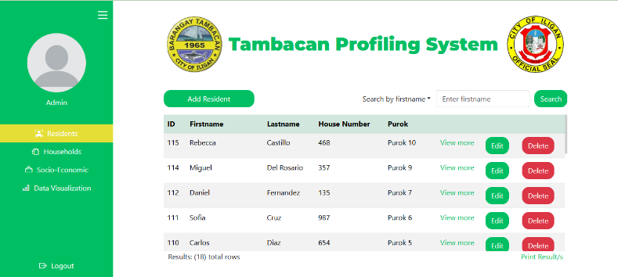
Fig. 1. Residents Page

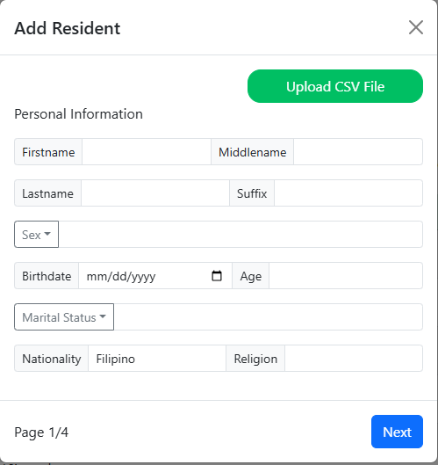
Fig. 2. Create Resident
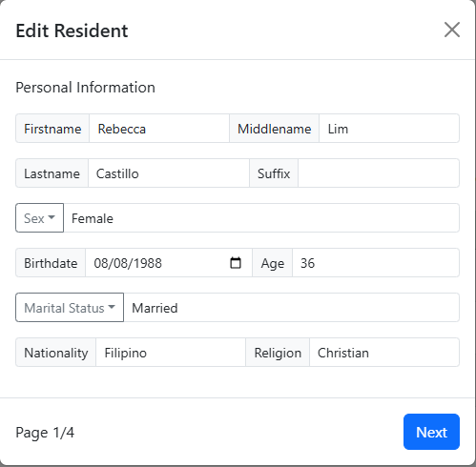
Fig. 3. Update Resident

3.1.2 Household Management
A household management module enables users to add, update, and delete household records, ensuring a comprehensive understanding of the barangay’s population structure. This feature supports the efficient organization of family units within the community, improving resource allocation and service delivery.
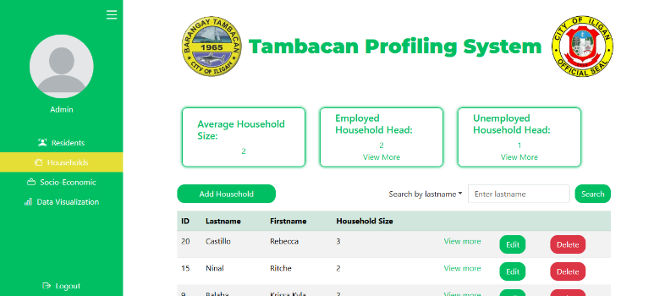
Fig. 4. Household Page

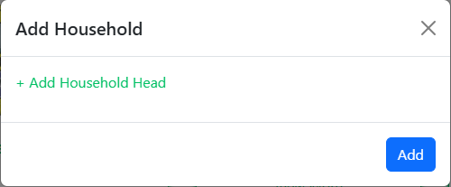
Fig. 5. Create Household
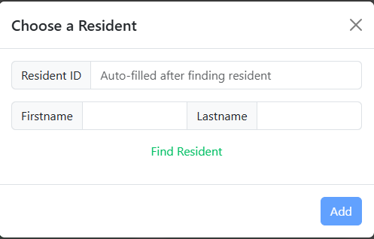
Fig. 6. Choosing a member from the Residents
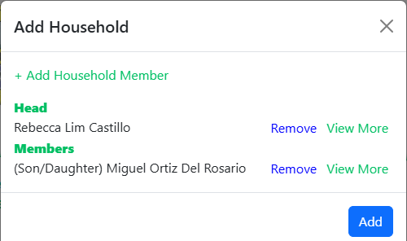
Fig. 7. Add Household Member/s
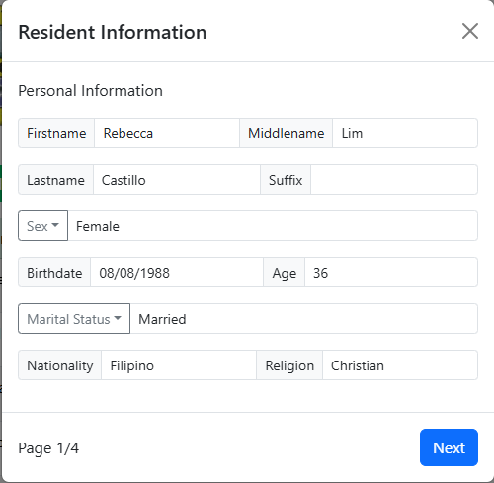
Fig. 8. View member data for verification

3.1.3 Search Functionality
A keyword-based search functionality was integrated into the system, enabling quick and efficient resident lookups. This feature allows barangay officials to retrieve resident information instantaneously, reducing administrative delays and improving service efficiency.
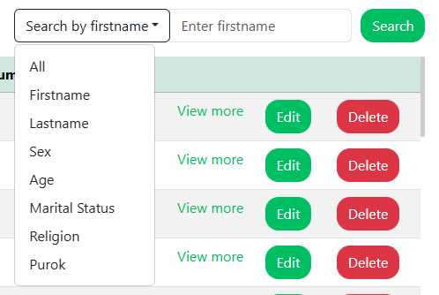
Fig. 9. Searching in Residents
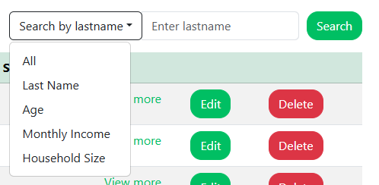
Fig. 10. Searching in Households

3.1.4 Print Functionality
Allows barangay officials to print lists of residents or households based on search results, ensuring easy documentation.

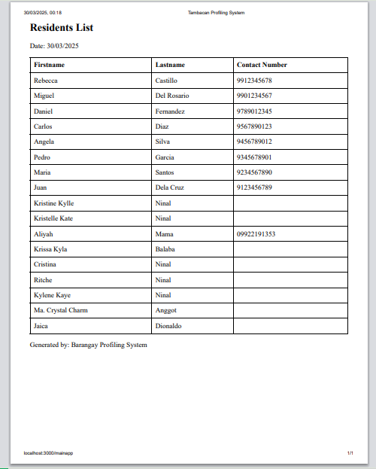
Fig. 11. Print Residents List
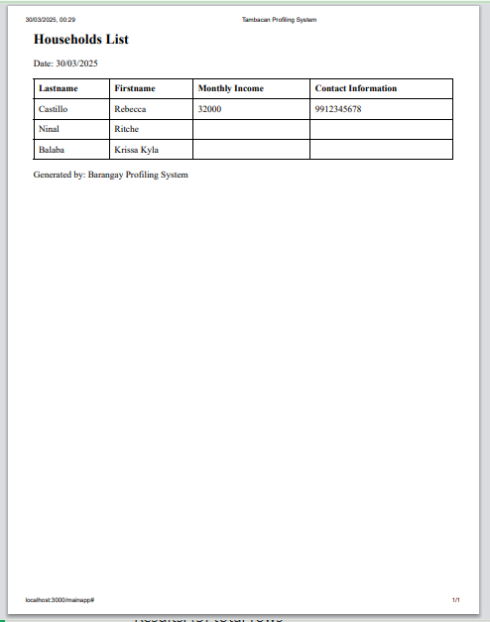
Fig. 12. Print Households List

3.1.5 Data Analytics and Reporting
The application includes data analytics and reporting capabilities, generating statistics and reports on demographics, socioeconomic trends, and other key insights. Visual representations, such as graphs and charts, provide real-time updates, allowing barangay officials to make data-driven decisions.

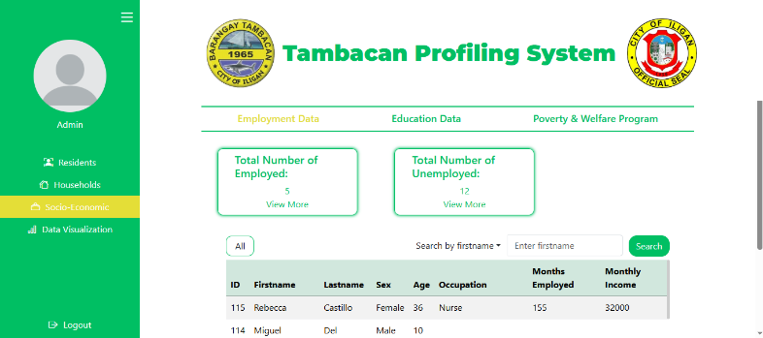
Fig. 13. Employment Data
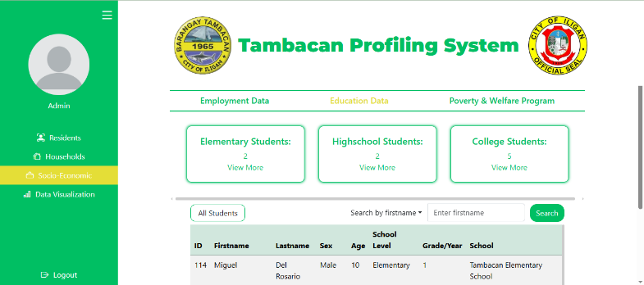
Fig. 14. Education Data
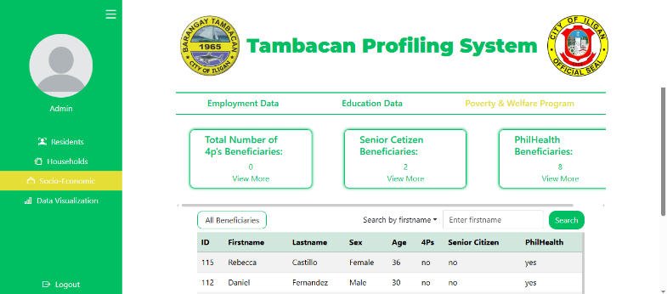
Fig. 15. Poverty & Welfare Data
3.1.6 User Authentication and Security
A secure login mechanism was implemented to ensure that only authorized users, specifically only the barangay administrator, have access to the system. This security measure protects sensitive resident data and prevents unauthorized access, reinforcing the integrity of the platform.
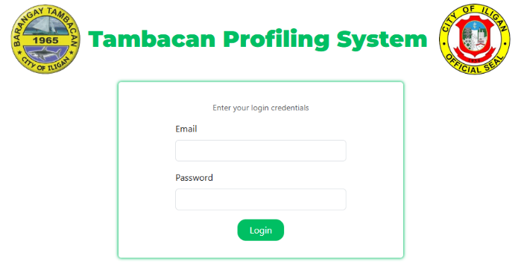
Fig. 16. Login Page
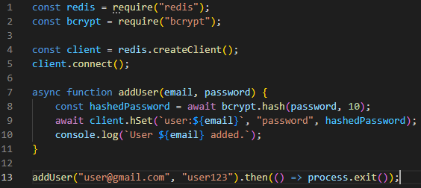
Fig. 17. Implementation of Authentication
- Conclusion and Recommendation
The Adopt-a-Barangay project can potentially modernized barangay administrative processes by transitioning from manual record-keeping to an efficient digital system. The web application can improved resident profiling, data management, and service delivery, ultimately enhancing governance and decision-making. By integrating search functionality, real-time data analytics, and print capabilities, the system can streamline operations and increased accessibility for barangay officials. The project also contributed to Sustainable Development Goals (SDGs) 10, 11, and 16 by promoting inclusivity, efficient urban management, and institutional transparency.
Despite this, the project encountered some limitations, including data constraints and the challenge of integrating digital systems with existing barangay workflows. Ensuring user adoption and providing adequate training remain crucial for maximizing the system’s impact. Additionally, reliance on internet connectivity may pose challenges in areas with limited access.
Future enhancements could include more features integrating other barangay workflows, AI-driven analytics for predictive insights, mobile app integration for wider accessibility, and enhanced security measures to protect sensitive resident data. These improvements would further strengthen the system’s capabilities and ensure its long-term sustainability in barangay governance.
References
[1] United Nations. (2015). Sustainable Development Goals. Retrieved from https://sdgs.un.org/goals
[2] React. (2021). React Documentation. Retrieved from https://reactjs.org/docs/getting-started.html
[3] Bootstrap. (2021). Bootstrap Framework. Retrieved from https://getbootstrap.com/
[4] Redis. (2021). Redis Documentation. Retrieved from https://redis.io/docs/
[5] Postman. (2021). Postman Documentation. Retrieved from https://learning.postman.com/docs/

