Assignment #12

Kayla Jamar

a)A sample run of your program with input given above (input is next to the title of the window)

b) Sample run with all parameters fixed except the number of queues (verbose =off)

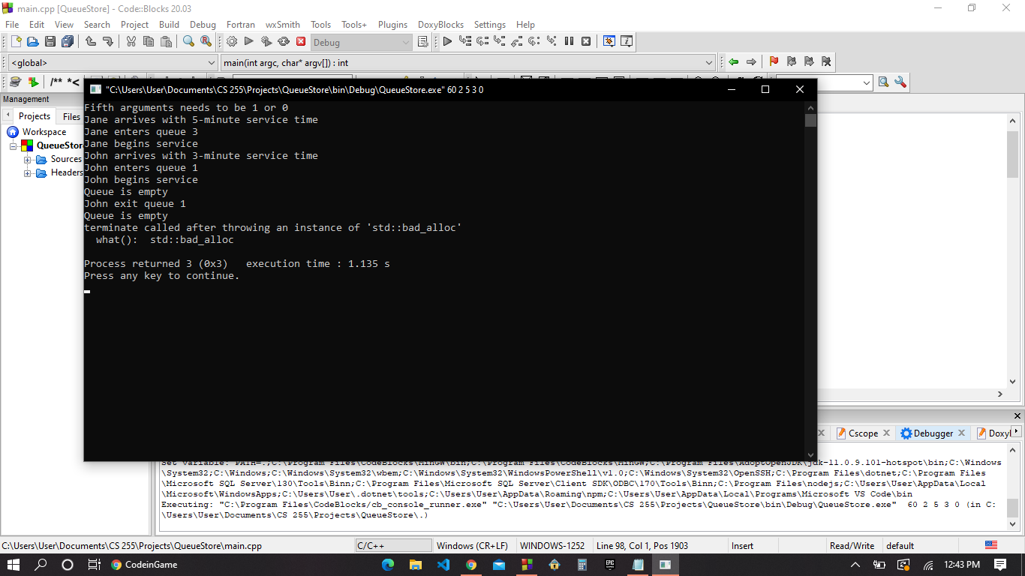

c)Another sample run with all parameters fixed except the number of queues (verbose =off)



d) After observing and analyzing my data from my experiments. I noticed once my queue is empty for a certain amount of time then my program shuts down. Others wise my program would continue until it reached the run time that the user input. Sadly, I could not find the difference in the statistics since I could not figure out how to output that information.