CS Making with Micro:bit

Simple Loop

Problem statement:

Create a program that will display a launch countdown followed by the message "Blast Off!". The countdown should start at 10, count down to 1 by 1, then display the blast off message. Use a loop for the countdown.

Program design:

We need to perform four tasks in our program based on the problem statement.

#1 Create a countdown variable

#2 Repeat the following tasks 10 times

display the countdown

subtract one from the countdown

#3 Display the blast message

Here is our plan as a picture:

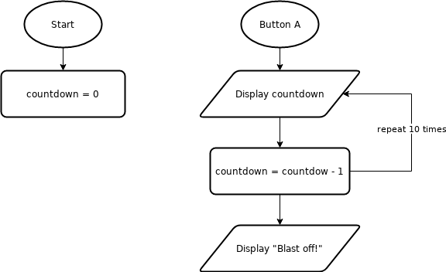

Now we are ready to turn our design into a program.

(program on next page)

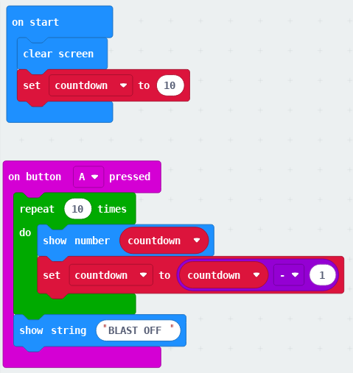

DLCS Standards

6th grade: Computational Thinker #6 and #8

7th grade: Computational Thinker #5 and #8

8th grade: Computational Thinker #2 and #3