CS Making with Micro:bit

Repeated subtraction using a loop

Problem statement:

Create a program that will compute *k* where *k = a modulo b*. Use a loop.

Program design:

We need to perform following tasks in our program based on the problem statement.

* Create and initialize variables for the operands
* Use button A to input the left operand
* Use button B to input the right operand
* Use the button combination A and B to compute the modulo (remainder)
* Reset the variables to zero and reset the screen when the Micro:bit is shaken

Here is our plan as a picture:

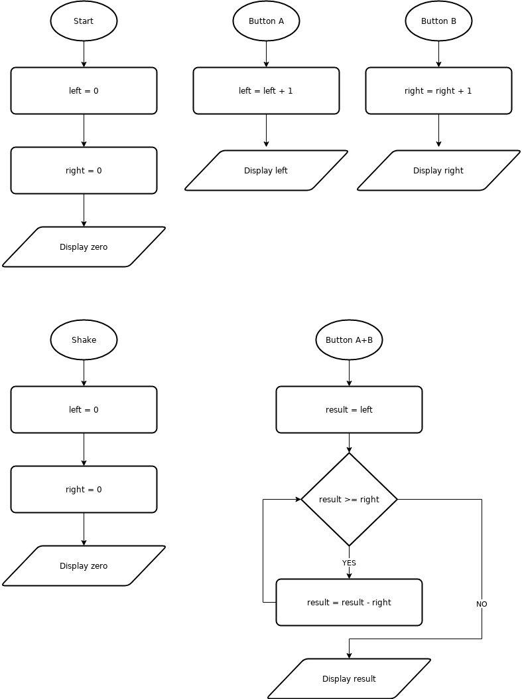

Now we are ready to turn our design into a program.

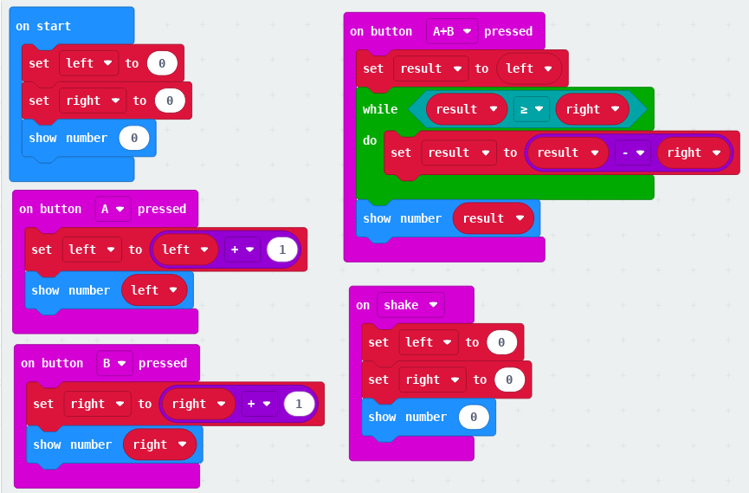

DLCS Standards

6th grade: Computational Thinker #6

7th grade: Computational Thinker #5 and #8

8th grade: Computational Thinker #2 and #3