Activity:

Create a Digital Name Tag

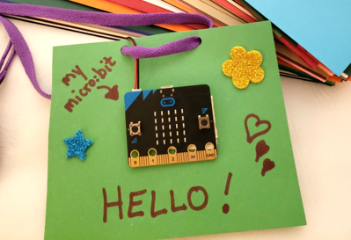

Description:

Apply concepts from the previous two lessons to create a digital name tag for a classmate.

Vocabulary Review:

**Design Thinking**: a process of creating a new idea or solving a problem.

**Empathy**: being able to share thoughts and understand where the other person is coming from.

**Ideation**: the process of forming ideas and concepts—creatively coming up with solutions to

problems.

**Prototype**: a sample model presented to a client before starting the actual project; it ensures

that the user and the maker of the product are on the same page and have the same “vision” before spending time building the product.

Step 1: Prototype Your Own Name Tag

Create a prototype of a name tag for yourself below. Be sure NOT to show your design to your partner!

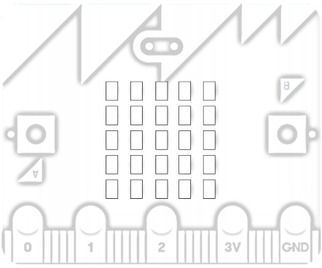

Step 2: Interview Your Partner

Use the space below to interview your partner. The idea is to use empathy to gain insight about what they would like on their name tag. You may ask questions about your partners likes/dislikes, hobbies, etc. You may NOT ask your partner about specific design ideas!

Interview:

__________________________________________________

__________________________________________________

__________________________________________________

__________________________________________________

__________________________________________________

__________________________________________________

__________________________________________________

__________________________________________________

__________________________________________________

__________________________________________________

__________________________________________________

__________________________________________________

__________________________________________________

Step 3: Create Prototype for Classmate’s Name Tag

Use your interviews from step 2 to create a name tag for your partner. Complete this without any assistance or input from your partner. You will reveal your design ideas to them in step 4 once it is completed. Two blank name tags are provided below if you would like to create more than one prototype!





Step 4: The Big Reveal!

Reveal your designs from step 3 to your partner. Compare the design you made for yourself to the design your partner made for you. Use aspects that you like of all designs to make a sketch of your partner’s final design. Also, decide what to display on the micro:bit. Would you like to display their name? Do you want to draw their name on the paper around the miro:bit and have a shape (such as a heart or a smiley face) appear on the micro:bit? Personalize it any way you would like!

Final Sketch for your Partner:

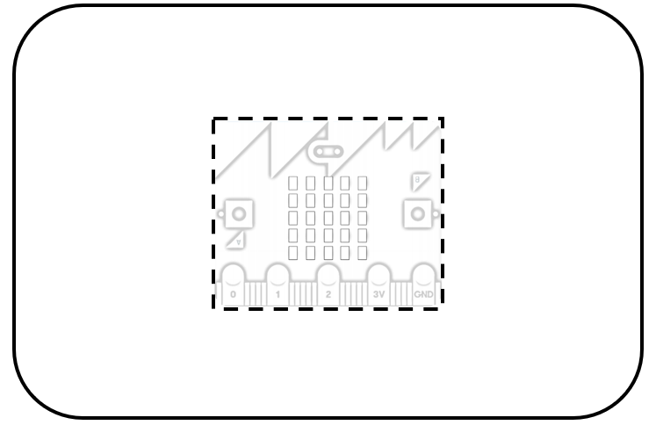

Step 5: Program your Micro:bit

Now we need to program the micro:bit to display your selection from Step 4. You may use your *Introduction to the micro:bit* handout for reference on how to code your program.

Step 6: (*OPTIONAL*) Recreate your Final Sketch with Arts/Crafts

If time allows, use construction paper, markers, crayons, etc. to create a name tag of your final sketch (as pictured at the top of page 1).

Step 7: Add your Micro:bit to your Name Tag

Once you have your micro:bit displaying your selection (name or shape), you can now add your micro:bit to your name tag! If Step 6 was completed, you may place your creation on top of the micro:bit. If not, you may set your micro:bit on top of your creation in Step 4 in the dotted-line area. You can also cut out the square to display your micro:bit from the back-side of the paper.

References

Online quick start tutorial: <http://microbit.org/guide/quick/>

Flowchart tool: <https://www.draw.io/>