Activity:

Human Robot

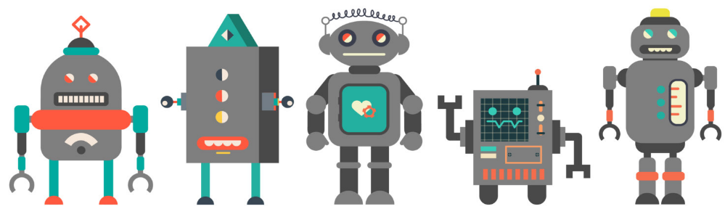

Write your set of instructions that your Human Robot will execute:

Remember,

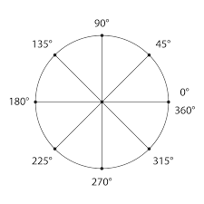the robot only follows the following set of instructions:

*Start

*Move Forward (by a #number of steps)

*Move Backward (by a #number of steps)

*Rotate 45°; 60°; 90°; 180°; 270°; 360° (To Turn your Robot)

*Stop

Step 1 __________________________________________________________________________

Step 2 __________________________________________________________________________

Step 3 __________________________________________________________________________

Step 4 __________________________________________________________________________

Step 5 __________________________________________________________________________

Step 6 __________________________________________________________________________

Step 7 __________________________________________________________________________

Step 8 __________________________________________________________________________

Step 9 __________________________________________________________________________

Step 10 _________________________________________________________________________

Step 11 _________________________________________________________________________

Step 12 _________________________________________________________________________