Lesson: Single Numeric Variable

**Big Picture**

All useful computer programs store and manipulate information. In order to store information that can be changed (i.e. vary), we need variables. This lesson will build upon the previous lesson by adding additional functionality to the program.

**Objectives**

Students will be able to:

* Demonstrate the use of a single numeric variable in a micro:bit program

**Alabama Standards Alignment**

7: Create a program that includes selection, iteration, or abstraction, and initializes, and updates, at least two variables.

* Examples: Make a game, interactive card, story, or adventure game.

**Links to Resources**

N/A

**Preparation**

Write the program provided in the image below:

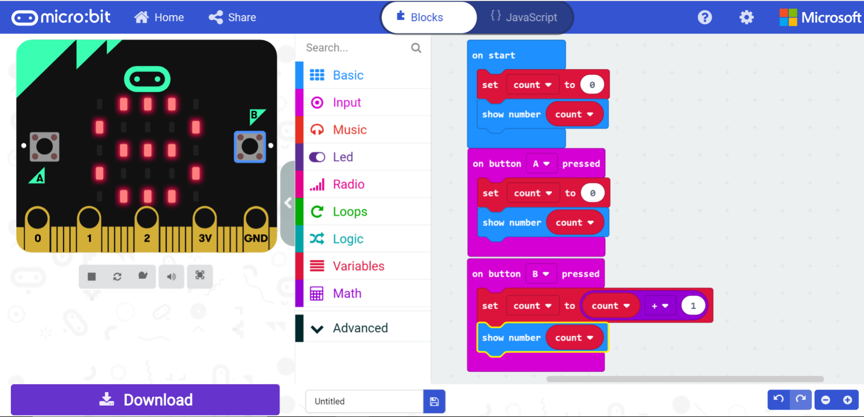

**Materials Required**

Each student (or pair of students) requires:

* micro:bit kit
* USB cable
* Internet connected computer with modern browser

*\*Note: Browsers known to work with micro:bit software includes Firefox, Chrome, Safari, and Microsoft Edge*

*For a complete list, visit this page:* <https://makecode.microbit.org/browsers>

**Vocabulary and Concepts**

* Variable - a named location in memory that stores a value that may change
* Data type - describes the kind of data a variable may store, the range of values, the allowed operations, and the amount of memory required
  + Variables may hold numbers, letters, characters, etc.

**Teaching Guide**

Getting Started (1 min)

Inform students that you will build the program in front of the class and that they should follow along on their computers. The program will be similar to the one built in the previous lesson with one change. The counter in this program can be reset with the A button.

Activity (20 mins)

The teacher will review the concept of variables and will illustrate how to use variables with a hands-on demonstration using the program in provided on this guide. The teacher should build the program in front of the class while explaining the reasoning behind each block/line of code. The students should NOT be allowed to follow along. For the “on start” block, a variable named “count” is created and set to zero. The current value of the “count” variable (zero) is displayed on the LED display. For the “on button A pressed” block, the “count” variable is reset to zero and the current value of “count” (zero) is displayed on the LED display. *Note: this programs the A button to be a reset button where, whenever A is pressed on the micro:bit, the value of “count” is reset to zero and displayed on the LED display.* For the “on button B pressed” block, the “count” variable’s value is incremented by one, then the new value of “count” is displayed on the LED display. *Note: this programs the B button to increment the value of “count” by one each time the B button is pressed on the micro:bit*. The teacher will now ask students to build this program and test it on their micro:bits. If the teacher thinks the students are ready, she can ask them to build the program without having the code on display.

Wrap Up (10 mins)

The teacher can ask students to modify their programs to make Button b increment the value of “count” by more than one.