Lesson: Multiple Numeric Variables

**Big Picture**

All useful computer programs store and manipulate information. In order to store information that can be changed (i.e. vary), we need variables. This lesson involves the creation of a program that utilizes variables, (x,y) coordinates, and the modulo operator.

**Objectives**

Students will be able to:

* Demonstrate the use of multiple numeric variables in a micro:bit program

**Alabama Standards Alignment**

7: Create a program that includes selection, iteration, or abstraction, and initializes, and updates, at least two variables.

* Examples: Make a game, interactive card, story, or adventure game.

**Links to Resources**

<https://makecode.microbit.org/device/screen>

**Preparation**

The following file will be needed:

* lesson-6_student_handout: Tutorial handout found on lesson page

Write the program provided in the image below and test it on a micro:bit before class:

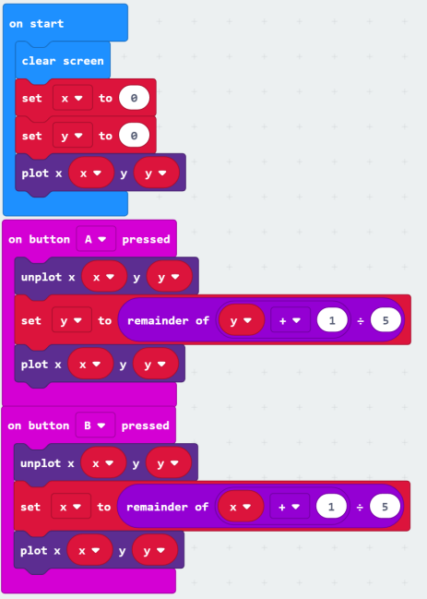

**Materials Required**

Each student (or pair of students) requires:

* Tutorial handout
* micro:bit kit
* USB cable
* Internet connected computer with modern browser

*\*Note: Browsers known to work with micro:bit software includes Firefox, Chrome, Safari, and Microsoft Edge*

*For a complete list, visit this page:* <https://makecode.microbit.org/browsers>

**Vocabulary and Concepts**

* Variable - a named location in memory that stores a value that may change
* Data type - describes the kind of data a variable may store, the range of values, the allowed operations, and the amount of memory required
  + Variables may hold numbers, letters, characters, etc.
* Modulo - an operator that performs division and only keeps the remainder.

**Teaching Guide**

Getting Started (30 min)

The teacher will use the **lesson-9_student_handout.pdf** to help explain that the micro:bit LED screen consists of 25 red LED lights arranged in a 5X5 grid (5 LEDs across by 5 LEDs down). There is a picture of the micro:bit with coordinates on the student handout that can help with this explanation. The program in this exercise will use the “remainder of” (modulo) operator, the student handout has modulo examples and exercises for the students to complete. Next, the teacher will explain the concept of the program students will be building. In this program, students will be using the buttons on the micro:bit to move a LED element around the micro:bit display. The A button will be used to increment the y-coordinate by one, and the B button to increment the x-coordinate by one.

Activity (30 min)

DO NOT SHOW THE CODE TO THE STUDENTS AT THIS POINT.

The teacher should draw diagrams illustrating this motion and ask students the coordinates for various locations based on the micro:bit’s coordinate system.

The teacher can ask students “what happens when the LED is moved to the edge?”, “how can we handle “wrapping around the display?””. The teacher should discuss the purpose of using the modulo operator/statement, and what happens if it is not used. The teacher will guide students through the algorithm and flowchart for the program. Once this is done, allow students time to implement and test the program. The teacher may need to provide hints and help. If the students have difficulties in implementing this program on their own, the teacher should implement it in front of the class and walk them through each step and the reason for each block/statement.

Wrap Up (5 min)

If the program did not have to be shown to the students, be sure to have a student show off their solution for everyone, or the teacher can show their solution.

**Answers**

1. 12 **mod** 6 = 0
2. 7 **mod** 5 = 2
3. 12 **mod** 5 = 2
4. 9 **mod** 12 = 9