Program #2 – Making with Micro:bit

Blink a LED

Problem statement:

Make a circuit and create a program that will blink a LED on and off. The LED should be on for one half of a second and then off for one half of a second. The LED will blink continuously until the Micro:bit is turned off.

Program design:

We need to perform four tasks in our program based on the problem statement.

#1 Turn the LED on

#2 Wait one half of a second

#3 Turn the LED off

#4 Wait one half of a second

Here is our plan as a picture:

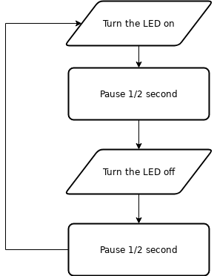

Now we are ready to turn our design into a program.

(program on next page)

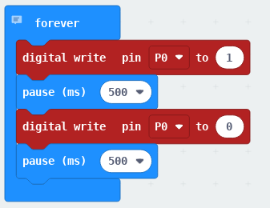

Here is a picture of the circuit.



DLCS Standards

6th grade: Computational Thinker #6

7th grade: Computational Thinker #5 and #8

8th grade: Computational Thinker #2 and #3