Program #3 – Variables

Simple Counter

Problem statement:

Create a program that will display the number zero initially. When the A button is pressed increment the value shown on the display. When the B button is pressed decrement the value shown on the display. Use a variable to manage the value.

Program design:

We need to perform three tasks in our program based on the problem statement.

#1 Create a variable to store the value count and initialize the variable to zero.

#2 Add one to the value and display it when the A button is pressed (increment).

#3 Subtract one from the value and display it when the B button is pressed (decrement).

Note that we must create the variable and initialize it before we can use the variable in any input, computations, or output. This means that task #1 in our list must be done first. Actions that must be done first always go in the “On Start” block of our Micro:bit program.

Here is our plan as a picture:

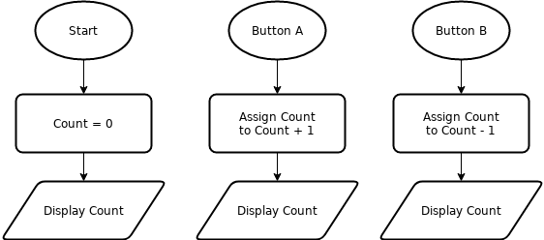

Now we are ready to turn our design into a program.

(program on next page)

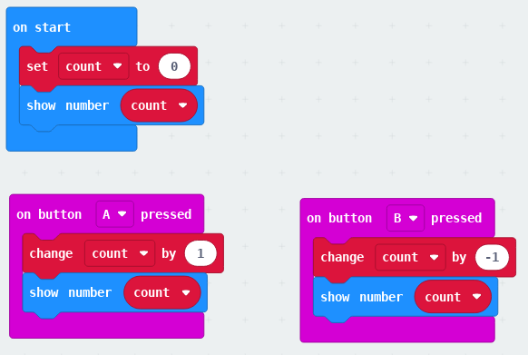

Here is a different implementation of our plan. This program uses blocks from the math drawer to increment and decrement the count variable.

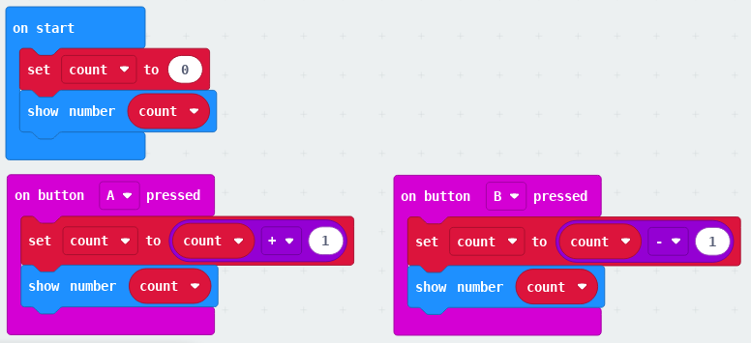

DLCS Standards

6th grade: Computational Thinker #6 and #8

7th grade: Computational Thinker #5 and #7

8th grade: Computational Thinker #3