1. Maven
   1. Type of repositories
      1. Local repository
         1. cd ~/.m2 可以access
      2. Central repository – every developer can access
      3. Remote repository – belongs to company, need some credential (password etc.)
   2. Life cycle of Maven
      1. Validate
      2. Compile (all the source code in the project)
      3. Test
      4. Package (to jar/war file)
      5. Verify (run any checks to ensure the quality match, code coverage something)
      6. Install (install package into local repository)
      7. Deploy (to local or to company’s domain or to cloud service)
   3. Maven commend lines
      1. mvn clean
      2. mvn test
      3. mvn install (call 某个，life cycle之前的步骤也会被做)
   4. 创建project
      1. pom.xml文件，放dependencies
2. Git – tool used for version control
   1. Git vs svn – git has local and can work offline, svn must be used online
   2. Commend lines
      1. Git branch
      2. Git add .
      3. Git commit -m “add read me file”
      4. Git push
3. Eight basic date type
   1. Primitive type
      1. byte, short, int, long, float, double, char, boolean
   2. Wrapper class
      1. Byte, Short, Integer, Long, Float, Double, Character, Boolean
   3. Autoboxing and unboxing
      1. Autoboxing: primitive -> wrapper
      2. Unboxing: wrapper -> primitive
4. String/StringBuilder/StringBuffer
   1. String – immutable, thread safe
   2. StringBuilder – mutable, not thread safe
   3. StringBuffer – mutable, thread safe
      1. Slower than StringBuilder
5. String/String constant pool
   1. == compares reference address
   2. Object.equals() compares content PS自己的class需要自己写，不然Object.equals() default即==
   3. Diagram

      Description automatically generated
   4. Integer constant pool注意range -128 to 127
6. Equals / hashCode
7. Collection
   1. Big Picture (Map is not a part of Collection!)

* 1. List
     1. ArrayList – Resizable array, stored in consecutive space
        1. Get – O(1), support random access in ArrayList
        2. Remove – O(n)
     2. LinkedList – not stored in consecutive space
        1. Get – O(n)
        2. Remove – O(n)
  2. Vector – arraylist + synchronized (deprecated)
     1. Thread safe
  3. Stack – use Deque to implement
     1. Thread safe
     2. FILO
     3. Push, pop
  4. Deque: implementation is ArrayDeque
     1. first [ ] last
     2. replace stack: deque.offerFirst(), deque.pollFirst()
  5. Set – unique!
     1. HashSet – all element unique, unsorted, don’t keep the insertion order
     2. TreeSet – all element unique, sorted
     3. LinkedHashSet – all element unique, keep the insertion order
  6. Map – stores key-value pairs
     1. HashMap – <key, value>
        1. Use key to get hashcode
        2. Hashcode % length
        3. Get index of the bucket
        4. Equals() to check
        5. Return value
        6. A picture containing diagram

           Description automatically generated
        7. 某个index上的LinkedList长度大于8，transfer it into a red-black tree
     2. LinkedHashMap
     3. TreeMap – ordered by key
     4. HashTable – thread safe, has only one lock, only one thread can access at the same time
     5. ConcurrentHashMap – thread safe, 16 threads can access at the same time
  7. Queue – use Deque to implement
     1. FIFO
  8. Heap - use PriorityQueue to implement
     1. minHeap – parent smaller that left and right, but don’t know whether left > right or right > left
     2. maxheap
  9. array
     1. int[] String[] Object[]
     2. int[][], char[][]
  10. Common interview questions
      1. list vs. set
      2. HashMap vs. HashTable vs. ConcurrentHashMap
      3. HashSet implemented by a HashMap, just ignore the value, and keep the key
      4. TreeSet vs. TreeMap

1. Comparator vs Comparable
2. JVM
   1. Diagram

      Description automatically generated
   2. Class loader

* 1. Runtime data area

* 1. Execution engine

1. Class Loader
   1. Diagram

      Description automatically generated
2. Garbage Collection
   1. Serial GC – single thread
   2. Parallel GC – multi thread
   3. G1 GC – separate all the memory space into different chunks
   4. CMS GC – concurrent mark and sweep GC
      1. Deprecated since java 9
      2. Completely removed in java 14
   5. Diagram

      Description automatically generated
      1. Minor GC
      2. Major GC
3. Keywords
   1. Keywords overview
      1. Reserved words

* + 1. For data types (8)
       1. byte, short, int, long, float, double, char, boolean
    2. flow control (11)
       1. if, else, switch, case, default (2 kinds), for, do, while, break, continue, return
    3. modifiers (11)
       1. public, private, protected, static, final, abstract, synchronized, native, strictfp, transient, volatile
    4. exception handling (6)
       1. try, catch, finally, throw, throws, assert
    5. class related (6)
       1. class, package, import, extends, implements, interface
    6. object related (4)
       1. new, instanceof, super, this
  1. Final
     1. Final variable
        1. Create constant variable
        2. Must be initialized
     2. Final method
        1. Can’t be overridden
     3. Final class
        1. Can’t be extended
  2. Immutable class
     1. Final class
     2. Private final fields
     3. No setter
     4. Return deep copy of the collections for getter
  3. Static
     1. Block
     2. Variable
     3. Methods
     4. Classes
     5. Diagram

        Description automatically generated
  4. Implements vs extends
     1. Diagram

        Description automatically generated

1. OOP
   1. Abstraction – hide all the internal implementation
      1. Abstract class
      2. Interface
   2. Encapsulation
      1. Declare all the variables be private
      2. Provide getter and setter
   3. Inheritance
      1. Extends
      2. Implements
   4. Polymorphism
      1. Override
      2. Overloading
2. Exception
   1. Diagram

      Description automatically generated
   2. Checked exception vs unchecked exception
   3. How to handle the exception
      1. Try catch
      2. Throws
   4. How to customize exception
   5. How to handle multiple exceptions
      1. try {} catch (IOException ioe) {} catch (SQLException sqle) {} catch …
      2. try {} catch (IOException | SQL Exception | …) {}
      3. try { Connection con = DataDriver.getConnection();} catch (IOException ioe) {} catch (Exception ex) {} finally { if (con != null) {con.close();}}// from child to parent
3. Generics
   1. Easier and less error prone
   2. Enforce type correctness at compile time
   3. Without causing any extra overhead to your application
   4. Can check: <? Extends E>, <? Super T>, <T extends E>
4. IO stream
   1. Stream – a continuous flow of data
   2. Byte Stream – inherited from inputStream, outputStream
      1. Each time read 1 byte = 8 bits
   3. Character Stream – inherited from Reader, Writer
      1. Each time read 2 byte = 16 bits
   4. 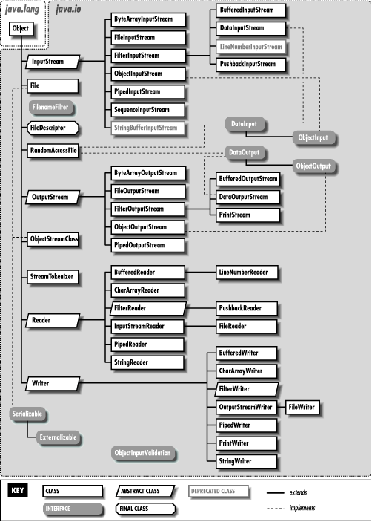
   5. File – part of java.io
      1. Gives you access to underlying file systems
5. Serialization and deserialization
   1. Kafka – serialized (?)
6. Java 8 features
   1. Lambda
      1. (arguments) -> {body}
      2. Functional programming
      3. Less code
   2. Functional interface
      1. Predicate
         1. Public boolean test(T t)
      2. Function
         1. Public R apply(T t)
      3. Consumer
         1. Public void accept(T t)
      4. Supplier
         1. Public R get(T t)
   3. Optional
      1. used to prevent NPE
      2. If (obj == null) {

} else {

} // don’t have to use these

* 1. Stream API
     1. Intermediate operation: return a stream as result
        1. Map, flatmap, filter…
     2. Terminal operation: return nun-stream
        1. forEach, collect

1. Multi-threading
   1. Thread vs process
      1. Process – Independent memory space, heap, OS resources
      2. Thread – shared memory space, private stack, program counter, register
   2. Thread states
      1. New – thread create, not yet start
      2. Runnable – executing in JVM
      3. Blocked – wait for a monitor lock to enter synchronized block or method
      4. Waiting – object.wait with no timeout, thread.join() with no timeout, park()
      5. Timed waiting – thread sleep, Object.wait() with timeout, thread with timeout, park
      6. Terminated – thread has completed

* + 1. Diagram

       Description automatically generated
  1. Thread creation
     1. Extends thread
     2. Implements Runnable
     3. Implements callable
     4. Thread pool
  2. Runnable vs callable
     1. No return / has
     2. No exception / has
     3. Run() / call()
  3. Thread pool

* 1. ThreadPoolExecutor
     1. corePoolSize
     2. maximumPoolSize
     3. keepAliveTime
     4. timeUnit
     5. workQueue
     6. threadFactory
     7. handler
        1. abortPolicy
        2. callerRunPolicy
        3. discardPolicy
        4. discardOldestPolicy
     8. goodnotes
  2. in-built thread pool
  3. OutOfMemoryError
  4. Lock
     1. synchronized
     2. Lock interface
  5. Synchronized
     1. Block
     2. Method
     3. Static method
     4. Class

Class demo {

Public void method() {

Synchronized(Demo.class) {

}

}

Public synchronized void method() {

}

Public synchronized static void method() {

}

Public void method() {

Synchronized(this) {

}

}

}

* 1. Lock interface
     1. Lock(), unlock(), newCondition(), tryLock(), lockInterruptibly()
     2. reentrantLock class
  2. ReadWriteLock interface
     1. – method
        1. Lock readLock()
        2. Lock writeLock()
     2. Class
        1. reentrantReadWriteLock
  3. Future / CompletableFuture