Kayla Pham

May 17, 2021

Foundations of Databases & SQL Programming

Module 06 Assignment

# SQL Views, Functions, and Stored Procedures

Introduction

The purpose of this paper is to explain the concepts learned in Module 06 on views, functions, and stored procedures.

Explain when you would use a SQL View.

A view is a select statement saved with a given name and is a form of an abstraction layer. Views provide a way to give access to the data in a table without giving access to the table itself. This is one way to control permissions. Another option is to limit access to the data within a table by partitioning it into different views and granting separate permissions to those views. Views can also be used to create a customized way of looking at the data apart from how the data is stored in the table. For example, in our Module 06 assignment, we created a field for Employee Name which is a concatenation of the first and last name.

Explain the differences and similarities between a View, Function, and Stored Procedure.

A function is a SQL statement that performs a specific task. The two types of functions either return a table of values (table value function) or return a single value (scalar function). Views and functions are similar in that they can create the same way of returning data from a table. The difference between them is that functions can accept parameters where views can’t. Another difference is a view can’t return a single value as an expression unlike a scalar function.

A stored procedure is a way of saving a set of SQL statements. Stored procedures are flexible in that they can have many statements and they don’t have to be select statements; for example, they can insert, update, delete and even create tables. Stored procedures are often used for very complex reporting.

Views, functions and stored procedures are all ways of saving code and can present data in the same way as shown in Figure 1. Functions and stored procedures can go beyond what views can do and stored procedures can go beyond what functions can do. It is recommended to go with which one is the most simple and easy for a given scenario.

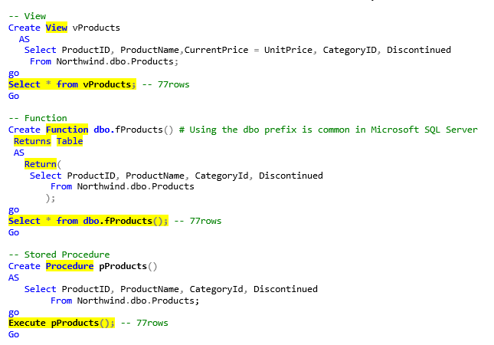

***Figure 1: View, function and stored procedure***

***Reference: Taken from Module06 lab***

Summary

To recap, Module 06 includes the topic of views, functions and stored procedures and the differences between them and when they are used.